



**Module Code & Title**

CS6P05 Final Year Project MAD

Food Share – Android App

**Assessment Weightage & Type**

Final Report

**Supervisor By**

Mr. Shekhar Timsina

Mr. Bishal Gharti Chhetri (GC)

**Student Details**

Name: Sita Ram Thing

London Met Id: 22015892

College Id: NP01MA4S220003

Islington College, Kathmandu

24 April 2024

**Git Hub:** [FYP-23-24/22015892-SitaRamThing (github.com)](https://github.com/FYP-23-24/22015892-SitaRamThing)

**Contents**

CHAPTER 1: INTRODUCTION 1

1.1 Project Introduction 1

1.2. Current Scenario 2

1.3. Problem Domain and Project as a Solution 4

1.4. Aim and objectives. 5

1.4.1. Aim 5

1.4.2. Objectives 5

1.5. Structure of the Report 6

1.5.1. Background 6

1.5.2. Development 6

1.5.3. Testing and analysis 7

1.5.4. Conclusion 7

CHAPTER 2: BACKGROUND 8

2.1. About the End Users 8

2.2. Understanding the solution 10

2.2.1. Overview of the system 11

2.2.2. Technical Terms and Definition (Technical Terms related to the project) 12

2.2.3. Function and Features 16

2.3. Comparison 18

2.3.1. Similar Projects 18

2.3.2. Comparisons (Comparing the features and critical evaluation of the solution) 21

CHAPTER 3: DEVELOPMENT 22

3.1. Methodology 22

3.1.1. Considered Methodologies 22

3.1.2. Justification for Not Selected Methodologies 29

3.1.3. Justification for Selected Methodology 33

3.2 Survey Result 36

3.2.1. Pre-Survey Results 36

3.2.2. Post-Survey Question 43

3.2.3 Post survey result 44

3.3. Requirement Analysis 48

3.3.1 Introduction 48

3.3.2 Purpose 48

3.3.3 Scope 48

3.3.4 Reference 49

3.3.5 Overall Descriptions 52

3.3.6 Functional Requirement 53

3.3.7 External Interface Requirements 54

3.3.8 External Requirement 57

3.3.9 Non-Functional Requirement 59

3.9.1 Usability 59

3.9.2 Security 59

3.9.3 Performance 59

3.9.4 Error Handling 59

3.9.5 Ease of Use 60

3.9.6 Maintainability 60

3.9.7 Portability 60

3.4. Design (Concerning methodology what are the core design techniques. For eg: If the methodology is USDP, UML diagrams are a must) 61

3.4.2. Use Case 61

3.2.1. High-Level Use Case 63

3.3. Sequence Diagram 68

3.3.1. View profile sequence diagram 68

3.3.4. Donation rating sequence diagram 71

3.3.5. Complaint with admin 72

3.4. Context Diagram 73

3.5. Data Flow Diagram Level -1 74

3.6. Activity Diagram 75

3.6.1. Take Membership Activity 75

3.6.2. Donation Activity 76

3.6.3. View History Activity 77

3.6.4. Donation Rating Activity 77

3.6.5. Complaint with Admin Activity 78

3.7. Wireframes 79

3.7.1 Mobile UI 79

3.7.2. Web UI for Admin 93

3.8. ER-Diagram 95

3.9. System Architecture Diagram 97

3.10. Class Diagram 98

3.11. DFD’s level 2 99

3.11.1. Take Membership 99

3.5. Implementation 105

3.5.1. System Development (Important screenshots of development core features and architecture) 105

3.5.2. System Architecture 123

CHAPTER 4: TESTING AND ANALYSIS 126

4.1. Test Plan 126

4.1.1. Unit Testing 126

4.1.2. System Testing 127

4.2. Test Execution 128

4.2.1. Unit Testing 128

4.2.2. System Testing 152

4.3. Critical Analysis 231

CHAPTER 5: CONCLUSION 233

5.1. LEGAL, SOCIAL AND ETHICAL ISSUES 234

5.1.1. LEGAL ISSUES 234

5.1.2. SOCIAL ISSUES 234

5.1.3. ETHICAL ISSUES 234

5.2. Advantages of waste food or surplus food donation system 235

5.4. Limitations 236

5.1.1 Limited User Control: 236

5.1.2 Risk of Misuse: 236

5.1.3 Potential for Inefficiency: 236

5.1.4 Limited Transparency: 236

5.1.5 Dependency on Volunteer Availability: 237

5.1.6 Geographical Constraints: 237

5.1.7 Communication Challenges: 237

5.1.8 Limited Platform Availability: 237

5.1.9 Unequal Access: 237

5.3. FUTURE WORK 238

5.3.1 Dark Mode 238

5.3.2 Chat (Messaging)s 239

5.3.3. Kotlin multi-platform 241

CHAPTER 6: References 243

References 243

CHAPTER 7: APPENDIX 246

7.1 Appendix A: Introduction 246

7.1.1 Current Scenario Additional information 246

7.2 Appendix B: Background 247

7.2.1 About the End User 247

2.2.1.1 Web (Admin) 247

2.2.1.2 Mobile 247

7.3 Appendix C: Methodology 249

7.3.1 Survey 249

7.3.2 UML Diagram 267

7.4 Appendix D: Implementation 318

7.4.1 Unit Test Plans 318

7.5 Appendix E: Testing and Analysis 322

7.5.1 System Testing 322

7.5 Appendix F: Deployment (Not real deployment) 345

**List of table**

Table 1: Comparison to a similar project 21

Table 2: Justification scenario 1 for waterfall methodology 29

Table 3: Justification scenario 2 for waterfall methodology 30

Table 4: Justification scenario 3 for waterfall methodology 30

Table 5: Justification scenario 1 for prototype methodology 31

Table 6: Justification scenario 2 for Prototype methodology 32

Table 7: Justification scenario 3 for Prototype methodology 32

Table 8: Hardware interface Requirement 54

Table 9: Register user high-level use case 63

Table 10: Take membership user high-level use case 64

Table 11: Login user high-level use case 64

Table 12: Food donation high-level use case 65

Table 13: View donation info high-level use case 65

Table 14: Donation rating high-level use case 66

Table 15: View the history of high-level use case 66

Table 16: View profile high-level use case 66

Table 17: Complaint with high-level use case 67

Table 18: Register Unit Test 128

Table 19: Login Authentication Unit test 131

Table 20: Device token save unit 134

Table 21: View history unit test 137

Table 22: Report to admin history unit test 139

Table 23: Donation Rating 142

Table 24: The number of system ration 145

Table 25: Email verify unit test 147

Table 26: NOG register unit test 150

Table 27: Web testing for login table 153

Table 28: Empty web login screen 154

Table 29: Web testing to login screen in unauthenticated user 156

Table 30: Web testing register user table 158

Table 31: Web test in enter the email, password and confirm password 159

Table 32: Web test update password success to navigate to the login page 159

Table 33: Test for the home page has a history in pie-chart 160

Table 34: Web testing for View history tables 162

Table 35: Web testing for deleting table details 164

Table 36: Web test for adding new user table 166

Table 37: Web testing for user account activate table 169

Table 38: Web Logout Testing Table 171

Table 39: Registered user test in mobile app 174

Table 40: Login credential user account test in the mobile app 177

Table 41: Login credential user account test in the mobile app 180

Table 42: Forgot Password test in mobile app 183

Table 43: View the History test in the mobile app 187

Table 44: View the Donation location test in the mobile app 190

Table 45: View user profile test in the mobile app 194

Table 46: Donate food test in mobile app 197

Table 47: View notification history 202

Table 48: Report to admin test in mobile app 223

Table 49: Update profile details test in the mobile app 227

Table 56: Register user expanded use case table 270

Table 57: Table membership Expanded use case 271

Table 58: Take membership expanded use case table 272

Table 59: Login expended use case diagram 273

Table 60: Login user expanded use case table 274

Table 61: Food donation expended use case diagram 275

Table 62: Food donation user expanded use case table 276

Table 63: View Donation history expended use case diagram 277

Table 64: View history user expanded use case table. 278

Table 65: Donation rating expanded use case diagram. 279

Table 66: Donating rating expanded use case table 280

Table 67: Complaint with admin expanded use case diagram 281

Table 68: Complaint with admin expanded use case table 282

Table 69: Unit testing planning tables 321

Table 50: Update profile image test in the mobile app 322

Table 51: Deactivate user account test in mobile app 326

Table 52: Change password test mobile app 330

Table 53: Logout test mobile app 334

Table 54: Logout test mobile app 337

Table 55: View the History test in the mobile app 340

**List of Figures**

Figure 1: Current Scenario of Nepal context food problems. 3

Figure 2: Client Approvable latter. 9

Figure 3: Flash floods similar app image 18

Figure 4. Food Rescue similar project image 19

Figure 5: No Food Waste similar projects image. 20

Figure 6: Waterfall methodology. 24

Figure 7: Scrum Methodology 26

Figure 8: Prototype methodology. 28

Figure 9: Justification scenario 1 for Scrum methodology. 33

Figure 10: Justification scenario 2 for Scrum methodology. 33

Figure 11: Justification scenario 3 for Scrum methodology. 34

Figure 12: Justification scenario 4 for Scrum methodology. 34

Figure 13: Justification scenario 5 for Scrum methodology. 35

Figure 14: Justification scenario 6 for Scrum methodology. 35

Figure 15: Pre-survey form introduction with username 36

Figure 16: Pre-servery percentage of user age 37

Figure 17: Pre-servery user occupations 38

Figure 18: Preservay result of excess food for donated 38

Figure 19: Pre-survey result per cent of users participated in the donation program 39

Figure 20: Pre-survey result user can food donates or dump 39

Figure 21: Pre-survey result of user interest directly or through donations organisations 40

Figure 22: Pre-survey result of user interest in food donation 40

Figure 23: Pre-survey rating point of food donation idea 41

Figure 24: Pre-survey results for use need donation tracking 41

Figure 25: Pre-survey result of the user is interested in receiving the update 42

Figure 26: User feeb back for system requirement 42

Figure 27: Post-survey introductions with questions of email and username 43

Figure 28: Post-survey of User Occupations 44

Figure 29: Post-survey results of user experience 44

Figure 30: Post-survey results used to recommend the system 45

Figure 31: Post-survey of system navigation survey response 45

Figure 32: Post-survey result of finding the helpful 46

Figure 33: Post survey results of recommendations for donations 46

Figure 34: Post-survey of overall system rating 47

Figure 35: Use Case Diagram 62

Figure 36: View profile sequence diagram 68

Figure 37: View the history sequence diagram 69

Figure 38: Food Post for donation sequence diagram 70

Figure 39: Donation rating sequence diagram 71

Figure 40: Complaint with admin sequence diagram 72

Figure 41: Context diagram 73

Figure 42: DFD Level-1 74

Figure 43: Take the membership activity diagram 75

Figure 44: Food donation system activity diagram 76

Figure 45: View the history system activity diagram. 77

Figure 46: Rating donation system activity diagram 77

Figure 47: Complaint with admin system activity diagram 78

Figure 48: Walkthrough screen mobile UI 79

Figure 49: Welcome screen mobile UI 80

Figure 50: Login screen mobile UI 81

Figure 51: Register screen mobile UI 82

Figure 52: Forgot password screen mobile UI 83

Figure 53: Donor Home screen mobile UI 84

Figure 54: Donor History screen mobile UI 85

Figure 55: Donor Post/Donation screen mobile UI 86

Figure 56: Volunteer Home screen UI 87

Figure 57: Volunteer Pending screen UI. 88

Figure 58: Volunteer History Screen 89

Figure 59: NGO Home screen UI 90

Figure 60: NGO History screen UI 91

Figure 61: NGO Setting Screen UI 92

Figure 62: Admin login page web UI 93

Figure 63: Admin forgot password UI. 93

Figure 64: Admin dashboard UI 94

Figure 65: ER-Diagram 96

Figure 66: System Architecture Diagram 97

Figure 67: Class diagram of food donation application 98

Figure 68: Take membership details DFD Level-2 100

Figure 69: Food donation DFD Level-2 101

Figure 70: View Donation History DFD Level-2 102

Figure 71: Donation rating DFD Level-2 103

Figure 72: Complaint with admin DFD Level-2 104

Figure 73: Implementation of the database user model 106

Figure 74: Implementation of database food model. 107

Figure 75: Implementation of database report model. 108

Figure 76: Implementation of database history model. 108

Figure 77: Implementation of database notification device token. 108

Figure 78: Implementation of Firebase service account key- backend. 109

Figure 79: Implementation of service account key in Firebase admin. 109

Figure 80: Implementation of notification send function. 110

Figure 81: implementation for receiving the notification message 110

Figure 82: Implementation for generating notifications. 111

Figure 83: Implement Food donations (post) - backend. 112

Figure 84: Implementations of view donor history 114

Figure 85: Implementation of view volunteer history. 115

Figure 86: Implementation of Donation rating - backend. 116

Figure 87: Implementation of donation rating frontend. 117

Figure 88: Implementation of the report - backend. 118

Figure 89: Implementation of report-frontend. 119

Figure 90: Implementation of map key 120

Figure 91: Implementation of map access to the current location late value 121

Figure 92: Implementation of map state man tent. 122

Figure 93: Implementation of Google Maps. 122

Figure 94: System Architecture 123

Figure 95: Register User unit test function 129

Figure 96: Register User unit test failed 129

Figure 97: Register success unit test function 130

Figure 98: Register success unit test response 130

Figure 99: Login User unit test function 131

Figure 100: Register User unit test failer response 132

Figure 101: Register success unit test function 133

Figure 102: Login success unit test response 133

Figure 103: Device token save unit test function 134

Figure 104: Device token save unit test failer response 135

Figure 105: Save device token success unit test function 135

Figure 106: Save device token success unit test response 136

Figure 107: History details get unit test failer response 138

Figure 108: Report to admin unit test function 139

Figure 109: Report to admin unit test response 140

Figure 110: Report to admin unit test success response 140

Figure 111: Report to admin unit test success function 141

Figure 112: Donation Rating unit testing function 143

Figure 113: Donation Rating unit testing failer response 143

Figure 114: Donation rating unit test function 144

Figure 115: Donation rating unit test failer response 144

Figure 116: Number of system ration unit test function 145

Figure 117: Number of system ration unit test failer response 146

Figure 118: Number of r action unit test success functions 146

Figure 119: Number of ratio unit test success responses 147

Figure 120: Email Evrify unit test function 148

Figure 121: Email Evrify unit test failer response 148

Figure 122: Email verify success function 148

Figure 123: Email verify unit test success response 149

Figure 124: Ngo register unit test is a success function 150

Figure 125: Ngo register unit test success response 151

Figure 126: Login screen with filled the email and password 154

Figure 127: successfully navigate to the dashboard web admin panel 155

Figure 128: Register data saved in a database 156

Figure 129: Web testing to fill in the login details 157

Figure 130: Display the Aunatheneticate user doesn't login to the web admin panel 157

Figure 131: Display the piechart with data 160

Figure 132: Display the percentage of food history 161

Figure 133: Display the percentage of food users 161

Figure 134: Web testing for history table list 162

Figure 135: View history of user details 163

Figure 136: View the history of food details 163

Figure 137: Web test for deleting item show 165

Figure 138: Web test deletes an item that does not show 165

Figure 139: New user register empty register screen 167

Figure 140: Web testing to enter the user details to register 168

Figure 141: Web testing to register user display in Table 168

Figure 142: Web testing shows the inactive account 170

Figure 143: Web testing user account is successfully activated 170

Figure 144: Logout view card with logout button 172

Figure 145: Web logout testing to successfully navigate the login page 173

Figure 146: Register user filled in the user details in the mobile app 175

Figure 147: Register user success in the mobile app 176

Figure 148: Register user details in the database 177

Figure 149: Login to inactivate the user account 178

Figure 150: show the unauthenticated error message in the dialogue box 179

Figure 151: Activate the user account from the admin 180

Figure 152: Login to activate the user account 181

Figure 153: Login success message 182

Figure 154: Enter the valid email address to verify the user 184

Figure 155: Enter the new password and valid both same password 185

Figure 156: Display the success message daily box 186

Figure 157: View list of food history history 188

Figure 158: View food details 189

Figure 159: View donation location content 191

Figure 160: View the location on the map with the pick-up point 192

Figure 161: View location details with distance 193

Figure 162: View the user profile content 195

Figure 163: View user profile details 196

Figure 164: Empty donation details 198

Figure 165: Donate food details filled 199

Figure 166: Donation success message 200

Figure 167: View the latest donated food on the home page 201

Figure 168: View donate food detail for notification 203

Figure 169: Received push notification 204

Figure 170: View the number of notifications in the badge 206

Figure 171: View notification history 207

Figure 172: Enter the donation completed info with rating and images 209

Figure 173: Donation rating completed message 210

Figure 174: Distribute the location image and send it to 211

Figure 175: View history with rating star 212

Figure 176: Update food Item 213

Figure 177: Change food details for an update 214

Figure 178: Display Updated food details 215

Figure 179: Delete donated food Item 216

Figure 180: Before detailing the food 217

Figure 181: Delete confirmation dialogue 218

Figure 182: Update donate food image 219

Figure 183: Before updating the food image 220

Figure 184: Food image update confirmation dialogue box 221

Figure 185: Updated food image 222

Figure 186: Report Item Menus 224

Figure 187: Write the report descriptions in the dialogue box 225

Figure 188: Report successful message 226

Figure 189: Before updating the username in the profile 228

Figure 190: Update food profile username 229

Figure 191: Latest updated user profile details 230

Figure 192: Future work Socket implementation for Chat. 240

Figure 193: Future work for multi-platform. 242

Figure 194: Multiplatform connection 242

Figure 195: Pre-survey form introduction with username 249

Figure 196: Pre-survey questions of age and occupation 250

Figure 197: Pre-survey questions of what could be donated and participants to the event 251

Figure 198: Preservay questions about the food of dump or donate and directly donate or through organizations 252

Figure 199: Pre-survey question of interest for donation and rating point of the system 253

Figure 200: Preservay questions of impact, updates, and suggestions for the system 254

Figure 201: Pre-survey questions filled with a sample of age and occupation 255

Figure 202: Pre-survey questions filled sample of what could be donated and participants to the event 256

Figure 203: Preservay questions about the food-filled sample of dump or donate and directly donate or through organizations 257

Figure 204: Pre-survey questions filled sample of interest for donation and rating point of the system 257

Figure 205: Preservay questions filled sample of impact, updates, and suggestions for the system 258

Figure 206: Post-survey questions of user experience 259

Figure 207: Post survey questions of user role 259

Figure 208: Post survey question of system navigation of surplus food donations system 260

Figure 209: Post-survey question of donations system which features is helpful 260

Figure 210: Post-survey of user recommend questions food donations system 261

Figure 211: Post-survey questions of a rating point to the overall system 261

Figure 212: Post-survey of feedback optional questions 262

Figure 213: Post-survey questions filled sample of user experience 263

Figure 214: Post survey questions filled sample of user role 263

Figure 215: Post survey question filled sample of system navigation of surplus food donations system 264

Figure 216: Post-survey question filled sample of donations system which features is helpful 264

Figure 217: Post-survey filled sample of user recommend questions food donations system 265

Figure 218: Post-survey questions filled sample of a rating point to the overall system 265

Figure 219: Post-survey of feedback optional filled sample 266

Figure 220: Register expanded use case 269

Figure 221: Sequence diagram of registered user 283

Figure 222: Login system activity diagram 285

Figure 223: Register system activity diagram 286

Figure 224: Logout system activity diagram 287

Figure 225: Splash screen mobile UI 288

Figure 226: Register response message mobile UI 289

Figure 227: Donor Profile screen mobile UI 290

Figure 228: Donor Setting screen mobile UI 291

Figure 229: Volunteer Setting screen UI 292

Figure 230: NGO Users screen UI 293

Figure 231: NGO Profile screen UI 294

Figure 232: Initial or Actual ER-Diagram 295

Figure 233: Final ER-Diagram 296

Figure 234: Register details DFD Level-2 298

Figure 235: Login details DFD Level-2 299

Figure 236: Login feature implementation in login API. 300

Figure 237: Login Api Call 300

Figure 238: Login Repository Implementation 301

Figure 239: Login user use-case implementation. 301

Figure 240: Login authentication view model implementation. 302

Figure 241: Register user Api view implementation. 303

Figure 242: Register user repository implementation. 303

Figure 243: Register user use case implementation. 303

Figure 244: Register user view model implementations. 304

Figure 245: Update password Api view implementations. 305

Figure 246: Forgot password API call implementation. 305

Figure 247: Forgot password repository implementation. 306

Figure 248: Forgot password use case implementation. 306

Figure 249: Forgot password view model implementation. 307

Figure 250: Update profile API call 308

Figure 251: Update profile repository implementation. 308

Figure 252: Update profile use case implementation. 309

Figure 253: Update user profile view model implementation. 309

Figure 254: Food update Api function implementation. 310

Figure 255: Update food details function and implementation in the view model 310

Figure 256: Update food details implementation in the use case 311

Figure 257: Implementation of the repositoryImpl in updated food details. 311

Figure 258: Update food details backend API call. 312

Figure 259: Delete Api function implement. 313

Figure 260: Delete Api call function Mobile. 313

Figure 261: Repositorium for Delete function 314

Figure 262: Food deletes use case implement. 314

Figure 263: Food Delete View Model is implemented with state management. 315

Figure 264: Create the notification channel 316

Figure 265: Generating the notification permission and asking for permission. 317

Figure 266: Publish the local notification. 317

Figure 267: Select the profile image 323

Figure 268: Display the confirmation message dialogue 324

Figure 269: View the latest updated profile image 325

Figure 270: Display Account deactivate dialogue box 327

Figure 271: Navigate the login page 328

Figure 272: Account deactivate and out logout the system with get local notification 329

Figure 273: Change password input dialogue box 331

Figure 274: Enter the new and confirmation passwords in the dialogue box 332

Figure 275: Display the success message7.5.1.4 Logout App 333

Figure 276: Logout confirmation dialogue box 335

Figure 277: Logout success dialogue box 336

Figure 278: Before the Internet disconnects page 338

Figure 279: Display the no internet connection fails the screen 339

Figure 280: Display the local notification 341

Figure 281: Show more details about the local notification 342

Figure 282: System testing for Google Maps permission 343

Figure 283: System test for Google Maps permission 344

**Acknowledgement**

In closing, I would like to thank my external supervisor sincerely, Mr. Shekhar Timsina, and internal supervisor, Mr. Bishal GC, for their invaluable advice, support, and upbeat feelings during the completion of this report. I could not have finished this report with such excitement without their joint continuous work from the beginning and the helpful feedback that motivated us. Additionally, I would like to sincerely thank all the seniors and other students who helped me with the composition and compilation of this coursework. Their direct and indirect assistance inspired me to complete this coursework before the deadline. Their invaluable input and continuous commitment to editing several iterations of the report have given me the best chance to enhance my report-writing abilities and the standard of my upcoming and present coursework.

Finally, I want to sincerely thank the RTE Department, London Metropolitan University, and other professors and staff members for giving us the coursework requirements and setting up a conducive environment so that we could do our coursework without any confusion.

# CHAPTER 1: INTRODUCTION

Many countries, including Nepal, grapple with development challenges, where significant portions of the population face unemployment and poverty. In urban areas, the plight of the homeless and impoverished individuals struggling to afford basic meals is particularly pronounced. Recognizing this pressing issue, initiatives have emerged to address food scarcity by redistributing surplus food resources to those in need. Among these initiatives is the Food Donation App, known as "Food Share," which harnesses technology to streamline the process of collecting and distributing surplus food.

## 1.1 Project Introduction

In the ever-evolving landscape of technological advancements, the Food Donation App, "Food Share," stands as a testament to the transformative power of innovation in addressing social challenges. Spearheaded by Yuvraj Tamang of ING Food Company, this project aims to revolutionise the charitable food donation sector by leveraging digital solutions. By providing a platform for efficient surplus food collection and distribution, the Food Share app bridges the gap between surplus food sources and vulnerable communities, reducing food waste and alleviating hunger.

By consolidating surplus food resources and facilitating their redistribution to those in need, the Food Share app embodies a paradigm shift in charitable food donations. Its user-friendly interface and innovative features empower individuals and organizations to contribute to the fight against food scarcity and waste. Through the collaborative efforts of stakeholders, this digital solution promises to make a meaningful impact in ensuring that no one goes hungry in communities where access to food remains a daily challenge.

## 1.2. Current Scenario

The Nepalese Government established the right to food as a fundamental right for its residents. In response, the Nepali government made it a top priority to guarantee that all of its residents had access to wholesome food. To do this, the government used the UN Food Systems Summit 2021 to evaluate the current food systems and investigate ideas for developing just, resilient, and sustainable systems. Aligning with the objectives of Periodic Plans, the Sustainable Development Goals (SDGs) by 2030, and the aim for national prosperity necessitated this.

In keeping with this goal, the National and Provincial Food Systems Conversations were held by the National Planning Commission (NPC) with the subject "Nepal towards an equitable, resilient, and sustainable food system." Important players from various food system domains convened for these discussions to examine the state of affairs at the municipal and provincial levels. With a focus on the policy environment, they concentrated on five action tracks that complemented the goals of the UN Food Systems Summit in 2021. Under the policy environment track, the Food Sovereignty Act and the Right to Food serve as the legal foundations for reforming Nepal's food systems, and these frameworks were the focus of discussion.

The previously mentioned discussions have been crucial in cultivating cooperation among many actors across the country and raising consciousness of the significance of food systems in advancing the well-being of humanity and the environment. It was clear that food systems are essential to fulfilling national plans, attaining national ambitions, and advancing the Sustainable Development Goals, which serve as the roadmap for all development initiatives, including Nepal's attempt to leave the list of least developed countries (Nepal, Nepal towards an equitable, resilient and sustainable food systems, 2020-2021).m Developed nations discard vast quantities of perfectly edible food daily, contributing to environmental degradation and resource inefficiency. Supermarkets, restaurants, and households are major contributors to this surplus, often disposing of food due to overproduction, expiration dates, or aesthetic imperfections. The resulting environmental impact, including methane emissions from landfills, underscores the urgency of addressing this issue.

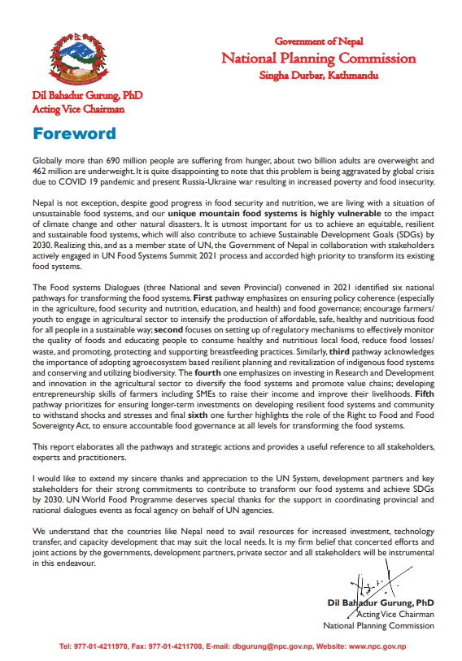

Figure 1: Current Scenario of Nepal context food problems.

**Appendix_A_Current_Scenario**

## 1.3. Problem Domain and Project as a Solution

In the face of the multifaceted challenges posed by surplus food, the Food Share app emerges as a transformative solution. This visionary project leverages technology to streamline the collection and redistribution of surplus food, addressing not only the logistical hurdles of surplus food management but also the underlying issues of environmental degradation and food insecurity. By serving as a comprehensive platform, the app revolutionizes the process of surplus food distribution, ensuring that valuable resources are efficiently allocated to those in need.

The Food Share app lies in its ability to bridge the gap between surplus food providers and marginalized communities. Through its user-friendly interface, donors can easily input surplus food details, including type, quantity, and expiry dates, with location facilitating a seamless donation process. The app then matches surplus food to the specific requirements of shelters and communities, ensuring that resources reach where they are most needed. Moreover, the inclusion of educational resources and awareness campaigns empowers both donors and volunteers (recipients) with knowledge about waste reduction and responsible food utilization, fostering a culture of social responsibility.

By facilitating efficient surplus food distribution and promoting education and awareness, the Food Share app embodies a holistic approach to addressing the global challenge of food. Through its innovative features and commitment to sustainability, this project promises to make a meaningful impact in ensuring that no one goes hungry while valuable resources are not needlessly discarded.

## 1.4. Aim and objectives.

### 1.4.1. Aim

The food donation system aims to minimize food waste by efficiently redistributing surplus food to needy communities, reducing hunger, and fostering a more equitable and sustainable food distribution network.

### 1.4.2. Objectives

* Develop a user-friendly interface to facilitate surplus food input, donation matching, and recipient organization interaction.
* Establish a secure database management system to store and retrieve surplus food data efficiently, ensuring data integrity and confidentiality.
* Integrate an effective communication system between food providers and recipient organizations through API programming, enabling seamless coordination and information exchange.
* Implement innovative design elements, incorporating UI/UX principles and material design for an engaging user experience, enhancing accessibility and usability.
* Conduct comprehensive research on existing technologies and tools, identifying and integrating the most suitable ones for optimal application functionality, ensuring the app's effectiveness and efficiency.
* Ensure scalability and adaptability of the food donation platform to accommodate potential expansion and growth, allowing it to meet increasing demands and evolving needs.
* Promote community engagement and awareness through features that educate users about food waste reduction and proper food utilization, fostering a culture of responsible consumption and social responsibility.

## 1.5. Structure of the Report

### 1.5.1. Background

The development phase of the Food Share app involved the creation of both web and mobile platforms. The mobile platform, developed using Kotlin and Jetpack Compose, allows users to access the app's features seamlessly. On the other hand, the web platform, built using Django, HTML, CSS, and Bootstrap, serves as an administrative interface for managing the app's operations. Design considerations encompassed creating a user-friendly interface, establishing database management systems, and integrating communication systems for efficient food distribution. Throughout the implementation process, various challenges were encountered and addressed. These challenges ranged from technical complexities in integrating APIs to ensuring data security and scalability.

### 1.5.2. Development

The development phase of the Food Share app involved the creation of both web and mobile platforms. The mobile platform, developed using Kotlin and Jetpack Compose, allows users to access the app's features seamlessly. On the other hand, the web platform, built using Django, HTML, CSS, and Bootstrap, serves as an administrative interface for managing the app's operations. Design considerations encompassed creating a user-friendly interface, establishing database management systems, and integrating communication systems for efficient food distribution. Throughout the implementation process, various challenges were encountered and addressed. These challenges ranged from technical complexities in integrating APIs to ensuring data security and scalability.

### 1.5.3. Testing and analysis

The testing phase involved rigorous quality assurance measures to ensure the app's functionality, performance, and user experience met the desired standards. Testing methodologies included unit testing and system testing with user feedback. Testing focused on individual components of the app, verifying their correctness and robustness. Integration testing validated the interactions between different modules and systems, ensuring seamless functionality. The analysis of test results revealed areas of strength and areas for improvement. Positive outcomes included the app's intuitive user interface, efficient food donation matching, and secure data management. Areas identified for improvement included performance optimization, user engagement features, and accessibility enhancements.

### 1.5.4. Conclusion

The Food Share app project represents a significant step forward in leveraging technology to address surplus food and food insecurity. Despite challenges encountered during development, the project has succeeded in creating a platform that streamlines the process of surplus food redistribution and fosters community engagement.

Looking ahead continued efforts will be directed towards refining the app's features, addressing user feedback, and expanding its reach to serve more communities in need. By harnessing the power of technology and collaboration, the Food Share app stands poised to make a meaningful impact in reducing food waste and alleviating hunger.

# CHAPTER 2: BACKGROUND

## 2.1. About the End Users

While most of Food Share's end users are members of the public who value and want to purchase art, the platform was originally designed to meet the requirements of a single artist who recognizes the importance of internet exposure and giving. The end users for the food share donation project encompass a variety of roles, each with specific functionalities and needs:

Client Name: **Yubaraj Tamang**

Client Information and Idea:

Yubraj Tamang is the employer of the ING Food Company's branch in Naxsal, which currently operates under ING Group. He is a beast innovator, helpful, and skilled in cooking. He has a knack for creating numerous food dishes and recipes. His passion for cooking extends beyond the kitchen, as he actively seeks solutions to minimize food wastage and contribute to the community through his culinary skills.

Currently, he works as a Cookman at Naxsal Herald College. Mr Tamang has been involved in cooking food and delivering it from Naxsal to Innovate Tech. He mentioned having an idea regarding the issue of food wastage, where sometimes food goes to waste due to overproduction or the absence of some employees. Consequently, this surplus food cannot be utilized the next day. He suggests that this excess food could be donated to poor or homeless people, thereby solving the problem of wastage. Thus, the food would not be discarded or wasted.

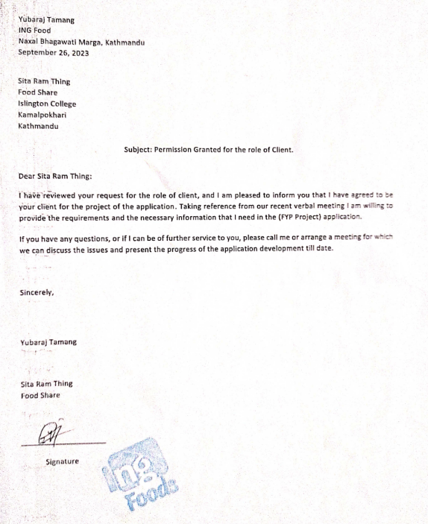

Figure 2: Client Approvable latter.

**Appendix: B About the End User**

## 2.2. Understanding the solution

The Food Share app addresses surplus food management by helping its collection and distribution to those in need. It runs on a web interface for administration and a mobile platform for funders, volunteers, and farmers. The system is intended to effectively connect surplus food sources with beneficiaries, reducing food waste and combating food insecurity. Here's a breakdown of its main components.

Web Interface (Admin):

Administrators control the whole system via a web browser. They handle user accounts, oversee contribution and allocation procedures, analyze data, and configure system settings.

Mobile Platform:

People or organizations may contribute food using the smartphone app. They may examine contribution history and receipts, as well as schedule pickups. Facilitate the collection and delivery of donated food, get information about pickups or distribution events, and track the status of deliveries. Coordinate surplus food contributions using the app by registering, providing produce information, indicating availability, and communicating about collection logistics. The registration procedure includes user verification by the administrator, which grants authenticated access. After logging in, users may view role-specific dashboards. The software supports password management, profile changes, and account deactivation.

### 2.2.1. Overview of the system

The Food waste food management system is the surplus food collected by the distribution system. The food provider (Donor) and volunteers (received) can communicate to pick the food from the donor and goose to distribute to the poor and homeless people. Where the web is using the admin to control the system. The mobile user is a donor and volunteer where the donor can donate the available food and the volunteer can contract to receive the food from a donor.

The new user can register user details from mobile and admin goes to verify the user and give the authenticate access for using the system. After receiving the access, the user can log in to the food share app with, his/her selection role. The donor dashboard has all user's donated latest data. The donor can go to the post screen and new food is posted with all the food details. The donor after donating then goes to check the view history with details. Then the donor can home page has multiple donated food view details with a location map and contract to the donor and received food and goes to distribute the food. After completing the distribution then view history with rating. The app has additional features such as forgetting passwords or changing passwords, permanent account deactivation, profile details update and more.

### 2.2.2. Technical Terms and Definition (Technical Terms related to the project)

To ensure understanding, technical terms related to the project should be defined. This section elucidates terms such as API, database management system, UI/UX, scalability, framework, programming language, firebase push notification etc., providing readers with a comprehensive understanding of the technology and concepts underpinning the Food Share app.

#### 2.2.2.1 Django Rest Framework

Django is a framework used for creating the "behind-the-scenes" parts of websites. It organizes code and helps handle tasks like showing web pages, connecting to databases, and managing user accounts. With Django, developers can build these parts quickly and efficiently using the Python programming language. The rest framework is used to develop the APIs (Application Programming Interface). (MkDocs, 2024)

**2.2.2.2 Application Programming Interface (API)**

An API is a set of rules, protocols, and tools that allow different software applications to communicate with each other. It defines the methods and data formats that one application can use to request or manipulate data from another application. A computer code collection called an API allows data transfer across different software products. The conditions of this data exchange are also included. (Singtel, 2024)

#### 2.2.2.3 HTML, CSS, JavaScript

The front end is what users see and interact with directly on a website. It includes things like buttons, forms, and menus, as well as the code that makes them work. Developers use technologies like HTML, CSS, and JavaScript to create these user interfaces, making sure they look good and respond smoothly to user actions.

#### 2.2.2.4 MySQL Database

MySQL is a type of software used to store and organize data in a structured way. It's commonly used for websites and other applications that need to manage large amounts of information. MySQL offers features that help ensure data is stored securely, accessed quickly, and managed efficiently.

#### 2.2.2.5 Room Database

Room is a tool used in Android app development to help manage data locally on a user's device. It makes it easier for developers to work with databases by providing helpful features and simplifying common tasks. The room helps ensure that data in apps is stored and accessed reliably, improving the overall performance and user experience. Verification of SQL queries at compile time. (Developer, Developer, 2024)

#### 2.2.2.6 Python

Python is a programming language often used with it. Together, they make it easier for developers to build web applications by providing tools and resources to handle common tasks. Python is known for being easy to read and write, making it a popular choice for developers.

**2.2.2.7 Kotlin**

Kotlin is a statically typed programming language that runs on the Java Virtual Machine (JVM). It is fully interoperable with Java and is used for Android app development. It works with Kotlin, a programming language commonly used for Android development.

#### 2.2.2.8 Jetpack Compose

Jetpack Compose is a tool used in Android app development to create user interfaces (UI) more easily. Jetpack Compose simplifies the process of building UIs, making it faster and more intuitive for developers to create visually appealing and interactive apps. Jetpack Compose is a modern UI toolkit for building native Android UIs. (Developer, Googl for developer, 2024)

#### 2.2.2.9 Firebase Push Notification

Firebase is a platform provided by Google that offers various tools and services to help developers build and manage apps more efficiently. It includes features like authentication (managing user accounts), real-time database (storing and syncing data across devices in real-time), cloud messaging (sending messages to users), and hosting (hosting web content). Firebase helps developers focus on creating great user experiences without having to worry about managing server infrastructure.

#### 2.2.2.10 Serializer

A serializer is a program that translates the data or state of an object into a format that can be stored, transmitted, or reconstructed later in the same or another computer environment. With the use of serializers, complicated data such as query sets and model instances can be simply transformed into native Python datatypes for rendering into other content types, such as JSON or XML. After verifying the incoming data, serializers also offer deserialization, which enables parsed data to be transformed back into complicated types. (Django Rest Framework, 2024)

#### 2.2.2.11 Data Transfer Object (DTO)

An object that carries data between processes. It's often used to transfer data between a client and a server in a distributed application. Data transfer objects (DTOs) differ from business objects or data access objects (DTOs) in that DTOs only exhibit the ability to store, retrieve, serialize, and deserialize data. (Weir, 2024)

#### 2.2.2.12 Authentication

The process of verifying the identity of a user or system. Finding out if someone or something is who or what they claim to be is the process of authentication. By comparing a user's credentials to those in a data authentication server or a database of authorized users, authentication technology grants access control for systems. (Nick Barney, 2024)

#### 2.2.2.13 Pojo (Plain Old Java Object)

A Java object that encapsulates only fields and doesn't contain any business logic. It is used to transfer data between different components of an application. Any Java program may use a plain old Java object (POJO), which is a class declaration unrelated to any Java framework. There are no specific naming guidelines or limitations for properties and methods in a POJO. Their main benefits are simplicity and reusability. (StevenSwiniarski, 2024)

#### 2.2.2.14 FCM Token (Firebase Cloud Messaging Token)

A unique token is assigned to a mobile device by the Firebase Cloud Messaging (FCM) server. It is used to send push notifications to that specific device. A simple notification channel with default parameters is offered by FCM. Set the default notification channel ID to the ID of your notification channel object as indicated if you would rather make and use your default channel. FCM will use this value if incoming messages do not specifically set a notification channel. (developer, 2024)

#### 2.2.2.15 Access Token

A credential is used to access protected resources on behalf of an application. Through the use of an access token, a client application can access a certain resource and carry out particular tasks on the user's behalf. (Chiarelli, 2024)

#### 2.2.16 Share Preference

A simple way to store small key-value pairs of primitive data types in Android applications is provided by a SharedPreferences object. It offers simple methods for reading and writing key-value pairs and refers to a file storing them. Each SharedThe preferences file has its structure and can be made private or shared. (Google, 2024)

### 2.2.3. Function and Features

The system has so many functions and features where some major functions and features are given below:

#### 2.2.3.1. Login and Registration:

New users can create or register for the system with valid data and select their role. Authenticated users can access the app's functionalities. Once authenticated, users cannot log in to the system again.

#### 2.2.3.3. Forgot/Reset Password:

Users can change or update their password before logging in if it's forgotten, and they can recover or reset forgotten passwords. The option to reset the password is available both before and after logging into the system.

#### 2.2.3.4. Food Donation:

Enables donors to post surplus food details for donation. Donors can access information about the surplus food they've donated and notify all users.

#### 2.2.3.5. View Food Details:

Provides comprehensive information about available food items. Users can view donated food items, the details of the donating user, the donation location, and the food's status. After completing the donation, users can view who will receive the food for distribution.

#### 2.2.3.6. View Donation Locations:

Displays the locations for donation pickups. Both donors and volunteers can view donation locations via Google Maps. The map shows both the current user location and the food donation locations.

#### 2.2.3.7. View Profile:

Users can access and update their profile information. All authenticated users can view user profile details. Also, users can view the NGO profiles.

#### 2.2.3.8. Account Deactivation:

Allows users to permanently deactivate their accounts. If users are no longer interested in keeping their accounts active, they have the option to permanently deactivate them.

#### 2.2.3.9. Report/Complaint:

If a donor donates food and the volunteer accepts it for distribution, but the donor cannot give the food to the volunteer, the volunteer can report to the admin. Similarly, if a volunteer cannot pick up the donated food, the donor can report to the admin.

#### 2.2.3.10. Notification (Firebase push notification and Local notification):

When a donor donates food, all user devices receive a notification. Additionally, local notifications are triggered for actions such as forgetting passwords and account deactivation.

#### 2.2.3.11. Rating

Volunteers can collect feedback from food consumers and provide ratings for the donated food. They can assign a rating ranging from a minimum of 0 to a maximum of 5 stars. This rating system helps to evaluate the quality of donated food and ensures continuous improvement in the donation process. Additionally, it encourages transparency and accountability within the food distribution network.

#### 2.2.3.12 View Location in Map

The volunteer can utilize the map feature to locate donations or pickup points efficiently. Both donors and volunteers have access to view donation locations through the integrated Google Maps feature. This functionality enables volunteers to confirm and accept food donations seamlessly.

These functions and features ensure a seamless user experience, facilitating efficient surplus food management and distribution while promoting user engagement and accountability.

## 2.3. Comparison

The Food system is so many available in different countries on different platforms where similar projects to some features are different in food share applications. A similar project is Flashfloods, Food Reduce No Waste Food etc.

### 2.3.1. Similar Projects

#### 2.3.1.1 Flashfoods

Author: local government bodies, NGOs,

Flashfoods is a mobile application that connects users with surplus food from local restaurants and grocery stores at discounted prices. Users can browse available food items, purchase them directly through the app, and pick them up from designated locations. Flashfoods aims to reduce food waste by offering discounted surplus food to consumers while providing additional revenue streams for businesses. Flashfood gives unbeatable deals on groceries at peak deliciousness. This application provides the save big on fruit, vegetables, meat, milk, cheese, pantry staples and more but is not fully free distributed. (local government bodies, 2024)

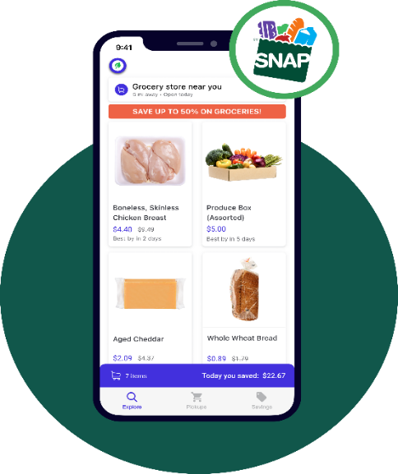

Figure 3: Flash floods similar app image

#### 2.3.1.2 Food Rescue

Author: Dave Lampert, Melissa Spiesman, Jeff Schacher and Kevin Mullins

Jeff Schacher and Kevin Mullins founded Food Rescue as Community Plates in Fairfield County in 2011, in response to serious concerns about food insecurity and waste. The system's main goals were to reduce food waste and provide meals to people in need. This innovative approach garnered widespread support from volunteers, food donors, and social service organizations. Over time, they expanded and eventually renamed the nonprofit Food Rescue. It reduces food waste by enabling food donors to donate their surplus food to social service agencies. It also provides meals to those facing food insecurity by allowing social service agencies to join and receive food. To collect and share surplus food seven days a week, and there is no cost to the food donor or the recipient. (Dave Lampert, Now Fair Food NZ, 2024)



Figure 4. Food Rescue similar project image

#### 2.3.1.3 No Food Waste

Author: Anne Frank

"No Food Waste" also collaborates with businesses, schools, and government agencies to implement strategies for reducing food waste in various settings. This includes initiatives such as food rescue programs, composting initiatives, and policy advocacy for standardized date labelling and food donation regulations. That aims to foster a culture of mindfulness and responsibility towards food consumption, ultimately contributing to a more sustainable and resilient food system. Through collective efforts and partnerships, the program seeks to minimize food waste and maximize the utilization of resources, ensuring that everyone has access to nutritious food while reducing the environmental impact of food production and disposal. (Dave Lampert, Food Reduces, 2024)

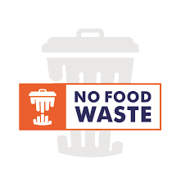

Figure 5: No Food Waste similar projects image.

### 2.3.2. Comparisons (Comparing the features and critical evaluation of the solution)

|  |  |  |  |  |
| --- | --- | --- | --- | --- |
| **Features** | **Flash flood** | **Food Rescue** | **No Food Waste** | **Food Share** |
| Food Post/Donation | Yes | Yes | Yes | Yes |
| View Location on Google Map | Yes | Yes | No | Yes |
| Push Notification | Yes | Yes | Yes | Yes |
| Local Notification | No | No | No | Yes |
| Email Notification for Distributed Message | Yes | Yes | Yes | Yes |
| Donation complaint for administration | No | Yes | Yes | Yes |
| Rating | No | No | No | Yes |
| User View History | No | No | No | Yes |

Table 1: Comparison to a similar project

when comparing the features of Flashfood, Food Rescue, No Food Waste, and my system "Food Share", I find that all platforms support basic functionalities like food posting and donation, as well as push notifications. However, Food Share distinguishes itself with additional features such as local notifications, donation complaint functionality, rating, and user view history. Flashfood lacks donation-compliant capabilities, while No Food Waste does not offer location viewing on Google Maps. Food Rescue lacks a rating feature and user view history. Overall, Food Share provides a more comprehensive set of features, enhancing user experience and administrative capabilities.

# CHAPTER 3: DEVELOPMENT

## 3.1. Methodology

The methodology used the develop the system where it can be helpful to the development process. The different types of projects are suitable for different methodologies.

### 3.1.1. Considered Methodologies

It is a broad topic that can be explored in various contexts, especially in the realm of research and project development. For a final-year project, understanding and explaining considered methodologies typically involves discussing the approaches, frameworks, or techniques that were evaluated and chosen for the project's development or research process. The three methodologies are research like waterfall, scrum and prototype.

#### 3.1.1.1 Water Methodology

The waterfall methodology is a sequential, linear approach to project management in which a project's phases must be finished one after the other. It places a strong emphasis on comprehensive documentation, clearly stated project requirements, and an organized, set plan (Theil, 2024). The waterfall methodology has some phases available where planning, designing, development testing and deployment.

Its structured nature can be beneficial for projects with well-defined requirements and stable scope. However, the waterfall methodology also has limitations. For instance, it may not accommodate changes or updates well once the project has progressed beyond the initial planning phase. This rigidity can lead to delays or difficulties in adapting to evolving requirements or unforeseen challenges. Additionally, the waterfall approach may result in longer development cycles, as each phase must be completed before moving on to the next, potentially slowing down the overall project timeline. Therefore, while the waterfall methodology can be effective for certain types of projects, it may not be suitable for those that require flexibility, iterative development, or frequent stakeholder involvement.

The advantages and disadvantages of the Waterfall Methodology in the format you've provided:

Advantages of waterfall methodology:

* Clear project organization and control.
* Early error detection, saving development time.
* Efficient time and cost estimation.
* Defect recognition before advancing phases.

The disadvantage of waterfall methodology:

* Requires upfront clear requirements.
* Limited flexibility for changes.
* Lack of risk and security management.
* Not suitable for large projects due to sequential completion.

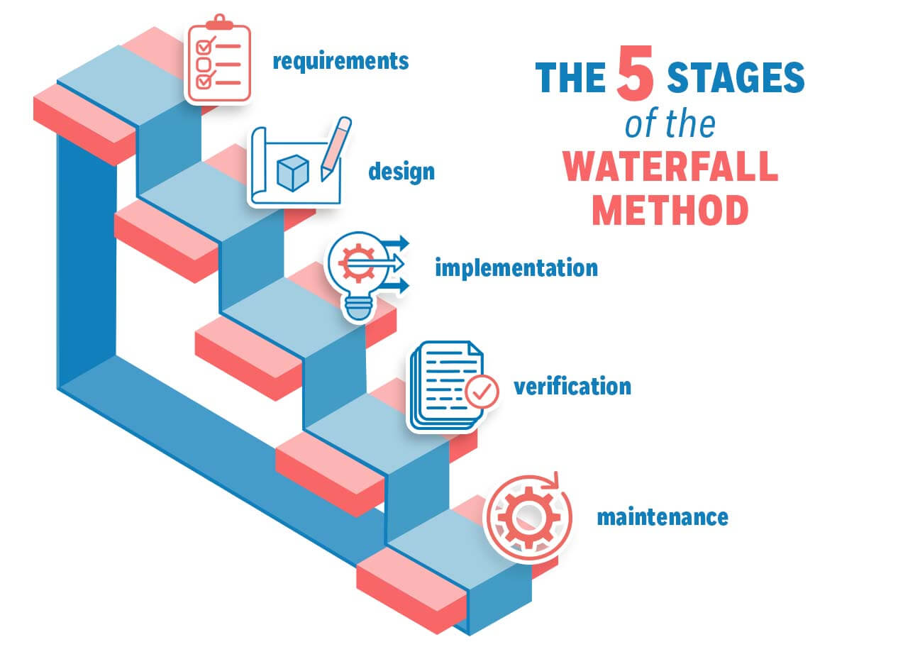

Figure 6: Waterfall methodology.

#### 3.1.1.2 Scrum Methodology

Scrum is, in fact, an advancement of Agile Management. The Scrum technique is predicated on well-defined roles and processes that need to be adhered to throughout the software development lifecycle. This adaptable approach incentivizes the use of the 12 agile principles inside a framework that has been decided upon by every member of the product team (S, 2024). Scrum is a management methodology used to self-organize and work together toward common goals. It outlines a sequence of meetings, materials, and duties to expedite project completion. Scrum approaches enable teams to manage themselves, learn from prior experiences, and adjust to changing conditions, much like a sports team prepares for an important competition (AWS, 2024).

While Scrum offers flexibility and responsiveness, it necessitates ongoing management and engagement to ensure smooth progress throughout iterative cycles. In the dynamic realm of software development, Scrum orchestrates agile processes akin to a conductor leading a symphony.

Advantages of Scrum Methodology:

* Ensures efficient utilization of time and resources.
* Breaks down large projects into smaller, manageable sprints, enhancing focus and productivity.
* Ideal for rapid development projects, facilitating quick iterations and delivery.
* Enables concurrent coding and testing during sprint reviews, promoting continuous improvement.
* Embraces agility by actively soliciting feedback from stakeholders and customers, fostering collaboration and alignment.

Disadvantages of Scrum Methodology:

* Lack of a set completion date can lead to scope creep, potentially affecting project timelines and deliverables.
* Project failure is more likely in the absence of commitment or cooperation from team members.
* Implementing the Scrum framework can be challenging in large teams, requiring additional coordination and communication.
* Projects may face significant setbacks if key team members depart midway, impacting continuity and progress.

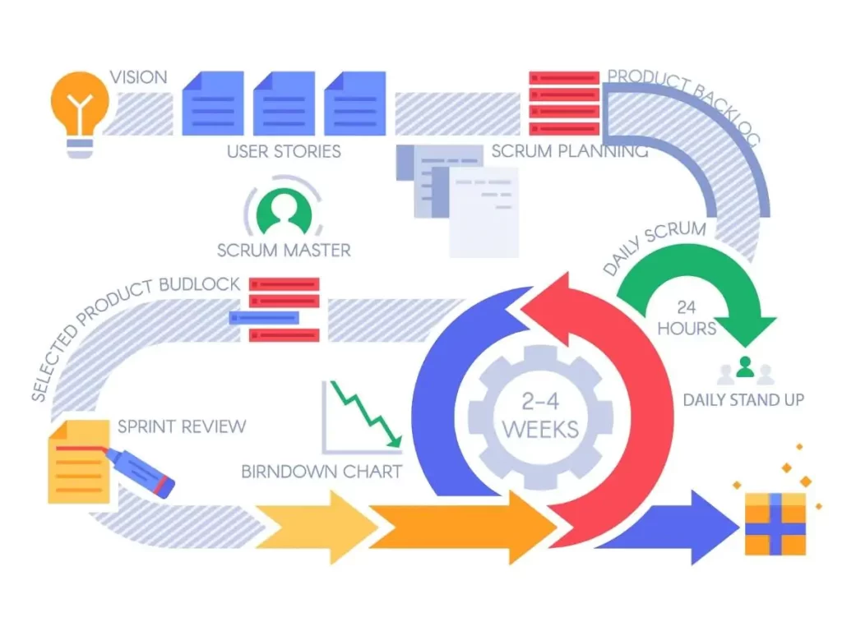

Figure 7: Scrum Methodology

#### 3.1.1.3 Prototype Methodology

According to the prototype process, a functional system prototype must be constructed before any real software development is done. A model that serves as an implementation of the system is called a prototype. In most cases, a prototype is a relatively unfinished version of the real system that may have few functional features, poor dependability, and ineffective performance when compared to the real software. Often, the client's expectations of the software product are only partially clear. The prototype approach may be used in this situation if there is a lack of precise information about the system's input, processing requirements, and output requirements (JavaTpoint, 2024).

The prototyping methodology is an iterative software development approach where a prototype (a preliminary version of a product) is created to validate and refine design concepts before full-scale development. In this methodology, a basic version of the software or product is quickly developed and presented to stakeholders or end-users for feedback and evaluation. The prototype methodology allows for rapid development, early validation of ideas, and continuous improvement, leading to the development of successful and user-friendly products. Prototyping helps in refining requirements, understanding user needs, and validating design concepts before investing heavily in full-scale development. (LUMITEX, 2024)

Advantages of Prototype Methodology:

* Prototype Methodology provides flexibility in design, allowing for adaptable design processes.
* It aids in the easy identification of errors during development.
* The opportunity for refinement facilitates the smooth integration of new requirements.
* It enhances customer satisfaction and engagement through active user participation.
* User involvement in the development phase promotes collaboration and user-centric solutions.

Disadvantages of Prototype Methodology:

* The implementation of this approach may lead to high development costs.
* Variations in requirements can result in inconsistencies and frequent modifications.
* Rapid prototype development may lead to rushed solutions, compromising quality.
* Increasing complexity may arise within the system as prototypes evolve.
* Inadequate problem analysis may result in deficiencies within the model.

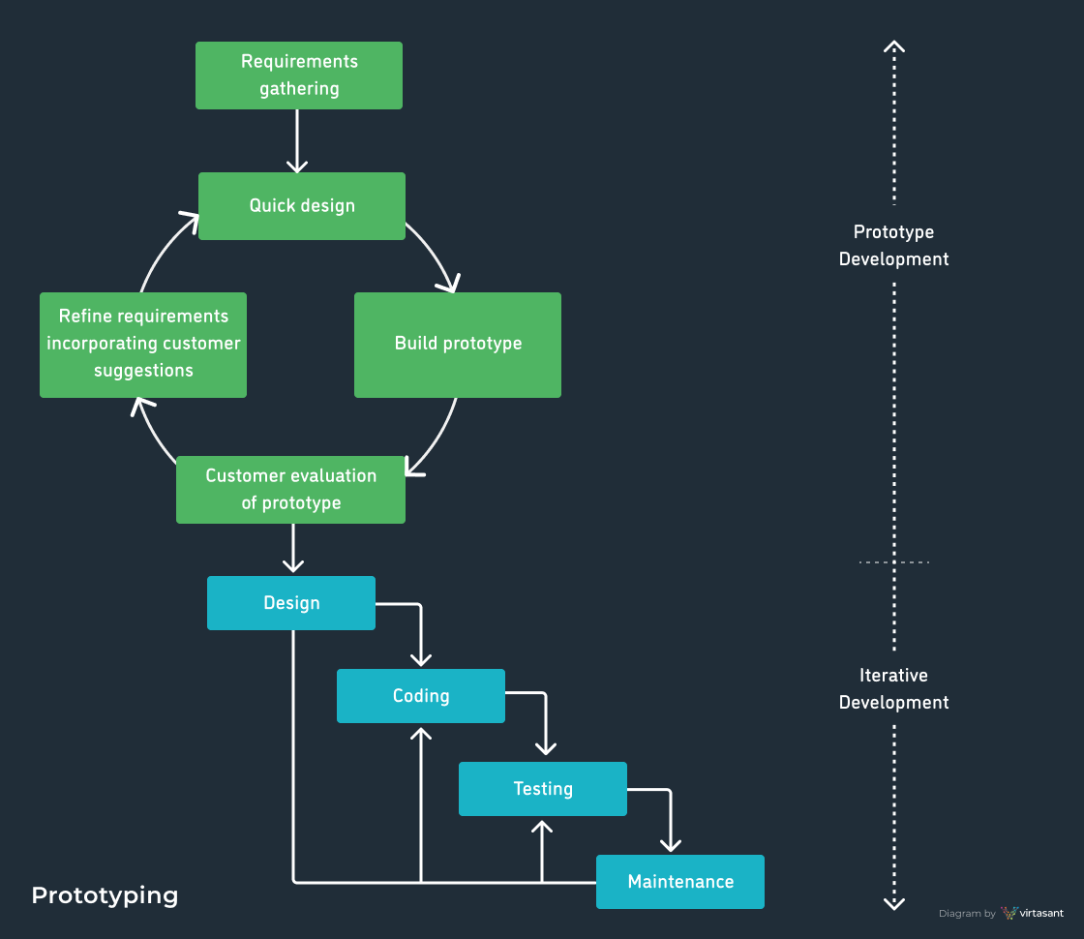

Figure 8: Prototype methodology.

### 3.1.2. Justification for Not Selected Methodologies

The three methodologies are researched to determine which is better suited for final-year project development. The waterfall and prototype methodologies are not selected due to their limitations, making them unsuitable for the project. Therefore, some limitations, problems, and issues to not suitable for the project so they are to not of these methodologies were chosen for the development of the FYP (Waste Food Management System).

#### 3.1.2.1 Reason for not choosing Waterfall methodology.

|  |  |
| --- | --- |
| Scenario | The food donation project requires a flexible approach due to evolving requirements and frequent adjustments during implementation. |
| Methodology | Waterfall Methodology |
| Justification | The Waterfall Methodology's linear progression may struggle to accommodate evolving project needs and frequent adjustments. In dynamic projects like food donation, where requirements evolve and continuous improvement is vital, a more adaptable methodology is preferred. Waterfall's rigid structure could hinder the project's ability to respond effectively to changing circumstances, potentially compromising its success. |

Table 2: Justification scenario 1 for waterfall methodology

|  |  |
| --- | --- |
| Scenario | Active stakeholder involvement and feedback are essential for the success of the food donation project, but the Waterfall methodology limits stakeholder engagement until the project's final stages. |
| Methodology | Waterfall Methodology |
| Justification | Waterfall typically restricts stakeholder involvement until late project stages, limiting opportunities for crucial feedback and collaboration throughout the project lifecycle. In projects like food donation, where stakeholder input is crucial for alignment with project goals and user needs, this restricted engagement could lead to misunderstandings and misaligned expectations. A more iterative methodology would better facilitate ongoing stakeholder involvement and feedback, enhancing project success. |

Table 3: Justification scenario 2 for waterfall methodology

|  |  |
| --- | --- |
| Scenario | The food donation project requires rapid iteration and learning from ongoing experiences to ensure its effectiveness. |
| Methodology | Waterfall Methodology |
| Justification | Waterfall's sequential approach does not support rapid iteration and learning from ongoing experiences. In projects like food donation, where continuous improvement and responsiveness are essential, a more iterative methodology is preferable. Waterfall's lack of flexibility and adaptability may hinder the project's ability to incorporate learnings and make necessary adjustments quickly, potentially affecting its effectiveness and success. |

Table 4: Justification scenario 3 for waterfall methodology

The Waterfall methodology, known for its linear progression through predefined stages, may not be the most suitable choice for a Food Donation final-year project (FYP). Its rigid structure poses challenges in accommodating evolving project requirements and lacks flexibility for continuous adaptation. In a dynamic project like food donation, where needs might change, Waterfall's fixed approach could hinder the project's responsiveness to these changes. Therefore, opting for a more adaptable and flexible methodology, such as Agile or iterative approaches, could better cater to the project's evolving needs, fostering continuous improvement and responsiveness throughout the project's lifecycle. So, this methodology is not suitable for the project and is not chosen for system development.

#### 3.1.2.2 Reason for not Choosing Prototype Methodology.

|  |  |
| --- | --- |
| Scenario | The FYP project encounters ongoing changes in project scope due to evolving community needs or unforeseen challenges. |
| Methodology | Prototype Methodology |
| Justification | While Prototype Methodology emphasizes building and refining a working model based on clear initial requirements, it may struggle to keep pace with rapid changes in a project with continually shifting needs. The iterative nature of prototyping could lead to frequent modifications, creating inefficiencies and making it challenging to maintain a stable prototype aligned with evolving project needs. |

Table 5: Justification scenario 1 for prototype methodology

|  |  |
| --- | --- |
| Scenario | The FYP project has strict deadlines and limited resources for development and testing. |
| Methodology | Prototype Methodology |
| Justification | Prototyping involves iterative cycles of development, testing, and refinement. In environments with constrained time and resources, the iterative nature of prototypes may lead to delays or inefficiencies. This methodology may not be suitable when fixed deadlines must be met or when resource utilization needs to be optimized within a confined timeframe. |

Table 6: Justification scenario 2 for Prototype methodology

|  |  |
| --- | --- |
| Scenario | The FYP project lacks initial clarity regarding client requirements and expectations. |
| Methodology | Prototype Methodology |
| Justification | Prototyping relies on a clear understanding of requirements and continuous client involvement for iterative improvements. If client needs or project expectations are unclear initially, this methodology may struggle to deliver a refined prototype that aligns with evolving client expectations. The lack of clarity in the early stages could impede the iterative development process. |

Table 7: Justification scenario 3 for Prototype methodology

In these scenarios, the Prototype methodology might face challenges in accommodating evolving scopes, managing limited resources and time constraints, and aligning with unclear stakeholder requirements. These limitations could impact its effectiveness for an FYP project focused on food donation. so will not select the prototype methodology.

### 3.1.3. Justification for Selected Methodology

The scrum methodology is selected for project development where the justification and reasons for Choosing the Scrum Methodology are given.

|  |  |
| --- | --- |
| Scenario | The project encounters frequent changes in community needs or regulatory requirements. |
| Methodology | Prototype Methodology |
| Justification | Scrum allows seamless adaptation to changes. Its iterative nature accommodates evolving requirements, ensuring that the project remains aligned with dynamic community needs throughout development. |

Figure 9: Justification scenario 1 for Scrum methodology.

|  |  |
| --- | --- |
| Scenario | New features or functionalities need to be incorporated swiftly into the project. |
| Methodology | Prototype Methodology |
| Justification | Scrum enables the quick integration of new features. Its iterative cycles prioritize and incorporate new functionalities into subsequent sprints, ensuring timely integration without disrupting the development flow. |

Figure 10: Justification scenario 2 for Scrum methodology.

|  |  |
| --- | --- |
| Scenario | Continuous client review and feedback are crucial for project success. |
| Methodology | Prototype Methodology |
| Justification | Scrum allows seamless adaptation to changes. With its iterative nature, Scrum promotes regular review and feedback loops. Through sprint reviews and retrospectives, stakeholders can provide continuous input, ensuring alignment with their expectations throughout the project lifecycle. |

Figure 11: Justification scenario 3 for Scrum methodology.

|  |  |
| --- | --- |
| Scenario | Thorough testing for each feature or component completed in the project is essential. |
| Methodology | Prototype Methodology |
| Justification | Scrum mandates testing for every increment. By completing and testing features within sprints, the methodology ensures each component is thoroughly examined, reducing the risk of undetected errors or bugs. |

Figure 12: Justification scenario 4 for Scrum methodology.

|  |  |
| --- | --- |
| Scenario | Continuous improvement is essential to enhance project outcomes, where Scrum aids in the development phase. |
| Methodology | Prototype Methodology |
| Justification | Scrum fosters iterative improvement. Each sprint's retrospective allows the team to reflect on what went well and what needs improvement, leading to incremental enhancements throughout the project. |

Figure 13: Justification scenario 5 for Scrum methodology.

|  |  |
| --- | --- |
| Scenario | The project may encounter sudden priority shifts due to unforeseen emergencies. |
| Methodology | Prototype Methodology |
| Justification | Scrum's flexibility in prioritizing tasks helps handle emergencies. The method allows reprioritization within sprints, ensuring that urgent tasks can be addressed without disrupting the project's overall progress. |

Figure 14: Justification scenario 6 for Scrum methodology.

Scrum's adaptability to change, rapid feature integration, regular review cycles, comprehensive testing, task prioritization flexibility, and iterative improvement capabilities make it a highly suitable methodology for the structured and efficient development of a Food Donation System FYP project. Therefore, I chose the Scrum methodology.

## 3.2 Survey Result

### 3.2.1. Pre-Survey Results

When developing the project, I researched to gather information related to the food donation system. Then, I created the survey form and provided it to both the end users and my client. The survey aimed to collect data from users and clients, as outlined.

#### 3.2.1.1 Pre-survey questions

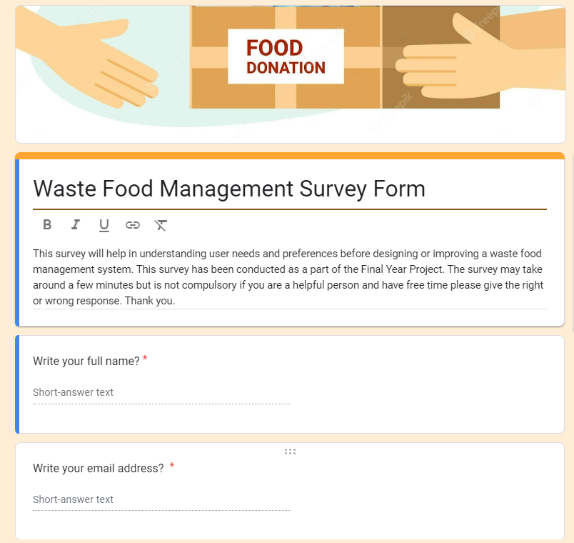

Figure 15: Pre-survey form introduction with username

**Appendix: C Pre-Servay Form Questions**

#### 3.2.2.2 Pre-survey response

Upon completion of system development and its dissemination to users and clients, feedback was collected to assess the effectiveness and gather insights for further improvements. Users and clients provided valuable input regarding the system's functionality, usability, and overall impact on surplus food donation initiatives. Their feedback highlighted areas of success, such as increased awareness, improved accessibility to donation locations through the integrated map feature, and streamlined communication between volunteers and donors. Additionally, constructive criticism was offered, identifying areas for refinement, including user interface enhancements and logistical optimizations for food distribution processes. The pre-survey result response is given below:

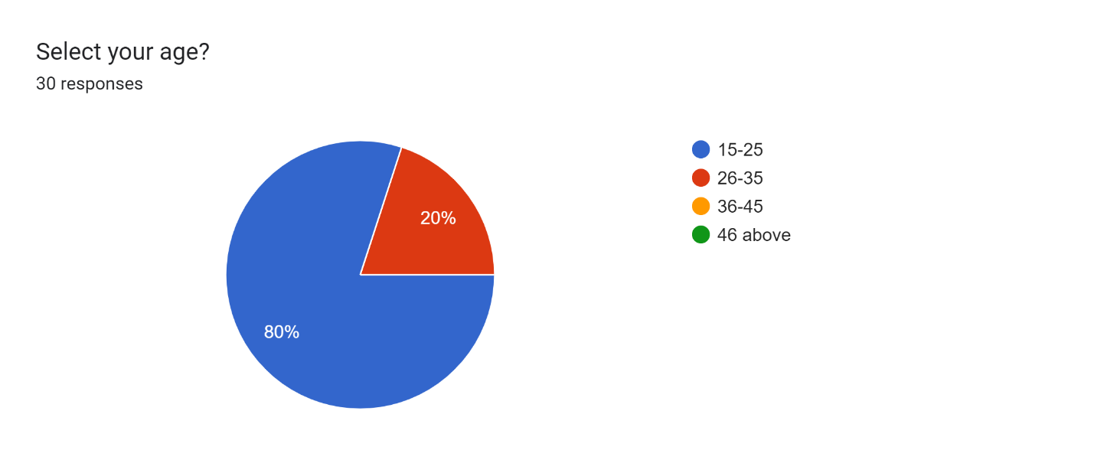

Figure 16: Pre-servery percentage of user age

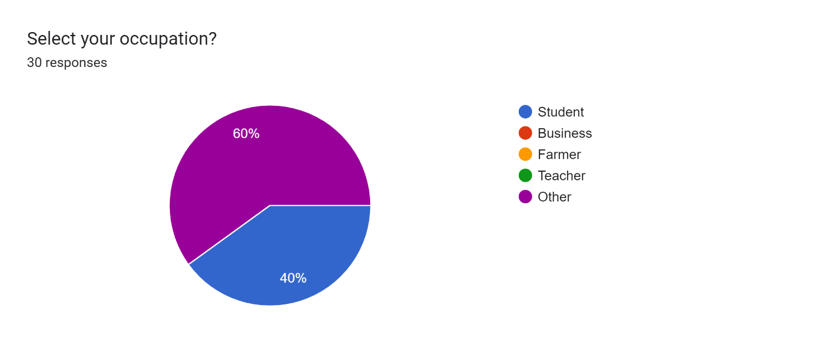

Figure 17: Pre-servery user occupations

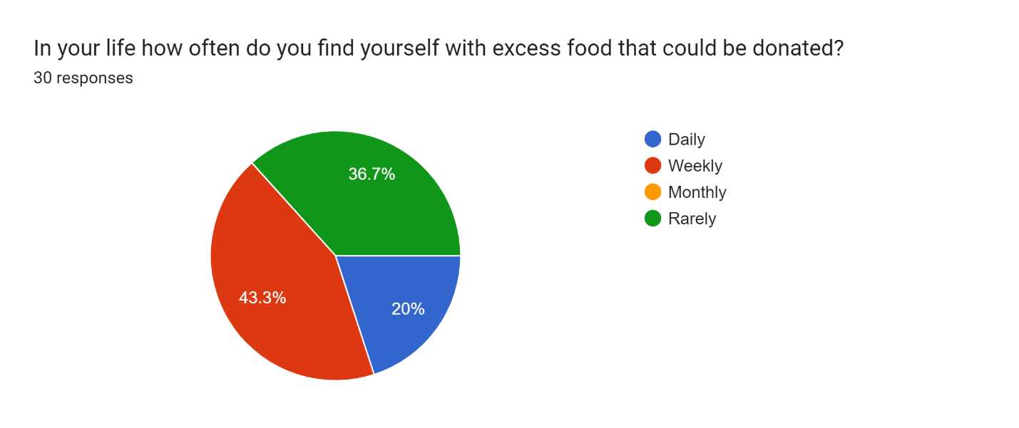

Figure 18: Preservay result of excess food for donated

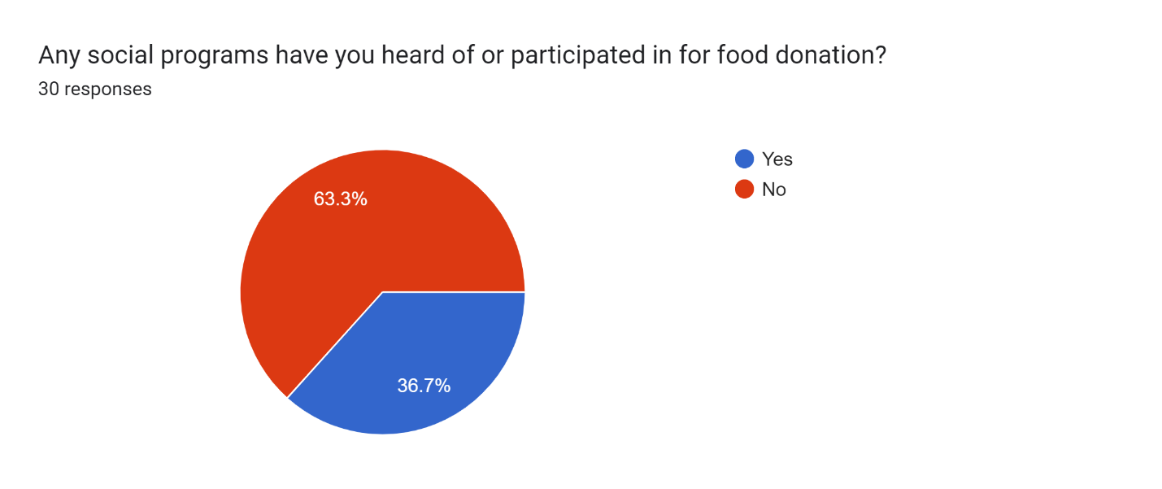

Figure 19: Pre-survey result per cent of users participated in the donation program

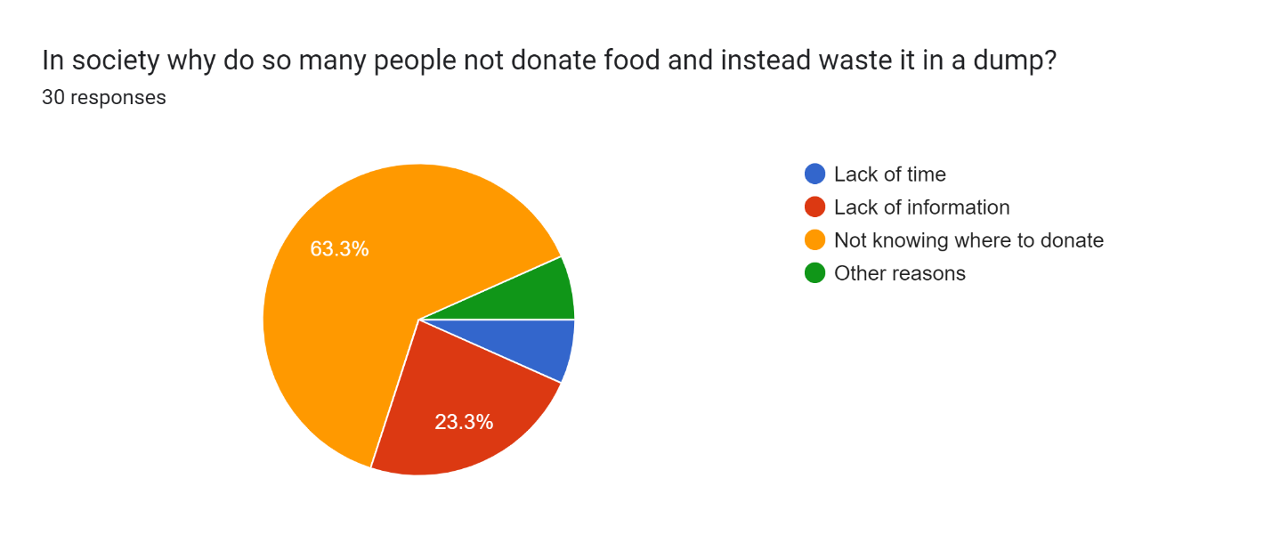

Figure 20: Pre-survey result user can food donates or dump

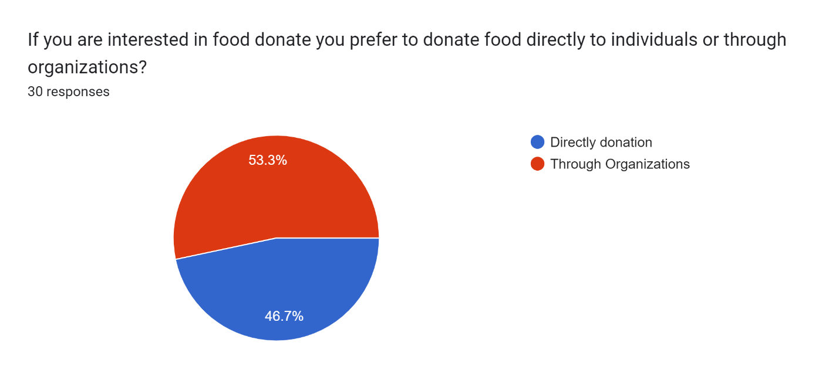

Figure 21: Pre-survey result of user interest directly or through donations organizations

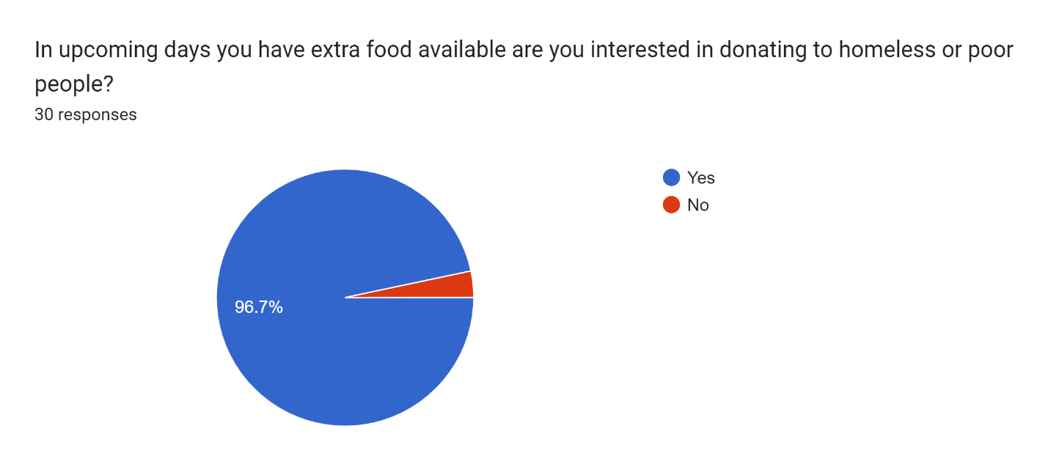

Figure 22: Pre-survey result of user interest in food donation

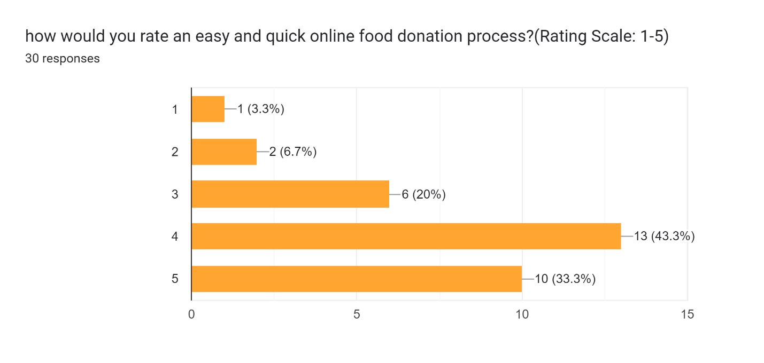

Figure 23: Pre-survey rating point of food donation idea

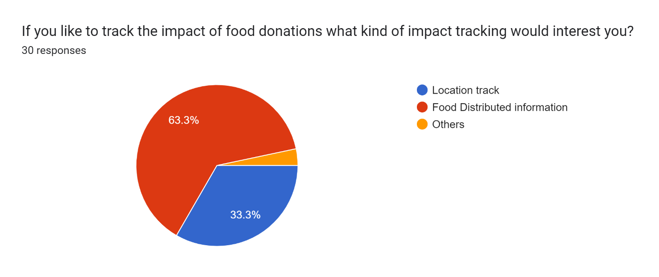

Figure 24: Pre-survey results for use need donation tracking

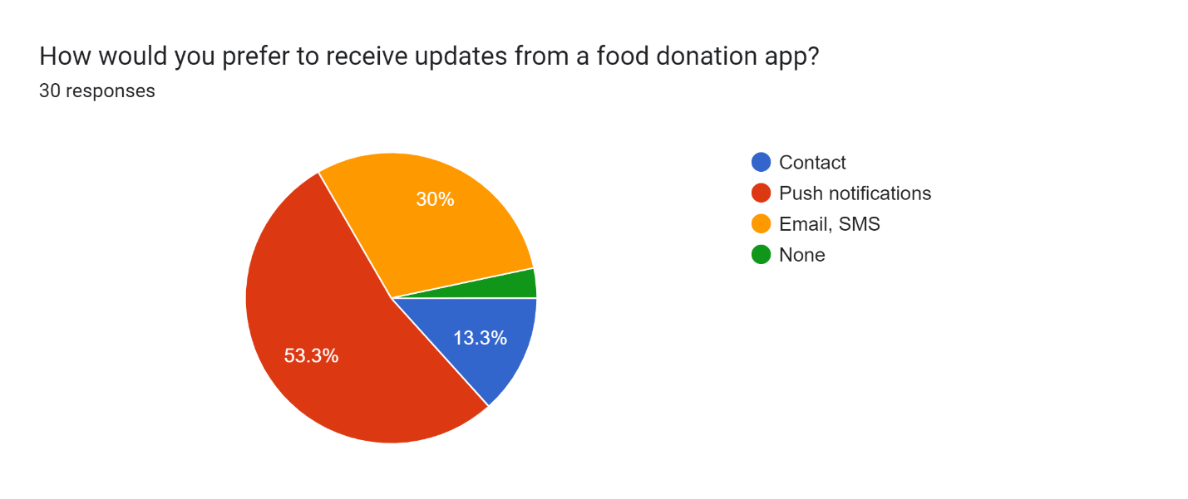

Figure 25: Pre-survey result of the user is interested in receiving the update

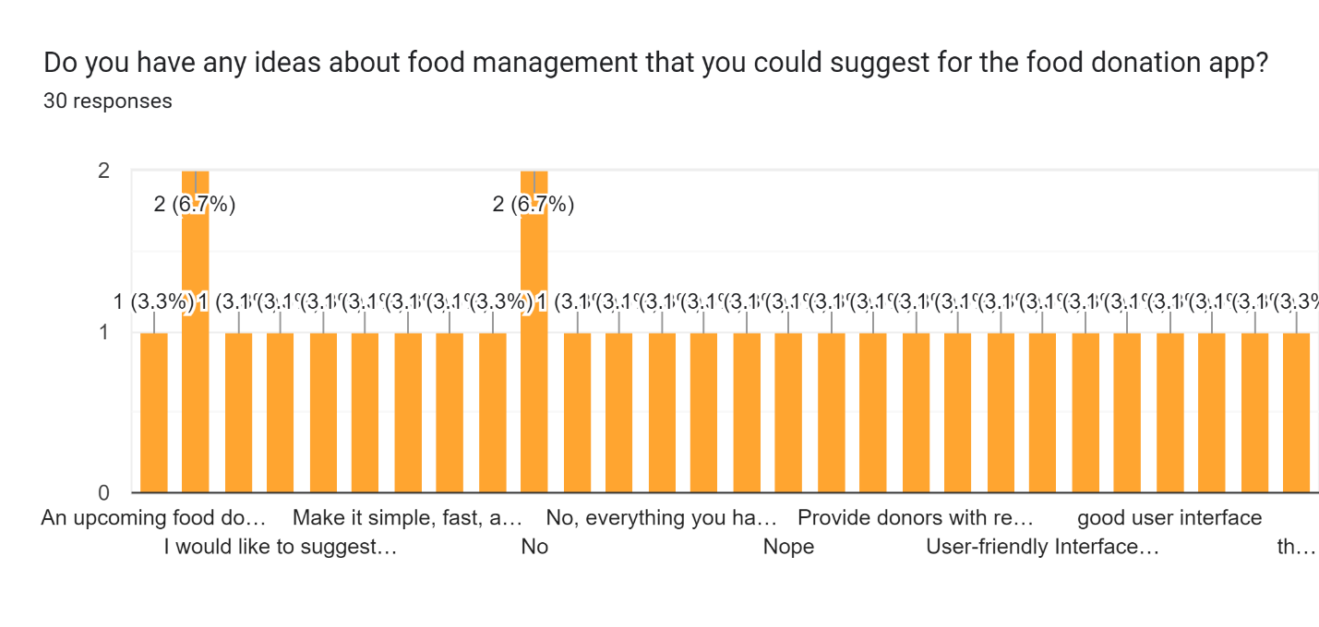

Figure 26: User feeb back for system requirement

Users provided valuable information and feedback, from which I collected the best ideas and data. Following the survey, several features of the project were changed, primarily based on user suggestions. Users mainly focused on User Interface improvements and enhancements related to the donation process and donation information.

### 3.2.2. Post-Survey Question

In the post-survey analysis, following the completion of system development and its distribution to users and clients, feedback was collected to assess its effectiveness and gather insights for further improvements. Users and clients provided valuable input regarding the system's functionality, usability, and overall impact on surplus food donation initiatives. Their feedback highlighted areas of success, such as increased awareness, improved accessibility to donation locations through the integrated map feature, and streamlined communication between volunteers and donors.

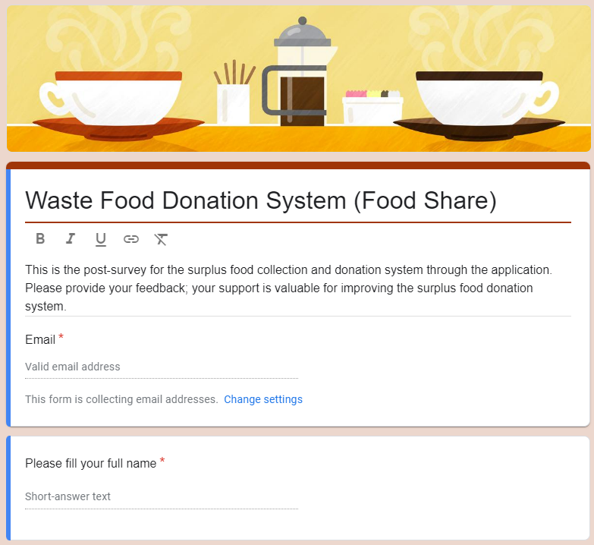

Figure 27: Post-survey introductions with questions of email and username

**Appendix: C Post-Survey Questions**

### 3.2.3 Post survey result

The overall system development part is completed and the release build creates and uploads the wormhole and shares the app for app downloads with the survey form. The user can give the best response that is given below:

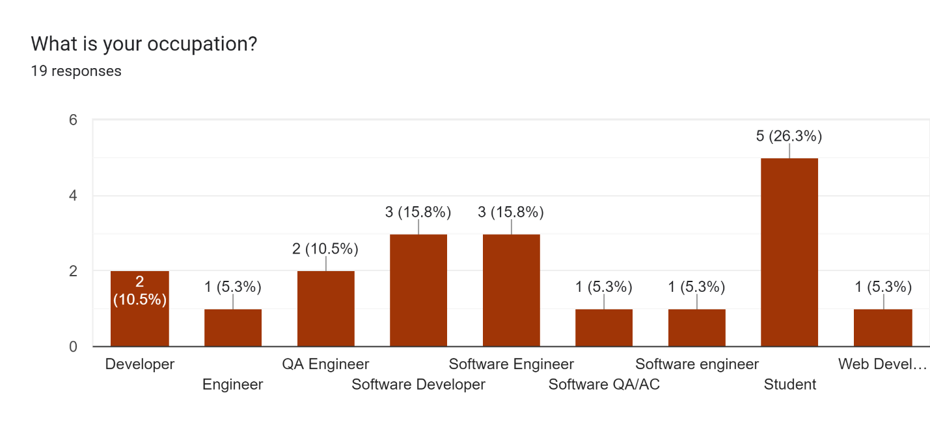

Figure 28: Post-survey of user occupations

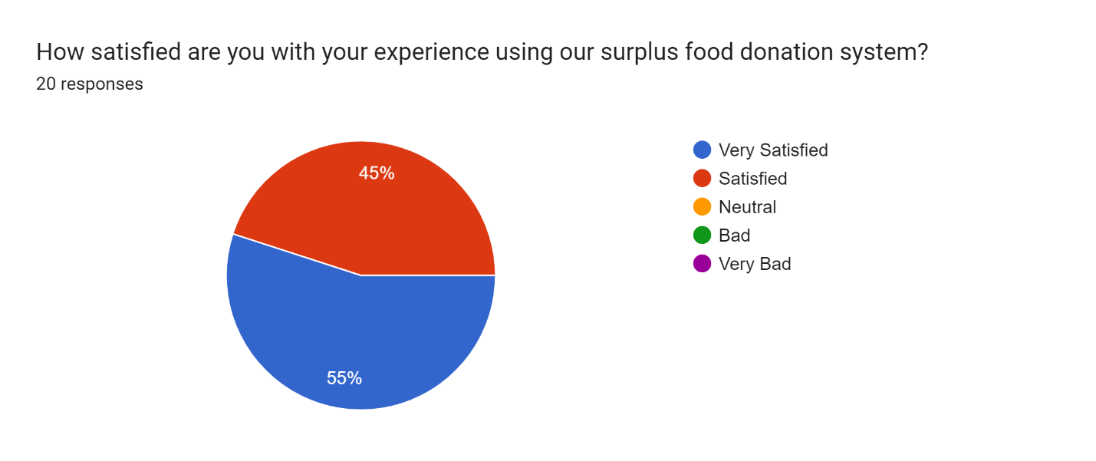

Figure 29: Post survey results of user experience

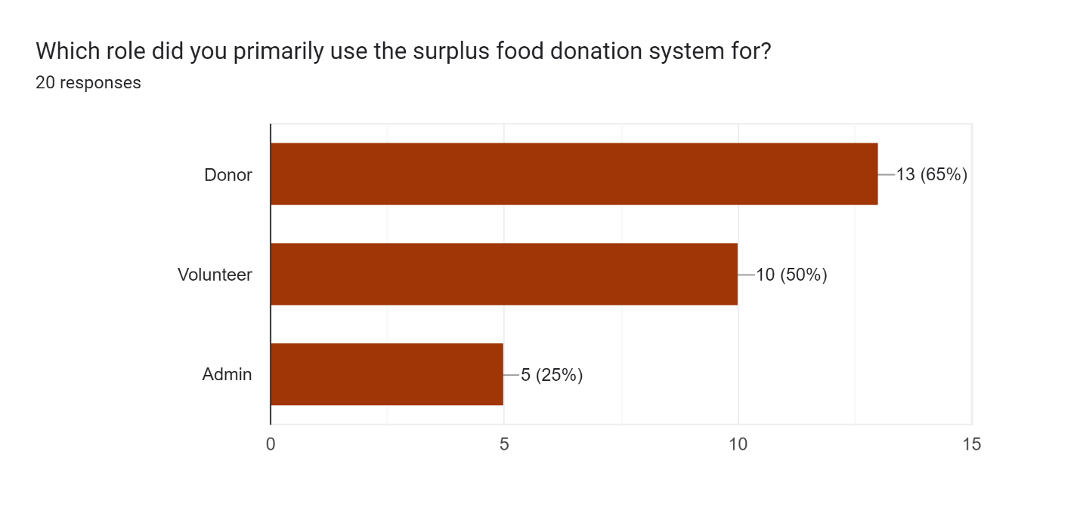

Figure 30: Post-survey results used to recommend the system

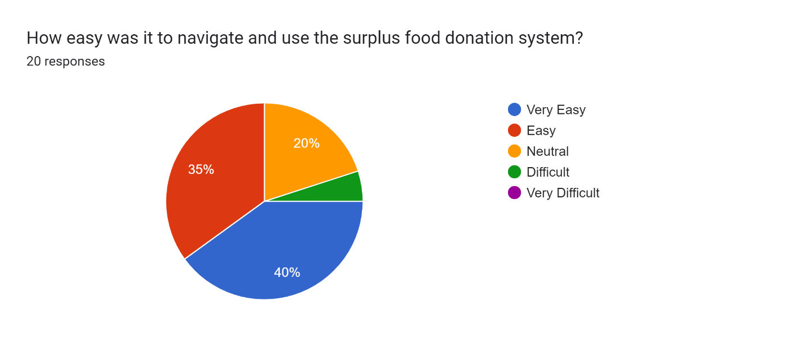

Figure 31: Post-survey of system navigation survey response

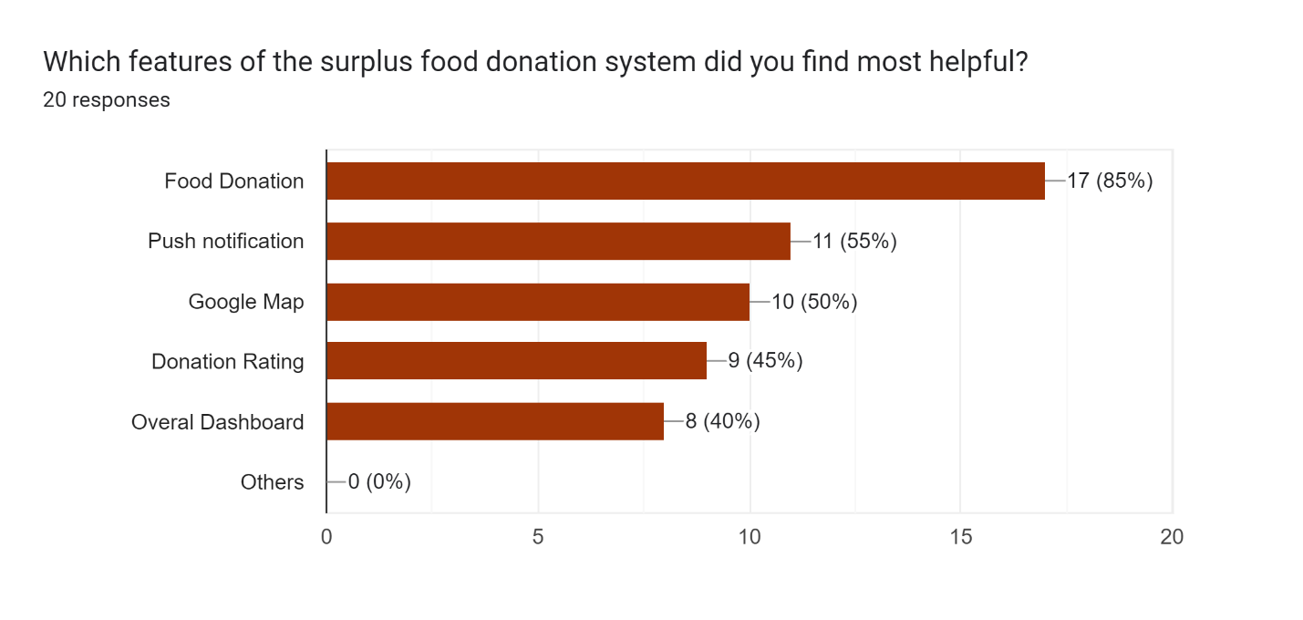

Figure 32: Post-survey result of finding the helpful

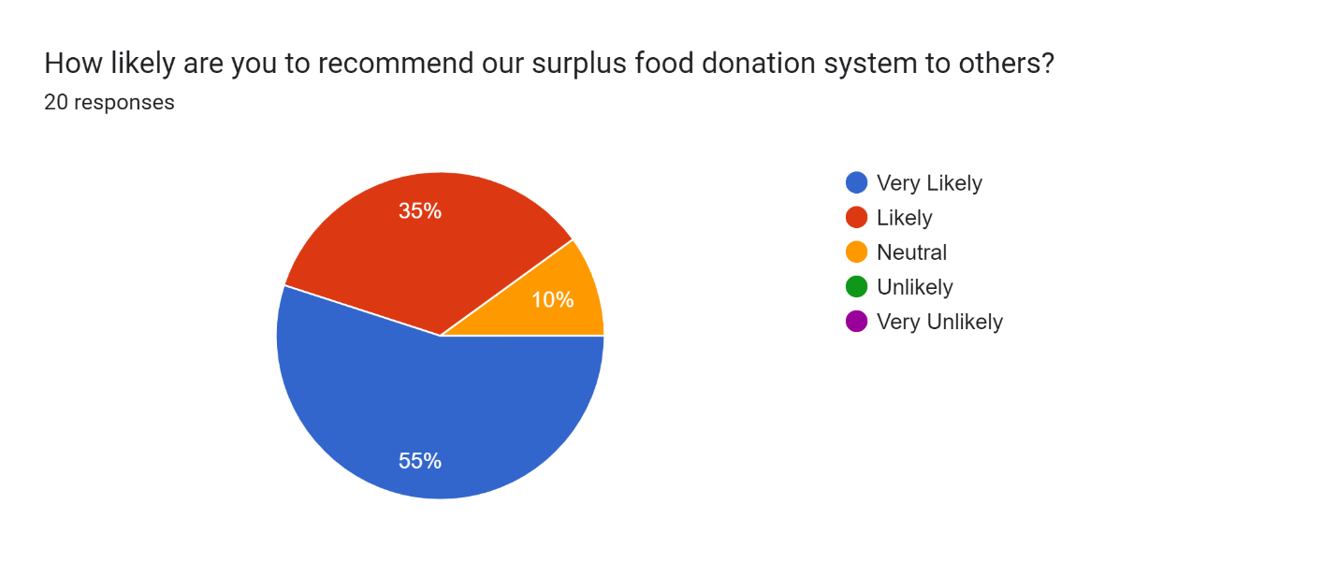

Figure 33: Post survey results of recommendations for donations

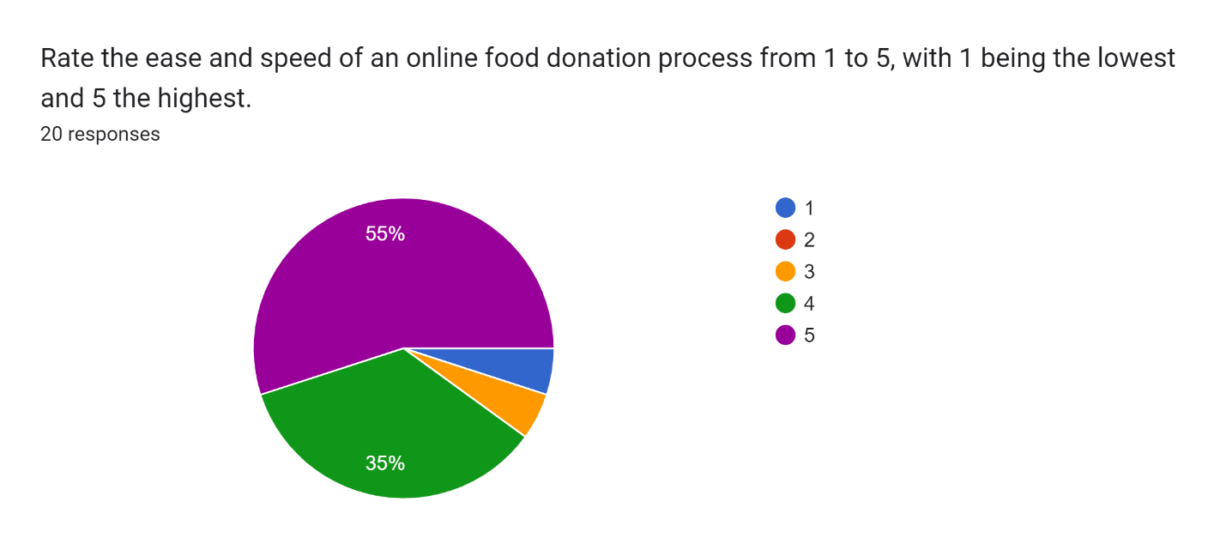

Figure 34: Post-survey of overall system rating

Additionally, the constructive criticism was offered, identifying areas for refinement, including user interface enhancements and logistical optimizations for food distribution processes. Overall, the post-survey results serve as a valuable resource for ongoing system refinement and the continued success of surplus food donation efforts. The survey form details and response with collection results are given below:

## 3.3. Requirement Analysis

### 3.3.1 Introduction

Requirement analysis for a surplus food management system involves understanding the needs and expectations of stakeholders and defining the specific functionalities and features that the system should have. The “Food Share” application is used in different locations, such as food companies, hotels, restaurants, and more sectors to surplus food to distribute to poor or homeless people. A recent analysis found that 1.3 billion tons of food are wasted annually. Further, leftovers account for one-third of all the food consumed. Currently, those who would like to donate food or other supplies must go in person to the organizations. If they need help, they will need to look for websites where they can give extra food. Large producers, distributors, and the organized community donate food to food banks or waste tons of food daily (Kruthika V, INTEGRATED APPROACH FOR FOOD DONATION SYSTEM, RESTAURANT, 07, July-2023).

### 3.3.2 Purpose

The purpose of the requirement analysis is to identify and document the functional and non-functional requirements of the "Food Share" application. By gathering input from stakeholders and understanding their needs, the analysis aims to define the scope of the system and specify the features and capabilities it should provide. Additionally, the requirement analysis helps prioritize requirements, identify constraints, and lay the foundation for the design and development of the system.

### 3.3.3 Scope

The scope of the "Food Share" application encompasses the following aspects:

* Donor Management: The system should allow food companies, hotels, restaurants, and other donors to register, log in, and submit details about surplus food donations, including type, quantity, and expiration date.
* Recipient Management: Recipient organizations, such as shelters, food banks, and community centres, should be able to register, request specific types of food donations based on their needs, and coordinate pickups.
* Logistics and Coordination: The system should facilitate the scheduling and coordination of food pickups between donors and recipients, optimizing routes and ensuring timely delivery.
* Reporting and Analytics: Administrators should have access to reporting tools to track donation activities, analyze trends, and measure the impact of the system in reducing food waste and addressing food insecurity.
* User Authentication and Security: The system should implement secure user authentication mechanisms to protect sensitive information and prevent unauthorized access.
* Usability and Accessibility: The user interface should be intuitive and accessible, catering to users with varying levels of technical proficiency and accessibility needs.
* Performance and Scalability: The system should be able to handle a large volume of donations and users, ensuring smooth operation and scalability as the user base grows.
* Regulatory Compliance: The system should comply with relevant regulations and standards related to food safety, data protection, and privacy.

By defining the purpose and scope of the requirement analysis, stakeholders can align their expectations and ensure that the "Food Share" application meets the needs of all parties involved in surplus food management.

### 3.3.4 Reference

AWS. (2024, 04 13). *What is Scrum*? Retrieved from AWS: https://aws.amazon.com/what-is/scrum/#:~:text=Scrum%20is%20a%20management%20framework,experience%2C%20and%20adapt%20to%20change.

Chiarelli, A. (2024, 04 19). *Auth0 by Okta*. Retrieved from THE CONFUSED DEVELOPER: https://auth0.com/blog/id-token-access-token-what-is-the-difference/

Dave Lampert, M. S. (2024, 04 07). *Now Fair Food NZ*. Retrieved from Food Rescue: https://fairfood.org.nz/about-us/our-story/#impact

Dave Lampert, M. S. (2024, 04 07). *Food Reduces*. Retrieved from Food Reduces Us: https://foodrescue.us/our-app/

Developer, G. (2024, 04 23). *Developer*. Retrieved from Save data in a local database using Room: https://developer.android.com/training/data-storage/room

developer, G. (2024, 04 18). *FCM*. Retrieved from Firebase: https://firebase.google.com/docs/cloud-messaging/android/client

Developer, G. (2024, 04 23). *Google for developer*. Retrieved from Build Better Apps Faster with: https://developer.android.com/develop/ui/compose

Dhanajay Jhala, K. s. (2021). Spread the smile. *Food Donation*, p. 51.

*Django Rest Framework*. (2024, 04 22). Retrieved from Serializers: https://www.django-rest-framework.org/api-guide/serializers/

GeekForGeek. (2024, 04 21). *GeekForGeek*. Retrieved from Levels in Data Flow Diagrams (DFD): https://www.geeksforgeeks.org/levels-in-data-flow-diagrams-dfd/

GeekForGeek. (2024, 04 21). *Unified Modeling Language (UML)*. Retrieved from Use Case Diagrams: https://www.geeksforgeeks.org/use-case-diagram/

Google. (2024, 04 17). *Developer*. Retrieved from Save simple data with SharedPreferences: https://developer.android.com/training/data-storage/shared-preferences

Inc, L. S. (2024, 04 21). *Lucidechart*. Retrieved from Entity Relationship Diagram: https://www.lucidchart.com/pages/er-diagrams

JavaTpoint. (2024, 04 13). *Software Engineering*. Retrieved from www.javatpoint.com: https://www.javatpoint.com/software-engineering-prototype-model

Kruthika V, L. H. (07, July-2023). INTEGRATED APPROACH FOR FOOD DONATION SYSTEM, RESTAURANT. *International Research Journal of Modernization in Engineering Technology and Science*, 8.

Kruthika V, L. H. (07, July-2023). INTEGRATED APPROACH FOR FOOD DONATION SYSTEM, RESTAURANT. *International Research Journal of Modernization in Engineering Technology and Science*, 8.

Levan, M. (2024, 04 20). *TeachTargate*. Retrieved from Unit Testing: https://www.techtarget.com/searchsoftwarequality/definition/unit-testing

local government bodies, N. (2024, 04 07). *Flashfood Grocery deals*. Retrieved from Google Play Store: https://play.google.com/store/apps/details?id=com.flashfoodapp.android&hl=en&gl=US

LUMITEX. (2024, 04 13). Prototyping Methodology. *Dow Circle Strongsville, Ohio*, p. 10.

Mello, M. (2024, 04 21). *System Architecture*. Retrieved from The Blueprint for Successful Systems: https://dev.to/msmello_/system-architecture-the-blueprint-for-successful-systems-35nn

MkDocs. (2024, 04 21). *Django REST framework*. Retrieved from Django: https://www.django-rest-framework.org/api-guide/serializers/

Nepal, G. o. (2020-2021). Nepal towards an equitable, resilient and sustainable food system. *Nepal’s Food Systems Transformation*, 64.

Nepal, G. o. (2020-2021). Nepal towards equitable, resilient and sustainable food systems. *Nepal’s Food Systems Transformation:* p. 64.

Nick Barney, M. E. (2024, 04 21). *TeachTargate*. Retrieved from authentication: https://www.techtarget.com/searchsecurity/definition/authentication

Reichert, A. (2024, 04 20). *TeachTargate*. Retrieved from system testing: https://www.techtarget.com/searchsoftwarequality/definition/system-testing

S, B. (2024, 04 13). *nimble Humanize work*. Retrieved from Scrum Project Management: https://www.nimblework.com/agile/scrum-methodology/

Singtel, P. (2024, 04 23). *Altexsoft*. Retrieved from What is API: https://www.altexsoft.com/blog/what-is-api-definition-types-specifications-documentation/

StevenSwiniarski. (2024, 04 18). *Codecademy*. Retrieved from POJO: https://www.codecademy.com/resources/docs/java/pojo

Theil, D. (2024, 05 13). *LogRoceket*. Retrieved from Understanding the waterfall methodology: https://blog.logrocket.com/product-management/waterfall-methodology-guide/#:~:text=The%20waterfall%20methodology%20is%20a%20linear%20and%20sequential,well-defined%20project%20requirements%2C%20and%20a%20structured%2C%20predetermined%20timeline.

Weir, S. P. (2024, 04 22). *Wikipedia*. Retrieved from Data Transfer Object: https://en.wikipedia.org/wiki/Data_transfer_object

Nepal, G. o. ( 2024, 04 15). Nepal’s Food Systems Transformation: *Nepal towards an equitable, resilient and sustainable food system*, p. 64.

### 3.3.5 Overall Descriptions

* Product Perspectives: This section will describe how the process of donating food fits into the larger scheme of charity activities and community assistance programs. It would go over the many parties involved, including administrators, volunteers, donors, and recipients, and how the system attempts to meet their requirements while rendering coordination and communication easier between them.
* Product Functionality: The characteristics and capabilities of the food donation system are described in detail in this section. For volunteers, donors, and beneficiaries, user registration and verification are required. Interface for submitting donations that allow food givers to list available food products with information such as kind, amount, expiration date, and preferred pickup or delivery. Recipients can use the search and browse features to locate available donations according to their location and dietary requirements. Tools for scheduling and coordinating the delivery or pickup of donations between donors and receivers. Tools for managing volunteers that are used to recruit, assign, and monitor volunteer tasks including gathering, sorting, and distributing food. Administrators may quantify the impact, track donation trends, and improve operations with the help of reporting and analytics capabilities.
* System Environment: The technical setting in which the food donation system functions is covered in this section. It would contain information like The architecture or platform that was utilized to create the system (such as a mobile app or web-based application). Requirements for the backend infrastructure, including servers, databases, and APIs. Compatibility across a range of hardware and operating systems. Security protocols are put in place that protect user information and maintain system integrity. Integration with external services or platforms, such as mapping services for location-based functionality or payment gateways for contribution transactions.

In general, the goal of a food donation system is to make the act of giving food to those in need easier by using technology to match surplus food donors with receivers who can use it, and by enlisting volunteers to help with the logistical aspects of the program.

### 3.3.6 Functional Requirement

* Register Membership: Users can register their details and submit them for membership. The admin reviews the user details and verifies the account, granting privileges or permissions accordingly.
* View History: Both donors and volunteers can view their donation history. Donors can see who accepted their donated food, while volunteers can view the history of accepted donations available for distribution.
* View Donation Details: Volunteers can access the latest donated food details, including user information and location.
* View Map: All users can access the food donation locations to find the nearest pickup and distribution points.
* Push Notification: When a donor donates new food with all the necessary details, all volunteer users receive a notification alerting them to the donation, including the food name.
* Complaint/Report: Users have the option to file a complaint with the admin. If a donor fails to provide the promised food or if volunteers are unable to pick up the food, both parties can report the issue to the admin.
* Donation Rating: After completing a donation, volunteers can provide feedback and rate the donation.
* View User Profile: Users can view their profile details.

### 3.3.7 External Interface Requirements

This project needs various hardware and software tools, technology is given below:

• Emulator: Android Mobile or Default Android Studio Emulator

• Internet Connection • IDE: Android Studio, Ngrok, wormhole etc.

• Code Editor: Visual Studio Code

• Programming Language: Kotlin, Python, HTML/CSS

• Framework: Django, Rest and JetPack Compose

• Database: MySQL, Room

• Version Control: GitHub

• Tools: Draw.io, TeamGantt, Balsmiq, Scrcp, wormhole, Drive etc.

#### 3.3.7.1 Hardware Requirements

|  |  |  |  |
| --- | --- | --- | --- |
| **S. N** | **Requirement** | **Version** | **Resources** |
| 1 | Development Device | Computer Window 11 | Computer (Window) |
| 2 | Test Device | Android 13 (above 8) | Mobile (Android) |

Table 8: Hardware interface requirement

#### 3.3.7.2 Software Requirements

|  |  |  |  |
| --- | --- | --- | --- |
| **S. N** | **Tools & Technology** | **Version** | **Purpose** |
| 1 | Django (DRF) | 4.2.5 | Django Rest Framework Integrated for Api Development |
| 2 | Python | 3.11.2 | The Python programming language used to develop the Django backend. |
| 3 | MySql Database | 8.0.3 | The MySql database is used to data store in the cloud. |
| 4 | HTML, CSS, JavaScript | | The HTM, CSS and JavaScript were used to develop the frontend web admin panel for system management. |
| 5 | Kotli | 1.9.0 | The Kotlin programming language was used to develop the Mobile application. |
| 6 | Jetpack Compose | 1.6.5 | The Jetpack compose is used to develop the Mobile User Interface (UI). |
| 7 | Room Database | 2.5.2 | The room database is a local database where it is used for temporary data saved for local storage. |
| 8 | GitHub | 2.38.1 | The GitHub is a version control tool that is used for all-project development and is stored in the cloud. |
| 9 | Android Studio | 2023.1.1 | The Android Studio is the IDE that is used to write the mobile app development code Kotlin and compose. |
| 10 | Visual Studio Code | 1.70 | The Visual Studio Code is used to develop backend Django rest framework and Frontend web applications. |
| 11 | Design and Documentation Tools | | Design and documentation tools like MS Word were used for documentation, Draw.io, was used for class diagram development and Team Gent was used for Gantt chart development also more tools were used for the project. |

#### 3.3.7.3 User Interface

To address the issue of the food donation system, here are some suggestions for improvement:

* Clarity and Consistency: Ensure that the user interface (UI) is clear and consistent throughout the system. This includes using consistent design elements such as colours, fonts, and layout across all pages. Consistency helps users navigate the system more easily and reduces confusion.
* Simplicity: Simplify the UI to make it more user-friendly. Avoid cluttered layouts and excessive text. Instead, focus on presenting key information and features clearly and concisely. This improves usability and enhances the overall user experience.
* User-Friendly Language: Use language that is familiar and easily understandable to the system's intended users. Avoid technical jargon or complex terminology that may be confusing. Use simple language to guide users through the system's features and functionalities.
* User Guidance: Provide clear instructions and guidance to users at each step of their journey through the system. This includes providing tooltips, hints, or on-screen prompts to help users understand how to navigate the system and perform various actions.
* Accessibility: Ensure that the UI is accessible to all users, including those with disabilities. This may involve providing alternative text for images, ensuring proper contrast for text and background colours, and implementing keyboard navigation shortcuts.
* Feedback Mechanisms: Incorporate feedback mechanisms into the UI to allow users to provide input or report issues. This could include feedback forms, rating systems, or contact options for reaching out to support staff. Feedback helps identify areas for improvement and ensures that user needs are addressed.

By implementing these suggestions, the food donation system can enhance its user interface to make it more attractive, user-friendly, and effective for donors, volunteers, and other users.

### 3.3.8 External Requirement

To develop an effective food donation system in Nepal, adhering to national and international best practices would be necessary. An overview of potential external requirements is provided below:

#### 3.3.8.1 Legal Compliance:

Make sure that your food donation activities adhere to all applicable laws and rules in Nepal concerning food distribution, safety, and charitable purposes. This could entail getting the required permits and registering your organisation with the appropriate government agencies. Follow the food safety guidelines established by the Nepali government or by international agencies like the Food and Agriculture Organization (FAO) and the World Health Organization (WHO). To avoid infection and spoiling, donated food must be handled, stored, and transported properly.**Invalid source specified.**

#### 3.3.8.2 Health Rules:

Adhere to health rules concerning the handling and distribution of food, including standards of hygiene for those who are volunteering or engaged in the gathering, preparing, and distributing of food. Cultural The sensitivity is When choosing and allocating donated food items, consider Nepalese customs and dietary preferences. Consider local eating customs as well as religious dietary requirements and preferences.

#### 3.3.8.3 Working with Government Agencies:

Organize with government organizations in charge of Nepal's disaster assistance and food security initiatives. Form alliances to guarantee the effective delivery of food donations to places in need, particularly in times of emergency like natural disasters or humanitarian crises.

#### 3.3.8.4 Identification & Reporting:

Keep thorough records of all food donations that are received and distributed, including information on the quantity, the helpfulness, and the recipients of the donations. Provide a monthly update outlining the work your organization is doing and the results it has achieved for the public, government agencies, and donors, among other stakeholders.

#### 3.3.8.5 Community Involvement:

Get to know your neighbourhood's needs and preferences when it comes to food aid programs. To ensure the relevance and efficacy of food donation projects, involve members of the community in their development and execution.

#### 3.3.8.6 Sustainability:

To guarantee long-term impact and efficacy, develop sustainable practices for food donation initiatives. This could entail encouraging the production and sourcing of food locally and minimizing food waste using careful planning and administration while implementing systems up and running to address the root causes of Nepal's food insecurity.

### 3.3.9 Non-Functional Requirement

The primary objective of this SRS document is to define the software requirements for the food donation system. The system aims to facilitate the process of donating surplus food to those in need. In this section, specific design and implementation information will be provided. Non-functional requirements, as the title suggests, focus on system characteristics beyond its core functionalities. Some of the non-functional requirements for the food donation system are as follows:

### 3.9.1 Usability

The system should ensure ease of use and effectiveness to satisfy end users. Each interface should include a help and information section to guide users in interacting with the system. The system's documentation should provide comprehensive guidance for remote management.

### 3.9.2 Security

The system must prioritize security to protect against unauthorized access. Users are required to provide a login and password, with passwords being at least eight characters long. Only authorized users with active credentials should be able to access the system's secured pages. The system should maintain a high level of security and integrity for the data it holds.

### 3.9.3 Performance

The system should respond to user instructions within 10 seconds at most. It should operate quickly and efficiently, with response times typically within milliseconds for most tasks. The system is expected to deliver optimal performance and complete tasks promptly.

### 3.9.4 Error Handling

The system should minimize errors and provide clear error correction instructions to help users recover from them. User inputs must be thoroughly validated, and the system should handle errors automatically, with minimal impact on user experience.

### 3.9.5 Ease of Use

The system should feature a simplified yet high-quality user interface to accommodate users of varying levels of understanding. It should require minimal training for users to navigate and utilize its functionalities effectively.

### 3.9.6 Maintainability

The system should allow users to reset all optional and stored user variables to default settings easily. It should be designed for easy maintenance, with automated maintenance processes utilizing stored user data to provide relevant information.

### 3.9.7 Portability

The software should be easily adaptable to different networks or operating systems, facilitating its distribution and deployment across various environments.

This section outlines the non-functional requirements that are essential for ensuring the effectiveness, security, performance, availability, error handling, usability, maintainability, and portability of the food donation system.

## 3.4. Design (Concerning methodology what are the core design techniques. For eg: If the methodology is USDP, UML diagrams are a must)

### 3.4.2. Use Case

A use case diagram is a visual representation that illustrates the interactions between actors and a system. It showcases various use cases of a system and how different actors interact with those use cases. The most important instrument for system design is the use case diagram, which shows users' interactions with a system visually. It acts as a road map for understanding a system's functional needs from the point of view of its users, enabling stakeholder communication and leading the development process. (GeekForGeek, Unified Modeling Language (UML), 2024)

The system has three types of end users where admin, donor and volunteer. The use case represents which user can do the system. Where the system can show the user connection and work in the system flow.

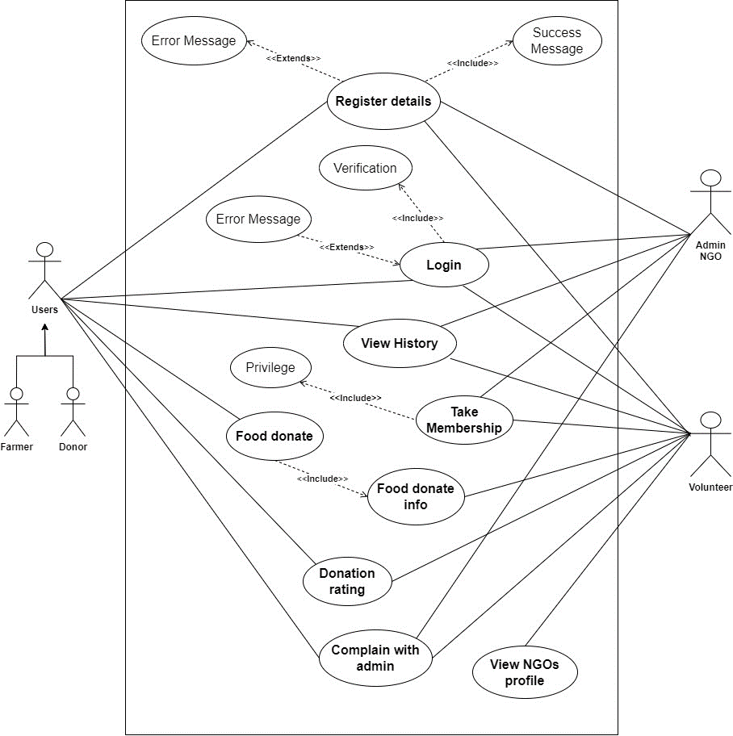

Figure 35: Use Case Diagram

**Appendix C: Use-Case Diagram**

### 3.2.1. High-Level Use Case

The system includes an extensive collection of use cases, many of which are high-level use cases that facilitate system design and development. Each high-level use case focuses on providing a brief explanation of each procedure as it develops and as a result, would be recognized by the customer.

The high-level use case is given below:

#### 3.2.1.1. Register user.

|  |  |
| --- | --- |
| **Use Case:** | Register Details |
| **Actors:** | Donor, Volunteer, NGO, Farmer |
| **Descriptions:** | All users can input their respective details into the system. Upon submission, the system automatically registers the provided information, ensuring seamless integration and efficient data management. If the register details are correct show the success message otherwise display the error message. |

Table 9: Register user high-level use case

#### 3.2.1.2. Take Membership

|  |  |
| --- | --- |
| **Use Case:** | Take Membership |
| **Actors:** | Volunteer, NGO |
| **Descriptions:** | A new volunteer provides the personal details, and his/her details are registered with the system. The NGO provide the membership, and then volunteers take the new membership. |

Table 10: Take membership user high-level use case

|  |  |
| --- | --- |
| **Use Case:** | Privilege |
| **Actors:** | Volunteer |
| **Descriptions:** | After taking a new member, a new volunteer gets the privilege of the food donation system. |

#### 3.2.1.3. Login System

|  |  |
| --- | --- |
| **Use Case:** | Login |
| **Actors:** | Donor, Volunteer, Farmer, NGO |
| **Descriptions:** | After registering details in the system, all the users can provide valid details and log in to the system Then successfully log in to the system. If the login details are valid display the success message otherwise error message. |

Table 11: Login user high-level use case

#### 3.2.1.4. Food Donate

|  |  |
| --- | --- |
| **Use Case:** | Food Donate |
| **Actors:** | Donor, Farmer, Volunteer |
| **Descriptions:** | The Donor or Farmer can donate the proper food information and details with location. The system can show the donation food details in the history after posting the donated food. All the volunteers can get the donation information (Notification). |

Table 12: Food donation high-level use case

#### 3.2.1.5. View Donation info

|  |  |
| --- | --- |
| **Use Case:** | Donation Info |
| **Actors:** | Volunteer |
| **Descriptions:** | After receiving the donation info, the volunteer can view the donation details if it is possible or not possible to distribute. |

Table 13: View donation info high-level use case

#### 3.2.1.6. Donation Rating

|  |  |
| --- | --- |
| **Use Case:** | Donation Rating |
| **Actors:** | Volunteer, Donor |
| **Descriptions:** | After the food is completely donated to some people the volunteer can give the donation rating to the donor with food distributed information. |

Table 14: Donation rating high-level use case

#### 3.2.1.7. View History

|  |  |
| --- | --- |
| **Use Case:** | View History |
| **Actors:** | Donor, Volunteer, NGO, Farmer |
| **Descriptions:** | All the users can view the history of food donation nate, where to donate or more details. |

Table 15: View the history of high-level use case

#### 3.2.1.8. View NGO profile

|  |  |
| --- | --- |
| **Use Case:** | View NGO profile |
| **Actors:** | Volunteer, NGO |
| **Descriptions:** | The volunteer can view the NGO profile details where some information gets more details. |

Table 16: View profile high-level use case

#### 3.2.1.9. Complain with Administration

|  |  |
| --- | --- |
| **Use Case:** | Complain with Admin |
| **Actors:** | Donor, Volunteer, Admin |
| **Descriptions:** | After contact with donors and volunteers the donors cannot be provided or donate food and the receiver cannot come to receive the donation food, they can complain to the admin |

Table 17: Complaint with high-level use case

**(Expanded use case for appendix)**

## 3.3. Sequence Diagram

### 3.3.1. View profile sequence diagram

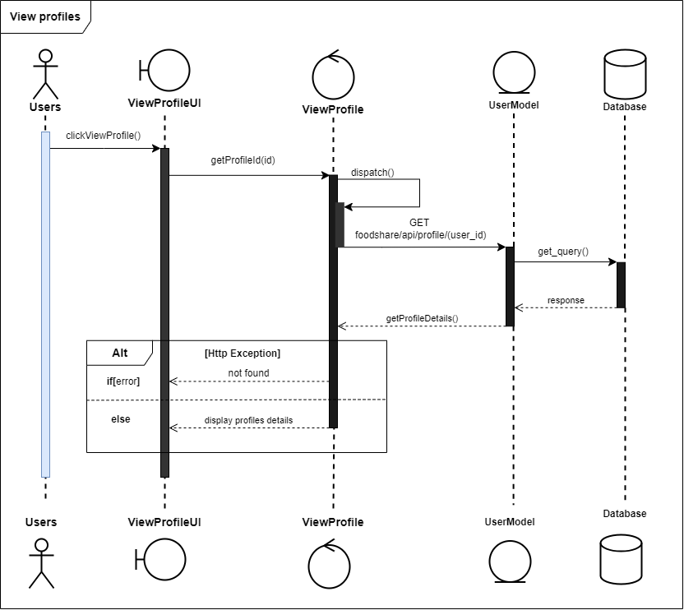

Figure 36: View profile sequence diagram

3.3.2. View history sequence diagram

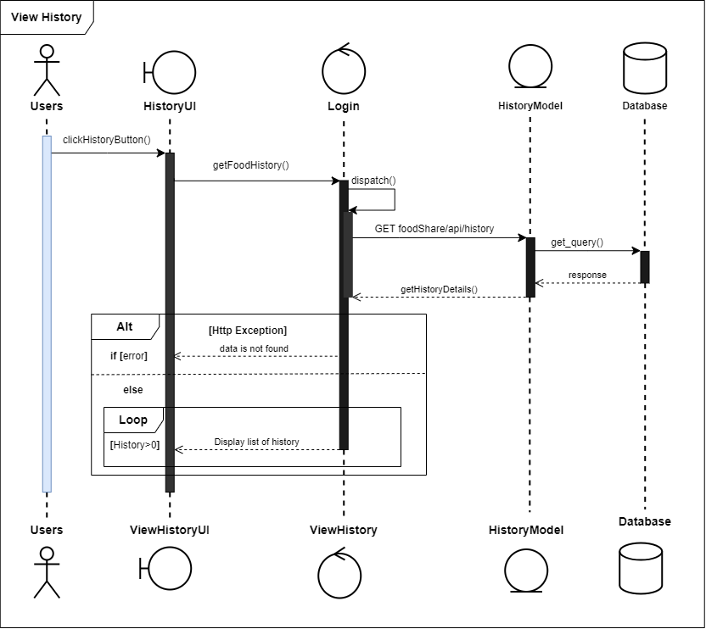

Figure 37: View the history sequence diagram

3.3.3. Post food donation sequence diagram

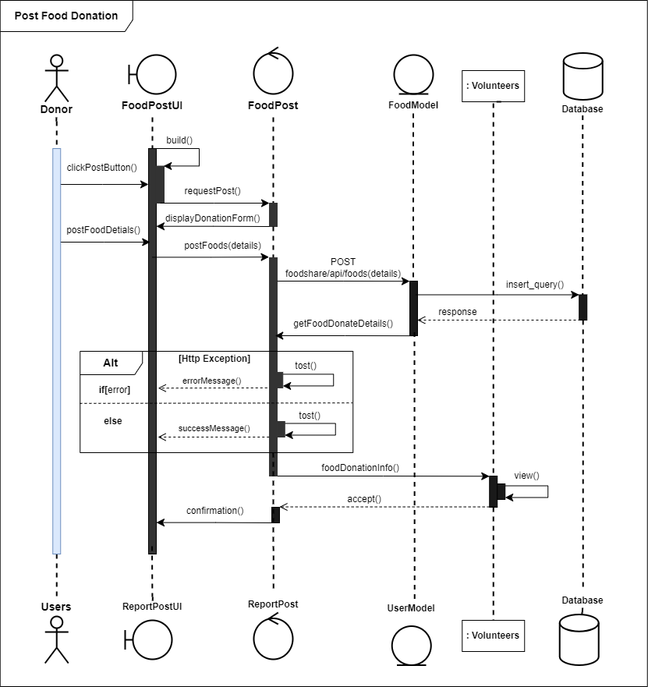

Figure 38: Food Post for donation sequence diagram

### 3.3.4. Donation rating sequence diagram

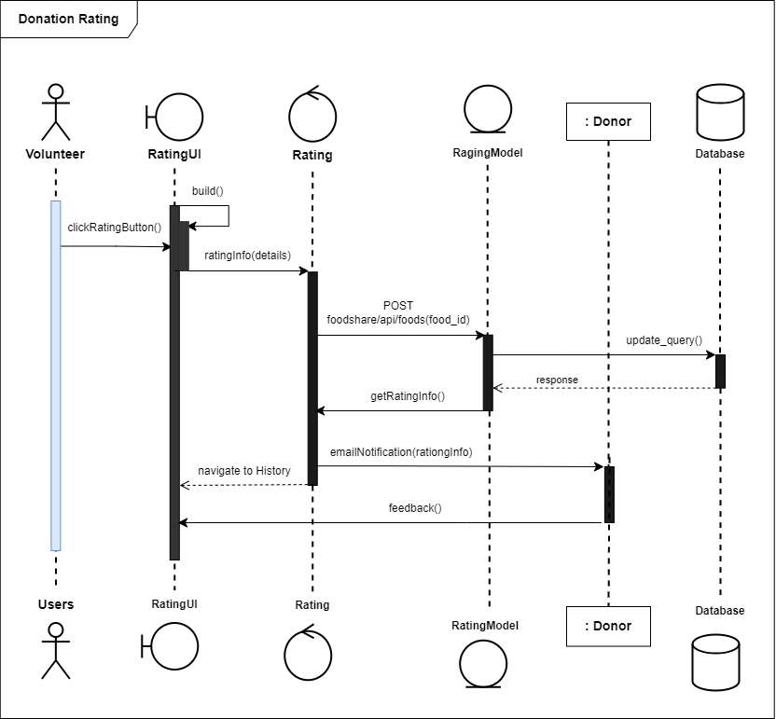

Figure 39: Donation rating sequence diagram

### 3.3.5. Complaint with admin

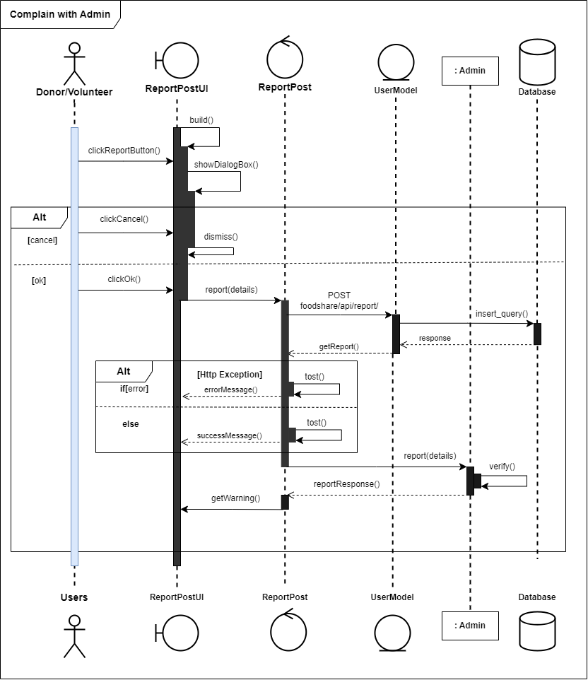

Figure 40: Complaint with admin sequence diagram

**(Sequence Diagram for appendix)**

## 3.4. Context Diagram

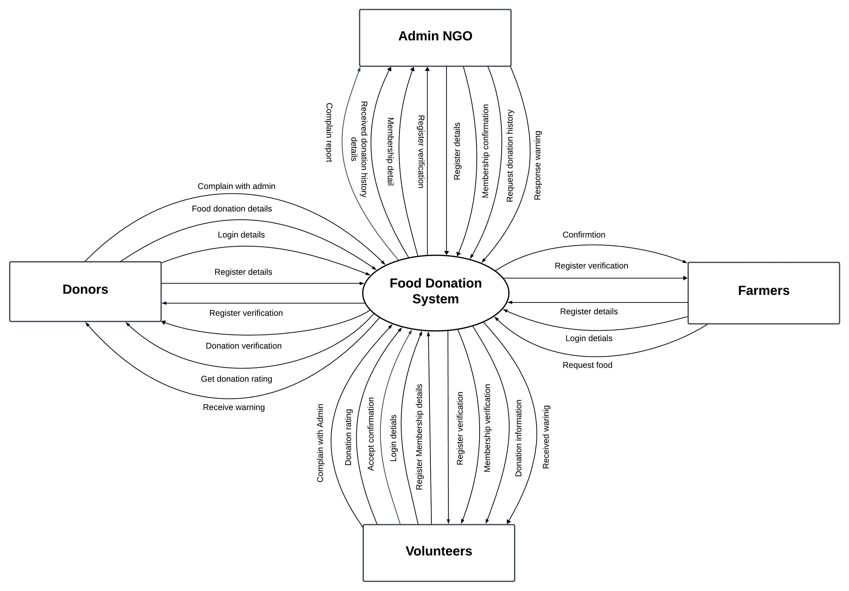

Figure 41: Context diagram

## 3.5. Data Flow Diagram Level -1

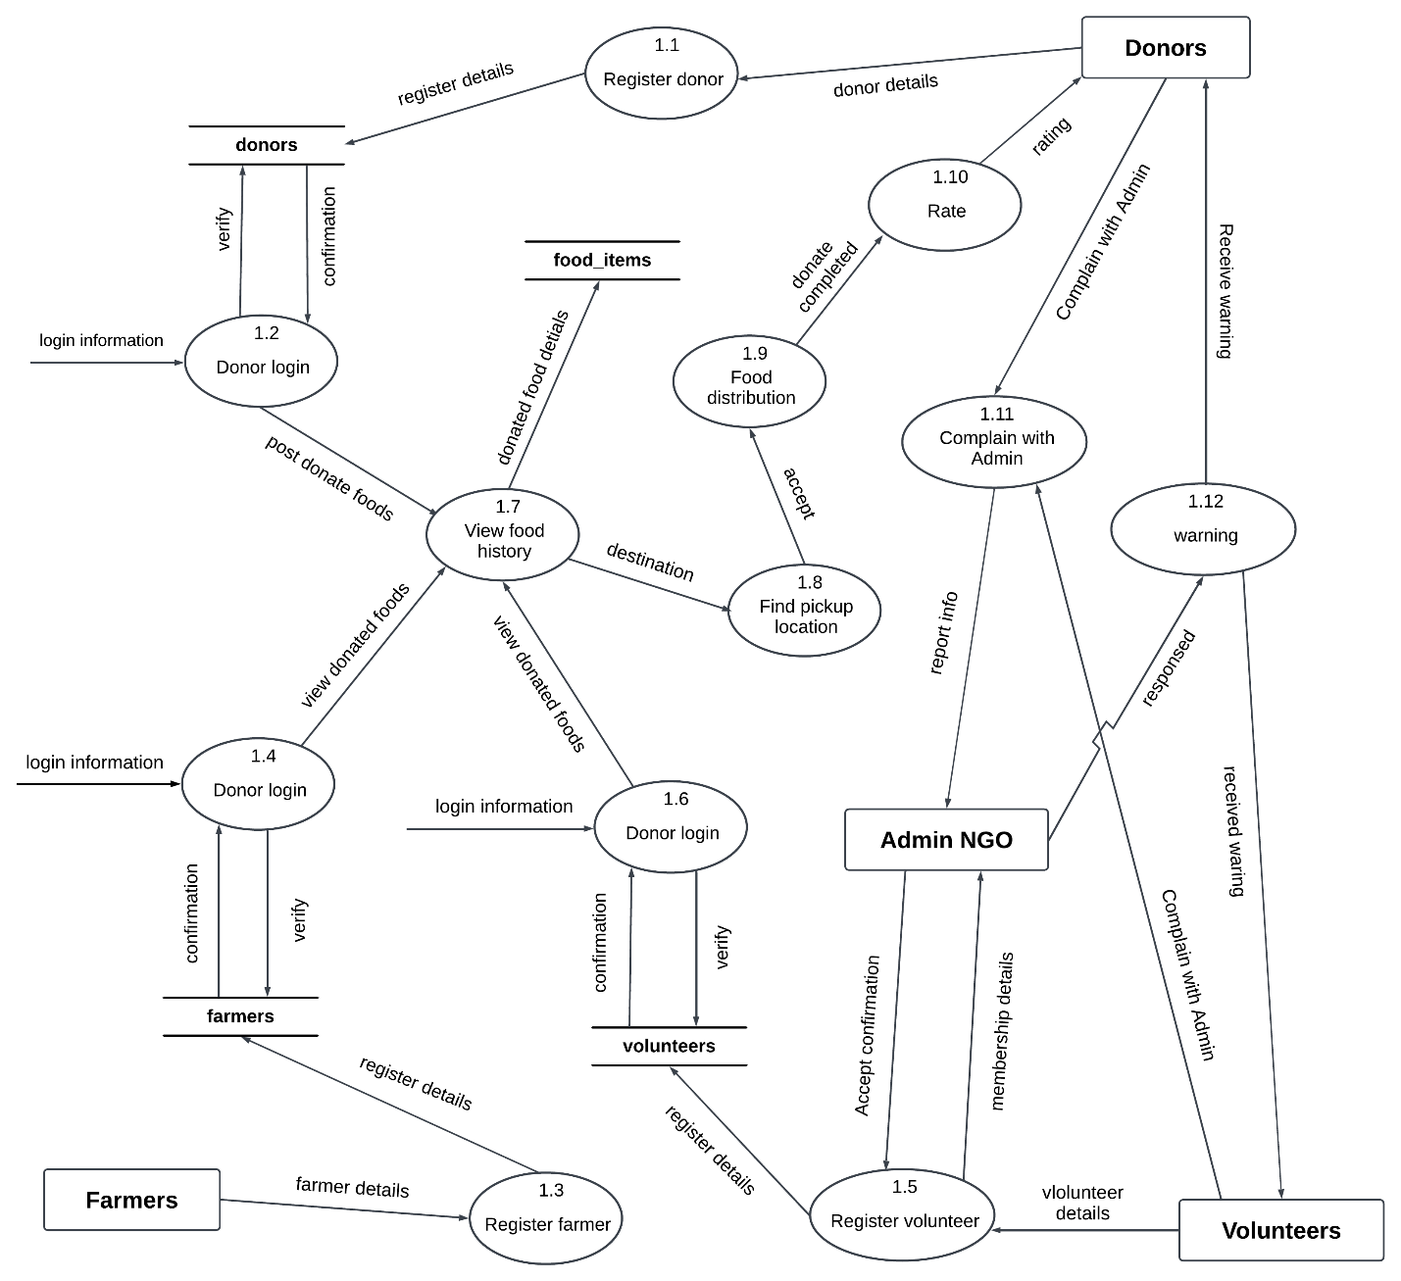

Figure 42: DFD Level-1

## 3.6. Activity Diagram

### 3.6.1. Take Membership Activity

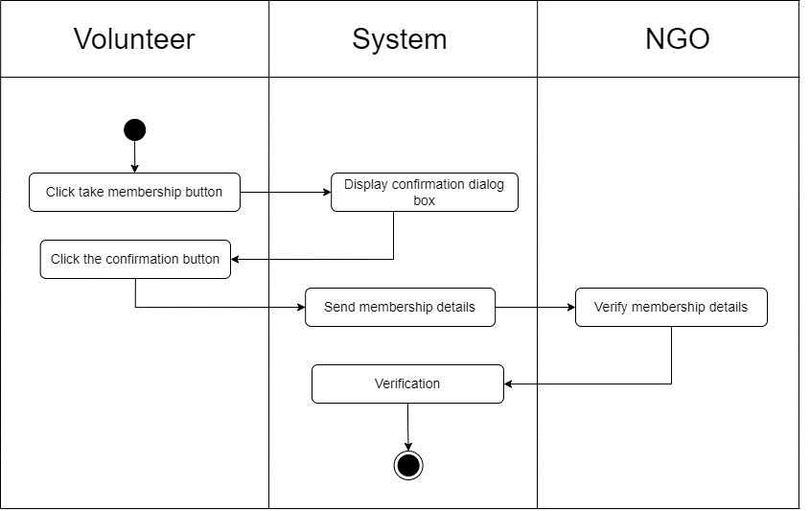

Figure 43: Take the membership activity diagram

### 3.6.2. Donation Activity

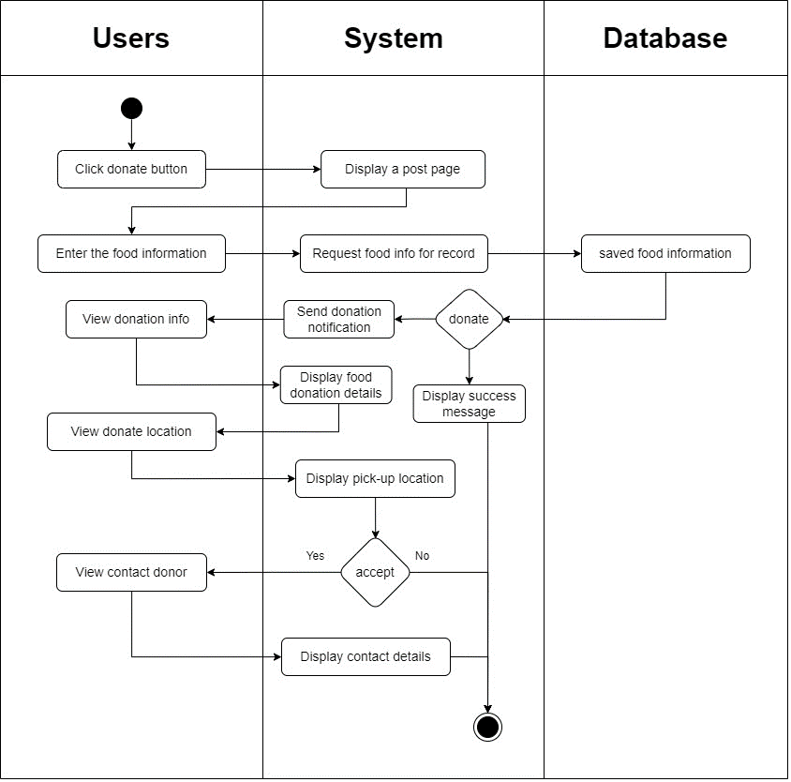

Figure 44: Food donation system activity diagram

### 3.6.3. View History Activity

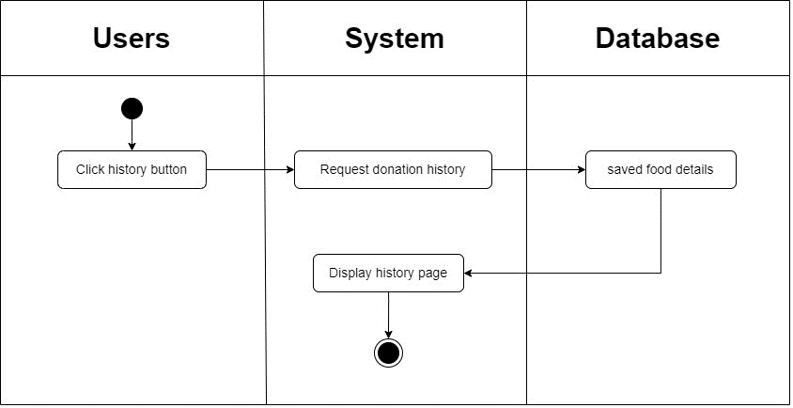

Figure 45: View the history system activity diagram.

### 3.6.4. Donation Rating Activity

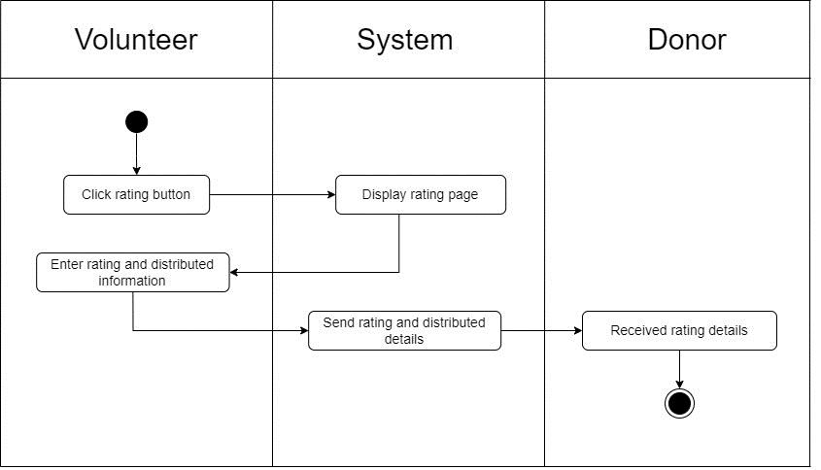

Figure 46: Rating donation system activity diagram

### 3.6.5. Complaint with Admin Activity

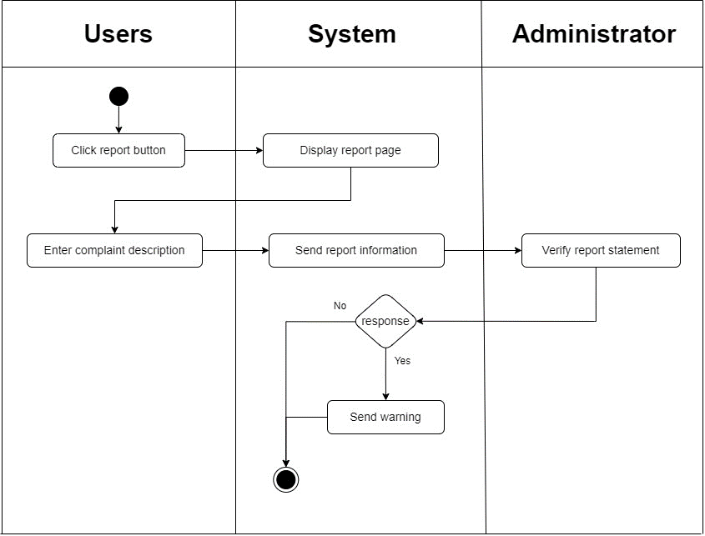

Figure 47: Complaint with admin system activity diagram

(Activity diagram for appendix)

## 3.7. Wireframes

### 3.7.1 Mobile UI

#### 3.7.1.1 Walkthrough Screen

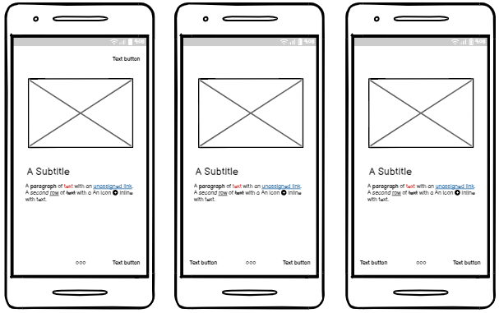

Figure 48: Walkthrough screen mobile UI

#### 3.7.1.2 Welcome Screen

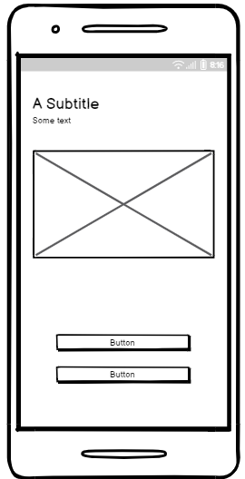

Figure 49: Welcome screen mobile UI

#### 3.7.1.3 Login Screen

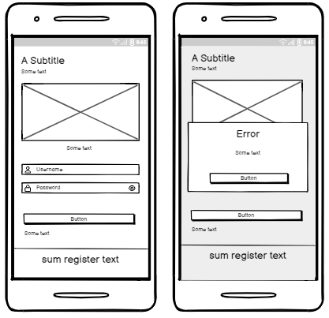

Figure 50: Login screen mobile UI

#### 3.7.1.4 Register Screen

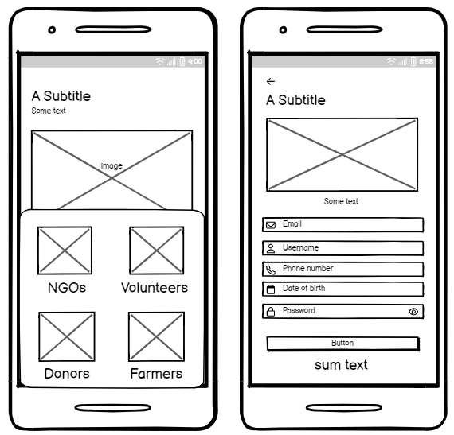

Figure 51: Register screen mobile UI

#### 3.7.1.5 Forgot Password Screen

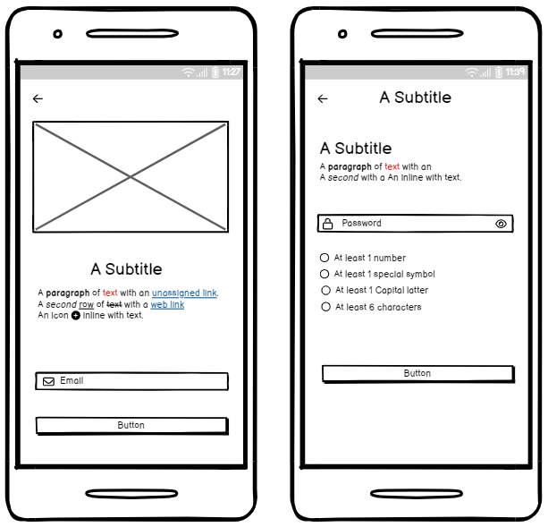

Figure 52: Forgot password screen mobile UI

#### 3.7.1.6. Dashboard for Donors

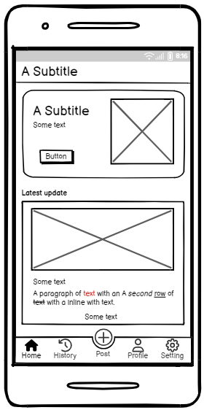

Figure 53: Donor Home screen mobile UI

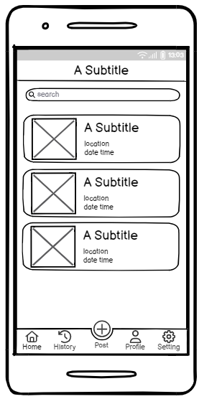

Figure 54: Donor History screen mobile UI

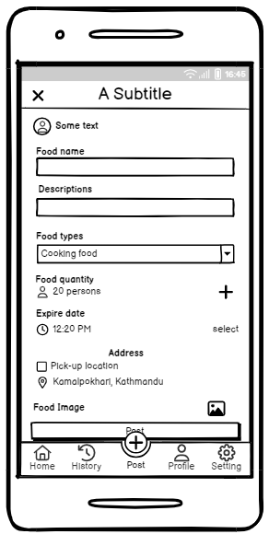

Figure 55: Donor Post/Donation screen mobile UI

#### 3.7.1.7. Dashboard for Volunteer and Farmer

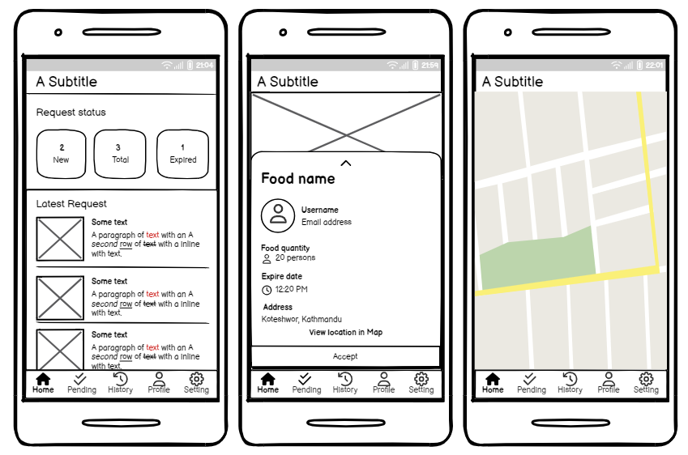

Figure 56: Volunteer Home screen UI

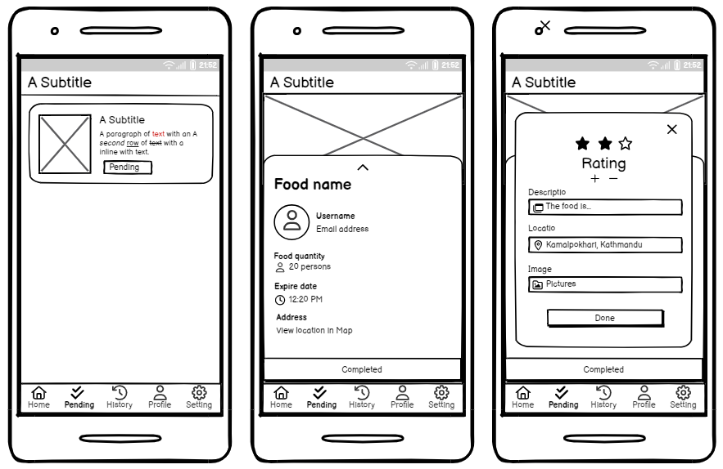

Figure 57: Volunteer Pending screen UI.

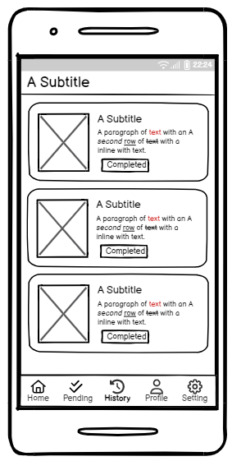

Figure 58: Volunteer History screen

#### 3.7.1.8. NOG Dashboard

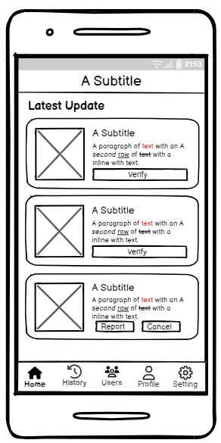

Figure 59: NGO Home screen UI

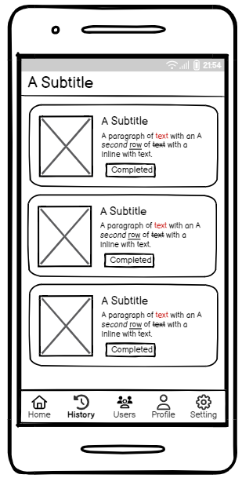

Figure 60: NGO History screen UI

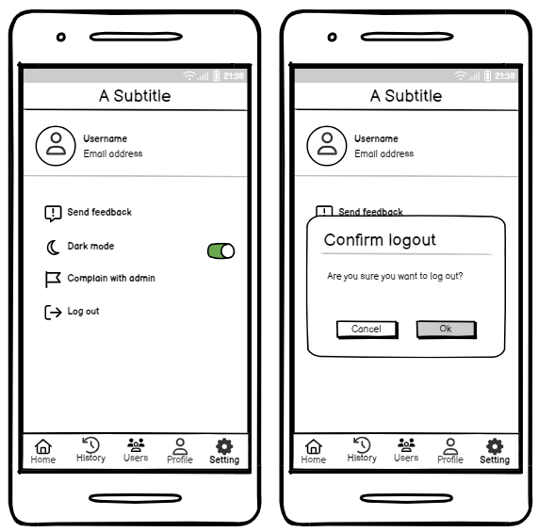

Figure 61: NGO Setting Screen UI

### 3.7.2. Web UI for Admin

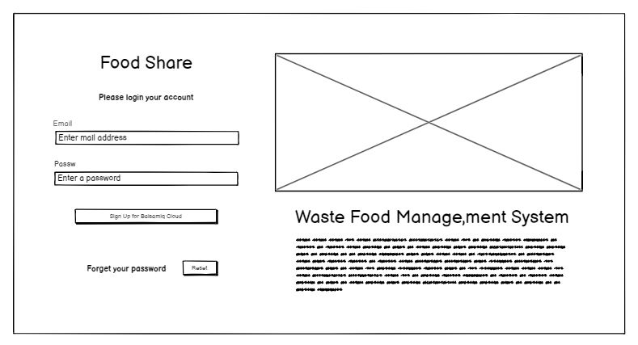

Figure 62: Admin login page web UI

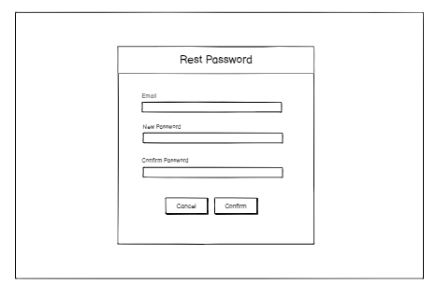

Figure 63: Admin forgot password UI.

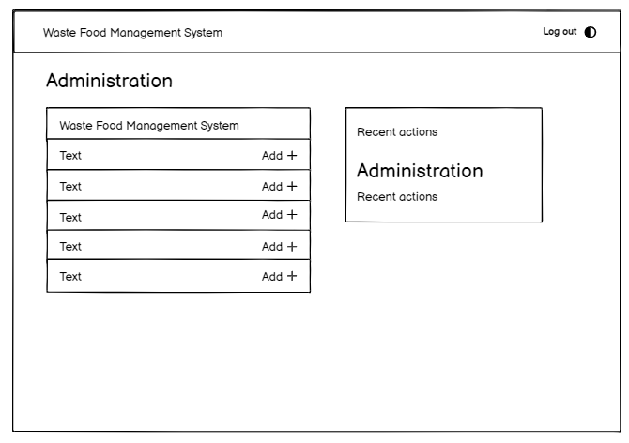

Figure 64: Admin dashboard UI

**(Wireframe UI for appendix)**

## 3.8. ER-Diagram

An Entity Relationship (ER) Diagram is a diagram that shows how "entities" like as persons, items, or ideas interact inside a system. ER Diagrams are commonly used to create or debug relational databases in software engineering, business-oriented systems, learning, and research. Also known as ERDs or ER Models, they demonstrate the interrelationships of entities, relationships, and their properties using a predefined set of symbols such as rectangles, diamonds, ovals, and connecting lines. They reflect linguistic structure, with items serving as nouns and relationships as verbs. (Inc, 2024)

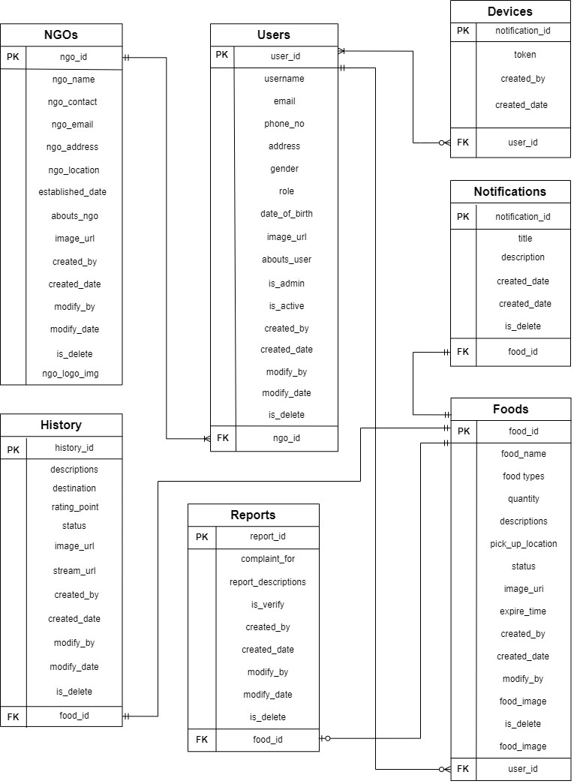

Figure 65: ER-Diagram

**Appendix C: Entity Relation -Diagram**

## 3.9. System Architecture Diagram

The system architecture is the conceptual model defining the structure, behaviour, and various views of a system. It involves identifying the components of the system, their relationships, and how they interact. System architecture reflects how the system functions and interacts with other systems and the external environment. It describes the interconnection of all system components and the data links between them. A system architecture consists of system components and subsystems that work together to implement the overall system (Mello, 2024). In waste food management have used the backend Django Rest Framework, database MySQL, as a frontend when HTML, CSS and mobile have Kotlin with Jet pack compose. The front-to-API through interaction backed the server where the frontend requests and the backend gives the response.

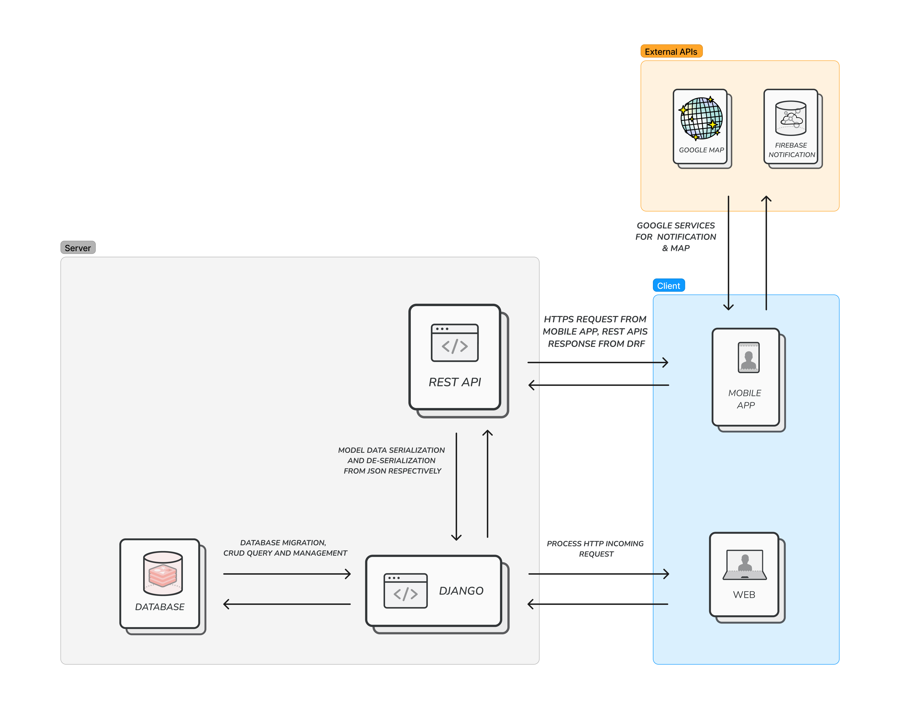

Figure 66: System Architecture Diagram

## 3.10. Class Diagram

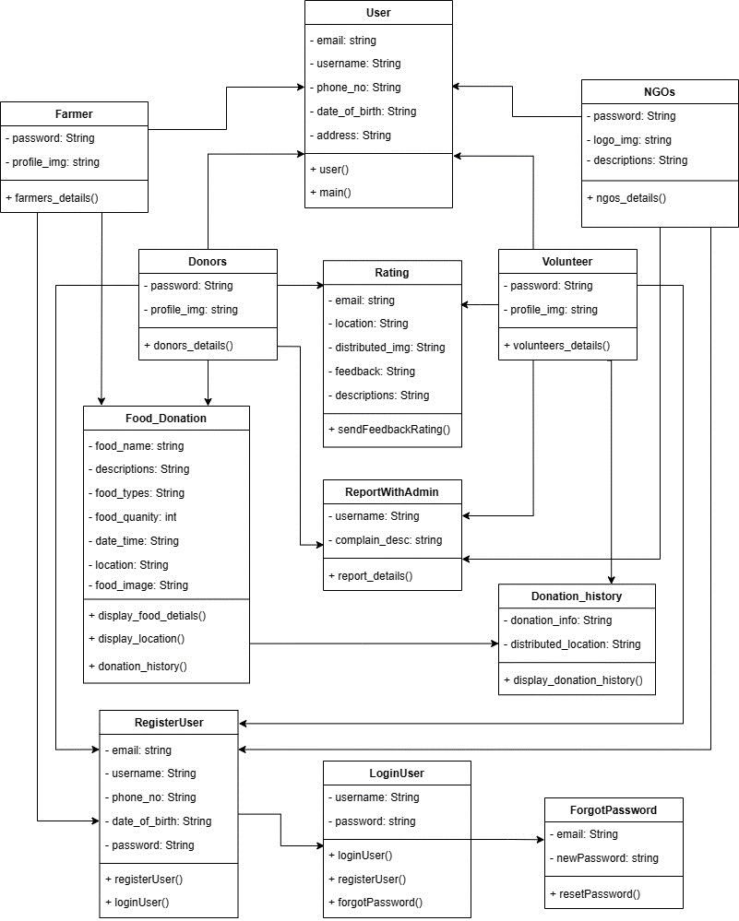

Figure 67: Class diagram of food donation application

## 3.11. DFD’s level 2

This level gives a more thorough perspective of the system by dividing the sub-processes found in the level 1 DFD into further sub-processes. Each sub-process is represented as a separate process on the level 2 DFD. The data flows and storage connected with each sub-process are also shown. (GeekForGeek, GeekForGeek, 2024). This DFD’s Level 2 (Data Flow Diagram’s Level 2) has a more detailed explanation of the features or system flow. Level 2 DFD breaks down the sub-processes identified in Level 1 into further sub-processes, allowing for a more detailed analysis. Each sub-process is represented as a separate process on the Level 2 DFD. This level provides a more comprehensive understanding of the system's functionality by offering detailed insights into each sub-process. It illustrates the data flows and storage associated with each sub-process, providing a clearer picture of how data moves through the system.

### 3.11.1. Take Membership

Users can provide their membership details to sign up for a membership. The system verifies the validity of the provided details. If the details are valid, the system records the data in the database and grants the user membership privileges. However, if the details are not valid, the membership is rejected.

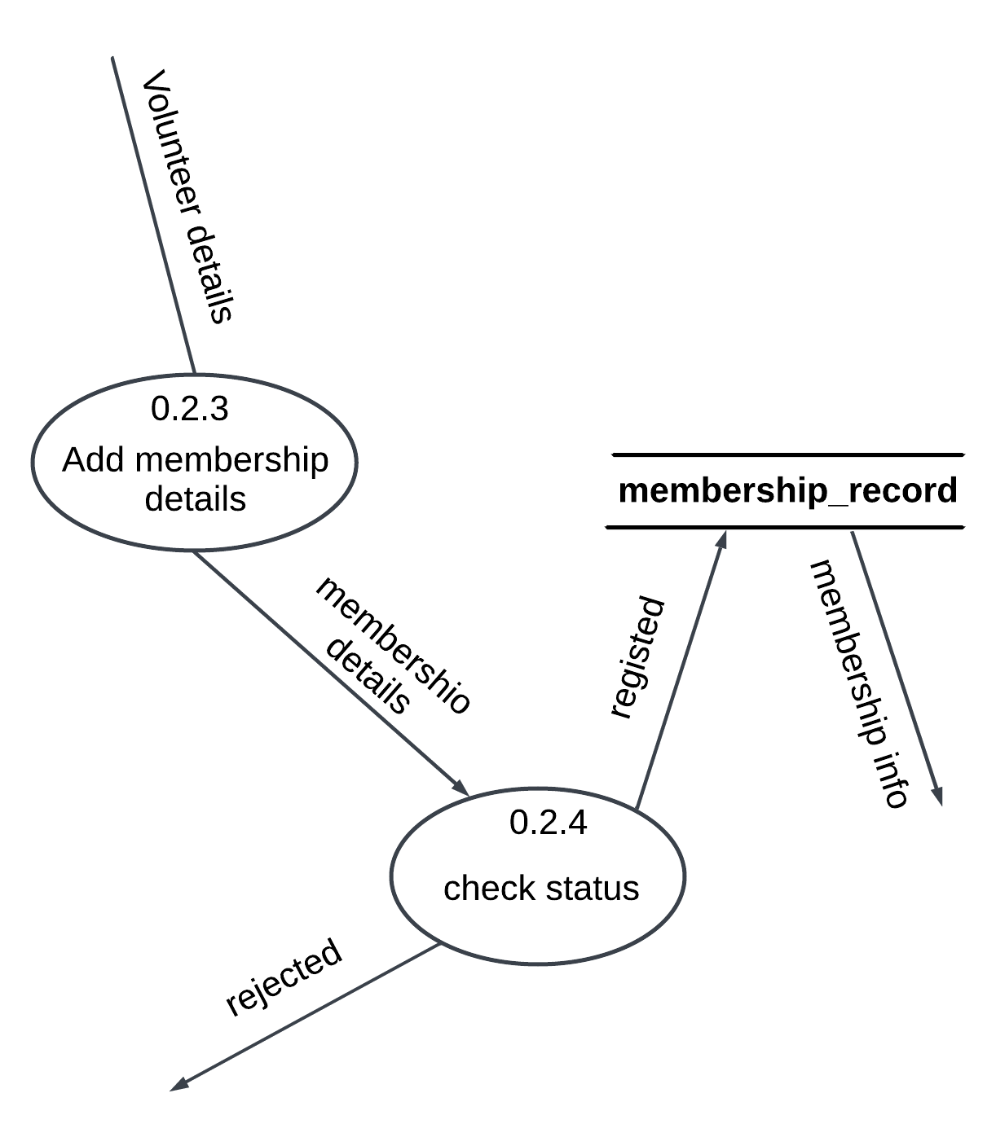

Figure 68: Take membership details DFD Level-2

#### 3.11.2. Food Donate

The donor can donate or post food details for donation. The system checks whether the provided data is valid or not. If the posted information status details are not valid, the system shows an error message; otherwise, if the details are valid, the data is recorded in the database, and a success message is displayed for the donor. Additionally, another user can receive push notifications.

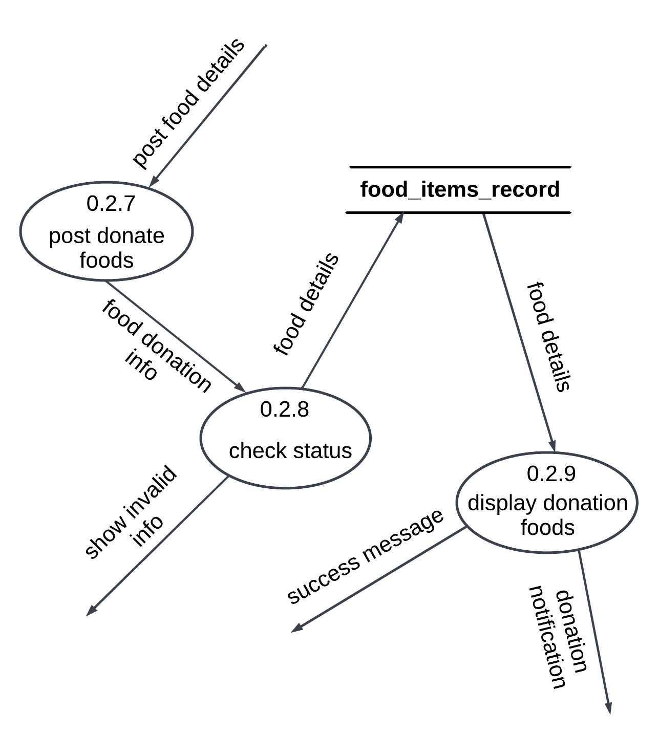

Figure 69: Food donation DFD Level-2

#### 3.11.3. View Donation History

The user can request to view post or donation information details for their history. The request is verified by the system, and the data is then displayed to the user. The user can view more details about their history.

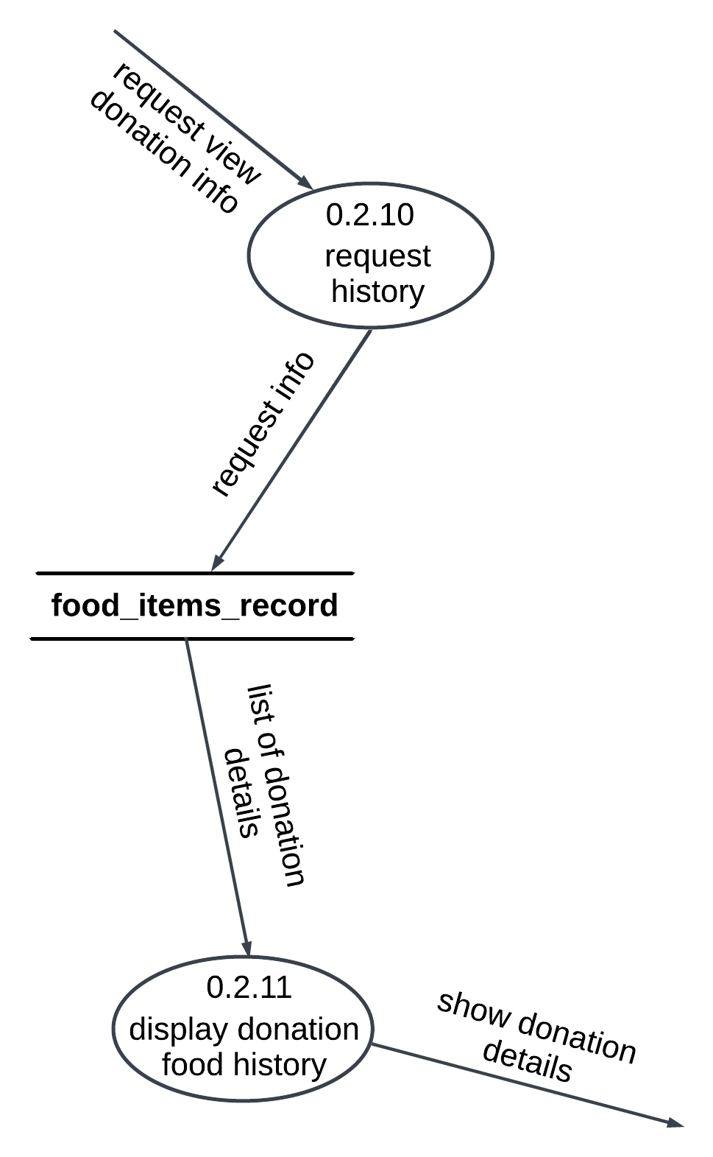

Figure 70: View Donation History DFD Level-2

**3.11.4. Donation Rating**

The volunteer can donate food received from donors and distribute the food to poor and homeless people. Then after completing the donation, the volunteer can provide the donation success information for a donor with a donation rating. The volunteer provides the rating details required for the system and it is verified and then recorded in the database displays the rating details with history details for the view more additional information.

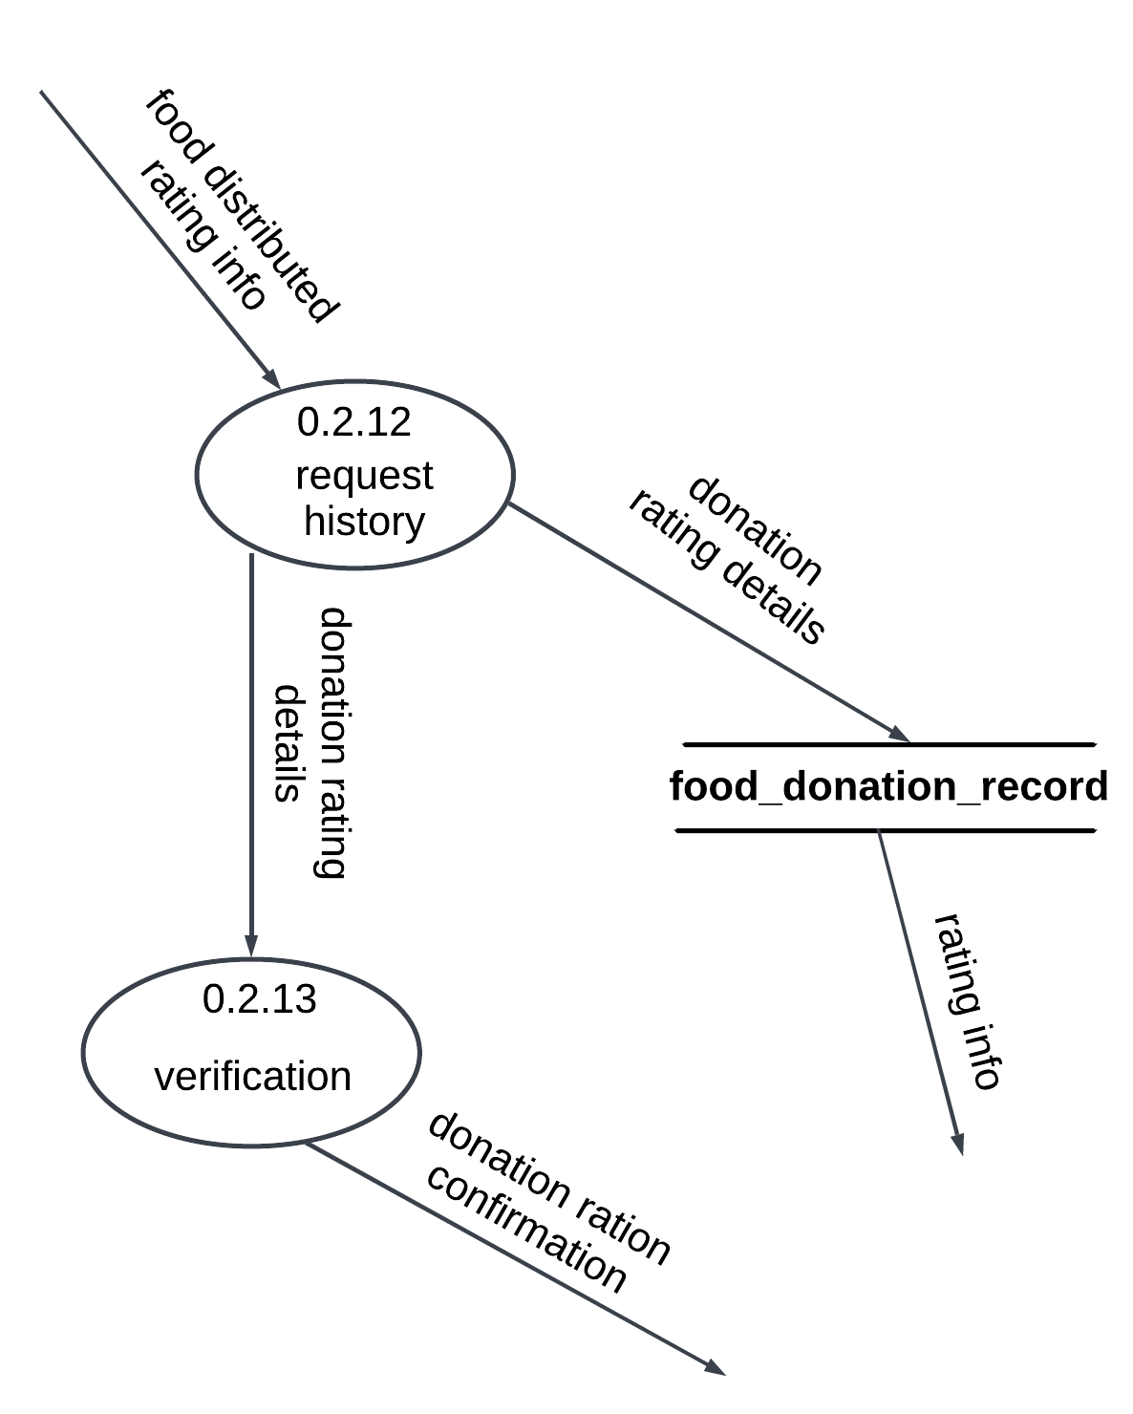

Figure 71: Donation rating DFD Level-2

#### 3.11.5. Complain with the Admin

The user can add the report details to the system the send the admin the information if valis the records in the database other how the error message report details are valid the system can send the admin dashboard and the admin can verify.

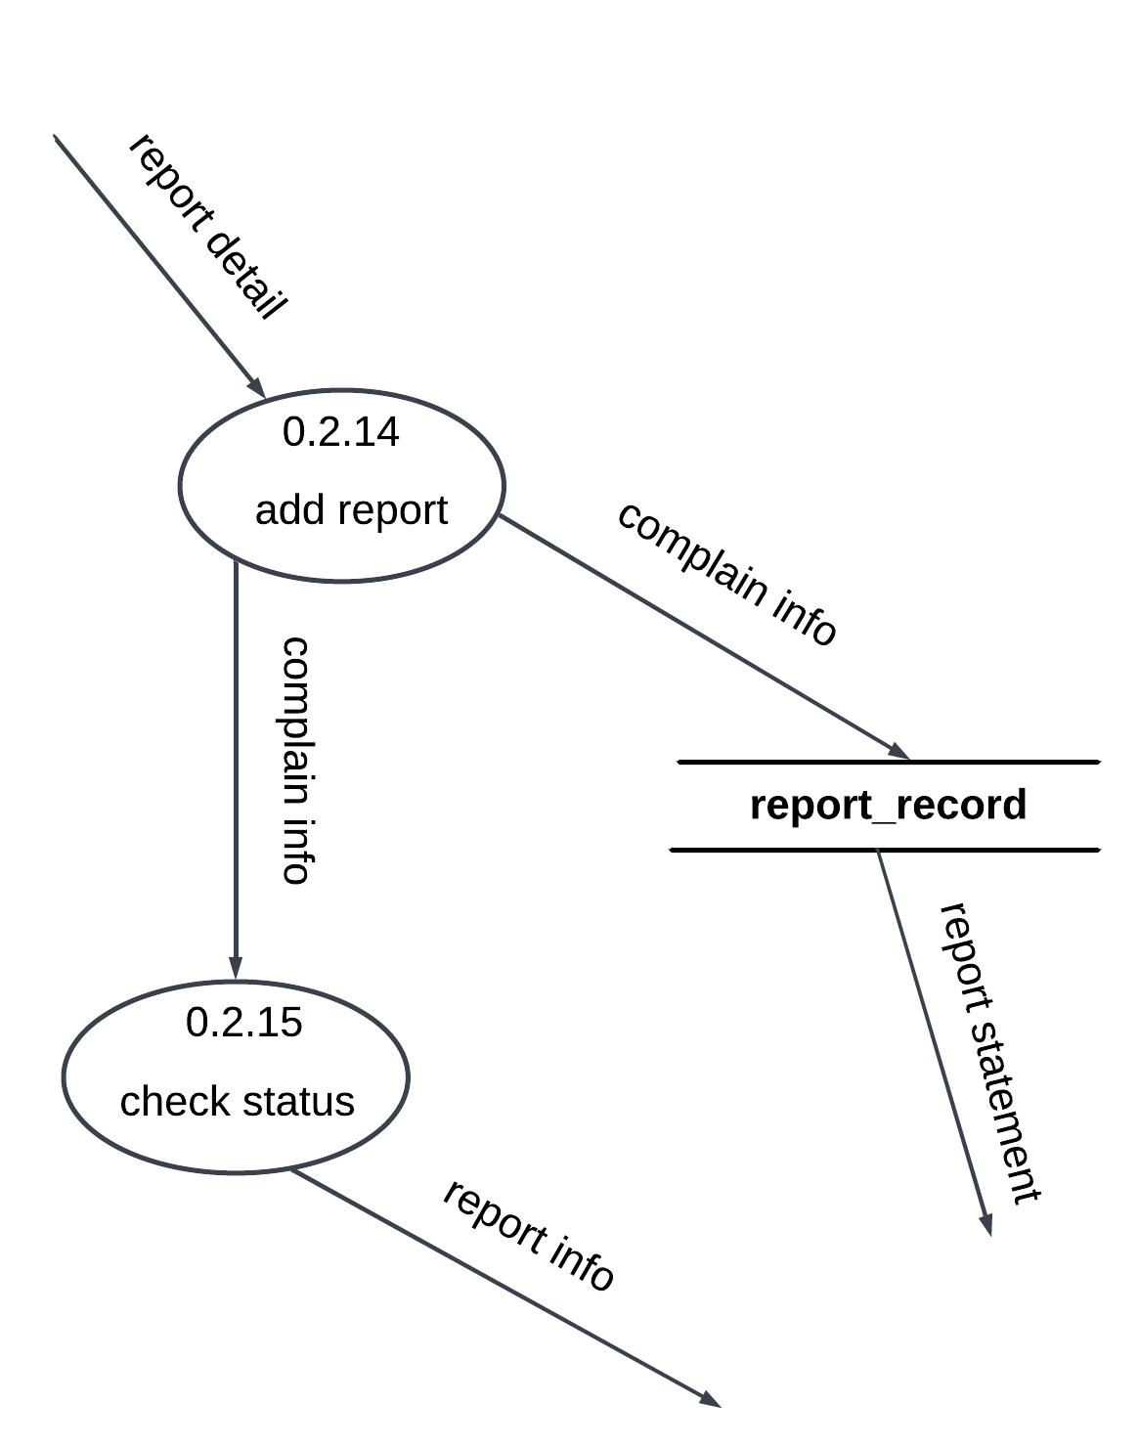

Figure 72: Complaint with admin DFD Level-2

**(DFD Level-2 for appendix)**

## 3.5. Implementation

The implementation phase of the system development involves translating the finalized design into a functional system.

### 3.5.1. System Development (Important screenshots of development core features and architecture)

#### 3.5.1.1 Database model implementation

This is the just database model implemented where more core features implemented helpful. This phase is crucial as it lays the foundation for storing and managing data efficiently. The user model contains details about users, such as their personal information, login credentials, and any other relevant data. The food model stores information about food items, including their type, quantity, expiration date, and any additional attributes. The history model tracks the history of actions or events within the system, providing a log of user interactions, food donations, or other relevant activities. The notification model manages device tokens, enabling the system to send notifications to users' devices for important updates or events. This phase focuses on structuring the database schema to accommodate the core features of the application, ensuring seamless data management and retrieval throughout the system.

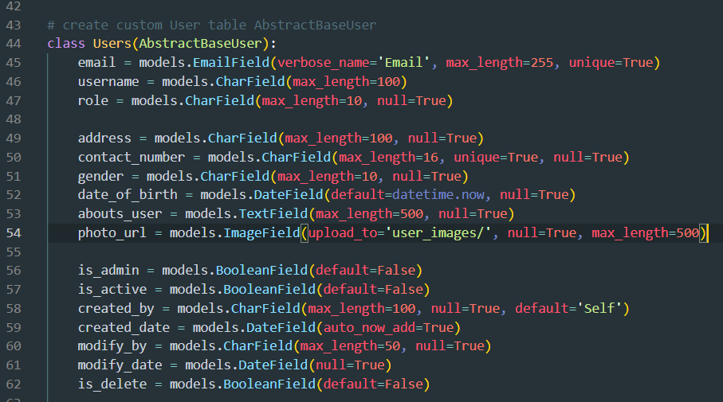

Figure 73: Implementation of the database user model

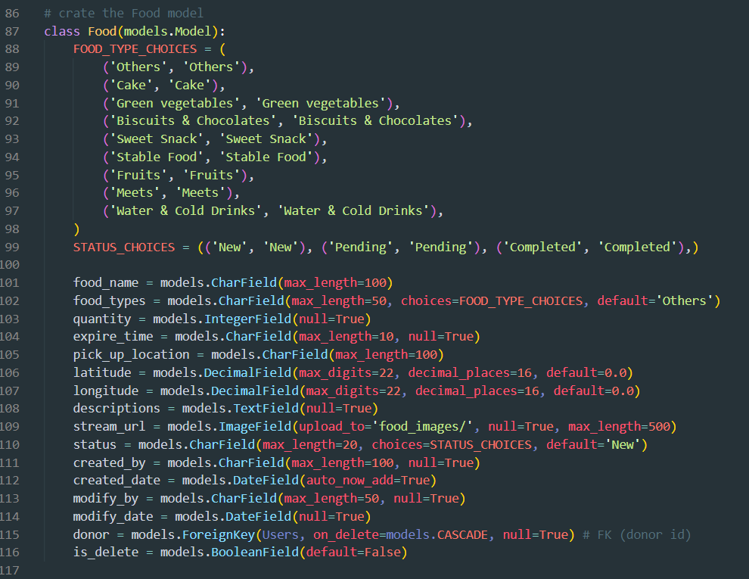

Figure 74: Implementation of database food model.

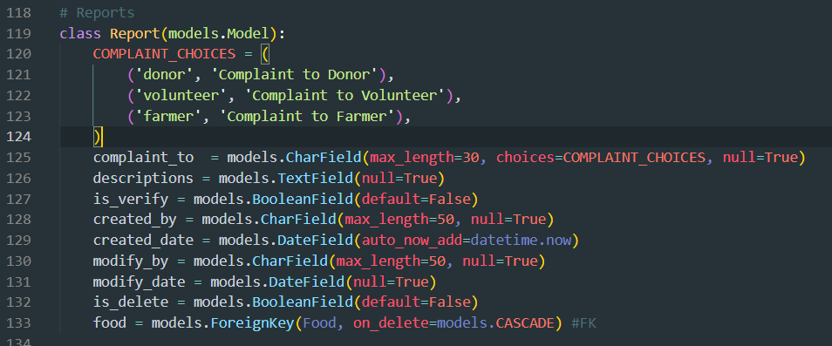

Figure 75: Implementation of database report model.

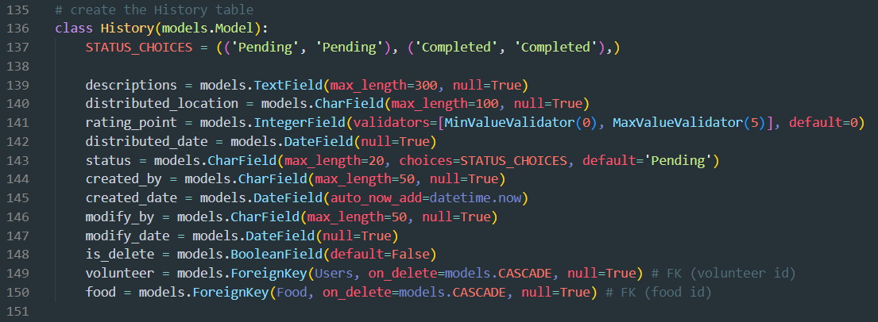

Figure 76: Implementation of database history model.

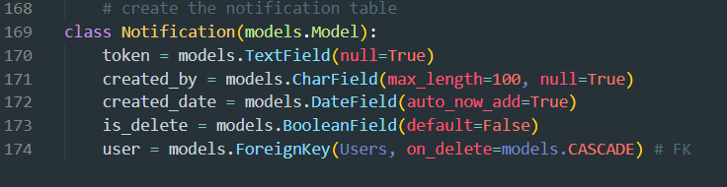

Figure 77: Implementation of database notification device token.

#### 3.5.1.1 Implementation of Push Notification

The system integrates Firebase push notifications for both the front end (mobile) and back end (Django). The system utilizes Firebase Cloud Messaging (FCM) to enable push notifications between the mobile application and the Django backend. Firebase provides a robust and scalable platform for sending messages to devices in real time. On the front (mobile) side, the application leverages the Firebase Messaging library to send and receive push notifications. This allows the application to deliver timely updates and alerts to users' devices, keeping them informed about important events or changes. On the backend (Django) side, the system integrates Firebase Admin SDK to send push notifications to mobile devices. This allows the backend server to trigger notifications based on certain events or conditions, such as new updates or notifications from users. Overall, the implementation of Firebase push notifications enhances the system's communication capabilities, enabling seamless and efficient delivery of notifications to users across both frontend and backend components.

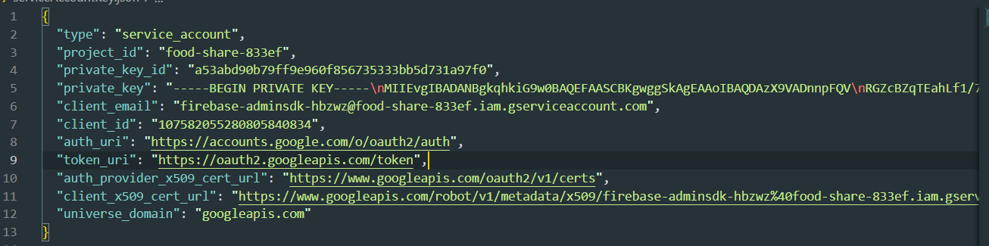

Figure 78: Implementation of Firebase service account key- backend.

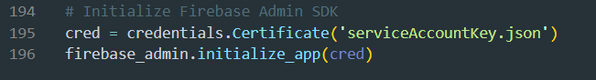

Figure 79: Implementation of service account key in Firebase admin.

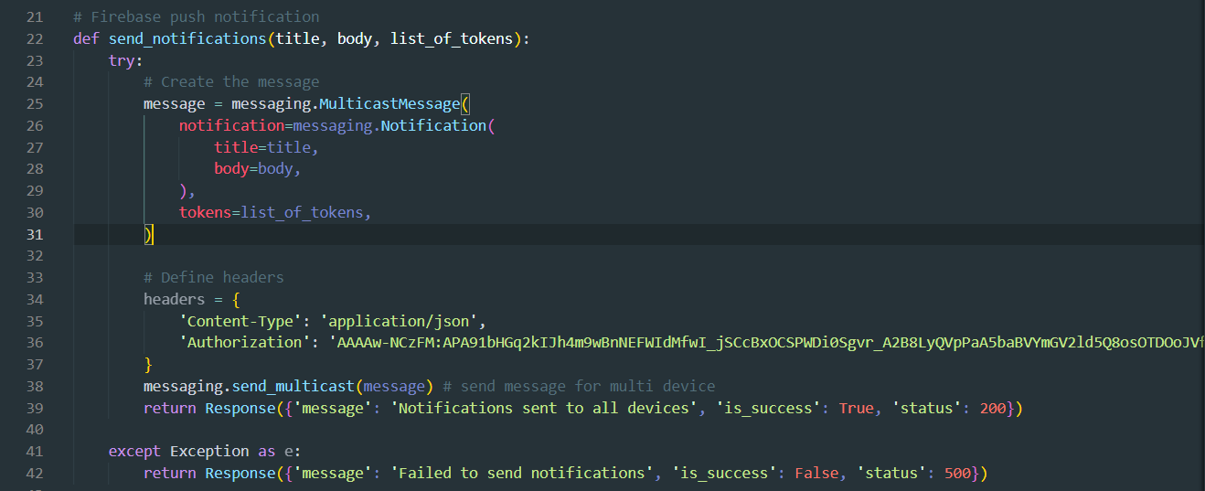

Figure 80: Implementation of notification send function.

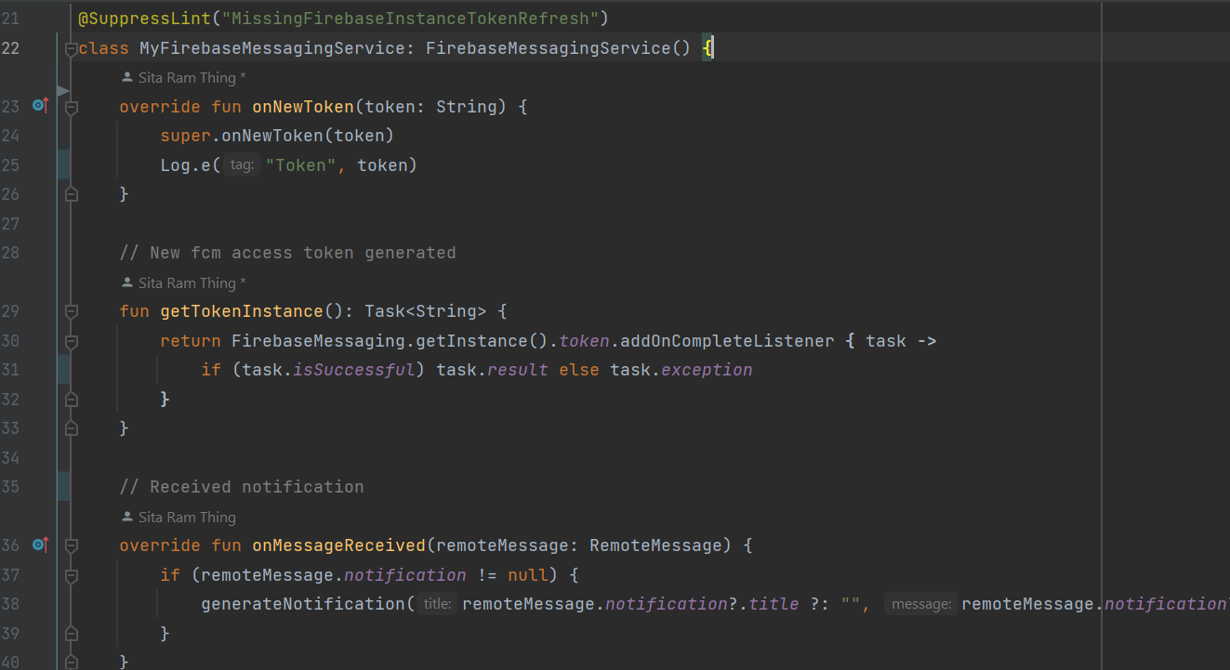

Figure 81: implementation for receiving the notification message

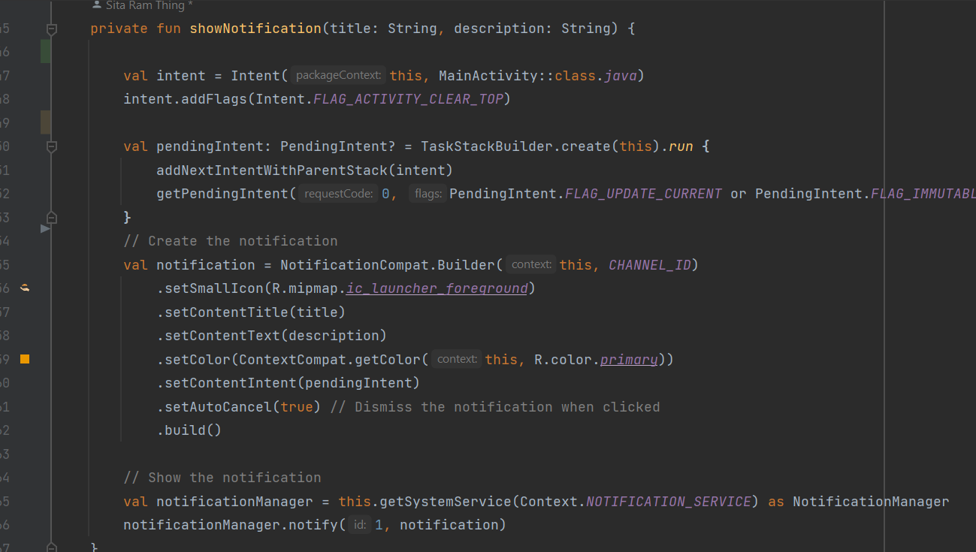

Figure 82: Implementation for generating notifications.

#### 3.5.1.2 Implementation of Donate/Post-Food

In the "Food Share" application, users, referred to as donors, are provided with the functionality to donate food items. This feature allows individuals or organizations who are interested in contributing to food donation initiatives to participate actively. Donors who have surplus food available can utilize this feature to post details about the food they intend to donate. This information may include the type of food, quantity, expiration date (if applicable), and any other relevant details. By utilizing this functionality, donors can easily contribute to the food donation process, thereby helping to reduce food waste and support those in need within the community.

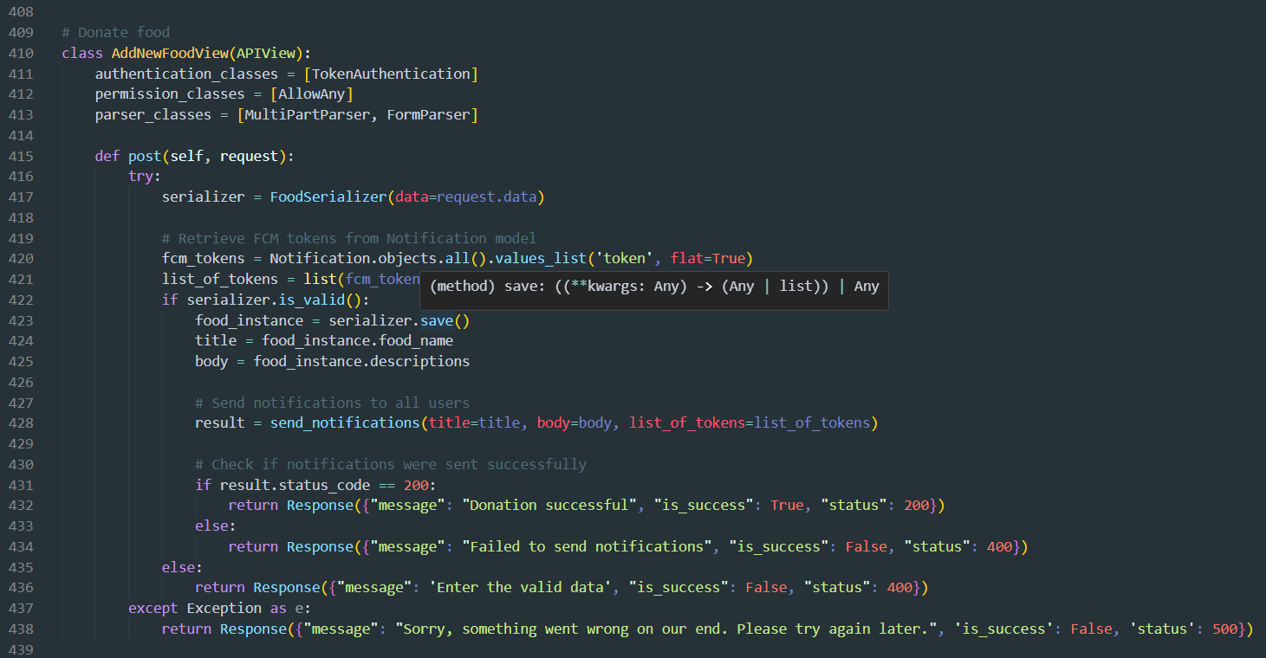

Figure 83: Implement Food donations (post) - backend.

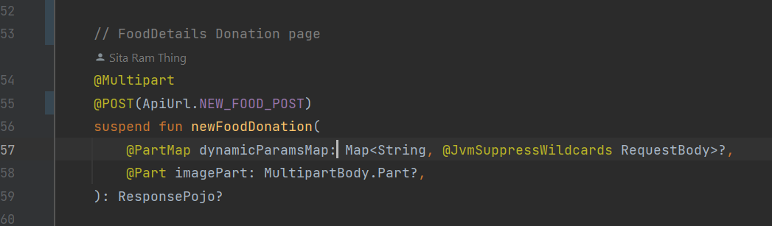

Figure 84: Food donation API call

#### 3.5.1.3 Implementation of View History

Users, whether donors or volunteers, can view the history of donations made or actions taken within the system. This includes details such as the type and quantity of donated food, the date and time of donation, and any additional relevant information. Donors can access volunteer profile details, allowing them to view information about the volunteers who have participated in the donation process. Similarly, volunteers can view donor profile details, providing transparency and fostering a sense of community within the platform. This feature enhances user experience by providing access to comprehensive donation history details and facilitating interaction between donors and volunteers within the system.

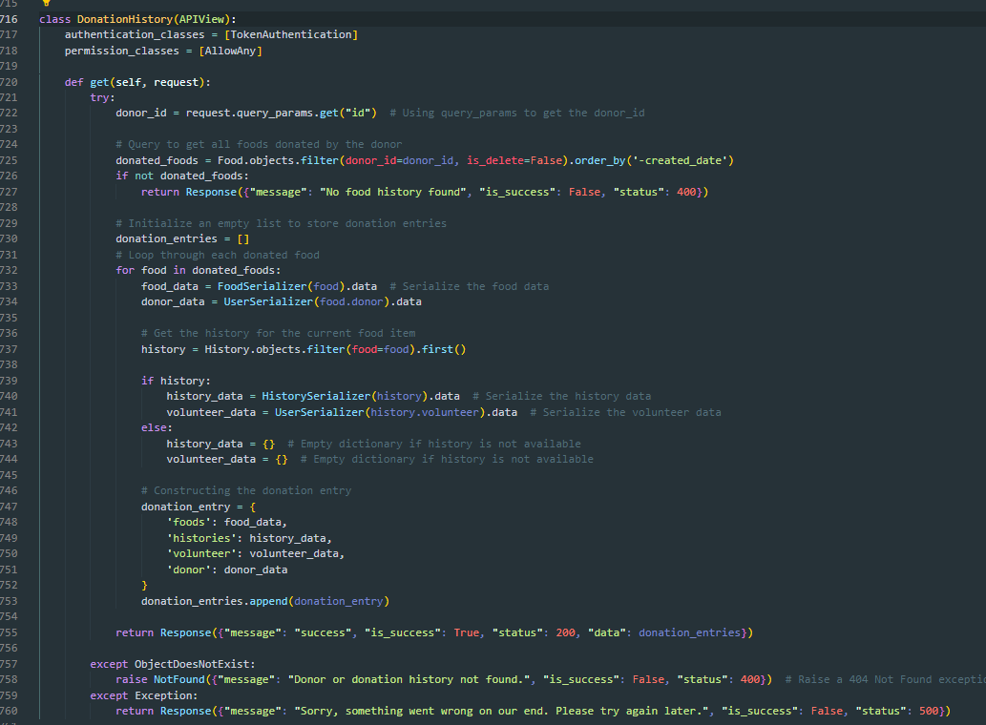

Figure 85: Implementations of view donor history

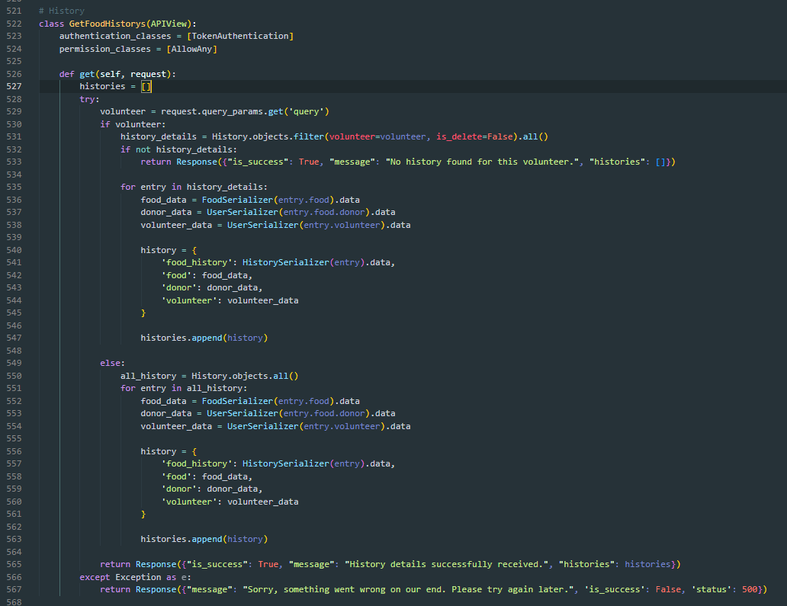

Figure 86: Implementation of view volunteer history.

#### 3.5.1.4 Implementation of Rating

The system incorporates a functionality where volunteers can provide feedback and rating points for donors who have donated food. Volunteers can give ratings and provide feedback regarding the donation experience to donors. This feedback may include factors such as the quality of the donated food, the donor's communication and cooperation, and overall satisfaction with the donation process. The system allows volunteers to collect and manage this feedback, ensuring that donors receive constructive input on their contributions. Additionally, volunteers can assign rating points to donors based on their evaluation of the donation experience. This feature promotes accountability and transparency within the donation ecosystem, allowing volunteers to recognize and appreciate donors for their contributions while also providing valuable feedback to enhance the donation process.

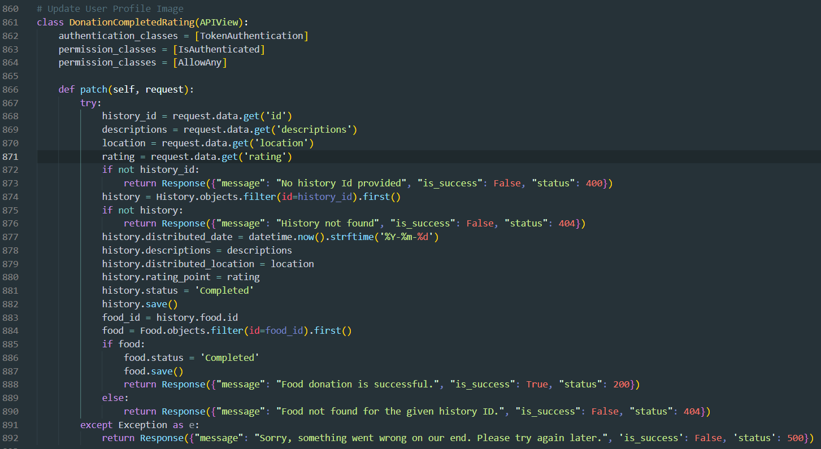

Figure 87: Implementation of Donation rating - backend.

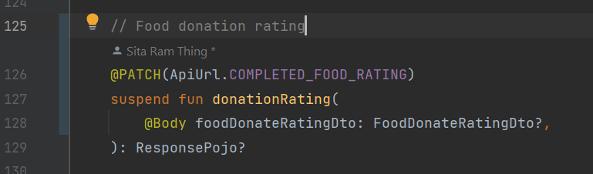

Figure 88: Implementation of donation rating frontend.

#### 3.5.1.6 Implementation of Complaint/Report

The system incorporates a feature that allows donors and volunteers to report issues or complaints to the admin. Both donors and volunteers have the option to report issues or file complaints to the system administrator. These reports may pertain to various scenarios, such as instances where a donor is unable to provide the promised food donation or when a volunteer fails to pick up the donated food. By providing this functionality, the system ensures that any discrepancies or problems encountered during the donation process can be promptly addressed and resolved. The admin can review the reported issues and take appropriate actions, such as facilitating communication between the parties involved or addressing any underlying issues within the system. The complaint/report feature enhances transparency and accountability within the donation platform, fostering trust and reliability among donors, volunteers, and administrators alike.

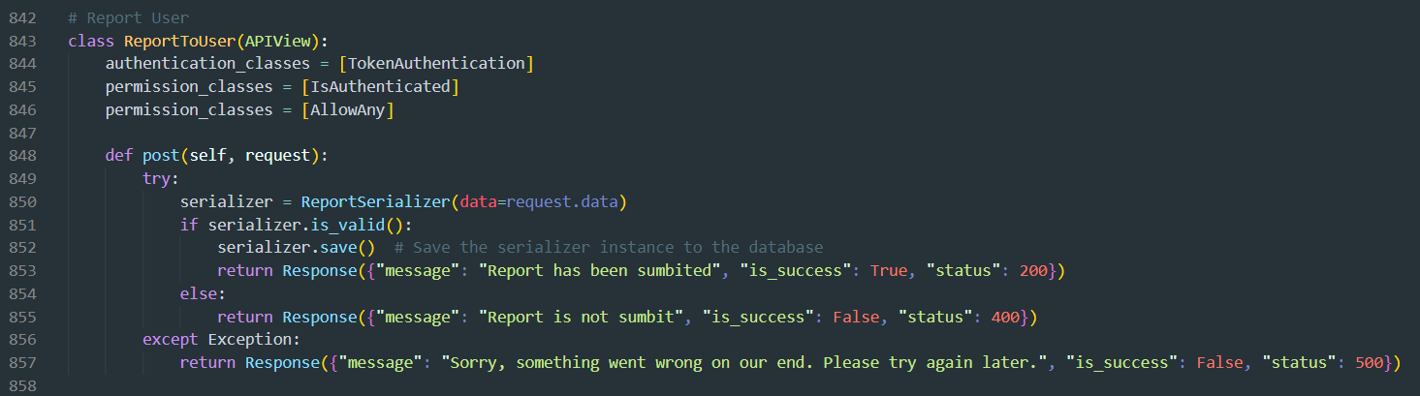

Figure 89: Implementation of report - backend.

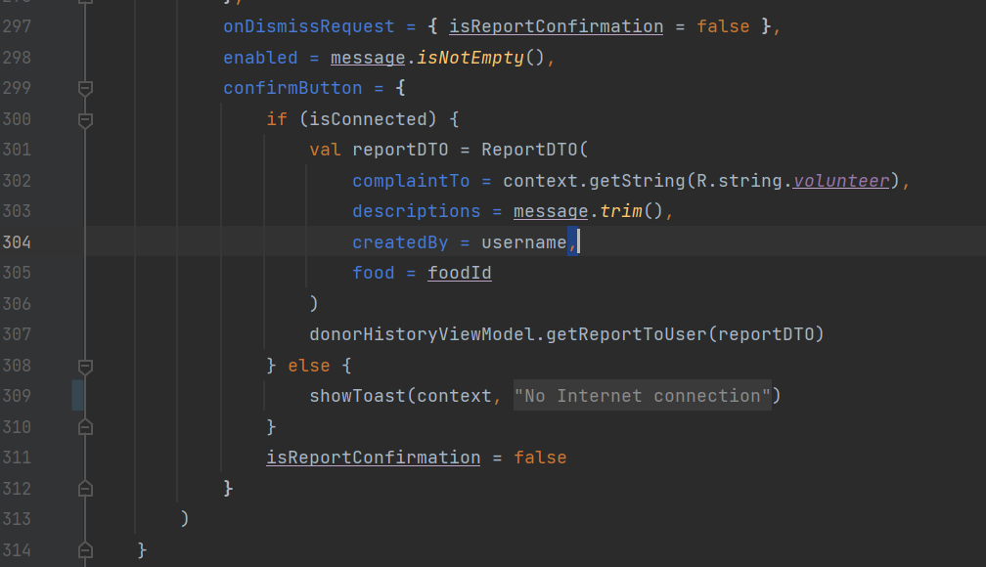

Figure 90: Implementation of report-frontend.

#### 3.5.1.7 Implementation of Map

The system incorporates a feature that utilizes maps to display donation locations. The system integrates mapping functionality to enable users to visualize the locations where food donations are made. Users, such as donors or volunteers, can access a map view within the application or platform to see the geographic distribution of donation points. By leveraging mapping technology, users can easily identify nearby donation locations and plan their donation or pickup activities accordingly. The map may display markers or pins indicating specific donation sites, allowing users to navigate and locate them with ease. Overall, the map implementation enhances the user experience by providing a visual representation of donation locations, facilitating efficient navigation, and promoting active participation in the donation process.



Figure 91: Implementation of map key

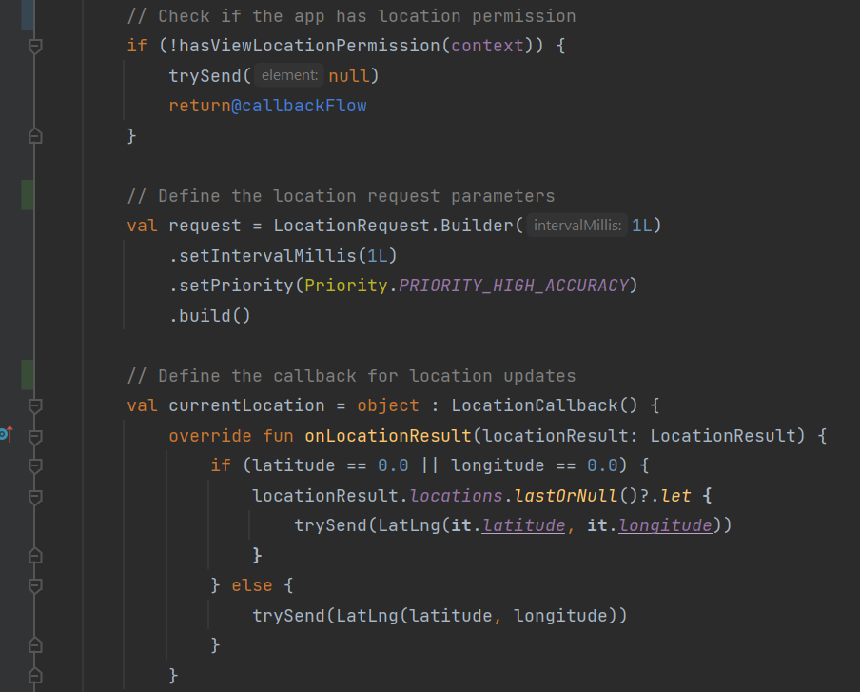

Figure 92: Implementation of map access to the current location late value

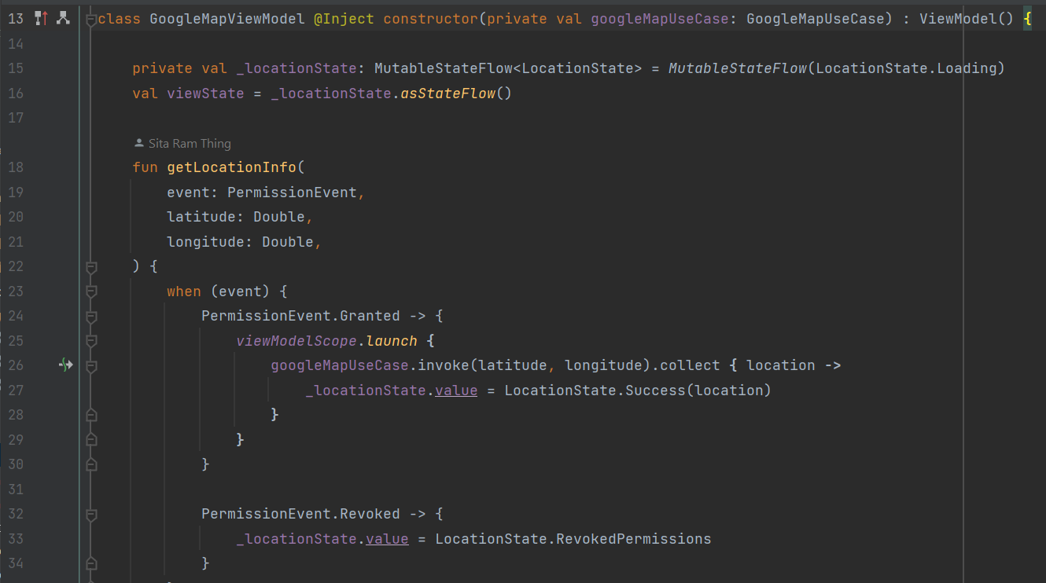

Figure 93: Implementation of map state man tent.

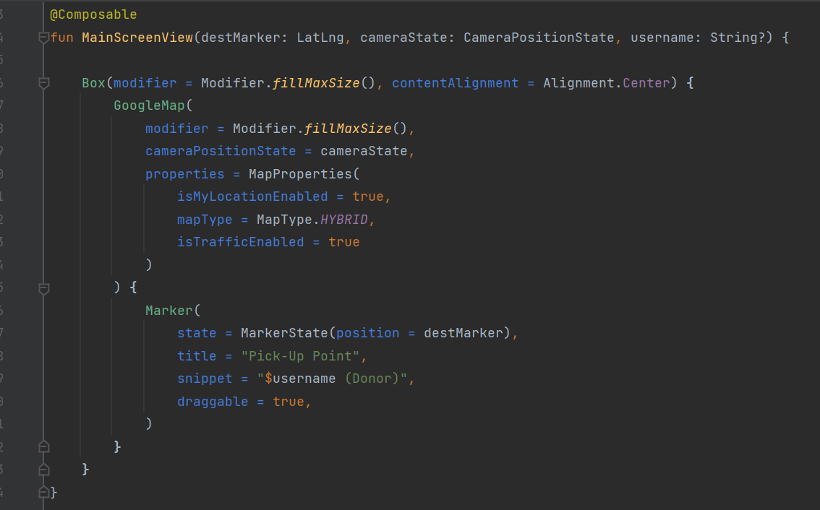

Figure 94: Implementation of Google Maps.

**Appendix C: Implementations of more features**

### 3.5.2. System Architecture

A system's development reflects its intended usage as well as its interactions with external systems and other systems. It explains how every part of the system is connected to every other part of the system through a data link. A system's architecture is the reflection of how its structure, functions, and interactions are considered. The Food share system allows users to interact with both mobile and desktop devices, where these devices can connect from the front end to the back end through an API built with the Django REST Framework. The Django server can connect to the MySQL database. Through the REST API, data can be stored in the database and fetched from it.

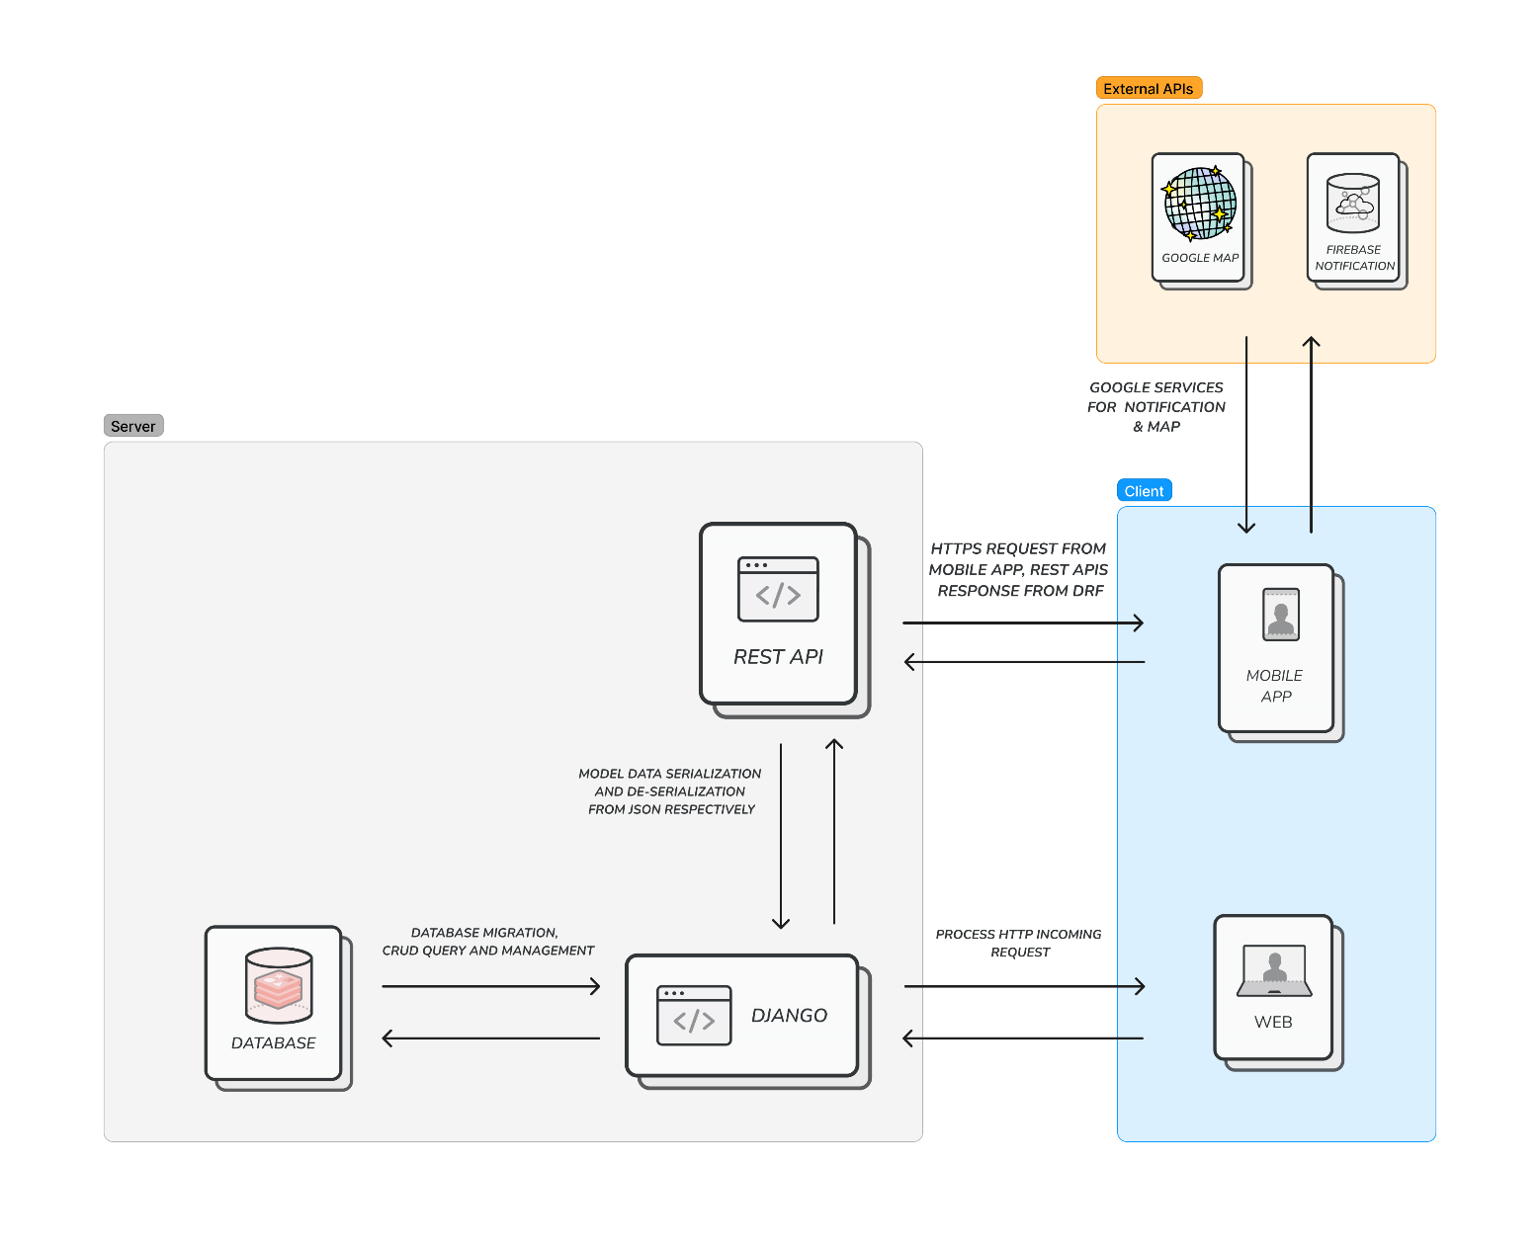

Figure 95: System Architecture

The system can be developed following the Clean Architecture with Dependency Injection implementation. This approach emphasizes modular design and separation of concerns, enabling easier maintenance and scalability. Let's delve into the details of how each layer contributes to the system's components:

#### 3.5.3.1 Presentation Layer:

The Presentation Layer is responsible for handling the user interface (UI) components, including both web and mobile interfaces. In this layer, the frontend UI and view models are developed, with a focus on maintaining the application's state. In a web application, HTML, CSS, and JavaScript would be utilized to develop the user interface, while in a mobile app Kotlin with Jetpack compose is implemented. Integration with external services such as Google Maps and Firebase push notifications is implemented within this layer to enhance user experience and functionality.

#### 3.5.2.2 Domain Layer:

The Domain Layer contains the business logic of the application. Here, different business rules and functionalities are defined to ensure the core operations of the system. Interfaces such as repositories, use cases, and data transfer objects (DTOs) are created within this layer to abstract the interactions between the Presentation and Data layers. These interfaces serve as contracts that define how data is exchanged between layers. The domain layer may include use cases for managing donations, handling user authentication, and coordinating logistics.

#### 3.5.2.3 Data Layer:

The Data Layer is responsible for API implementation to manage data storage, retrieval, and persistence. Here, the implementation of database connections is carried out. Two types of database connections are typically implemented: local and remote. The local database often utilizes technologies like Room for Android services as a cache for frequently accessed data. On the other hand, the remote database, such as MySQL stores the primary dataset and is accessed over the network. The Data Layer communicates with the databases and abstracts away the specific details of database management from the rest of the application. By adhering to the Clean Architecture principles, the system components are effectively organized into layers, each with its distinct responsibilities. This modular approach enables easier maintenance, testing, and future expansion of the system. Additionally, the implementation of Dependency Injection facilitates loose coupling between components, allowing for greater flexibility and ease of integration.

# CHAPTER 4: TESTING AND ANALYSIS

## 4.1. Test Plan

Before initiating any tests, a detailed test plan was meticulously developed to streamline the testing process, adhere to testing protocols, and allocate responsibilities for both system and unit testing. This plan served as a schematic, facilitating the testing process and ensuring the orderly distribution of materials following various testing rules. Below, we outline the test plans for the two main tests conducted on the application.

### 4.1.1. Unit Testing

Unit testing is testing individual software modules or components separately to ensure they operate as intended. A single function, method, or class is usually represented by each unit, which is the smallest tested component of the program. The purpose of unit tests is to confirm how these units behave under different input scenarios and edge situations. Developers can find and address defects early in the development cycle, resulting in more dependable and maintainable code, by isolating each unit and testing it separately. Throughout the development process, unit tests are often automated and run, which enables developers to identify regressions fast and make sure that modifications to the codebase don't generate new defects. Compound errors occur less frequently the earlier an issue is discovered. (Levan, 2024)

An essential part of our testing procedure is unit testing. After finishing each unit or feature, it's crucial to thoroughly test every component. My primary focus will be planning the project's unit testing phase and ensuring that each system component is put through a thorough testing process. The system has some components or features that are unit testing.

**Appendix D: Unit test plans**

### 4.1.2. System Testing

For interconnected systems, system testing is essential because any software or system flaw could put users through serious problems. System testing is the process of examining the overall system's performance and quality. It is also known as system-level testing or system integration testing (Reichert, 2024).

I completed the development of my wasted food donation system with all features implemented to meet the client's requirements. To ensure the system's functionality and user satisfaction, I will devise a plan for end-users to collect feedback, report issues, and receive responses. The system will undergo comprehensive testing to ensure all features work seamlessly. In case any issues arise during testing, a resolution plan will be created and implemented promptly. System testing will involve end-users and the client to gather feedback and ensure the system meets their expectations. This collaborative approach will ensure that the wasted food donation system is not only functional but also user-friendly and meets the client's needs effectively. The major test for UI and UX with system performance, google Maps, notification permission and internet status check, and stat management testing with the user.

## 4.2. Test Execution

The test plan is completed and now going to test. After applying unit tests and system testing, the actual results were found, and any errors were resolved. The identified issues are currently being researched to improve the test implementation. the testing is given below:

### 4.2.1. Unit Testing

#### 4.2.1.1 Register Unit Test

|  |  |
| --- | --- |
| **Test Case** | **Descriptions** |
| **Objectives** | To register under the test case function |
| **Actions** | Insert sample data (email, username, role, and password) to test the API and run the test function.  Input the :  email: test@example.com,  username: tester,  role: normal,  password: test |
| **Expected Result** | The user is registered successfully without any error. The response status code is 200, the message is registered successfully, the 'is_success' attribute is True, and the 'status' attribute is 200 |
| **Actual Result** | The register unit test is a success after failure resolved the issues to ensure the test case was successful. |
| **Test** | The test was successful. |

Table 18: Register Unit Test

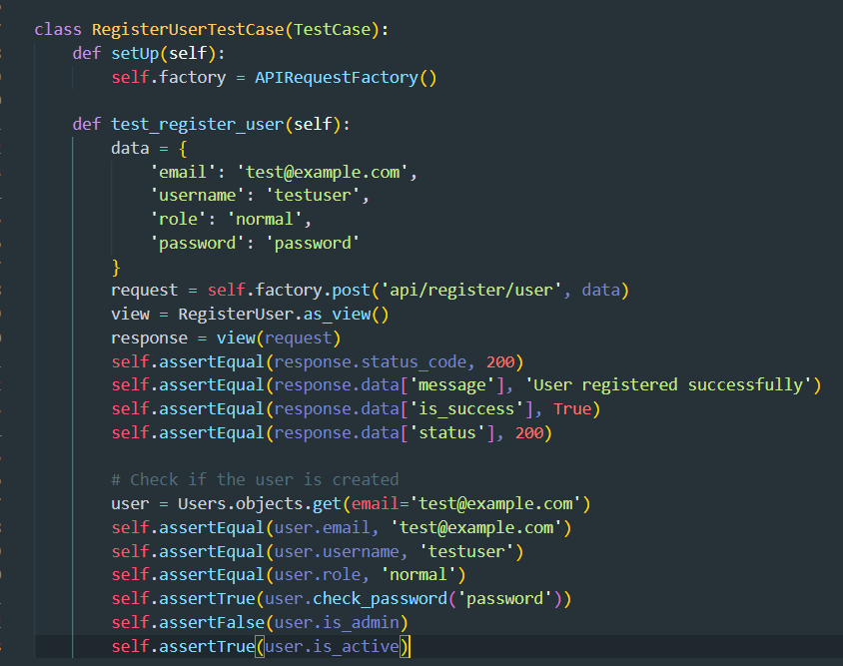

Figure 96: Register User unit test function

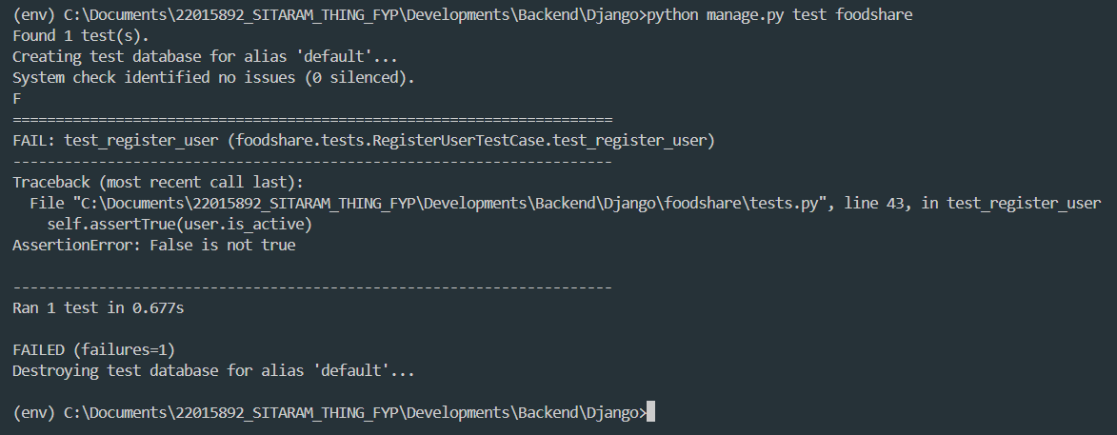

Figure 97: Register User unit test failed

Register success unit test

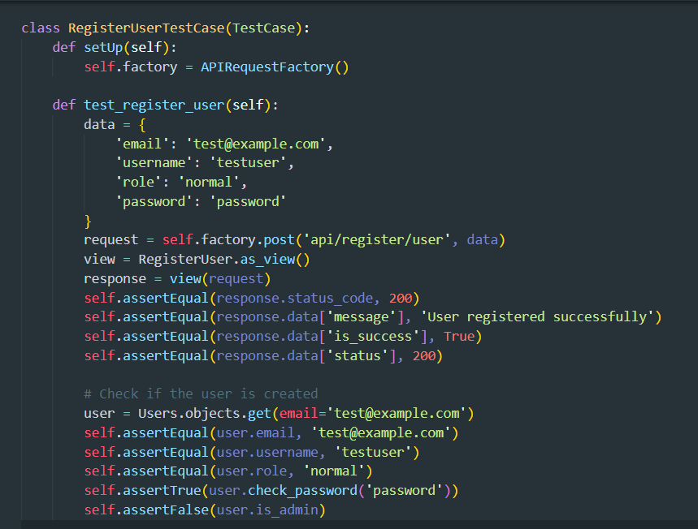

Figure 98: Register success unit test function

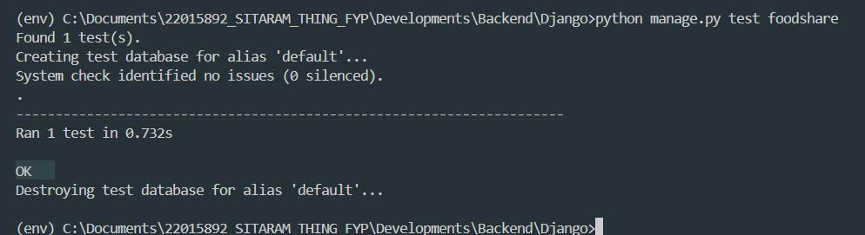

Figure 99: Register success unit test response

#### 4.2.1.2 Login Authentication Unit test

|  |  |
| --- | --- |
| **Test Case** | **Descriptions** |
| **Objectives** | To develop the login authenticate the test case function |
| **Actions** | Insert sample data (email, username, role, and password) to test the API and run the test function.  Input the :  email: test@example.com,  password: team password |
| **Expected Result** | The user is logged in successfully without any error. The response status code is 200, the message is 'Log in successful', the 'is_success' attribute is True, and the 'status' attribute is 200 |
| **Actual Result** | The login unit test was a success after failure resolved the issues to ensure the test case was successful. |
| **Test** | The test was successful. |

Table 19: Login Authentication Unit test

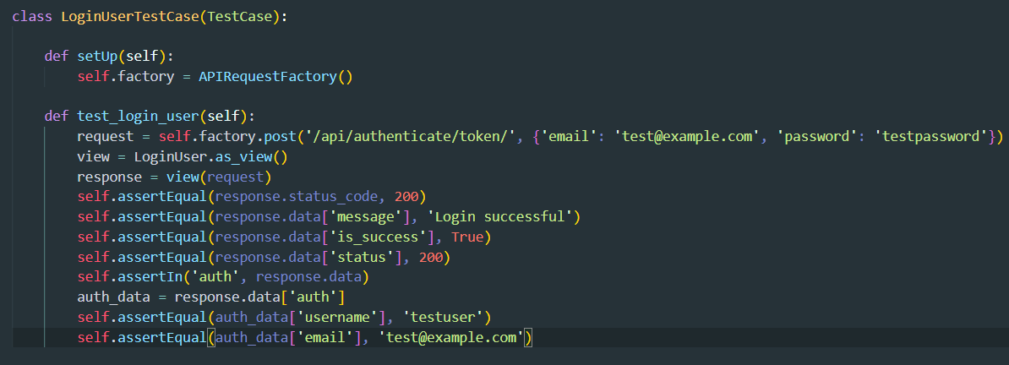

Figure 100: Login User unit test function

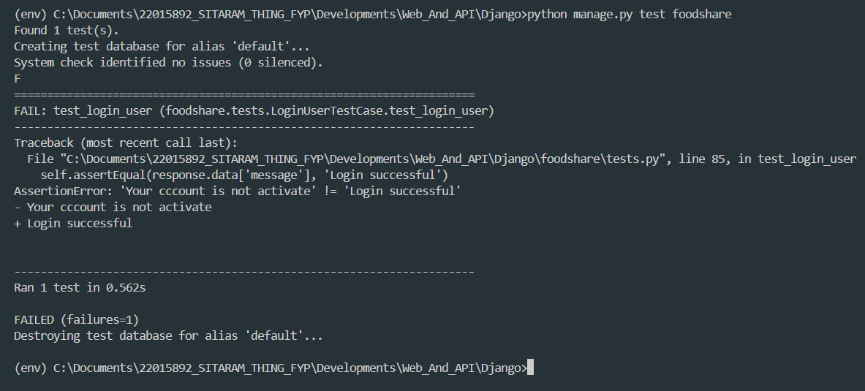

Figure 101: Register User unit test failer response

Login success unit testing

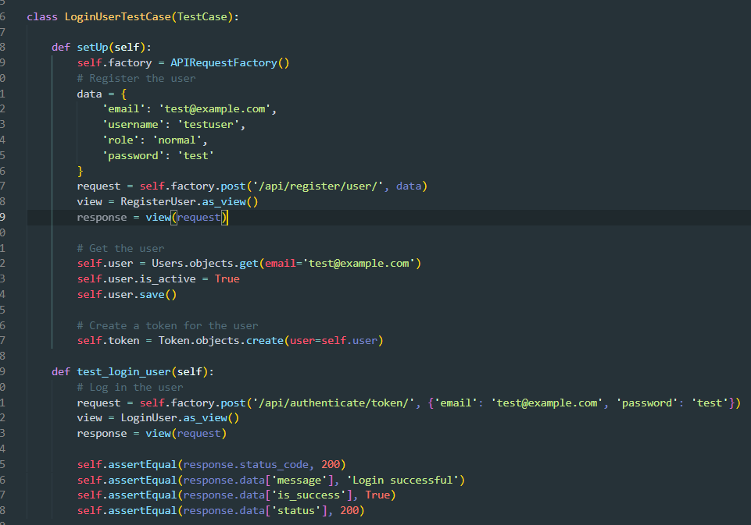

Figure 102: Register success unit test function

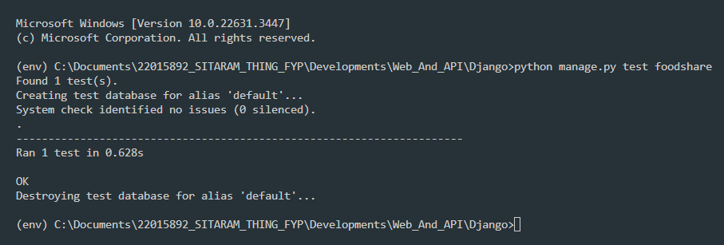

Figure 103: Login success unit test response

#### 4.2.1.3 Device token save unit

|  |  |
| --- | --- |
| **Test Case** | **Descriptions** |
| **Objectives** | To develop the device token save the test case function |
| **Actions** | Insert sample data (user_id, email and created_by) to test the API and run the test function.  Input the :  user_id: userId,  token: new_deveice_token  created_by: test_user |
| **Expected Result** | The user device token is saved successfully without any error. The response status code is 200, the message is New device token saved', the 'is_success' attribute is True, and the 'status' attribute is 200 |
| **Actual Result** | The device token save unit test is a success after failure resolved the issues to ensure the test case was successful. |
| **Test** | The test was successful. |

Table 20: Device token save unit

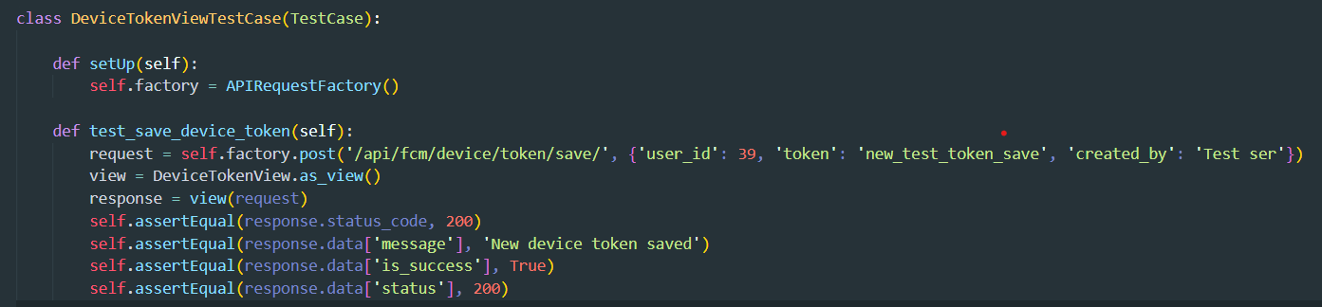

Figure 104: Device token save unit test function

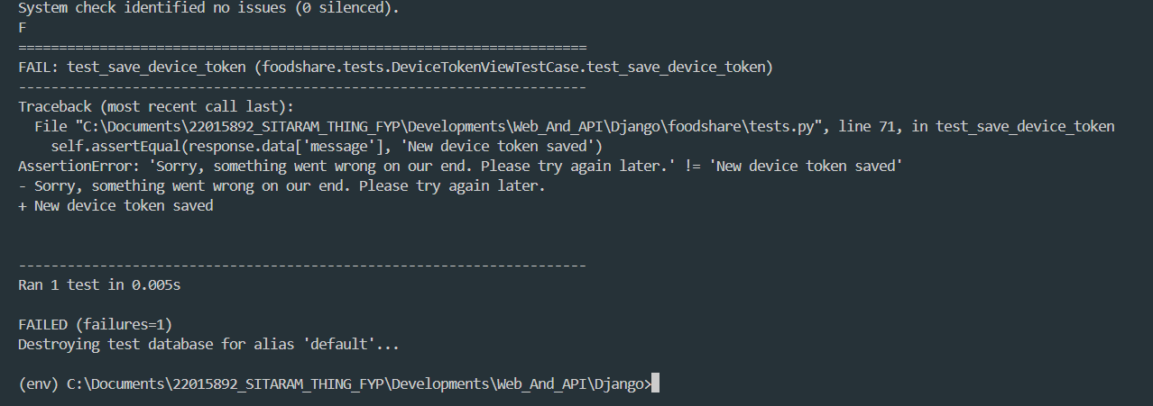

Figure 105: Device token save unit test failer response

Save device token unit test

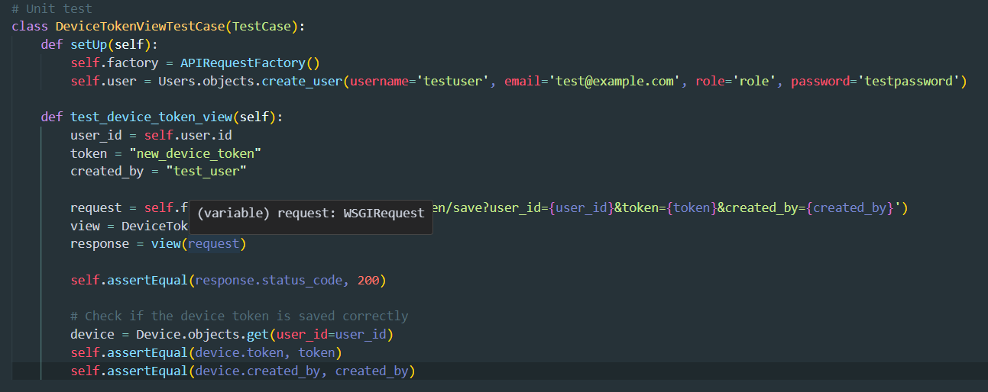

Figure 106: Save device token success unit test function

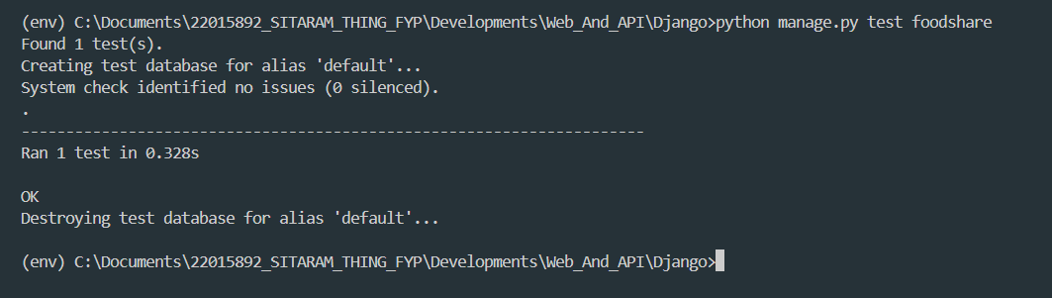

Figure 107: Save device token success unit test response

#### 4.2.1.4 View history unit test

|  |  |
| --- | --- |
| **Test Case** | **Descriptions** |
| **Objectives** | To develop the history details of the test case function |
| **Actions** | To call the food history details API function. |
| **Expected Result** | The food history details were successful without any errors. The response status code is 200, the message is 'Success', and the 'is_success' attribute is True. |
| **Actual Result** | The history unit test was a success after failure and resolved the issues to ensure the test case was successful. |
| **Test** | The test was successful. |

Table 21: View history unit test

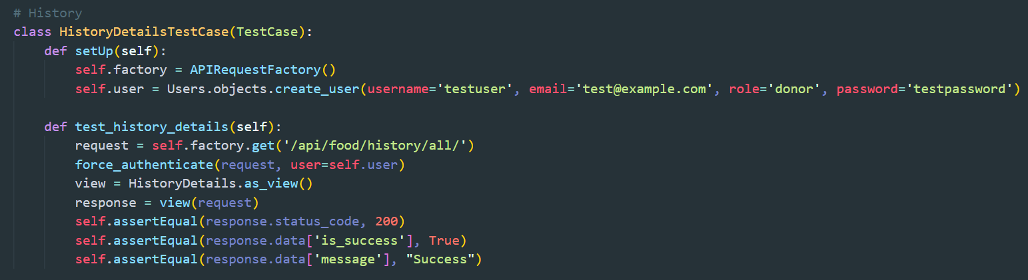

Figure 13: History details get unit test function

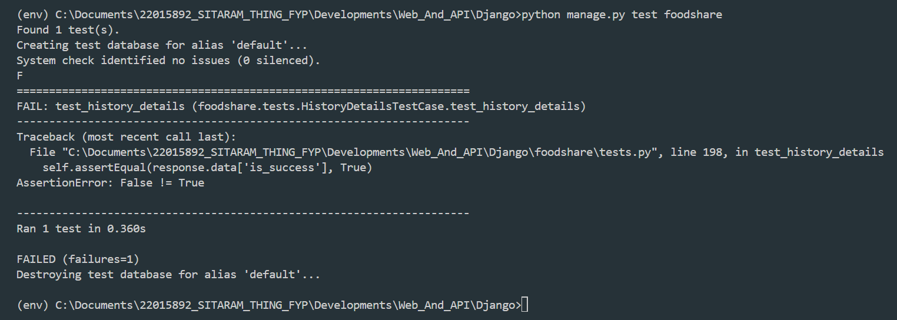

Figure 108: History details get unit test failer response

View success history details

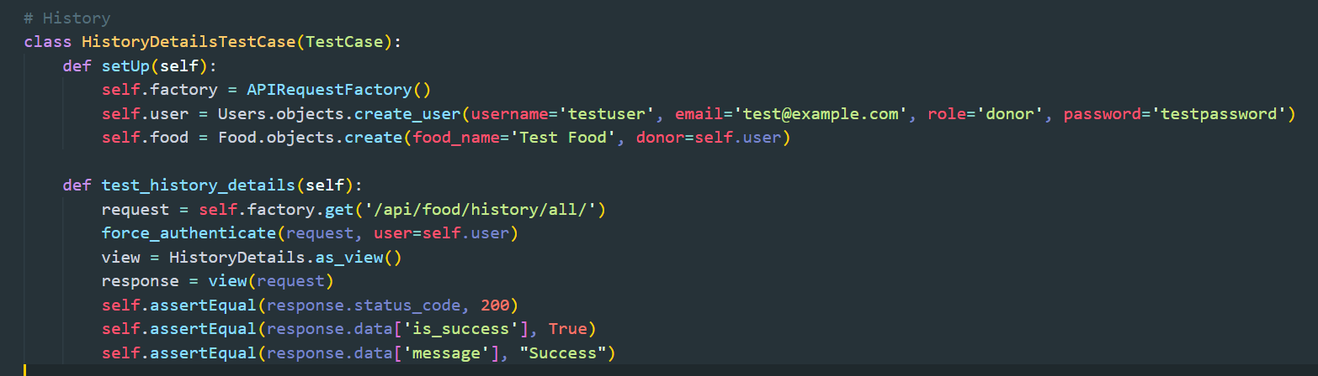

Figure 14: View history success unit test case

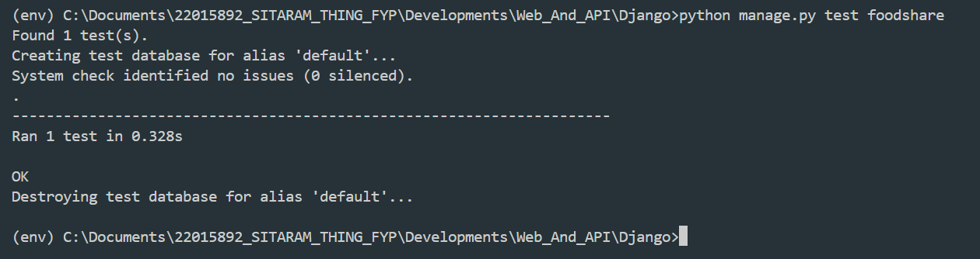

Figure 15: View history success unit test response

#### 4.2.1.5 Report to admin history unit test

|  |  |
| --- | --- |
| **Test Case** | **Descriptions** |
| **Objectives** | To develop the history details of the test case function |
| **Actions** | To call the food history details API function.  Food: food_id  Complaint_to: [complaint_update@example.com](mailto:complaint_update@example.com)  Descriptions: Update descriptions  Created_by: user_id |
| **Expected Result** | The complaint to admin details was successful without any errors. The response status code is 200, and the 'is_success' attribute is True. |
| **Actual Result** | The report to the admin unit test was a success after failure and resolved the issues to ensure the test case was successful. |
| **Test** | The test was successful. |

Table 22: Report to admin history unit test

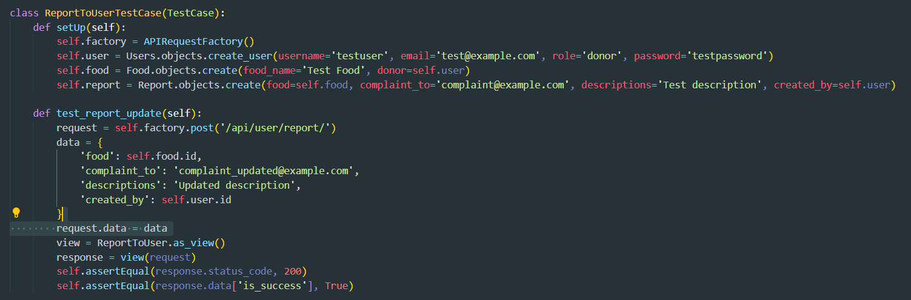

Figure 109: Report to admin unit test function

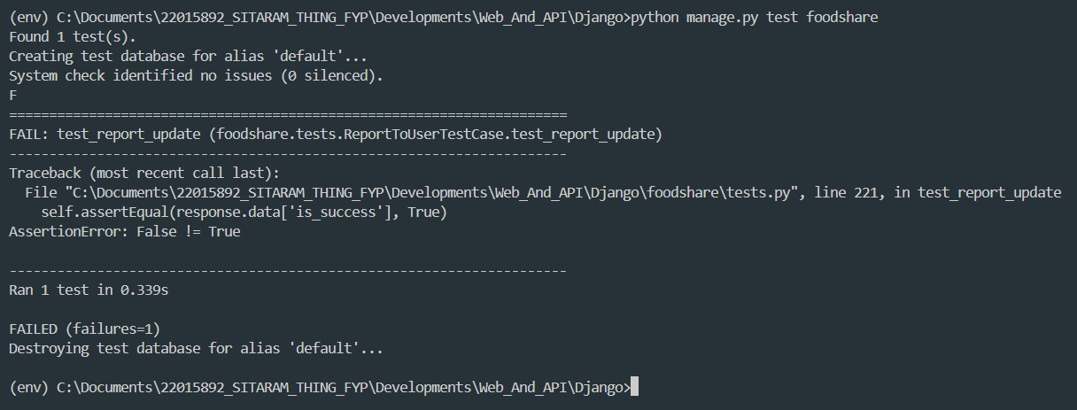

Figure 110: report to admin unit test response

Report to administrator

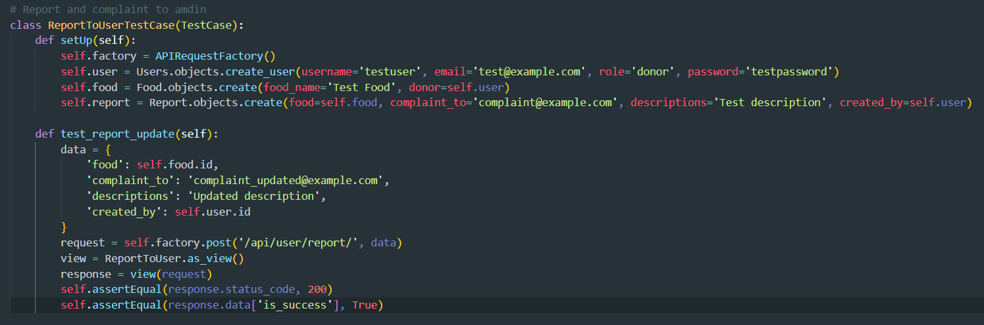

Figure 111: Report to admin unit test success response

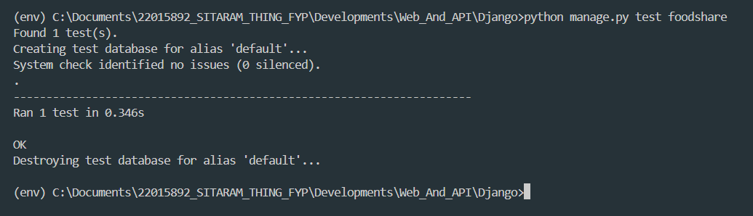

Figure 112: Report to admin unit test success function

#### 4.2.1.6 Donation Rating

|  |  |
| --- | --- |
| **Test Case** | **Descriptions** |
| **Objectives** | To develop the donation rating of the test case function |
| **Actions** | To call the food donate completed then give the donation rating for API function.  Food: food_id  Complaint_to: [complaint_update@example.com](mailto:complaint_update@example.com)  Descriptions: Update descriptions  Created_by: user_id |
| **Expected Result** | The complaint to admin details was successful without any errors. The response status code is 200, and the 'is_success' attribute is True. |
| **Actual Result** | The report to the admin unit test was a success after failure and resolved the issues to ensure the test case was successful. |
| **Test** | The test was successful. |

Table 23: Donation Rating

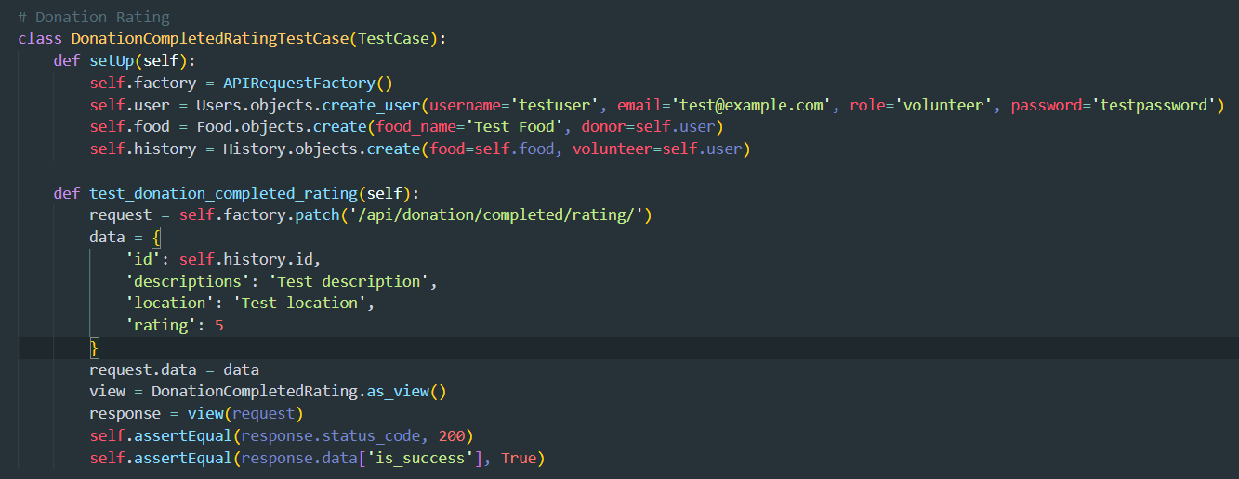

Figure 113: Donation Rating unit testing function

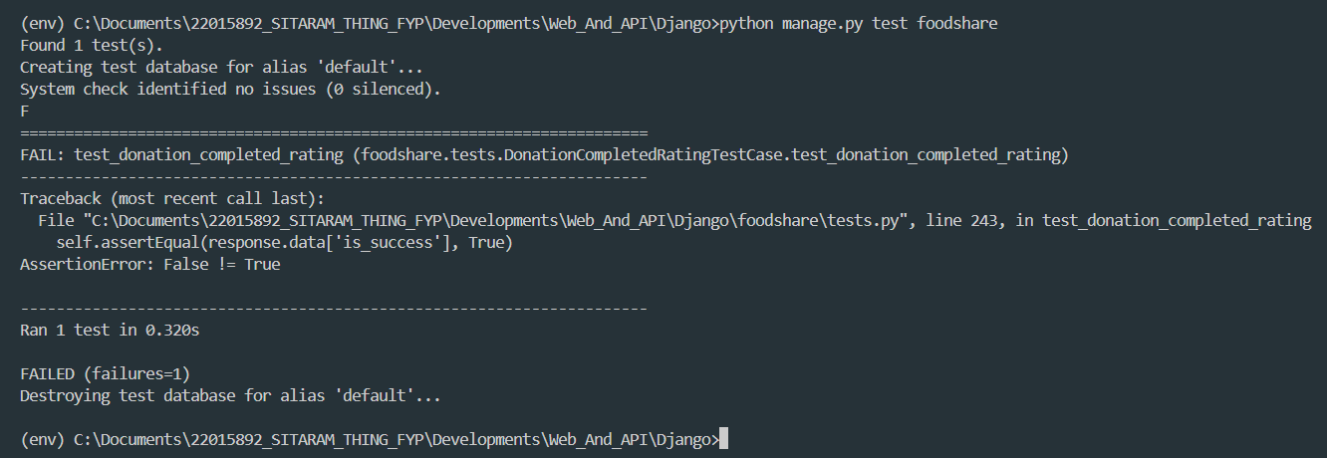

Figure 114: Donation Rating unit testing failer response

Donation Rating success

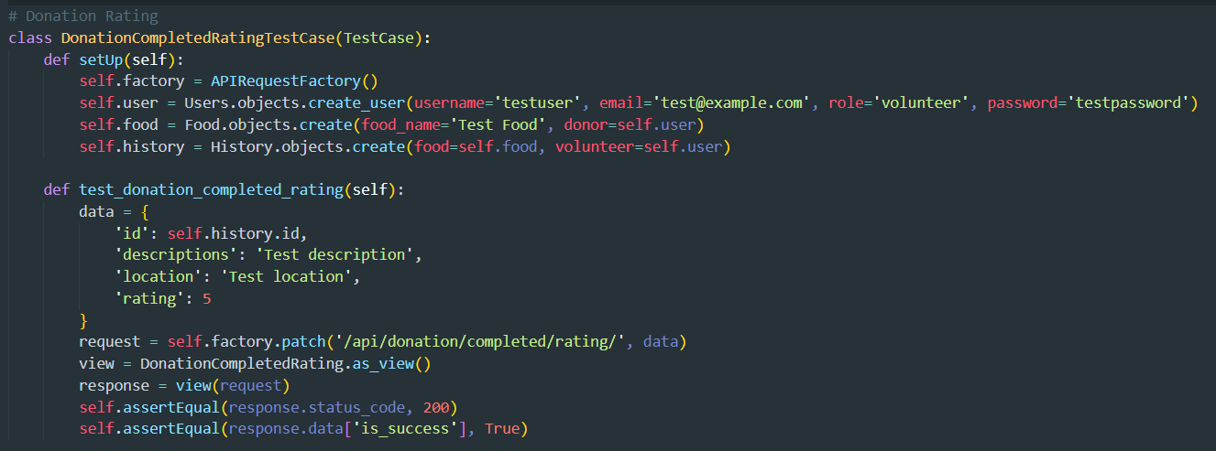

Figure 115: Donation rating unit test function

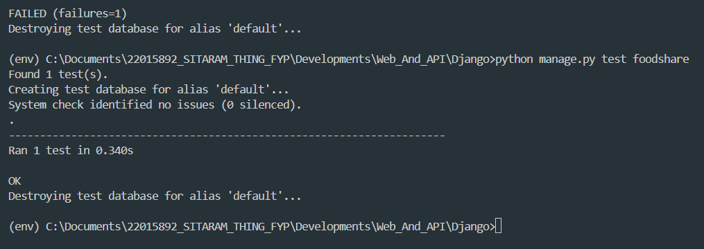

Figure 116: Donation rating unit test failer response

#### 4.2.1.7 The number of system ration

|  |  |
| --- | --- |
| **Test Case** | **Descriptions** |
| **Objectives** | To develop the user email verified of the test case function |
| **Actions** | To call the number of system data then give the forgotten or ration of data for the API function. |
| **Expected Result** | The data ratio that the password update was successful without any errors. The response status code is 200, and the 'is_success' attribute is True, the status is 20, several food is 1, the number of users is 1, the several history is 1, and several reports is also 1. |
| **Actual Result** | The data ratio of the unit test was a success after failure and resolved the issues to ensure the test case was successful. |
| **Test** | The test was successful. |

Table 24: The number of system ration

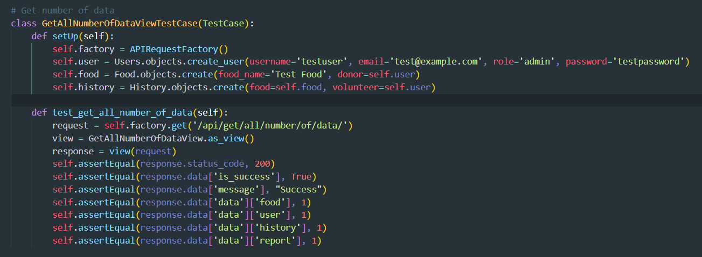

Figure 117: Number of system ration unit test function

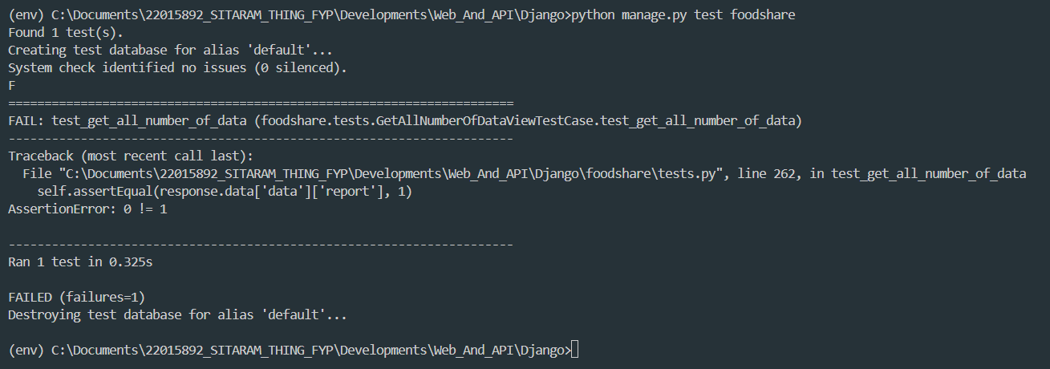

Figure 118: Number of system ration unit test failer response

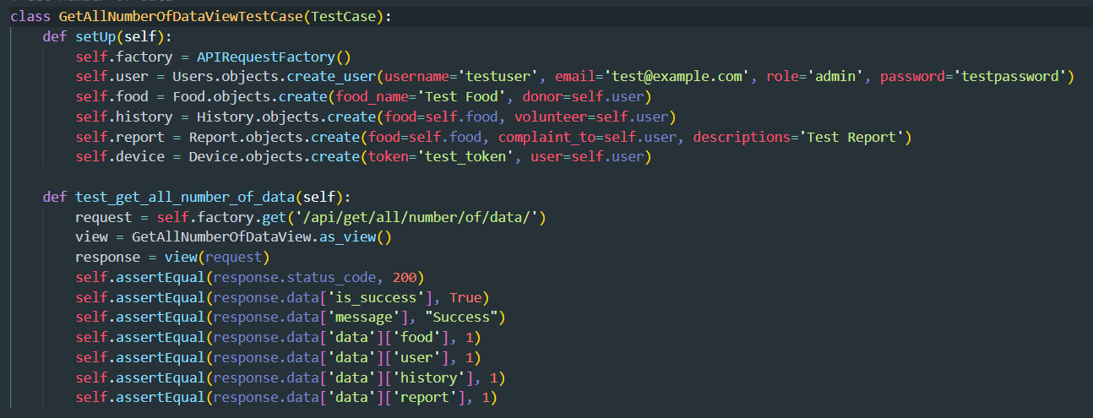

Figure 119: Number of r action unit test success functions

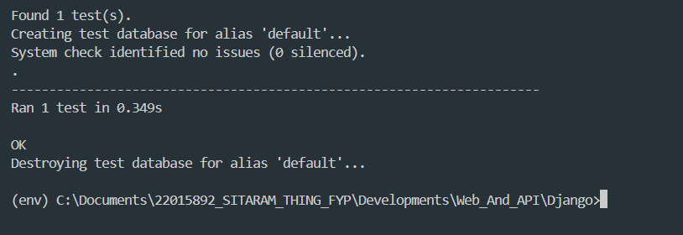

Figure 120: Number of ratio unit test success response

#### 4.2.1.8 Email verify unit test

|  |  |
| --- | --- |
| **Test Case** | **Descriptions** |
| **Objectives** | To develop the user email verified of the test case function |
| **Actions** | To call the email verify then give the forgotten or updated password for the API function.  email: test@gmail.com |
| **Expected Result** | The email verified that the password update was successful without any errors. The response status code is 200, and the 'is_success' attribute is True. |
| **Actual Result** | The email verified the unit test was a success after failure and resolved the issues to ensure the test case was successful. |
| **Test** | The test was successful. |

Table 25: Email verify unit test

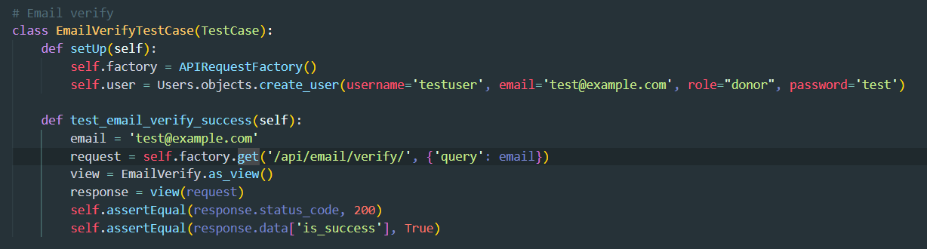

Figure 121: Email Evrify unit test function

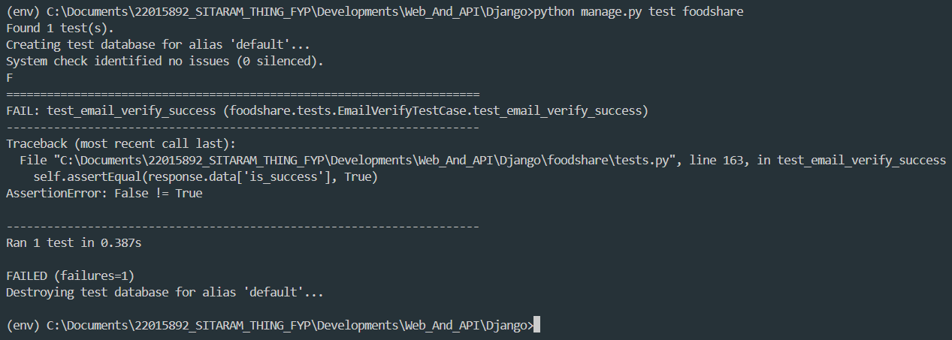

Figure 122: Email Evrify unit test failer response

Email Verify success

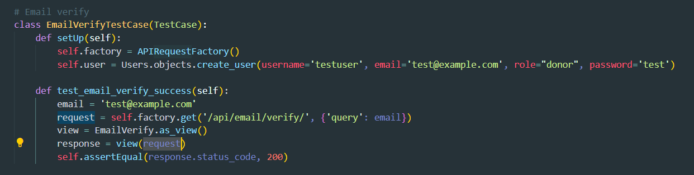

Figure 123: Email verify success function

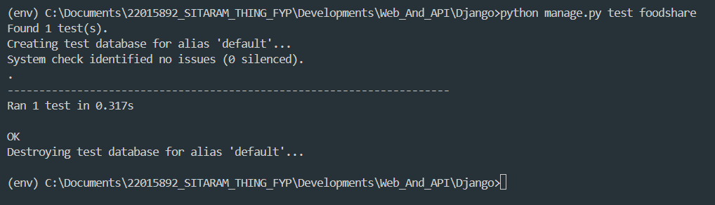

Figure 124: Email verify unit test success response

#### 4.2.1.9 NOG Register Unit Test

|  |  |
| --- | --- |
| **Test Case** | **Descriptions** |
| **Objectives** | To develop the register ngo of the test case function |
| **Actions** | To call the register ngo then give for the API function.  ngo_name: Test_Ngo  ngo_email: [test@gmail.com](mailto:test@gmail.com)  ngo_contact: 1234567890 |
| **Expected Result** | The new Ngo register was successful without any errors. The response status code is 200, and the 'is_success' attribute is True and more. |
| **Actual Result** | The new NGO registered the unit test as a success after failure and resolved the issues to ensure the test case was successful. |
| **Test** | The test was successful. |

Table 26: NOG register unit test

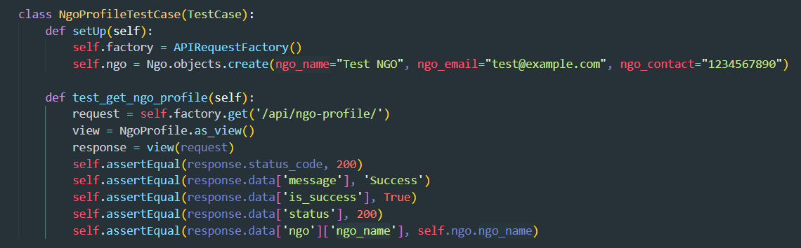

Figure 125: Ngo register unit test is a success function

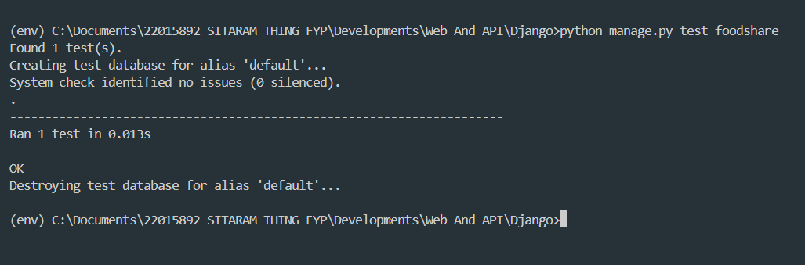

Figure 126: Ngo register unit test success response

### 4.2.2. System Testing

When I complete the development of the system, I will upload the wormhole server for 24 hours of free use. The app will be provided to both end-users and clients. The overall user interface part(UI) successfully accepts the end user with clients. After completing the development of the system, it was provided to both end-users and clients for system testing. The system testing was successful but identified several issues. End-user feedback indicated that the user interface (UI) and performance were satisfactory.

The system is now available for use, and users can also participate in a post-usage survey. Some UX and UI issues were encountered during testing, which are being addressed. The main issues identified during system testing were related to permissions, specifically regarding location, notifications, and user interaction when internet connectivity is unavailable. These issues are currently being resolved.

**Web Application Testing**

#### 4.2.2.1 Login credential Admin account

|  |  |
| --- | --- |
| **Test Case** | **Descriptions** |
| **Objectives** | To ensure the User can log in using credentials |
| **Actions** | The user enters the appropriate user's credentials on the login page and clicks the login button. |
| **Expected Result** | The user should be logged into the system and redirected to the home page. |
| **Actual Result** | The user was logged into the system and redirected to the home page. |
| **Test** | The test was successful. |

Table 27: Web testing for login table

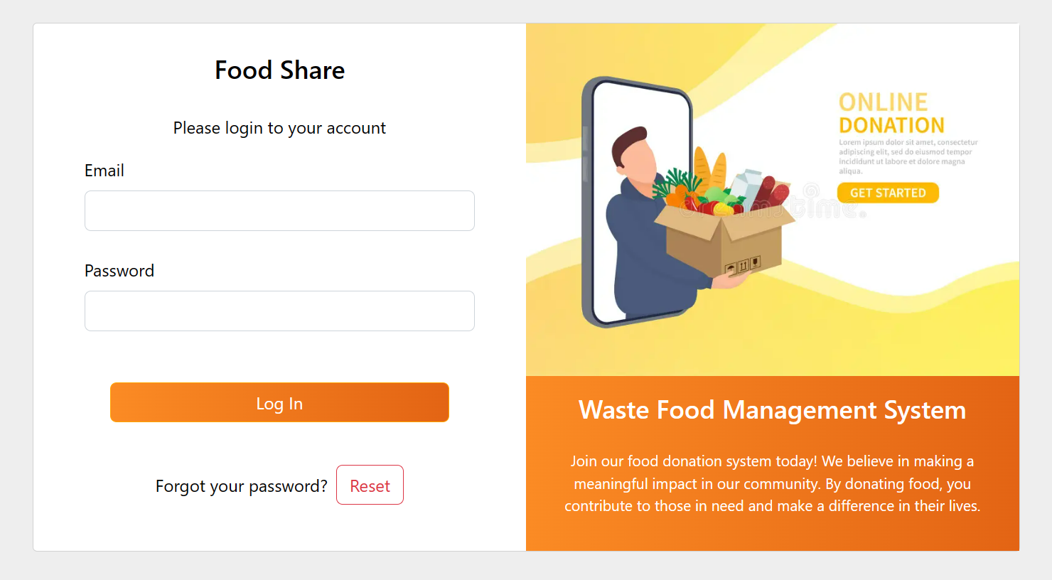

Table 28: Empty web login screen

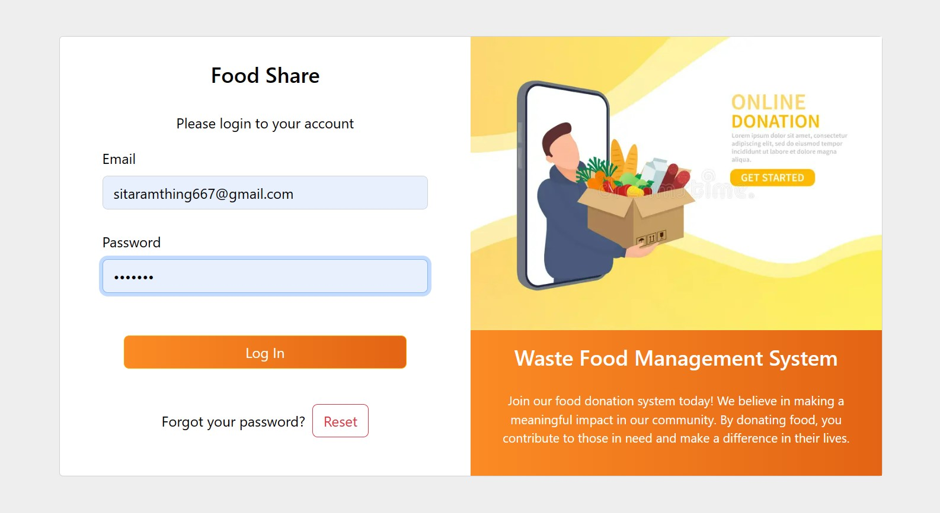

Figure 127: Login screen with filled the email and password

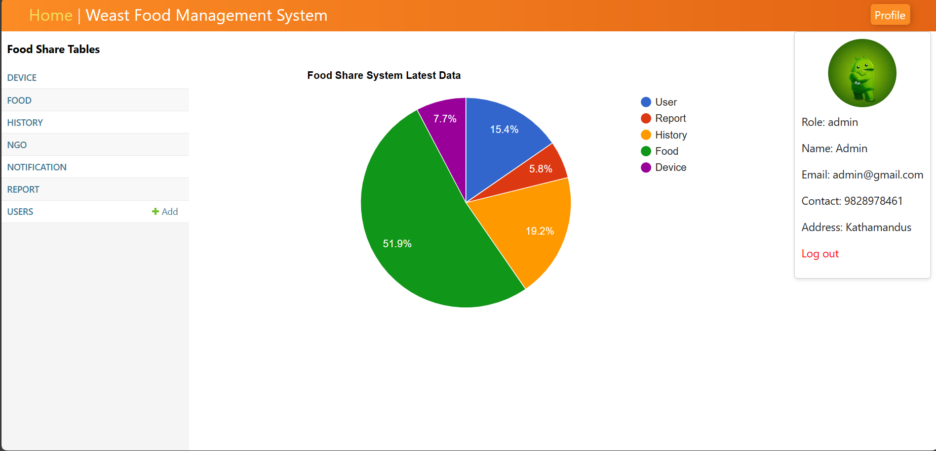

Figure 128: successfully navigate to the dashboard web admin panel

#### 4.2.2.2 Active and registered users try to log in to the admin panel

|  |  |
| --- | --- |
| **Test Case** | **Descriptions** |
| **Objectives** | To ensure the User can try registering an account login to the system in the admin panel. |
| **Actions** | The user enters a resisted account details and clicks the login button. |
| **Expected Result** | The form will display an error message at the bottom that states, “Invalid Credentials”. |
| **Actual Result** | The form displays an error message at the bottom that states, “Invalid Credentials”. |
| **Test** | The test was successful. |

Table 29: Web testing to login screen in unauthenticated user

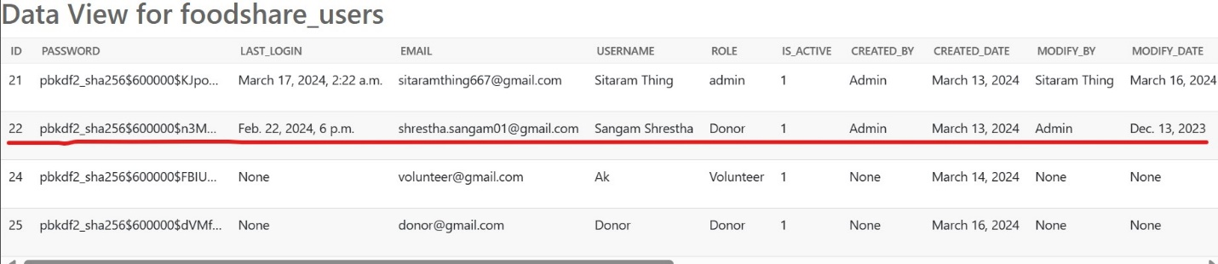

Figure 129: Register data saved in a database

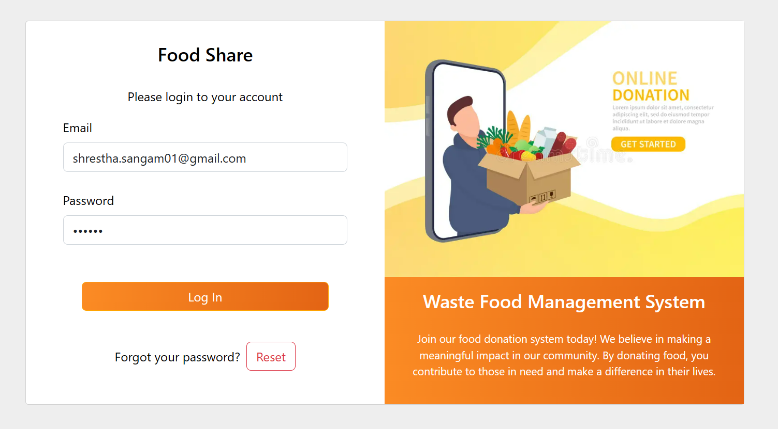

Figure 130: Web testing to fill in the login details

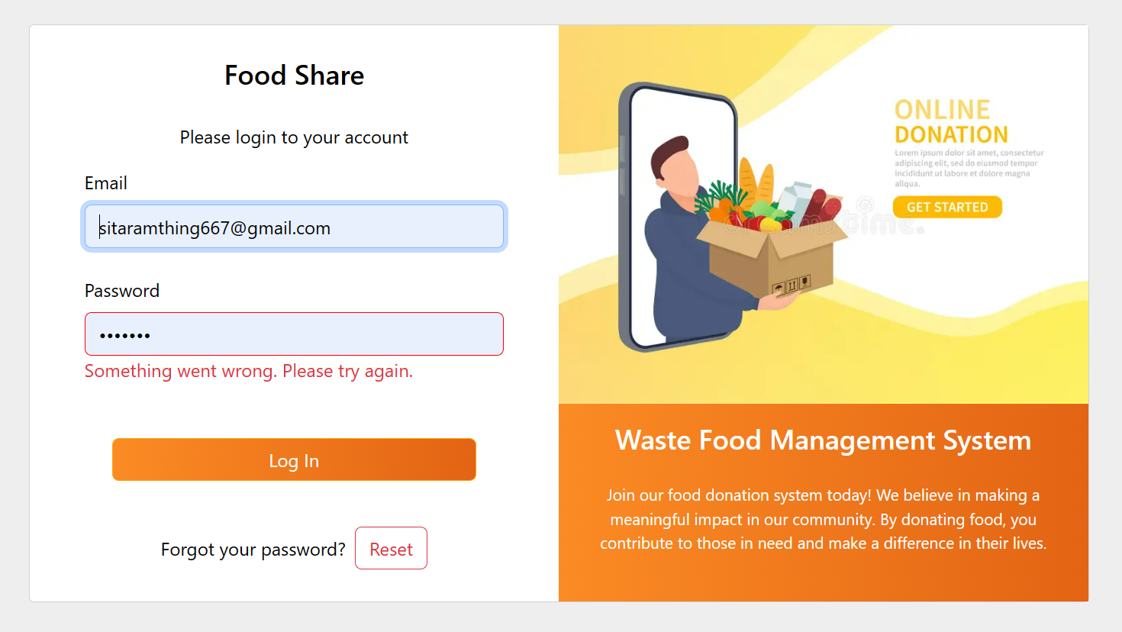

Figure 131: Display the Aunatheneticate user doesn't login to the web admin panel

#### 4.2.2.3 Reset Password Page

|  |  |
| --- | --- |
| **Test Case** | **Descriptions** |
| **Objectives** | To provide email and both password fields and redirect to the login page. |
| **Actions** | The admin provides the email and password the valid email and same password then clicks the confirm button.  Update password details:   * Email: [sitaramthing667@gmail.com](mailto:sitaramthing667@gmail.com) * New Passswoed: sitaram * Confirm Password: sitaram |
| **Expected Result** | The password is successfully reset and navigate to the login screen. |
| **Actual Result** | The password is successfully reset and without any exception redirected to the login page. |
| **Test** | The test was successful. |

Table 30: Web testing register user table

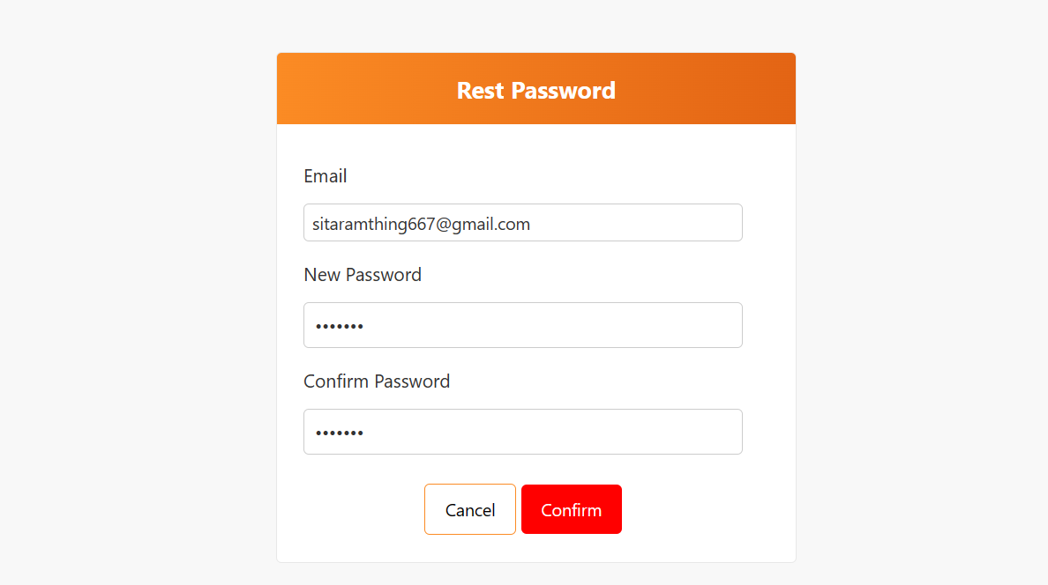

Table 31: Web test in enter the email, password and confirm password

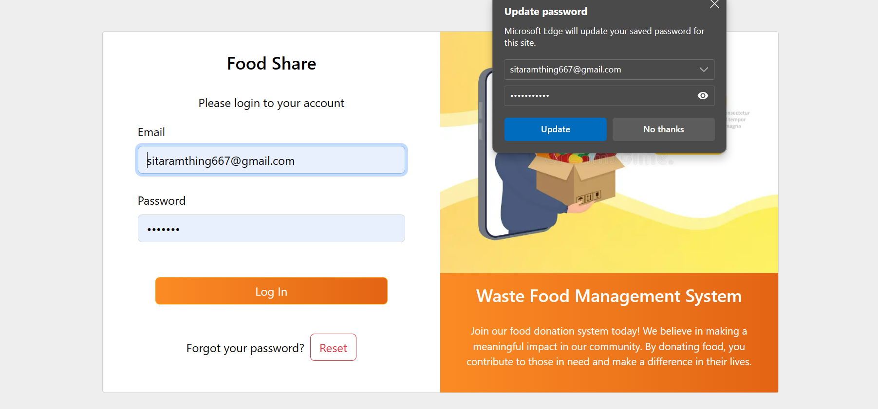

Table 32: Web test update password success to navigate to the login page

#### 4.2.2.4 View History in Paichart (Home Page):

|  |  |
| --- | --- |
| **Test Case** | **Descriptions** |
| **Objectives** | To navigate the home page hover or click to view the ratio of data in percentage. |
| **Actions** | Open the home page and click or hover over the pie chart. |
| **Expected Result** | The pie chart should display different types of data. Clicking or hovering over it should display the percentage of each data type. |
| **Actual Result** | The home page successfully displayed the pie chart with data and the percentage ratio. |
| **Test** | The test was successful. |

Table 33: Test for the home page has a history in pie-chart

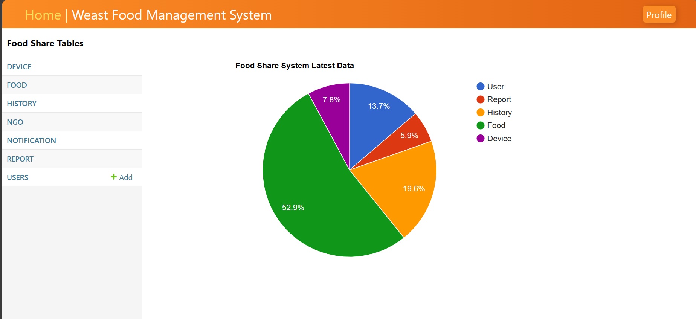

Figure 132: Display the piechart with data

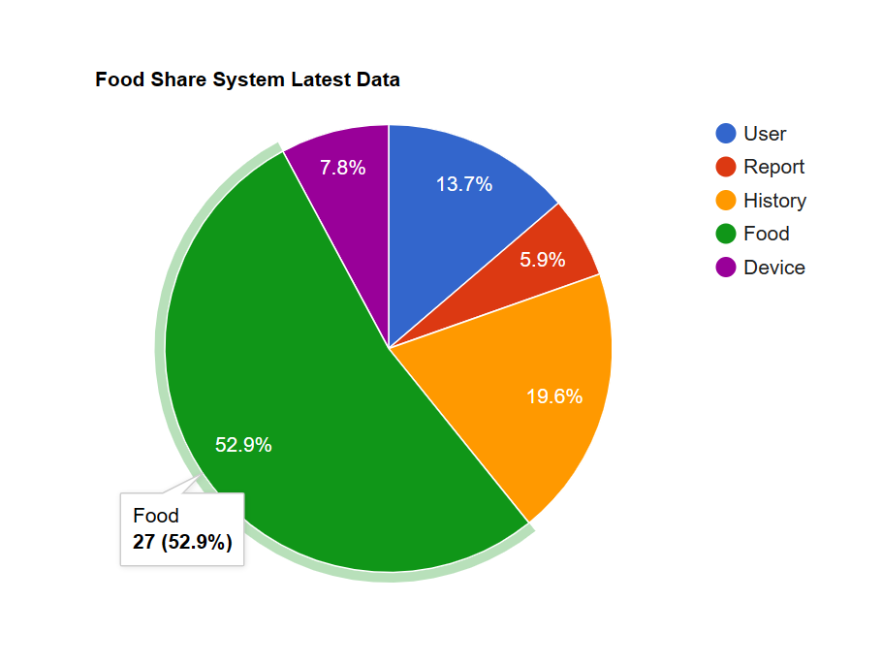

Figure 133: Display the percentage of food history

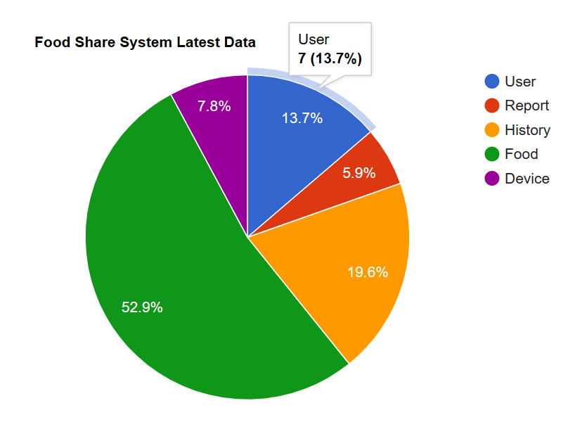

Figure 134: Display the percentage of food user

#### 4.2.2.5 View history data

|  |  |
| --- | --- |
| **Test Case** | **Descriptions** |
| **Objectives** | Navigate to the data view screen and display all table details in a table format. |
| **Actions** | Click on the table name in the sidebar to display the data and view it. |
| **Expected Result** | Clicking on the table name in the sidebar should successfully display the data within the table. |
| **Actual Result** | The data is successfully displayed in a table format. |
| **Test** | The test was successful. |

Table 34: Web testing for View history tables

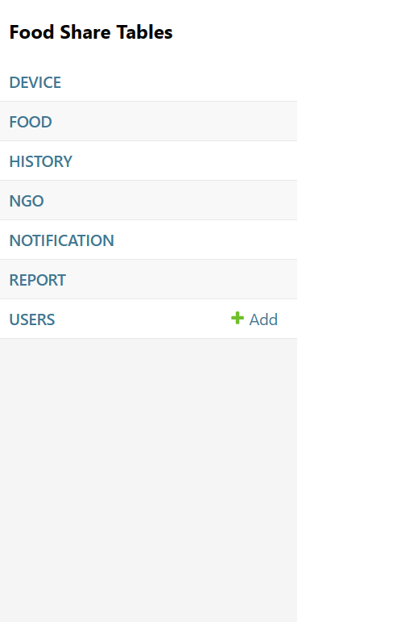

Figure 135: Web testing for history table list

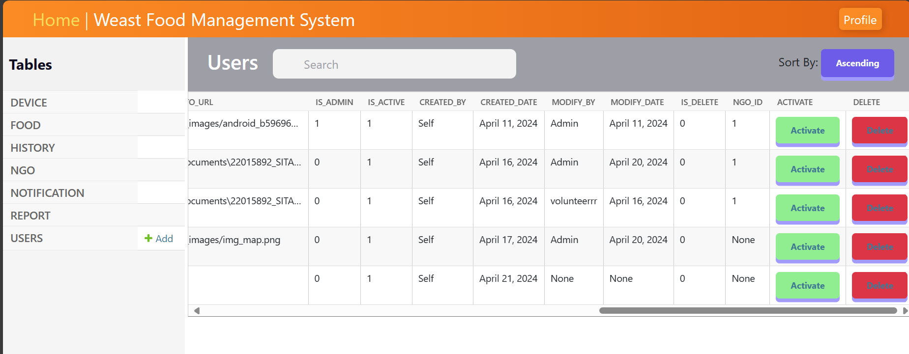

Figure 136: View history of user details

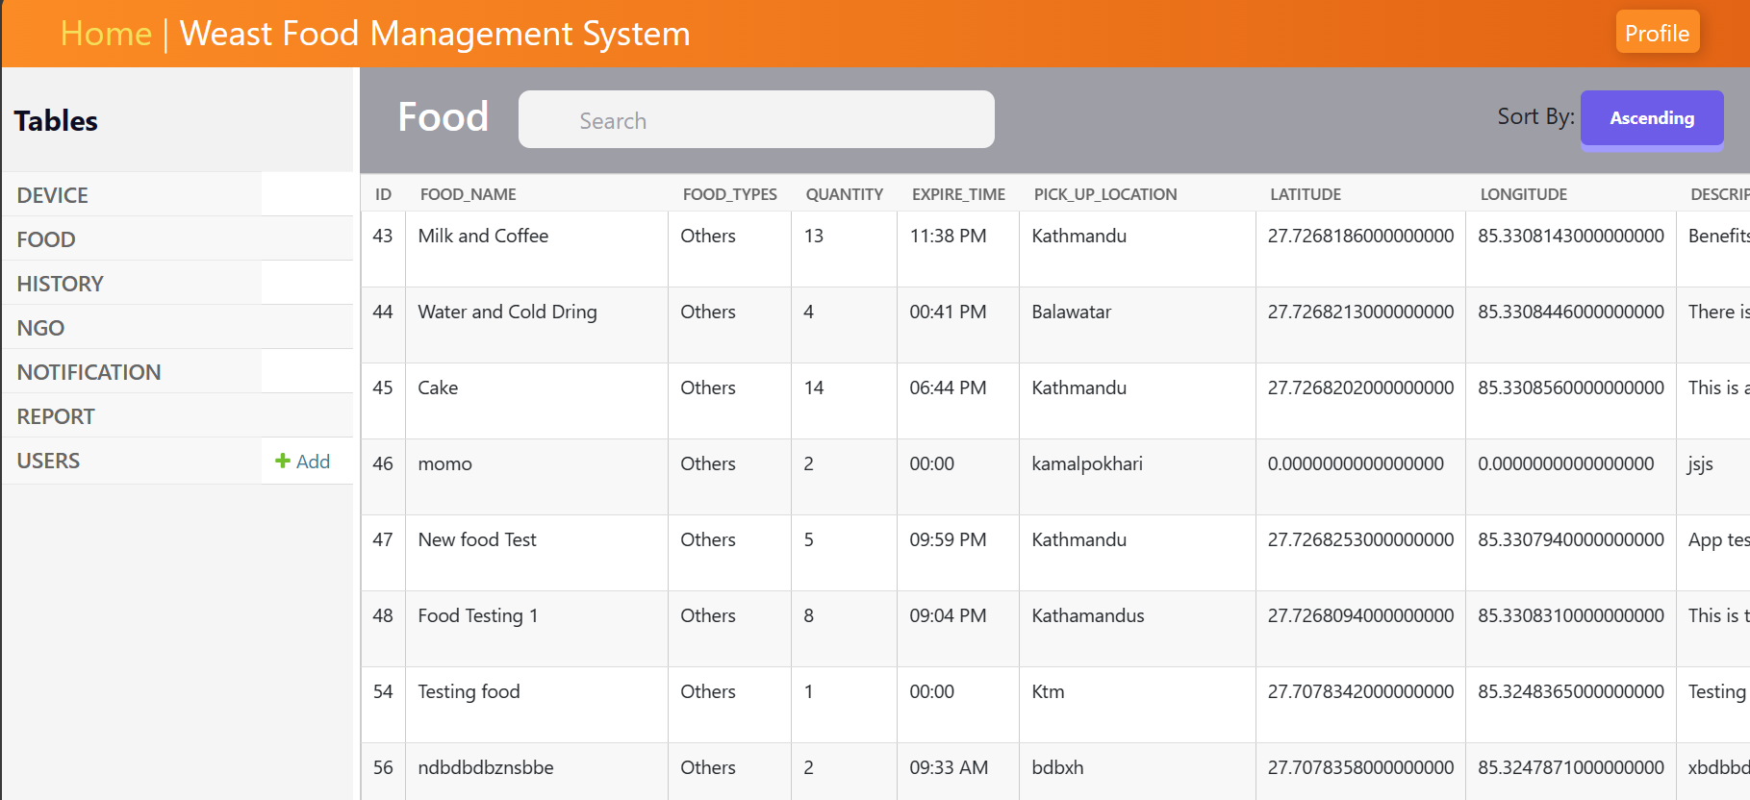

Figure 137: View the history of food details

#### 4.2.2.6 Delete Item

|  |  |
| --- | --- |
| **Test Case** | **Descriptions** |
| **Objectives** | The Admin can verify the data and delete unnecessary data by clicking the delete button. |
| **Actions** | Find the unnecessary data, click the delete button, and delete it temporarily, but not permanently, from the database. |
| **Expected Result** | The data should be successfully deleted from the web interface, and the deleted data should not be visible on the front end. |
| **Actual Result** | The data was successfully deleted from the front end. |
| **Test** | The test was successful. |

Table 35: Web testing for deleting table details

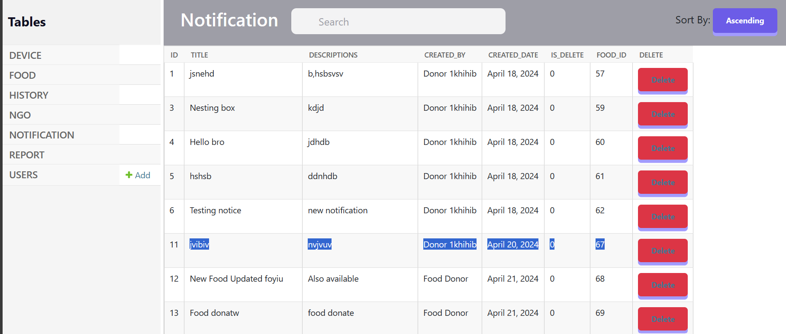

Figure 138: Web test for deleting item show

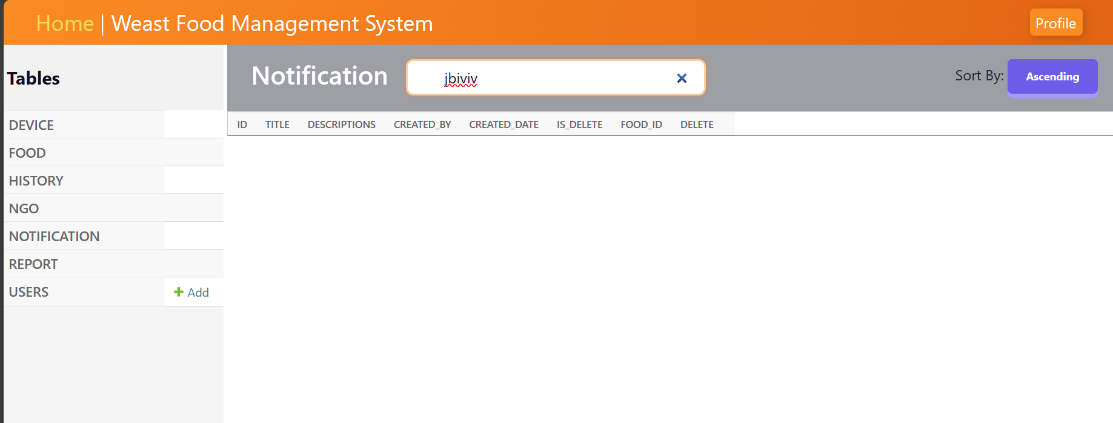

Figure 139: Web test delete an item not show

#### 4.2.2.7 Register a user account

|  |  |
| --- | --- |
| **Test Case** | **Descriptions** |
| **Objectives** | To add new user details and register successfully. |
| **Actions** | Open the registration screen, enter the username, email, password, and role, and then click the register button. |
| **Expected Result** | Result: The admin successfully adds a new user without any errors. |
| **Actual Result** | The user account was successfully registered. |
| **Test** | The test was successful. |

Table 36: Web test for adding new user table

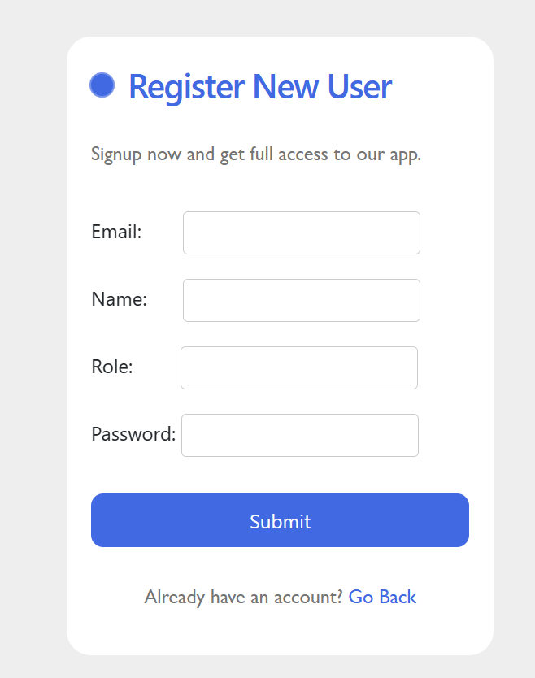

Figure 140: New user register empty register screen

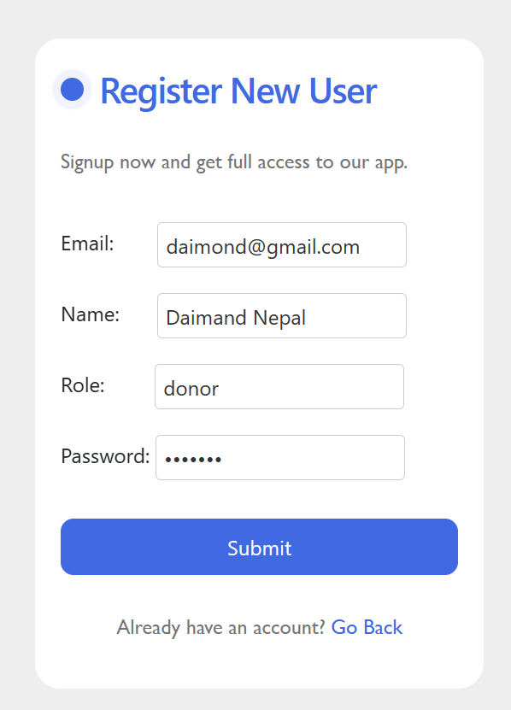

Figure 141: Web testing to enter the user details to register

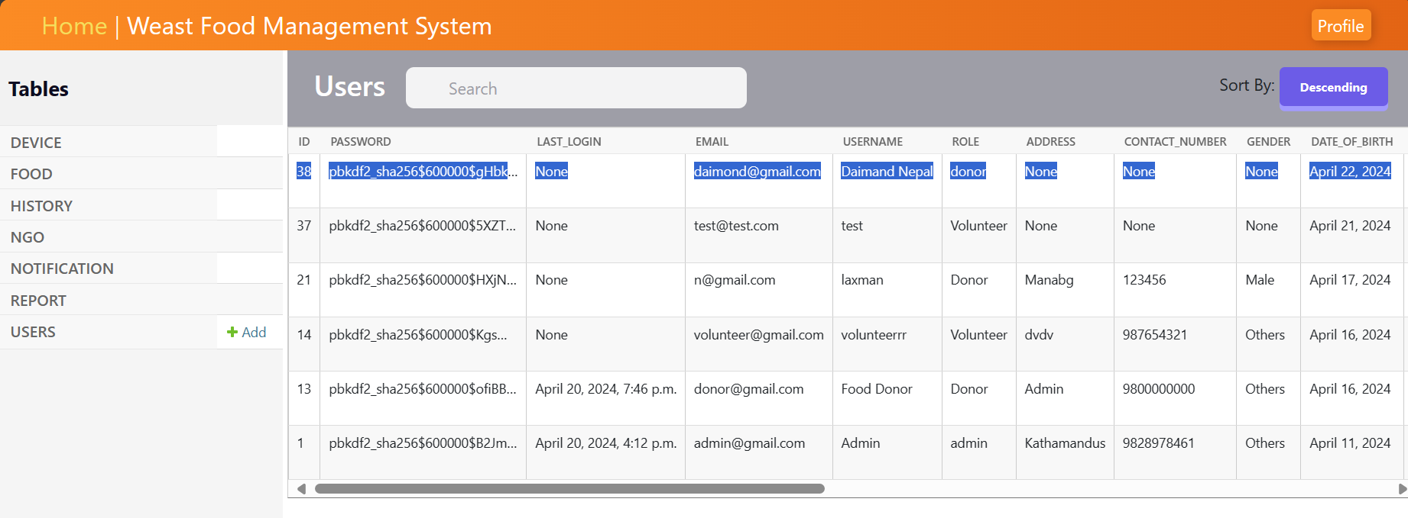

Figure 142: Web testing to register user display in a table

#### 4.2.2.8 Activate user account

|  |  |
| --- | --- |
| **Test Case** | **Descriptions** |
| **Objectives** | The Admin can find the newly registered user and activate their user account |
| **Actions** | Find the new user and verify their details, then activate their user account by clicking the "activate" button. |
| **Expected Result** | Clicking the "activate" button should successfully activate the user account. |
| **Actual Result** | The user account was successfully activated without any exceptions. |
| **Test** | The test was successful. |

Table 37: Web testing for user account activate table

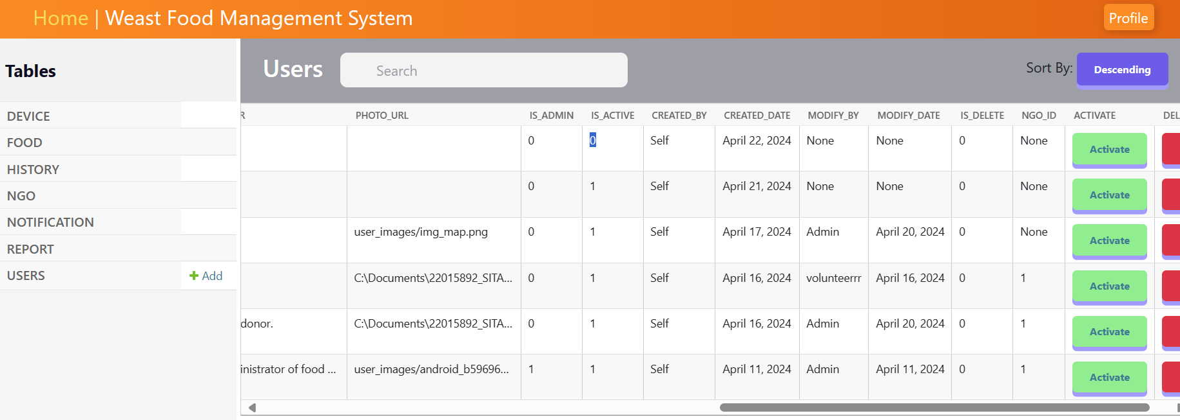

Figure 143: Web testing shows the inactive account

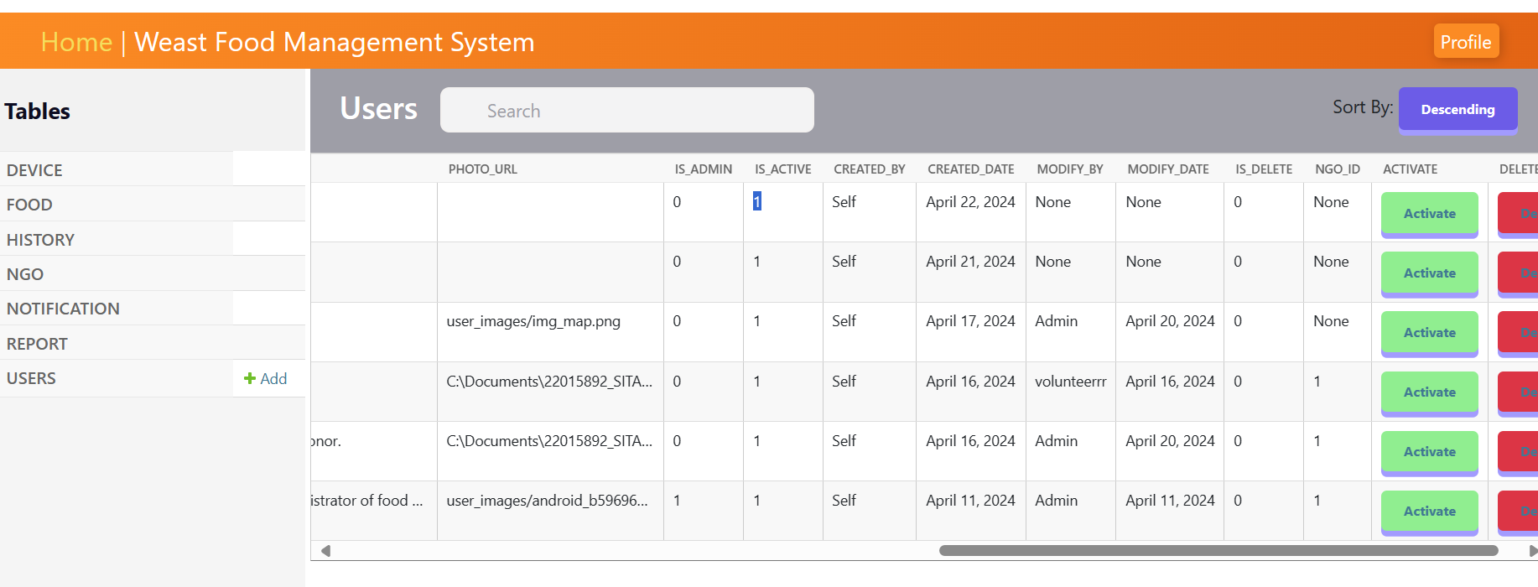

Figure 144: Web testing user account is successfully activated

#### 4.2.2.9 Logout administrator

|  |  |
| --- | --- |
| **Test No** | **Descriptions** |
| **Objectives** | To verify that the administrator can successfully log out of the system. |
| **Actions** | Click the logout button and successfully navigate to the login page. |
| **Expected Result** | The administrator is successfully logged out of the system. |
| **Actual Result** | The administrator was successfully logged out. |
| **Test** | The test was successful. |

Table 38: Web Logout testing table

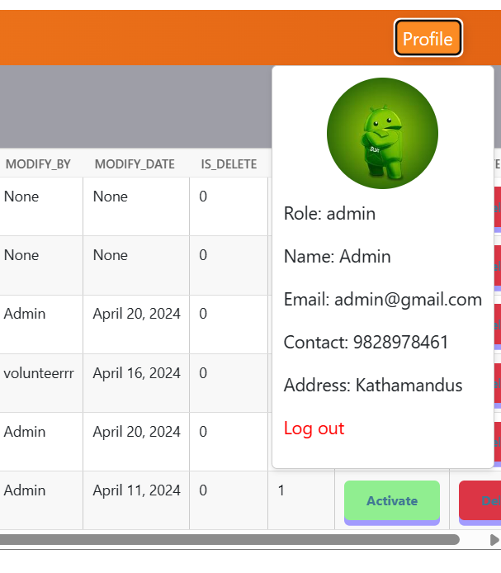

Figure 145: Logout view card with logout button



Figure 146: Web logout testing to successfully navigate the login page

**Mobile Application Testing**

#### 4.2.2.10 Registered user

|  |  |
| --- | --- |
| **Test Case** | **Descriptions** |
| **Objectives** | To ensure that the user can successfully register membership details to access the system. |
| **Actions** | The user enters new and valid registration details and clicks the register button.  Email: [Shrestha.sangam01@gamil.com](mailto:Shrestha.sangam01@gamil.com)  Username: Sangam Shrestha  Role: Donor  Password: Sangam |
| **Expected Result** | The user successfully registers and is redirected to the login page. |
| **Actual Result** | The user is successfully registered and redirected to the login page. |
| **Test** | The test was successful. |

Table 39: Registered user test in mobile app

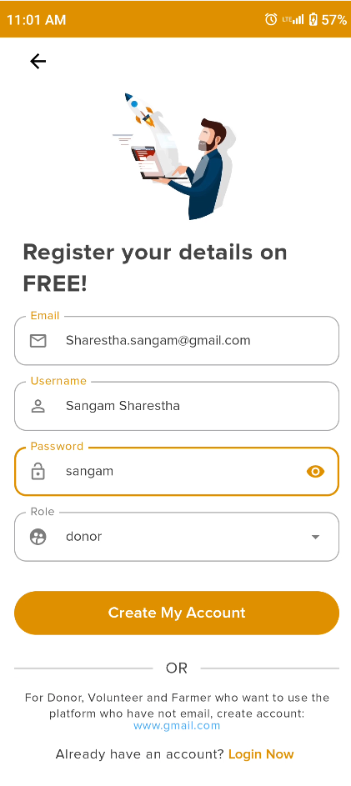

Figure 147: Register user filled in the user details in the mobile app

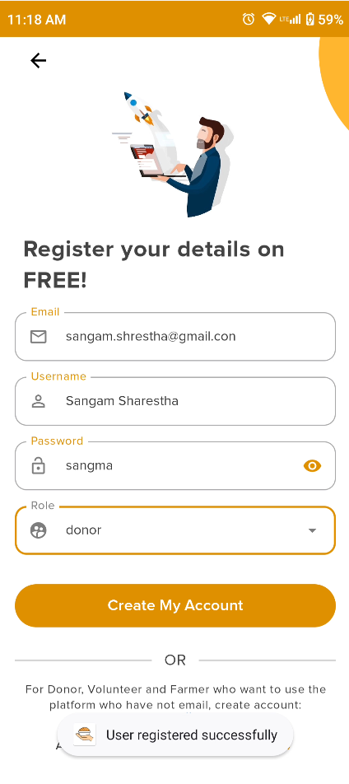

Figure 148: Register user success in the mobile app



Figure 149: Register user details in the database

#### 4.2.2.11 Login inactivate the user account

|  |  |
| --- | --- |
| **Test Case** | **Descriptions** |
| **Objectives** | To ensure the User can log in using uncredentials with valid login details. |
| **Actions** | The user enters the appropriate user's credentials on the login details and clicks the login button.   * Email: [donor@gmail.com](mailto:donor@gmail.com) * Password: donor |
| **Expected Result** | The user should be logged into the system and show the error message in the dialogue box. |
| **Actual Result** | The user logged in to an unauthenticated account and did not succeed in logging into the system. |
| **Test** | The test was successful. |

Table 40: Login credential user account test in the mobile app

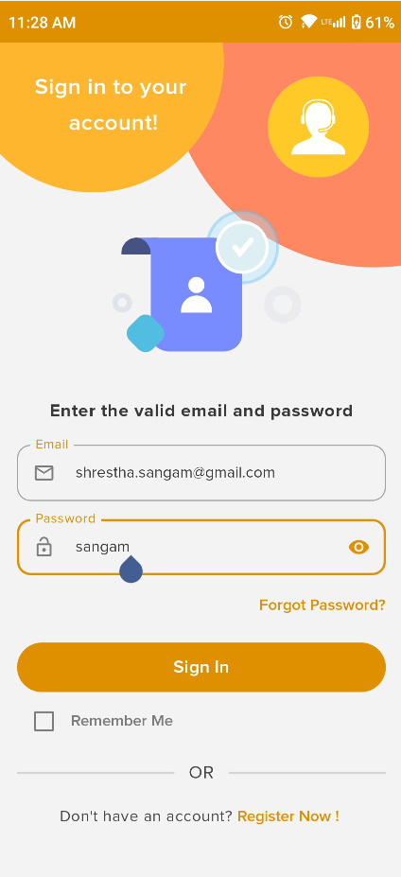

Figure 150: Login to inactivate the user account

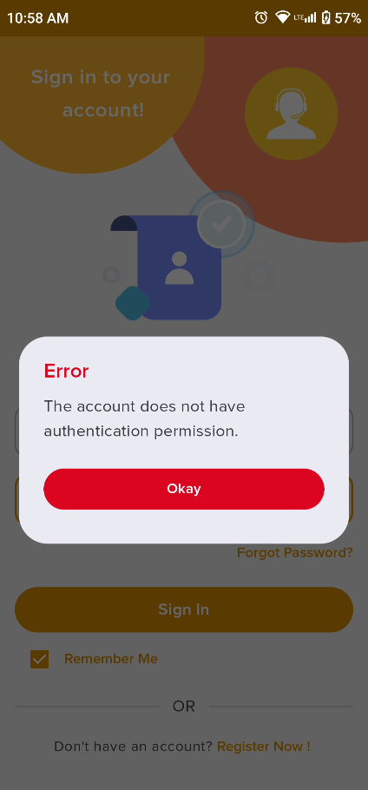

Figure 151: show the unauthenticated error message in the dialogue box

#### 4.2.2.12 Login credential user account

|  |  |
| --- | --- |
| **Test Case** | **Descriptions** |
| **Objectives** | To ensure the User can log in using credentials with valid login details. |
| **Actions** | The user enters the appropriate user's credentials on the login details and clicks the login button.   * Email: [donor@gmail.com](mailto:donor@gmail.com) * Password: donor |
| **Expected Result** | The user should be logged into the system and successfully navigate to the home page without any exceptions. |
| **Actual Result** | The user login is successfully authenticated to log into the system |
| **Test** | The test was successful. |

Table 41: Login credential user account test in the mobile app

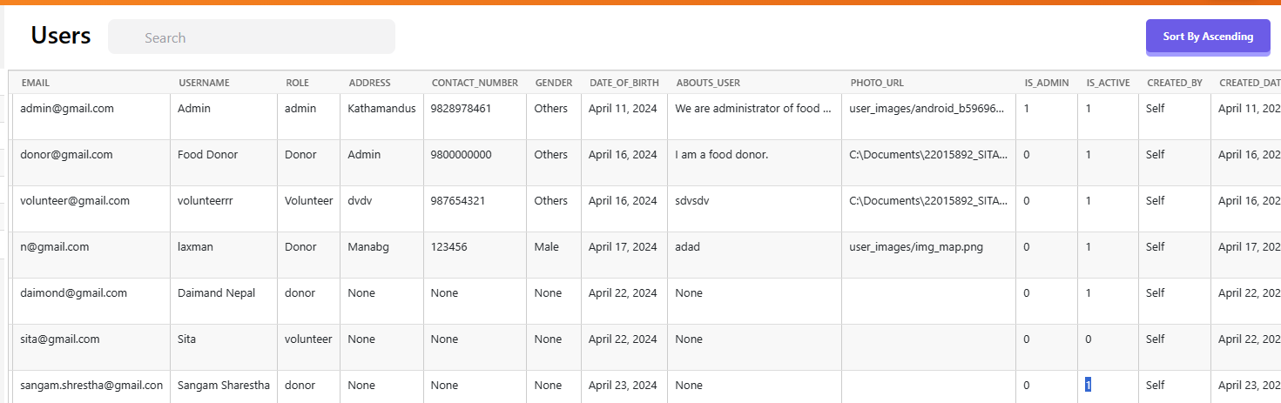

Figure 152: Activate the user account from the admin



Figure 153: Login to activate the user account

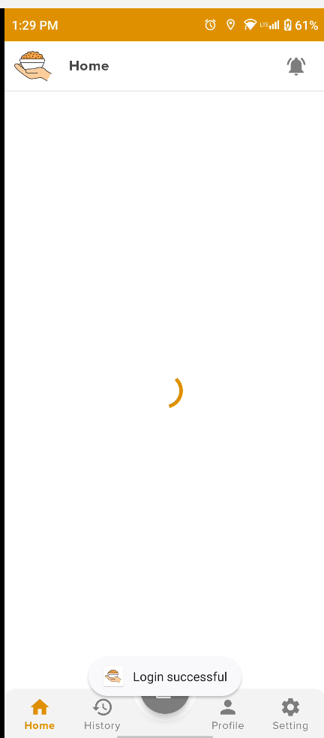

Figure 154: Login success message

#### 4.2.2.13 Forgot Password

|  |  |
| --- | --- |
| **Test Case** | **Descriptions** |
| **Objectives** | To provide an email to verify the active user enter both password fields and change the password. |
| **Actions** | The admin provides the email clicks the email verify button and after successfully verified enters the new password confirms the password is the same then clicks the confirm button. |
| **Expected Result** | The password is successfully reset and shows the success message. |
| **Actual Result** | The password is successfully reset and shows the success message and notification. |
| **Test** | The test was successful. |

Table 42: Forgot Password test in mobile app

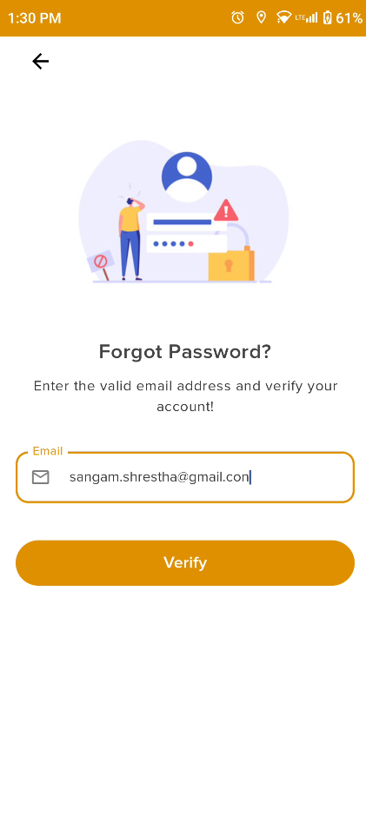

Figure 155: Enter the valid email address to verify the user

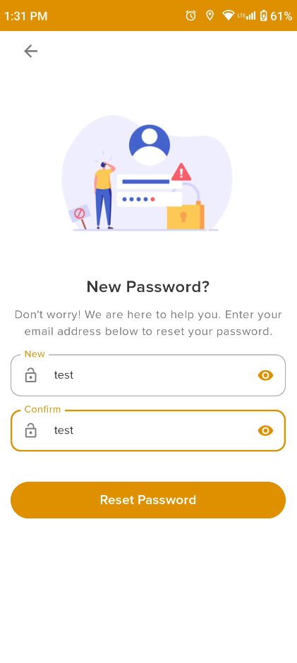

Figure 156: Enter the new password and valid both same password

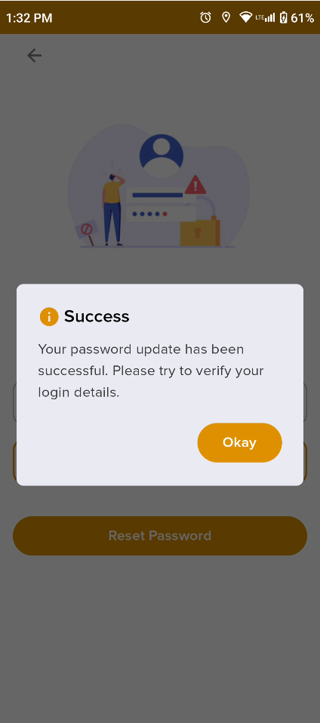

Figure 157: Display the success message daily box

#### 4.2.2.14 View History

|  |  |
| --- | --- |
| **Test Case** | **Descriptions** |
| **Objectives** | To navigate the history to view the all won history details. |
| **Actions** | Click the history button navigation bar and display the history list of history details. |
| **Expected Result** | To navigate the history page and show the history details without any error. |
| **Actual Result** | The histories are shown successfully. |
| **Test** | The test was successful. |

Table 43: View the History test in the mobile app

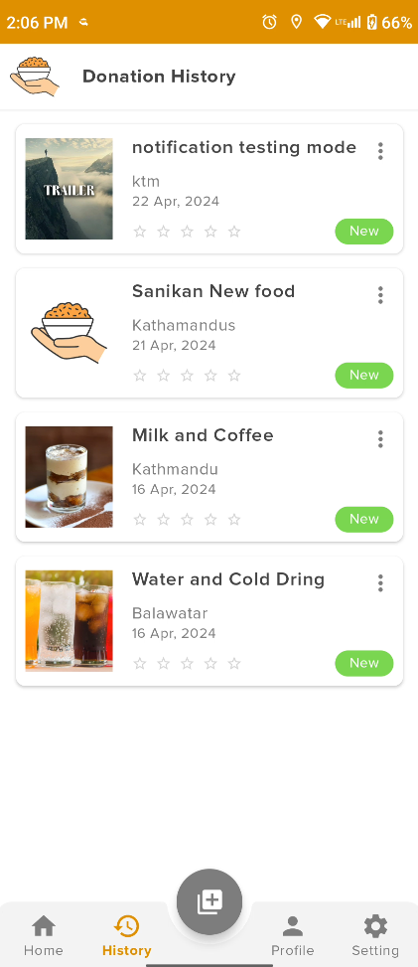

Figure 158: View list of food history history

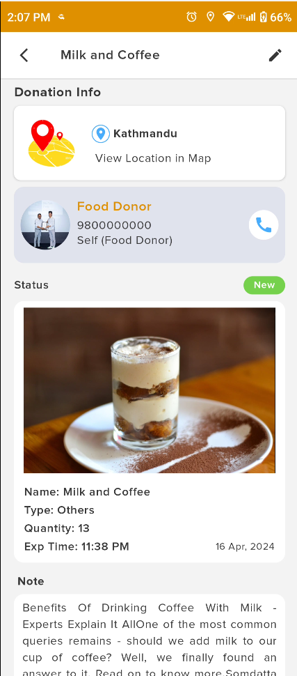

Figure 159: View food details

#### 4.2.2.15 View Donation location

|  |  |
| --- | --- |
| **Test Case** | **Descriptions** |
| **Objectives** | The user can view the donation location details with distance from the current location donation location. |
| **Actions** | Click the view location item and navigate to display the Google map if permission allows. |
| **Expected Result** | To navigate the view location screen and show the location distance. |
| **Actual Result** | The Google map is shown successfully. |
| **Test** | The test was successful. |

Table 44: View the Donation location test in the mobile app

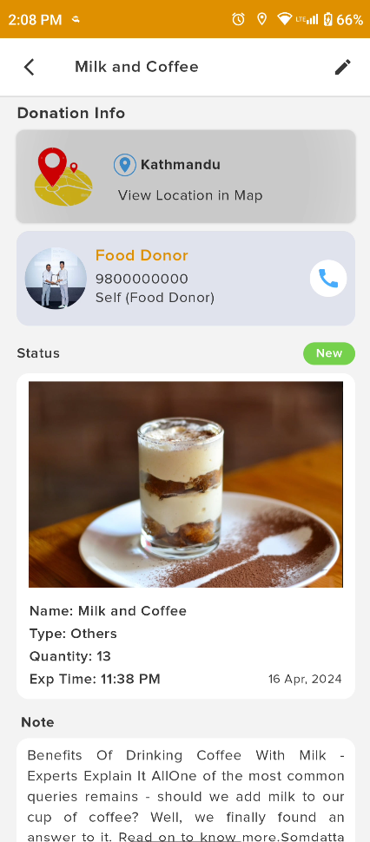

Figure 160: View donation location content

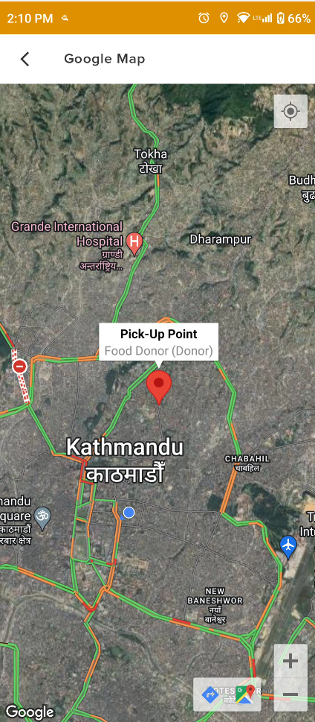

Figure 161: View the location on the map with the pick-up point

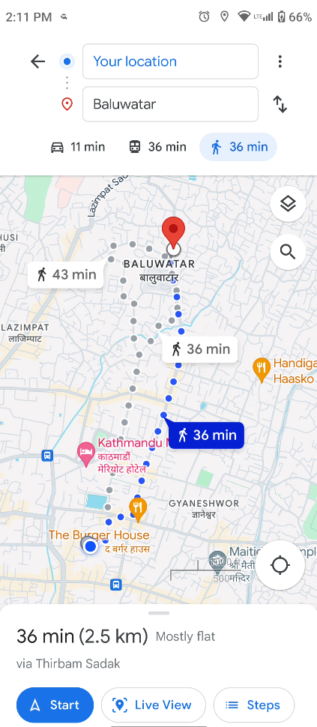

Figure 162: View location details with distance

#### 4.2.2.16 View user profile

|  |  |
| --- | --- |
| **Test Case** | **Descriptions** |
| **Objectives** | The user can view the other system user profile details are view and contacts. |
| **Actions** | To find the post food and navigate the food details then click the user profile and view user profile details. |
| **Expected Result** | The user profile is displayed without any exceptions. |
| **Actual Result** | The user profile is successfully displayed. |
| **Test** | The test was successful. |

Table 45: View user profile test in the mobile app

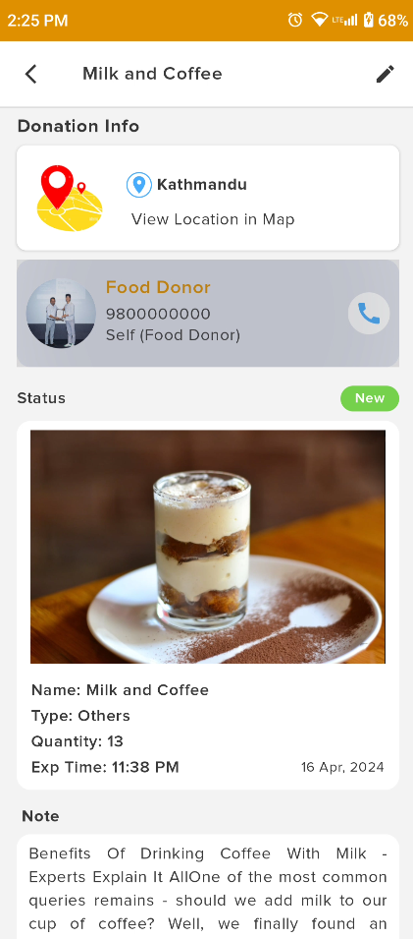

Figure 163: View the user profile content

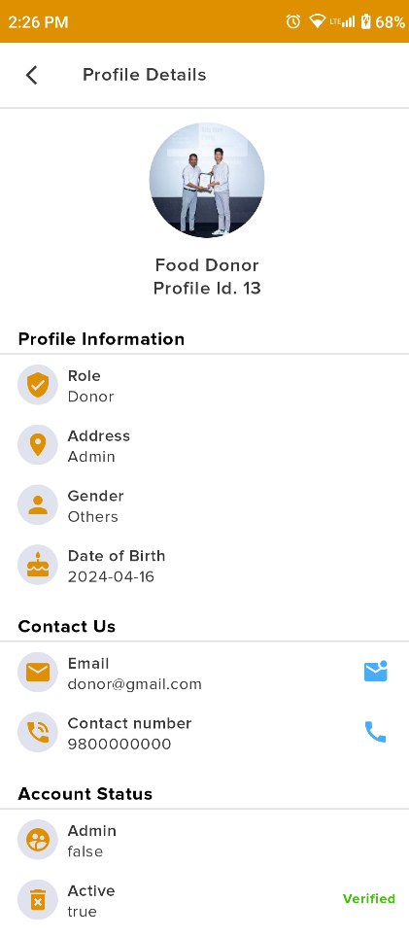

Figure 164: View user profile details

#### 4.2.2.17 Donate food (Post new food)

|  |  |
| --- | --- |
| **Test Case** | **Descriptions** |
| **Objectives** | To navigate the post screen and filled the required food details and publisher or post the system. |
| **Actions** | Enter the food details in the filled food details like food name, and description, click the drop-down to food types, and quantity, select the donate time, fill in the donation location click the select icon and get the image the successfully post the food.  Food name: Mo: Mo  Descriptions: This food is donated to homeless persons.  Time: 12:00 PM  Quantity: 12  Food types: Stable food  Location: Putalishadak  Image: momo’s food image |
| **Expected Result** | The food is successfully donated and if it is successful navigate the home screen and display the new food otherwise show the error message in the dialogue box. |
| **Actual Result** | The food was donated successfully without any errors or exceptions. |
| **Test** | The test was successful. |

Table 46: Donate food test in monile app

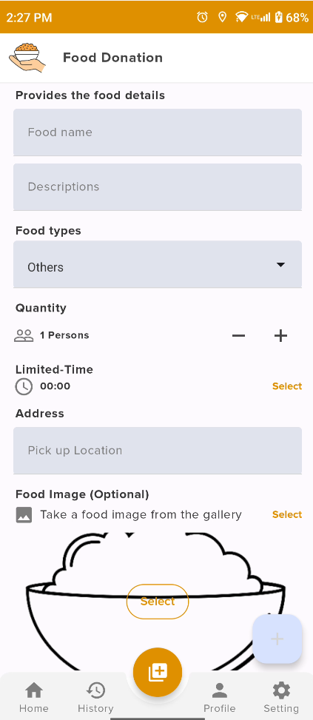

Figure 165: Empty donation details

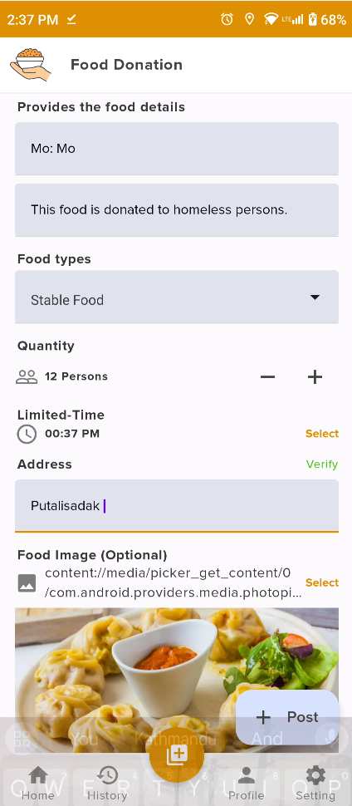

Figure 166: Donate food details filled

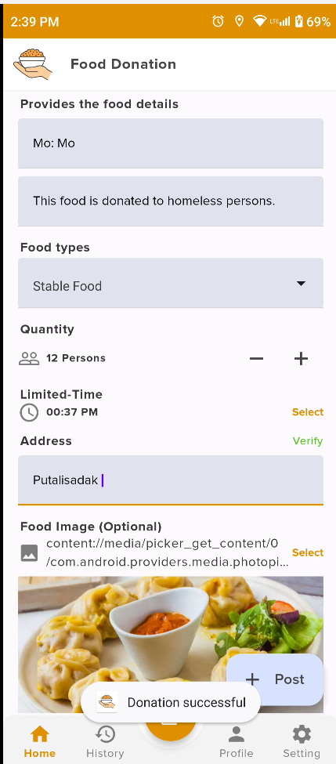

Figure 167: Donation success message

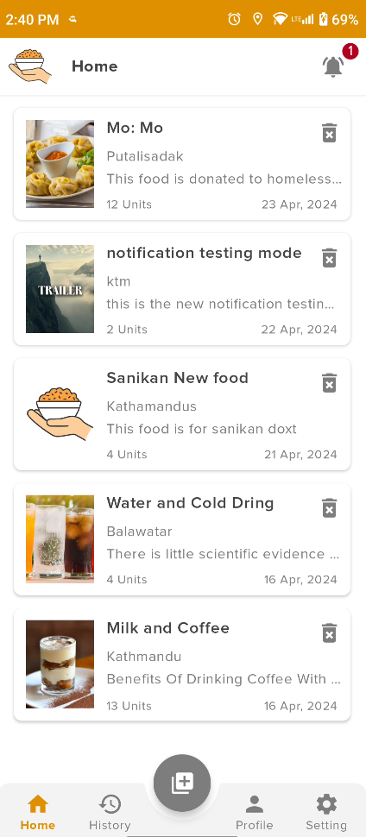

Figure 168: View the latest donated food on the home page

#### 4.2.2.18 Push Notification

|  |  |
| --- | --- |
| **Test Case** | **Descriptions** |
| **Objectives** | To new food donations from donors, all the users have come to the push notification. |
| **Actions** | The donor can donate the food with all the food details and a push notification can send the food name and descriptions where it is received to the other user.  Food name: Mo: Mo  Descriptions: This food is donated to homeless persons. |
| **Expected Result** | The push notification was received by all users without any exceptions. |
| **Actual Result** | The donate food push notification is successful. |
| **Test** | The test was successful. |

Table 47: View notification history



Figure 169: View donate food detail for notification

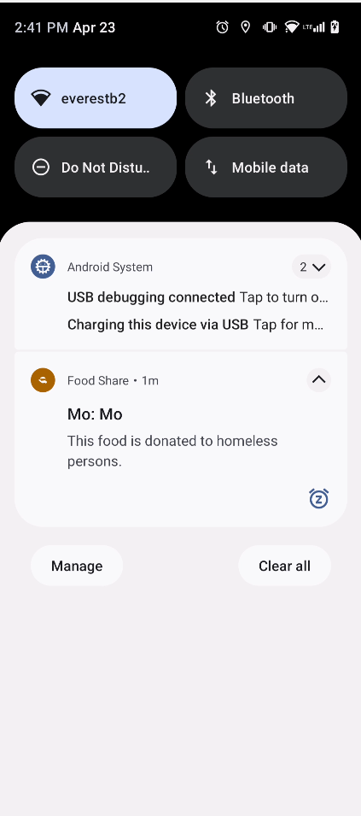

Figure 170: Received push notification

#### 4.2.2.19 View Notification History

|  |  |
| --- | --- |
| **Test Case** | **Descriptions** |
| **Objectives** | The user can view the latest number of notifications and notification details in the notification details. |
| **Actions** | Click the notification icon and navigate to the notification screen. |
| **Expected Result** | They view the number of notifications and display the identification history. |
| **Actual Result** | The notification was successfully displayed with history. |
| **Test** | The test was successful. |

Table 48: View Notification History



Figure 171: View the number of notifications in the badge

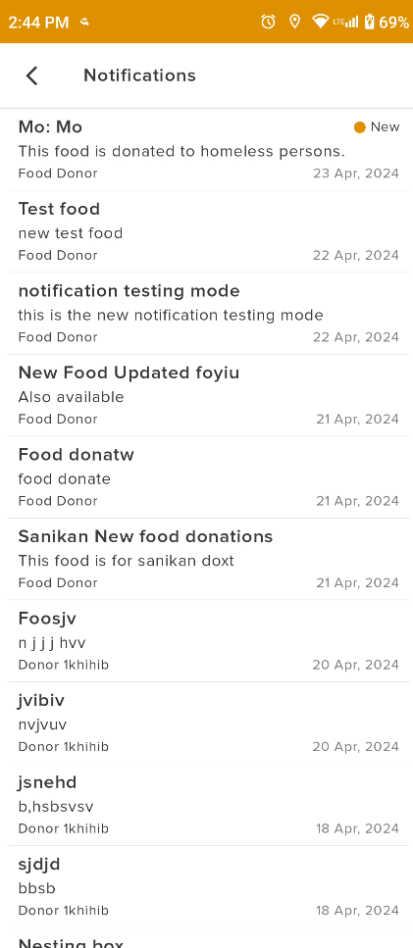

Figure 172: View notification history

#### 4.2.2.20 Donation Rating

|  |  |
| --- | --- |
| **Test Case** | **Descriptions** |
| **Objectives** | The volunteer can give the donation rating with the collect the feedback of food consumers. |
| **Actions** | The pending food is picked for distribution and completed the donation process then volunteer can input the distributed location, description rating and image if the donor can say donation completed evidence. |
| **Expected Result** | The donation rating is completed then show the history screen with a rating star. |
| **Actual Result** | The donation rating is successful and displays the history screen. |
| **Test** | The test was successful. |

Table 49: Donation Rating

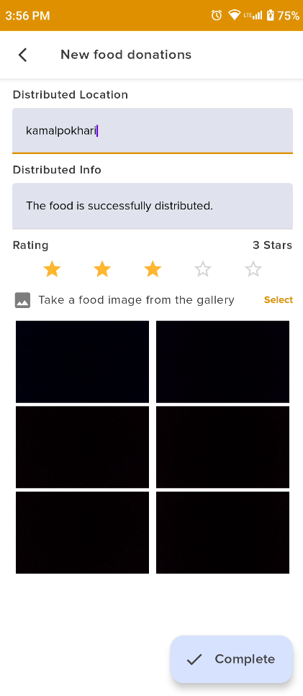

Figure 173: Enter the donation completed info with rating and images

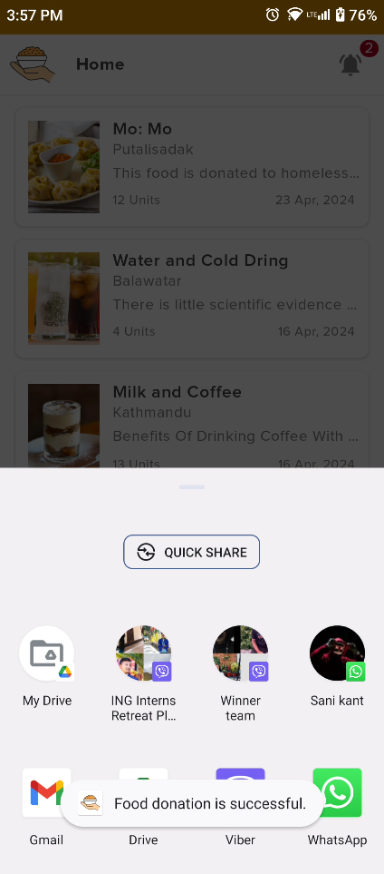

Figure 174: Donation rating completed message

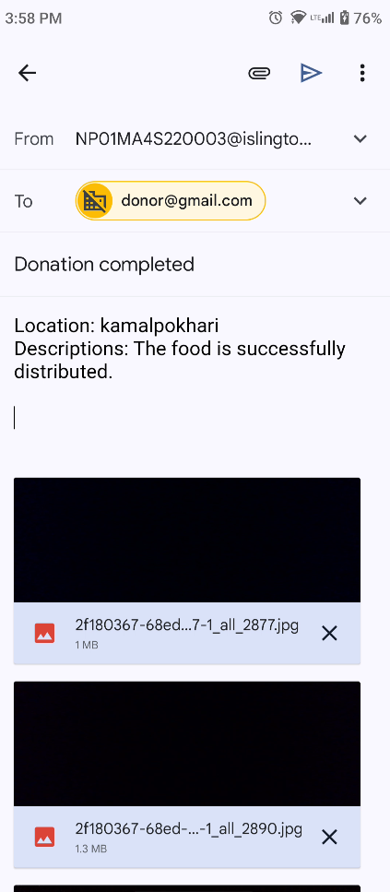

Figure 175: Distribute the location image and send

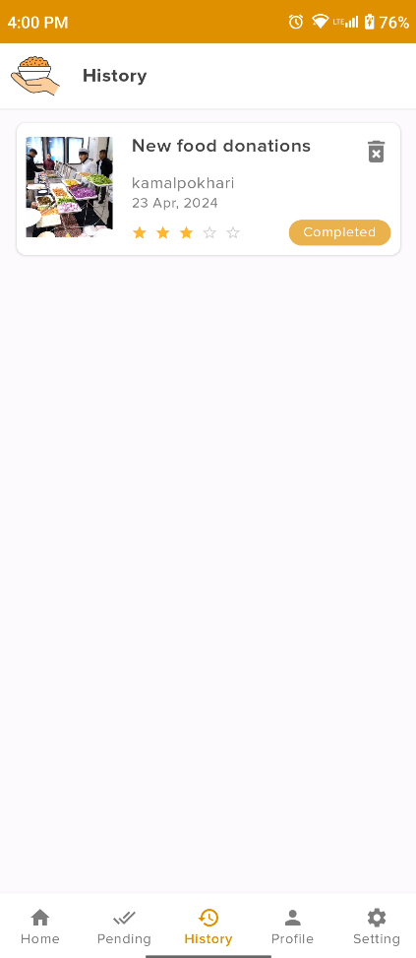

Figure 176: View history with rating star

#### 4.2.2.21 Update food Item

|  |  |
| --- | --- |
| **Test Case** | **Descriptions** |
| **Objectives** | The donor can donate food if this needs to change then they can update the food details. |
| **Actions** | The donor can click the edit icon and update the necessary items update. |
| **Expected Result** | The previously donated food details are successfully updated without any errors or exceptions. |
| **Actual Result** | The post was successfully updated |
| **Test** | The test was successful. |

Figure 177: Update food Item

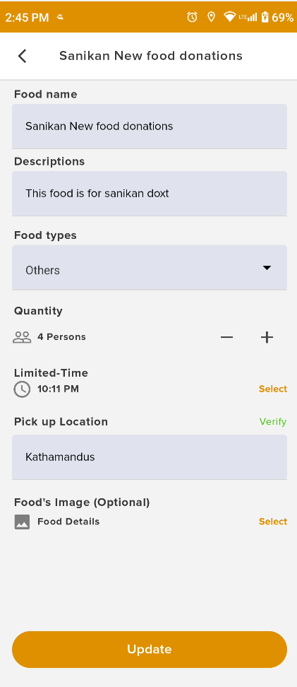

Figure 178: Change food details for an update

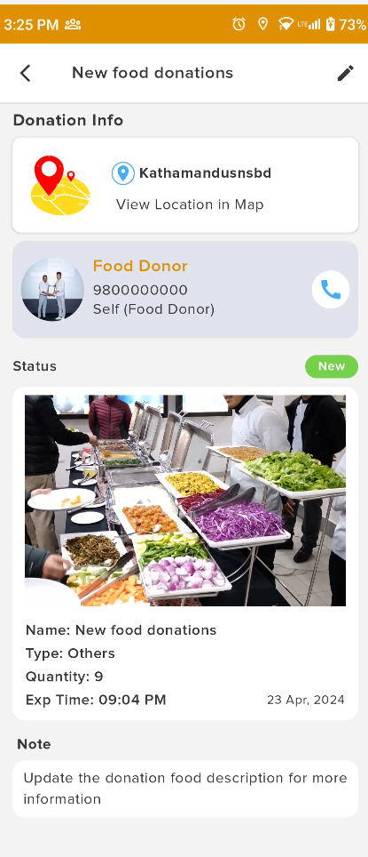

Figure 179: Display Update food details

#### 4.2.2.22 Delete donate food Item

|  |  |
| --- | --- |
| **Test Case** | **Descriptions** |
| **Objectives** | The donor can donate food if it can not be visible to donate the food. |
| **Actions** | The donated food items have a deleted icon and click the delete icon to show the confirmation and click the okay button. |
| **Expected Result** | The post food is deleted successfully without any exceptions. |
| **Actual Result** | The data was successfully deleted from the front end. |
| **Test** | The test was successful. |

Figure 180: Delete donated food Item

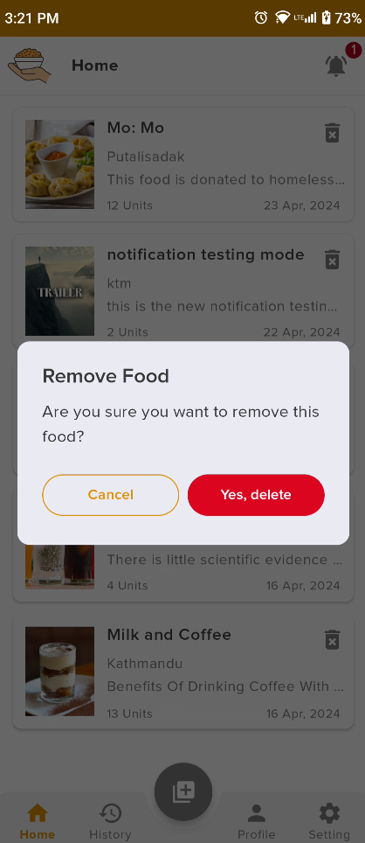

Figure 181: Before detailing the food

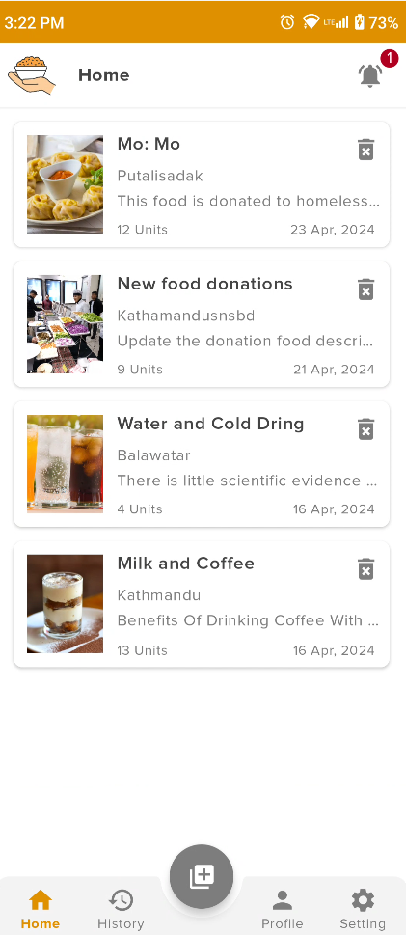

Figure 182: Delete confirmation dialogue

#### 4.2.2.23 Update donate food image

|  |  |
| --- | --- |
| **Test Case** | **Descriptions** |
| **Objectives** | The user can update the user profile image if the user can needed. |
| **Actions** | The user can click the profile edit icon update the food image and click the update confirm button. |
| **Expected Result** | The donated food images are successfully updated without any errors or exceptions. |
| **Actual Result** | The donated food image was successfully updated. |
| **Test** | The test was successful. |

Figure 183: Update donate food image

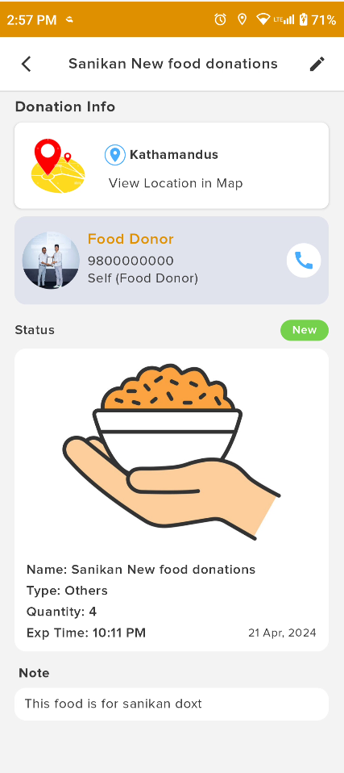

Figure 184: Before updating the food image

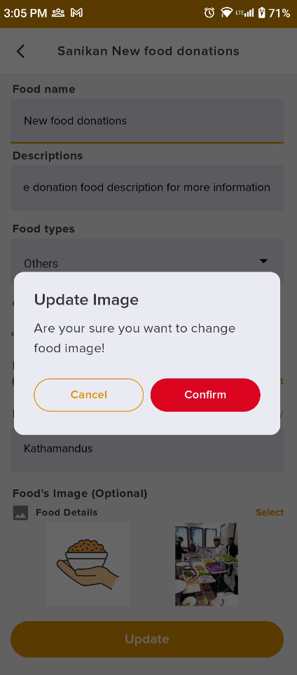

Figure 185: Food image update confirmation dialogue box

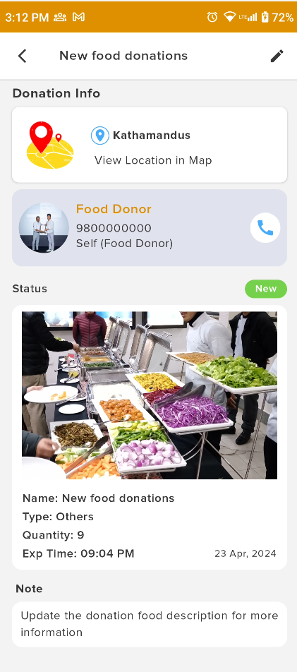

Figure 186: Updated food image

#### 4.2.2.24 Report to admin

|  |  |
| --- | --- |
| **Test Case** | **Descriptions** |
| **Objectives** | When food cannot be donated and volunteers are unable to pick up the food from the company, users should be able to report this issue to the admin. |
| **Actions** | Click the report icon, fill in the report description, and click the submit button. |
| **Expected Result** | The report is successfully submitted to the admin. |
| **Actual Result** | The report was successfully submitted to the admin. |
| **Test** | The test was successful. |

Table 50: Report to admin test in mobile app

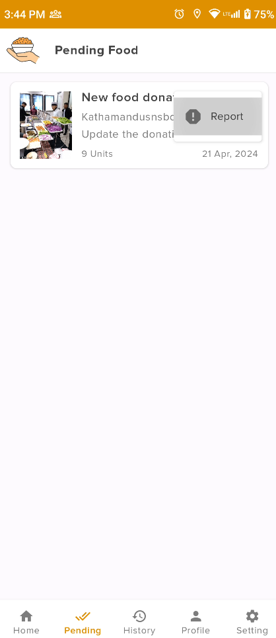

Figure 187: Report Item Menus

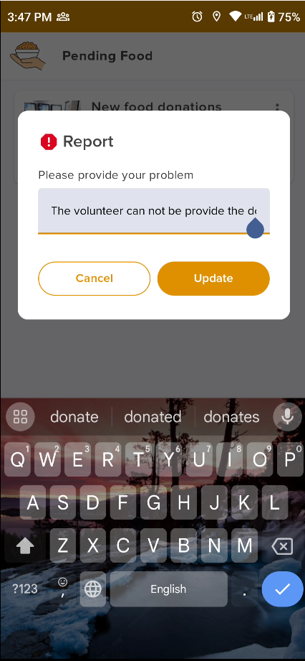

Figure 188: Write the report descriptions in the dialogue box

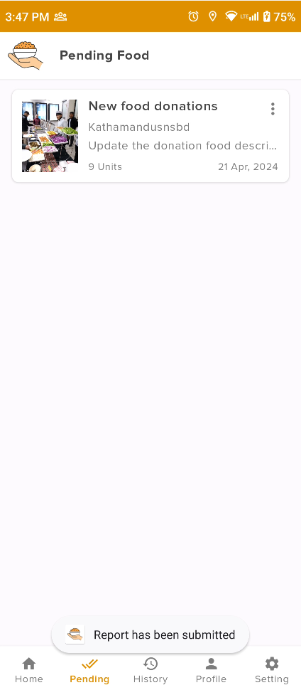

Figure 189: Report successful message

4.2.2.25 Update profile details

|  |  |
| --- | --- |
| **Test Case** | **Descriptions** |
| **Objectives** | The user can update user profile details like username, gender, contact number, location and about details. |
| **Actions** | The user can click the profile edit icon update the profile details and click the update button. |
| **Expected Result** | The user profile details are successfully updated without any errors or exceptions. |
| **Actual Result** | The user profile details were successfully updated. |
| **Test** | The test was successful. |

Table 51: Update profile details test in the mobile app

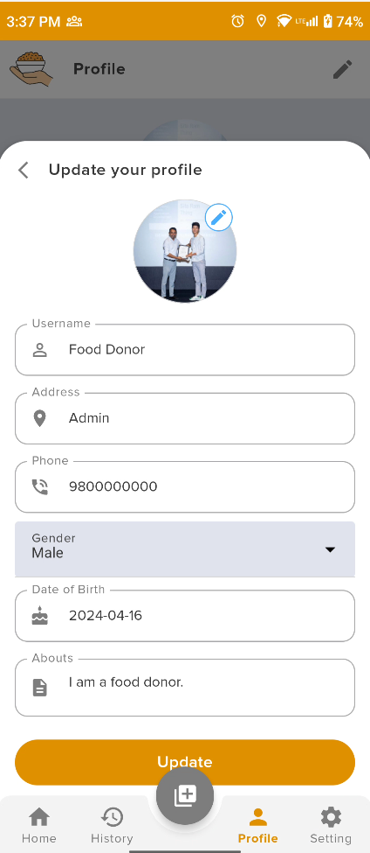

Figure 190: before updating the username in the profile

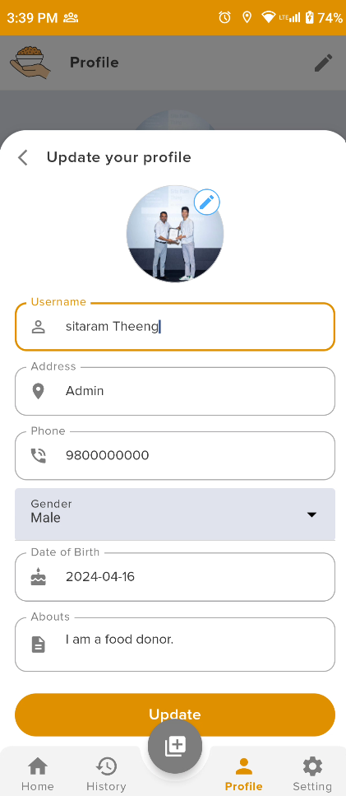

Figure 191: Update food profile username

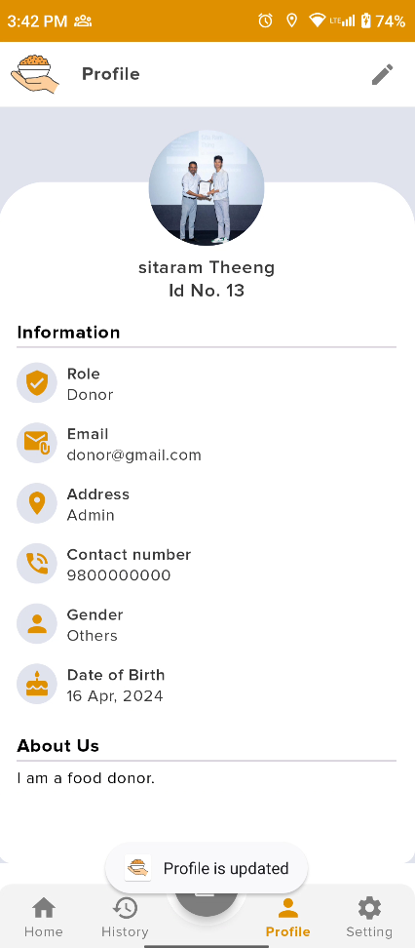

Figure 192: Latested updated user profile details

System testing findings and identified errors are detailed in the appendix.

## 4.3. Critical Analysis

The critical part of the systems development process lies in researching different topics and identifying the best approach for waste food management and food donation. Research plays a pivotal role in collecting data and identifying potential clients. The client then articulates their requirements, and the system's overall architecture is designed accordingly. Subsequently, the system's UI/UX design and database architecture are developed. Once the database development is complete, the Django Rest API is developed from Django to establish the backend. The backend facilitates the creation of the frontend web admin panel and mobile app for users. Each completed development part undergoes thorough testing, including API tests to ensure resolution and implementation of the front end. After completing the unit and system testing phases, a post-survey is conducted to fine-tune design and business logic. The final system test is then conducted to validate all features. The systems development phase encountered a major issue when the backend server failed to run, and the database decryption error arose. After some time, the issues were identified and resolved. Nonetheless, during the final stages, the mobile app encountered significant challenges, including class duplication and version duplication errors in Jetpack Compose. These issues necessitated further troubleshooting and resolution efforts.

The "Waste Food Management System" is developed by using stack in Kotlin, Jetpack Compose, Room database implemented to Android Mobile Applications and Python Django Rest Framework, HTML, CSS, MySQL Database implement to develop the Web and Backend system where it encountered several some problems. Despite these initial challenges, the system persevered, with errors being identified and corrected as development progressed. Eventually, all components of the project passed through both self-conducted unit and system tests, indicating a robust development process. The system now stands fully operational, boasting all the features outlined in its initial proposal. However, the testing phase not only identified areas for correction but also provided valuable insights into potential improvements and future development avenues.

User system testing for the latest version of the system provided crucial feedback from potential end-users. While certain features such as data capture and visualization were well-received, other aspects, notably the web user interface, did not garner the expected attention. User feedback highlighted the need for real-time comprehensive descriptions of intruders, suggesting a crucial area for future development. Additionally, users expressed a preference for mobile message alerts over email notifications, firebase push notifications, Google Maps, and Local Notification, for admin alerts, indicating an opportunity to enhance the system's alerting mechanisms. Furthermore, the successful incorporation of machine learning algorithms, particularly Decision Tree and Logistic Regression, showcased the system's advanced capabilities in traffic analysis. However, there remains room for exploration of more complex models to further enhance accuracy and predictive capabilities. Where issues and problems are successfully solved with the help of research and development skills.

In conclusion, the food donation system exhibits resilience and adaptability in its development journey, overcoming initial challenges to emerge as a fully functional platform. While it successfully implements key features and demonstrates advanced capabilities in traffic analysis, user feedback has illuminated areas for improvement, such as real-time data visualization and enhanced alerting mechanisms. Moving forward, a focus on addressing user needs, refining system functionalities, and exploring advanced modelling techniques will be crucial to ensuring the system's continued effectiveness and relevance in addressing food waste and security challenges.

# CHAPTER 5: CONCLUSION

In conclusion, developing the "Food Share" app which is a waste or surplus food management system represents a significant stride towards addressing food waste while fostering community engagement and social responsibility. Through the adoption of a scrum methodology, the project progressed methodically, overcoming complexities in mobile development and user interface design. Guided by the goal of creating a comprehensive solution accessible to various user groups involved in the donation process, the platform aims to streamline interactions and facilitate a cohesive donation process.

Utilizing technologies like Kotlin with Jetpack Compose for mobile development and HTML, CSS, and Bootstrap for web development, user experience has been prioritised across both platforms. Features like notifications and Google Maps integration enhance user engagement and highlight donation locations. As the project nears its conclusion, the focus shifts to final testing to ensure a flawless user experience before deployment. Plans include ongoing expansion and improvement, particularly in enhancing communication features to foster better collaboration among users.

Despite initial simplicity, the project presented obstacles requiring unwavering commitment and correction of mistakes during development. Guided by provided guidelines and constant advice, adjustments were made to ensure the project's quality met expectations. The project provided valuable learning experiences in various technologies including Jet Pack Compose, Kotlin, Bootstrap, Python, Django, MVVM with Clean Architecture, SQL and Room Databases, and Scrum Methodology.

Working on the project provided insight into real-world app development and collaboration with clients, contributing to a sense of professionalism. Additionally, my experience with version control using git, task management with Trello, and comprehensive documentation creation enriched my understanding and skills. Ultimately, the project facilitated learning and practical application of new languages and frameworks, enhancing readiness for future career endeavours.

## 5.1. LEGAL, SOCIAL AND ETHICAL ISSUES

### 5.1.1. LEGAL ISSUES

During the development of the "Food Share" app, we ensured strict adherence to legal standards. The system was meticulously designed to comply with user data protection laws and regulations. Clear terms and conditions were provided to users regarding data handling practices. To safeguard privacy, user activity logs were anonymized, and users were given the option to control their data-sharing preferences. Additionally, comprehensive documentation of all project materials and resources further reinforced our commitment to legal compliance, fostering transparency and accountability throughout the development process.

### 5.1.2. SOCIAL ISSUES

The "Food Share" app catalyzes inclusivity and community empowerment. It transcends cultural and economic barriers, offering accessibility to all sectors of society. By prioritizing transparency and integrity, the app cultivates trust and collaboration among users, thereby enhancing social cohesion. With a steadfast commitment to fair and equitable resource distribution, the app works towards mitigating disparities and advancing collective welfare.

### 5.1.3. ETHICAL ISSUES

Ethical integrity is paramount in the development and operation of the "Food Share" app. Upholding intellectual property rights and fostering a culture of integrity in software development are central tenets. Ethical considerations extend to data privacy and security, with robust measures implemented to protect user information from unauthorized access or misuse. By adhering to principles of transparency and respecting user autonomy, the app upholds ethical standards in all interactions.

## 5.2. Advantages of waste food or surplus food donation system

Advantages of the "Food Share" App:

* Utilize waste food effectively and efficiently, reducing food waste and promoting sustainability.
* Raise social awareness about food waste, fostering a culture of responsible consumption and environmental stewardship.
* Facilitate food donation and distribution, connecting food donors with those in need and contributing to hunger alleviation efforts.
* Encourage responsible food handling and safety practices, ensuring the safety and quality of donated food items.
* Promote a sense of community and social responsibility, fostering collaboration and collective action towards addressing food insecurity and waste reduction.
* Efficiently reduce food waste through surplus food management, optimizing resource utilization and minimizing environmental impact.
* Alleviate hunger by efficiently connecting food donors with individuals experiencing food insecurity, ensuring equitable access to nutritious meals.
* Promote community engagement and social responsibility by facilitating collaboration among users and encouraging active participation in food donation initiatives.
* Streamline the donation process with user-friendly interfaces and communication features, enhancing accessibility and usability for all stakeholders.
* Provide opportunities for skill development and learning for project contributors, fostering professional growth and expertise in social impact initiatives.
* Ensure scalability and continuous improvement, enabling the app to adapt to evolving user needs and challenges and maximize its positive social impact.

## 5.4. Limitations

Every application has its own set of benefits and drawbacks. This system lacks full user control, where donors have access to donate food and maintain their profile details, including updating, deleting, and managing them, while volunteers also have access to view donor details and donation information, along with the capability to communicate with donors and accept food for distribution. Volunteers can then pick up the food and proceed to distribute it to poor and homeless people in certain areas. In addition to the benefits listed above, this system has certain limitations as listed below:

### 5.1.1 Limited User Control:

Particularly volunteers and donors, may not have full control over their profile information and donation activities. This lack of control could lead to concerns about privacy and security.

### 5.1.2 Risk of Misuse:

Since donors can update, delete, and maintain their profile details, there's a risk of misuse or inaccurate information being provided, which could impact the effectiveness of the donation process.

### 5.1.3 Potential for Inefficiency:

Allowing donors to directly update and delete their donation information may lead to inefficiencies in the system, such as duplicate entries or inaccurate inventory management if proper oversight and validation mechanisms are not in place.

### 5.1.4 Limited Transparency:

While volunteers have access to view donor profiles and donation details, there may be limitations in transparency regarding the handling and distribution of donated food. This lack of transparency could raise concerns about accountability and trust within the community.

### 5.1.5 Dependency on Volunteer Availability:

The system relies heavily on the availability and commitment of volunteers to pick up and distribute donated food to the intended recipients. Fluctuations in volunteer availability could lead to inconsistencies in food distribution and service delivery.

### 5.1.6 Geographical Constraints:

The system's distribution model, where volunteers distribute food to specific areas, may create geographical constraints, limiting access to surplus food for individuals in remote or underserved locations.

### 5.1.7 Communication Challenges:

While volunteers can communicate with donors to accept food donations, there may be challenges in communication efficiency and effectiveness, particularly if there's a lack of standardized communication protocols or language barriers between volunteers and donors.

### 5.1.8 Limited Platform Availability:

The exclusivity to the Android app means users without Android devices, such as iOS users or those preferring web platforms, cannot access the system, restricting their participation and potentially reducing the overall impact of the surplus food donation initiative.

### 5.1.9 Unequal Access:

The system's reliance on volunteers and donors with internet access and digital literacy skills may create barriers for individuals or organizations without access to technology, potentially excluding certain demographics from participating in the surplus food donation process.

Addressing these limitations through continuous monitoring, feedback mechanisms, and system enhancements can help improve the efficiency, transparency, and inclusivity of the surplus food donation system, ensuring its effectiveness in addressing food waste and supporting vulnerable communities.

## 5.3. FUTURE WORK

The system is currently developed solely for native Android. However, several crucial features need to be implemented in the future to enhance the systematic handling of food donations and improve performance. Users vary in their preferences, with some preferring a light mode while others may have visual impairments necessitating a different theme. Real-time communication is far more efficient than email or calls, allowing donors and volunteers to interact seamlessly, thereby improving performance and communication. The system would greatly benefit from being accessible across multiple platforms, allowing all users to utilize different platforms at their convenience. Therefore, the project needs to expand beyond native Android to accommodate this requirement.

The "Food Share" waste food management system application is a commendable project that aims to assist both surplus food managers and the impoverished and homeless. The three major features Dark Mode, Chat (Message), and Multi-platform are work in future.

### 5.3.1 Dark Mode

In the future, I will implement a dark mode feature to enhance the user experience. This addition will provide an alternative colour scheme that is easier on the eyes, especially in low-light conditions. By incorporating dark mode, the application will become more accessible and user-friendly, catering to a wider audience, and improving overall usability. Additionally, dark mode can help reduce eye strain and battery consumption on devices with Olde screens, making the application more energy efficient. The features are research online, websites and reference material guidelines, Jet Pack compose theming part and implements in future. The user can activate the theme of the appropriate program, or the user can enable it via his system settings. The application has a dark theme, giving users an additional experience and can even increase engagement through user identification.

### 5.3.2 Chat (Messaging)s

Integrating a chat or messaging functionality into the application will enable users, donors, and volunteers to communicate directly within the platform. This feature will facilitate seamless coordination between users, offering real-time assistance, and fostering a sense of community among participants in the food donation process. By allowing direct communication, the application will enhance user engagement and satisfaction. Moreover, the messaging feature can serve as a valuable tool for providing updates, notifications, and reminders related to food donations, improving overall user experience and engagement. This feature can facilitate coordination between users, provide real-time assistance, and foster a sense of community among participants in the food donation process.

The Chant or messaging features work in future where the shock is implemented to develop the messaging system. In future, I will learn about the more advanced Django Chanel and develop the socket API for two-way communication. This can be better and easier for the system user and flexible. With the help of Django Channels, a potent Django extension, you can create WebSocket-based real-time apps. With WebSockets, you can push changes to the client without the client having to constantly request data because they allow bidirectional communication between the client and the server. The fundamentals of Django Channels and WebSockets, as well as how to leverage them to create real-time applications, will be addressed in this section **Invalid source specified.**. The web socket implementation to fully develop the messaging services in future.

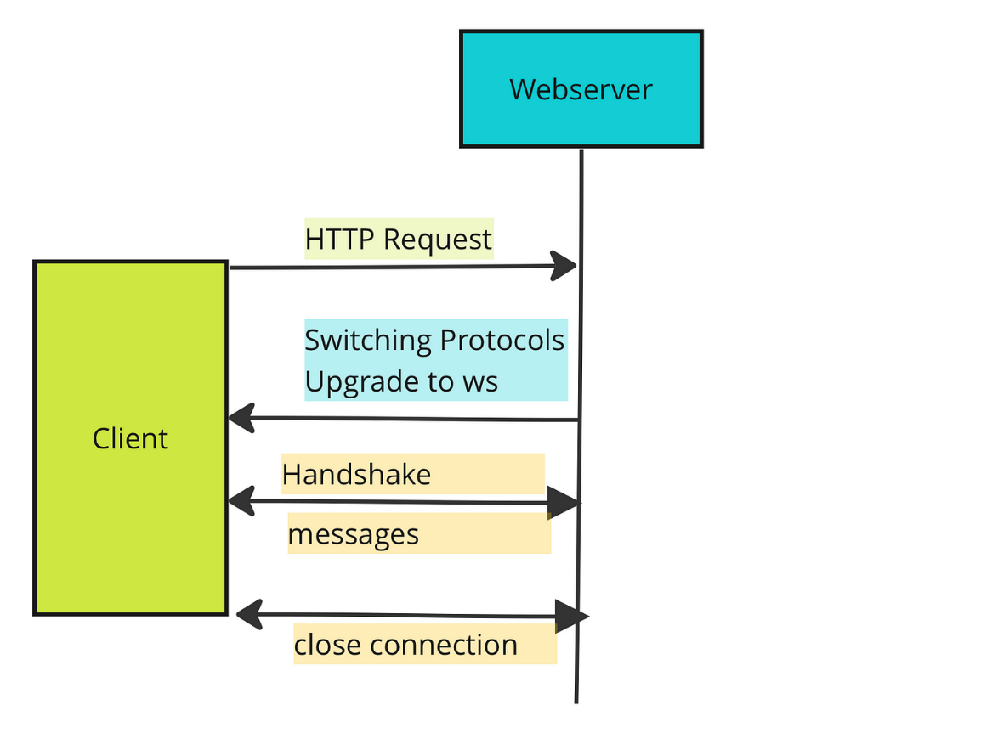

Figure 193: Future work Socket implementation for Chat.

### 5.3.3. Kotlin multi-platform

Adopting Kotlin multi-platform development in the future will revolutionize our approach to app development. This strategy will enable us to share code logic across different platforms, including Android, iOS, and the web. Leveraging Kotlin's multi-platform capabilities, we can streamline development efforts, reduce code duplication, and ensure consistency across all versions of the application. By embracing this approach, we will enhance maintainability and scalability while optimizing resource utilization, leading to a more efficient and robust system overall. Additionally, Kotlin's interoperability with existing Java codebases will facilitate seamless integration and transition, minimizing development time and effort. Adopting Kotlin multi-platform development would enable us to share code logic across different platforms, such as Android, iOS, and the web. By leveraging Kotlin's multi-platform capabilities, we can streamline development efforts, reduce code duplication, and ensure consistency across all versions of the application. This approach enhances maintainability and scalability while optimizing resource utilization.

Kotlin Multiplatform technology makes it easier to construct cross-platform solutions. It saves time on creating and maintaining the same code for several platforms while preserving the flexibility and benefits of native programming. Check out the Get Started with Kotlin Multiplatform and Construct a Multiplatform App Using Kator and SQL Delight lessons. These lessons will teach you how to construct Android and iOS mobile apps with desktop and web applications incorporating a module with shared code for both platforms. **Invalid source specified.**

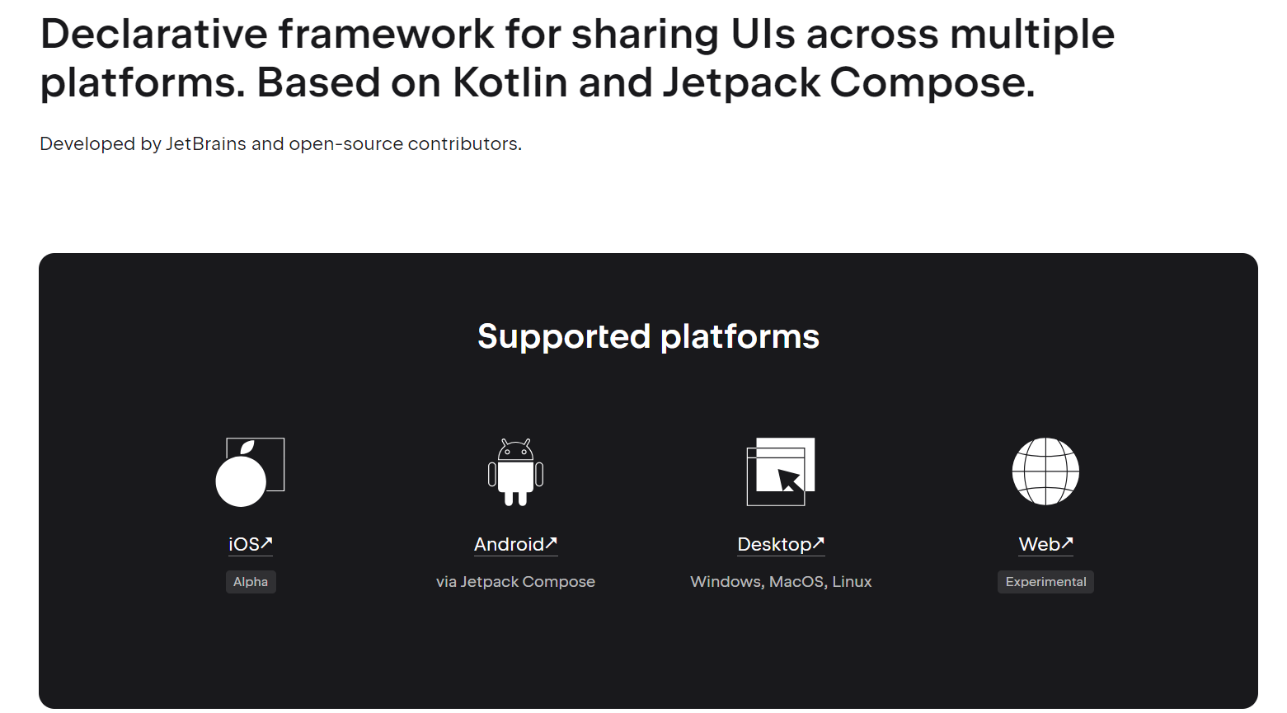

Figure 194: Future work for multi-platform.

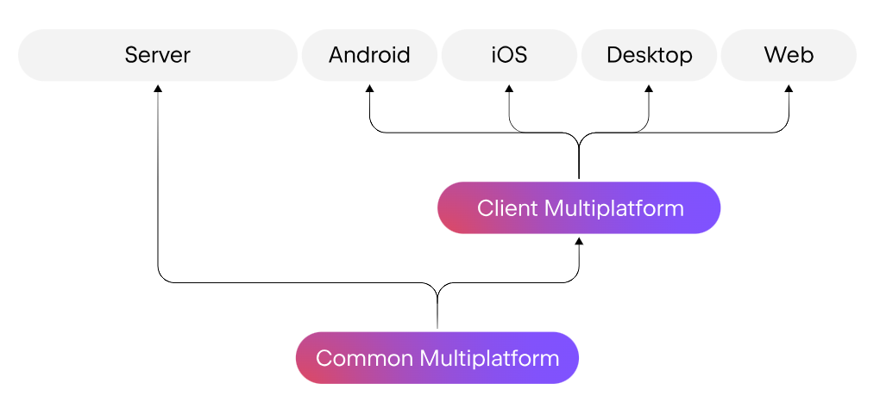

Figure 195: Multiplatform connection

# CHAPTER 6: References

AWS. (2024, 04 13). *What is Scrum***?** Retrieved from AWS: https://aws.amazon.com/what-is/scrum/#:~:text=Scrum%20is%20a%20management%20framework,experience%2C%20and%20adapt%20to%20change.

Chiarelli, A. (2024, 04 19). *Auth0 by Okta*. Retrieved from THE CONFUSED DEVELOPER: https://auth0.com/blog/id-token-access-token-what-is-the-difference/

Dave Lampert, M. S. (2024, 04 07). *Now Fair Food NZ*. Retrieved from Food Rescue: https://fairfood.org.nz/about-us/our-story/#impact

Dave Lampert, M. S. (2024, 04 07). *Food Reduces*. Retrieved from Food Reduces Us: https://foodrescue.us/our-app/

Developer, G. (2024, 04 23). *Developer*. Retrieved from Save data in a local database using Room: https://developer.android.com/training/data-storage/room

developer, G. (2024, 04 18). *FCM*. Retrieved from Firebase: https://firebase.google.com/docs/cloud-messaging/android/client

Developer, G. (2024, 04 23). *Google for the developer*. Retrieved from Build Better Apps Faster with: https://developer.android.com/develop/ui/compose

Dhanajay Jhala, K. s. (2021). Spread the smile. *Food Donation*, p. 51.

*Django Rest Framework*. (2024, 04 22). Retrieved from Serializers: https://www.django-rest-framework.org/api-guide/serializers/

GeekForGeek. (2024, 04 21). *GeekForGeek*. Retrieved from Levels in Data Flow Diagrams (DFD): https://www.geeksforgeeks.org/levels-in-data-flow-diagrams-dfd/

GeekForGeek. (2024, 04 21). *Unified Modeling Language (UML)*. Retrieved from Use Case Diagrams: https://www.geeksforgeeks.org/use-case-diagram/

Google. (2024, 04 17). *Developer*. Retrieved from Save simple data with SharedPreferences: https://developer.android.com/training/data-storage/shared-preferences

Inc, L. S. (2024, 04 21). *Lucidechart*. Retrieved from Entity Relationship Diagram: https://www.lucidchart.com/pages/er-diagrams

JavaTpoint. (2024, 04 13). *Software Engineering*. Retrieved from www.javatpoint.com: https://www.javatpoint.com/software-engineering-prototype-model

Kruthika V, L. H. (07, July-2023). INTEGRATED APPROACH FOR FOOD DONATION SYSTEM, RESTAURANT. *International Research Journal of Modernization in Engineering Technology and Science*, 8.

Kruthika V, L. H. (07, July-2023). INTEGRATED APPROACH FOR FOOD DONATION SYSTEM, RESTAURANT. *International Research Journal of Modernization in Engineering Technology and Science*, 8.

Levan, M. (2024, 04 20). *TeachTargate*. Retrieved from Unit Testing: https://www.techtarget.com/searchsoftwarequality/definition/unit-testing

local government bodies, N. (2024, 04 07). *Flashfood Grocery deals*. Retrieved from Google Play Store: https://play.google.com/store/apps/details?id=com.flashfoodapp.android&hl=en&gl=US

LUMITEX. (2024, 04 13). Prototyping Methodology. *Dow Circle Strongsville, Ohio*, p. 10.

Mello, M. (2024, 04 21). *System Architecture*. Retrieved from The Blueprint for Successful Systems: https://dev.to/msmello_/system-architecture-the-blueprint-for-successful-systems-35nn

MkDocs. (2024, 04 21). *Django REST framework*. Retrieved from Django: https://www.django-rest-framework.org/api-guide/serializers/

Nepal, G. o. (2020-2021). Nepal towards an equitable, resilient and sustainable food system. *Nepal’s Food Systems Transformation*, 64.

Nepal, G. o. (2020-2021). Nepal towards an equitable, resilient and sustainable food system. *Nepal’s Food Systems Transformation:* p. 64.

Nick Barney, M. E. (2024, 04 21). *TeachTargate*. Retrieved from authentication: https://www.techtarget.com/searchsecurity/definition/authentication

Reichert, A. (2024, 04 20). *TeachTargate*. Retrieved from system testing: https://www.techtarget.com/searchsoftwarequality/definition/system-testing

S, B. (2024, 04 13). *nimble Humanize work*. Retrieved from Scrum Project Management: https://www.nimblework.com/agile/scrum-methodology/

Singtel, P. (2024, 04 23). *Altexsoft*. Retrieved from What is API: https://www.altexsoft.com/blog/what-is-api-definition-types-specifications-documentation/

StevenSwiniarski. (2024, 04 18). *Codecademy*. Retrieved from POJO: https://www.codecademy.com/resources/docs/java/pojo

Theil, D. (2024, 05 13). *LogRoceket*. Retrieved from Understanding the waterfall methodology: https://blog.logrocket.com/product-management/waterfall-methodology-guide/#:~:text=The%20waterfall%20methodology%20is%20a%20linear%20and%20sequential,well-defined%20project%20requirements%2C%20and%20a%20structured%2C%20predetermined%20timeline.

Weir, S. P. (2024, 04 22). *Wikipedia*. Retrieved from Data Transfer Object: https://en.wikipedia.org/wiki/Data_transfer_object

# CHAPTER 7: APPENDIX

## 7.1 Appendix A: Introduction

### 7.1.1 Current Scenario Additional information

Concurrently, in many developing nations like Nepal, food insecurity remains a pressing concern despite ample food resources. Limited infrastructure for storage, transportation and costly prices to some low-income sources people cannot afford food coupled with poor market linkages and awareness, exacerbates the problem of food wastage. Even as a significant portion of the population faces hunger and malnutrition, surplus food, often deemed unsuitable for sale due to cosmetic imperfections or nearing expiration dates, goes to waste. This paradox highlights the critical need for innovative solutions to bridge the gap between surplus food sources and vulnerable communities.

In Nepal, where 5.1% of the employed population lives below the poverty line of $1.90 purchasing power parity/day, the challenge of food waste exacerbates existing inequalities. Effectively managing this surplus could significantly alleviate hunger and malnutrition in communities where access to food remains a daily challenge. Addressing this issue requires a multifaceted approach, including the implementation of efficient distribution channels, community education on food preservation and utilization, and the creation of systems that redirect surplus food to those in need. By ensuring that valuable resources are not needlessly discarded, while many go without adequate nutrition, these efforts can contribute to a more equitable and sustainable food system.

**Go back to the same page**

## 7.2 Appendix B: Background

### 7.2.1 About the End User

### 2.2.1.1 Web (Admin)

The admin interface is primarily accessed through a web browser. Administrators are responsible for managing and overseeing the entire system. Their tasks may include:

* Managing user accounts and permissions.
* Monitoring donation and distribution processes.
* Analyzing data and generating reports.
* Configuring system settings and parameters.

### 2.2.1.2 Mobile

Donor: Individuals or organizations who wish to donate food can use the mobile app to initiate and track their donations. Donors may perform tasks such as:

* Registering as a donor and providing necessary information.
* After verifying the account verified then log in to the system.
* Scheduling for food donations and donations, updates etc.
* Viewing donation history and receipts.
* Update his/her profile account details.
* Complain the volunteers if they cannot pick up the food.
* View donates food and updates information.

Volunteer: Volunteers play a crucial role in facilitating the collection and distribution of donated food. Their responsibilities may include:

* Registering as volunteers and specifying availability.
* Receiving notifications about donation pickups or distribution events.
* Updating the status of pickups or deliveries.
* Donation completed the send the email to the donor.
* Update his/her profile account details.
* Complaint to the donor if can’t provide the food.
* View donated food details with Google Maps to the location.
* View donor profile details.

Admin: Admin who also used the mobile app for user account verification and report verification.

* Log in to the application on mobile devices.
* Verify the new user and give access or authentication for using the system.
* The donor and volunteer can complete or report verification where food donation time has any problem and give the punishment.
* Update the admin user account details.

Farmer: Farmers who produce surplus food can use the mobile app to coordinate with the platform for donations. Their tasks may involve:

* Registering as farmers and providing details about their produce.
* Indicating availability for donation.
* Communicating with donors or administrators regarding pickup logistics. the farmer can date expired food collected to be used for farming.
* The unhealthy food received from the donor.

Each end-user group has specific functionalities tailored to their role within the food share donation ecosystem, ensuring smooth operation and effective utilization of resources.

**Go back to the same page**

## 7.3 Appendix C: Methodology

### 7.3.1 Survey

#### 7.3.1.1 Pre-Servay Form Questions

The pre-survey forma questions are given below:



Figure 196: Pre-survey form introduction with username

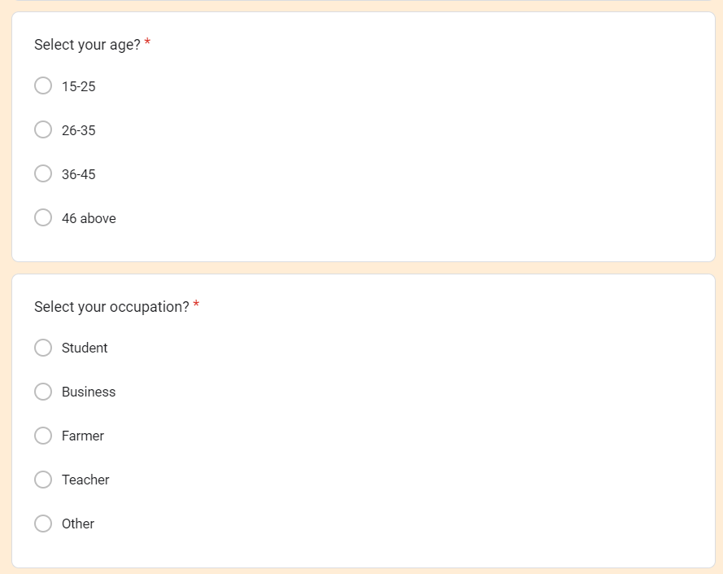

Figure 197: Pre-survey questions of age and occupation

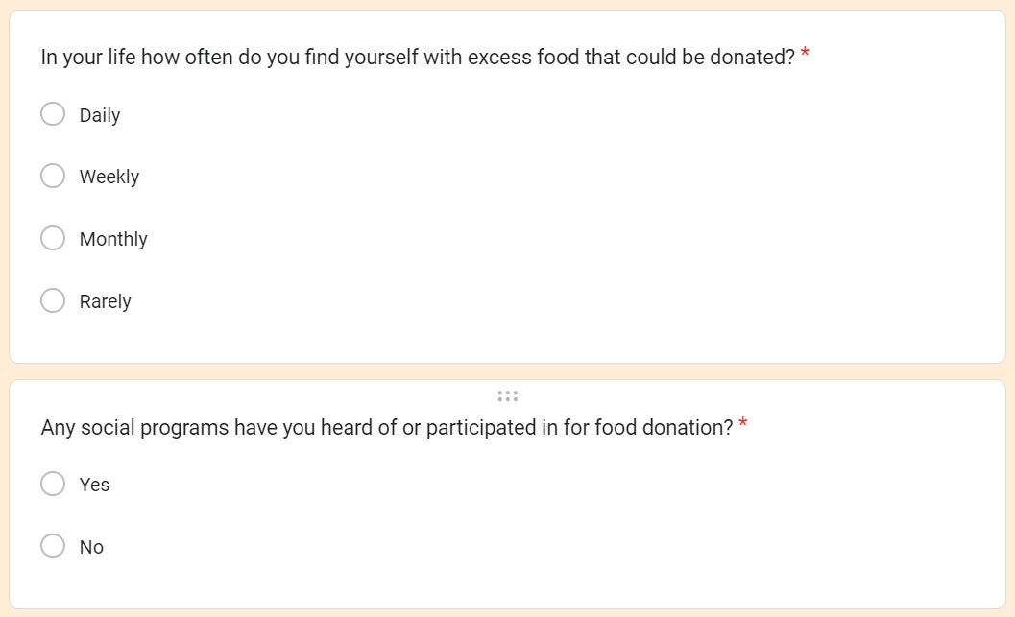

Figure 198: Pre-survey questions of what could be donated and participants to the event

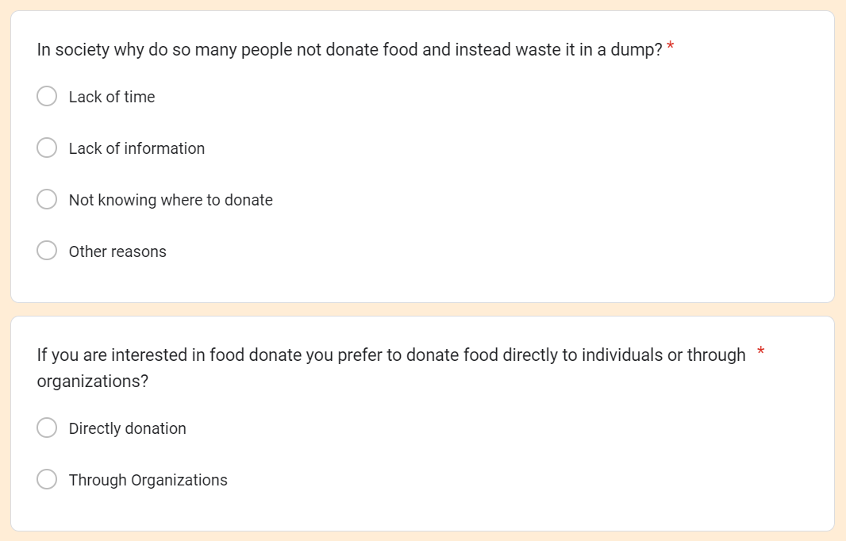

Figure 199: Preservay questions about the food of dump or donate and directly donate or through organizations

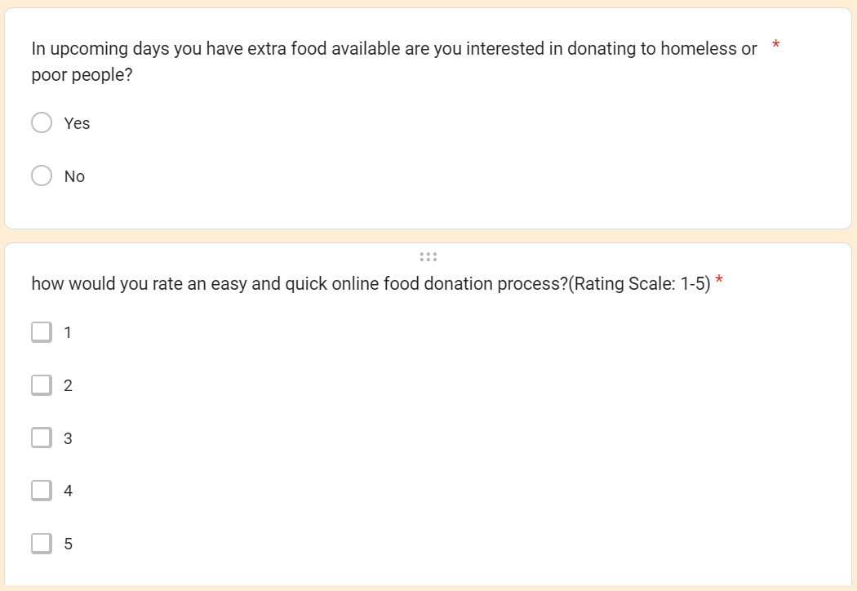

Figure 200: Pre-survey question of interest for donation and rating point of the system

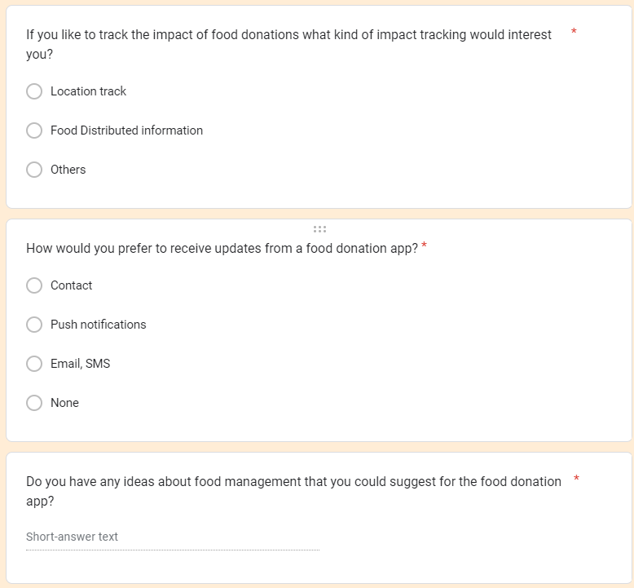

Figure 201: Preservay questions of impact, updates, and suggestions for the system

#### 7.3.1.2 Pre-Servay Form Filled Sample

The pre-survey forma filled sample is given below:

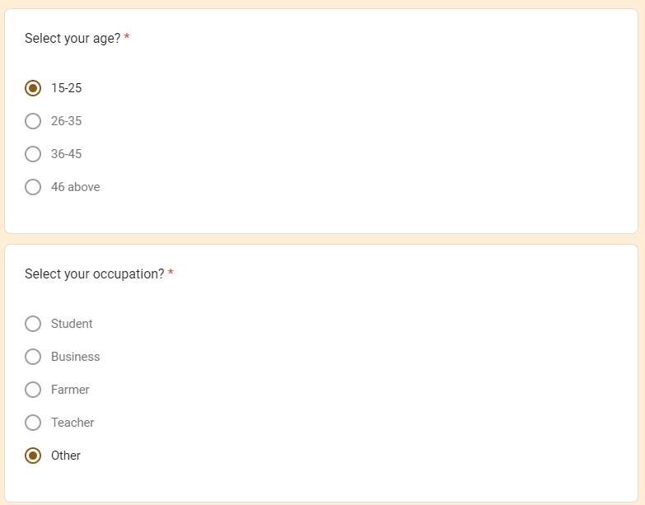

Figure 202: Pre-survey questions filled with a sample of age and occupation

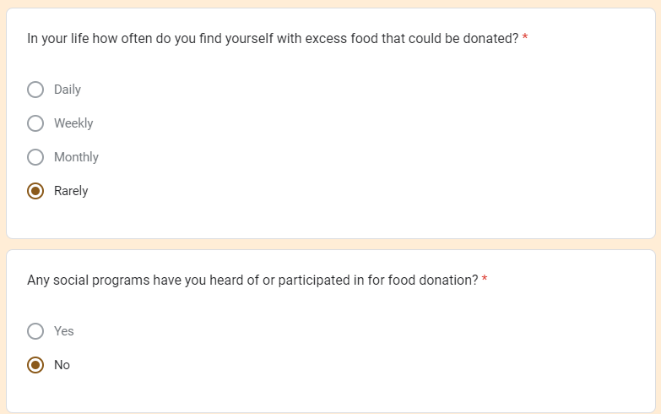

Figure 203: Pre-survey questions filled sample of what could be donated and participants to the event

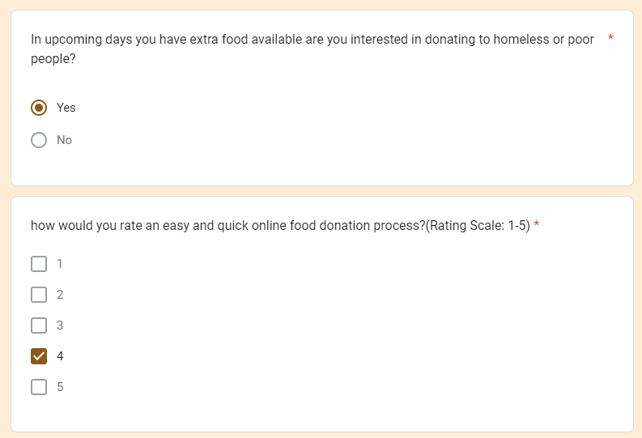

Figure 204: Preservay questions about the food-filled sample of dump or donate and directly donate or through organizations

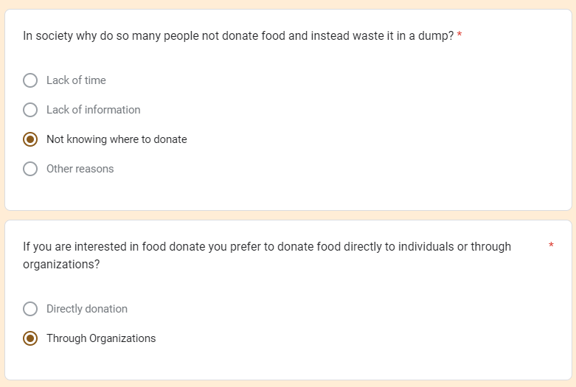

Figure 205: Pre-survey questions filled sample of interest for donation and rating point of the system

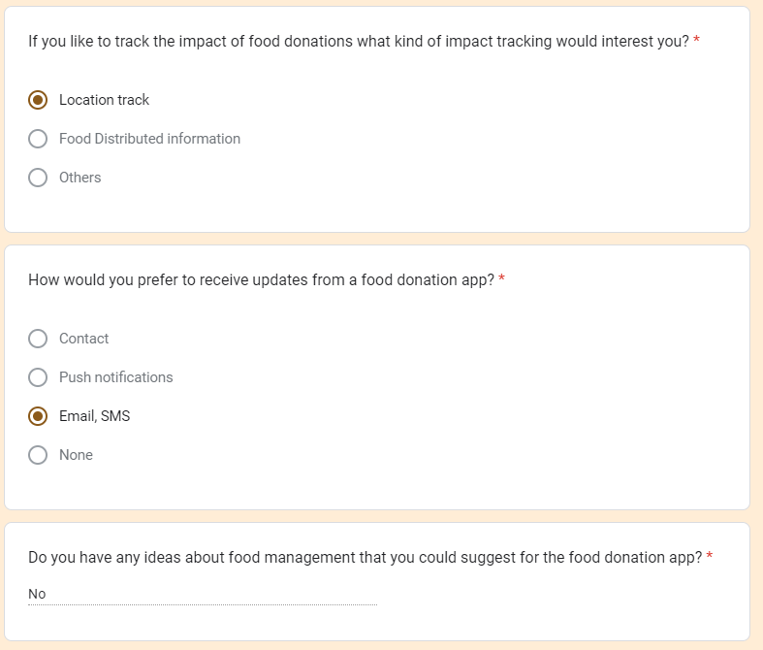

Figure 206: Preservay questions filled sample of impact, updates, and suggestions for the system

**Go back to the same page**

#### 7.2.1.3 Post-Servay Form Questions

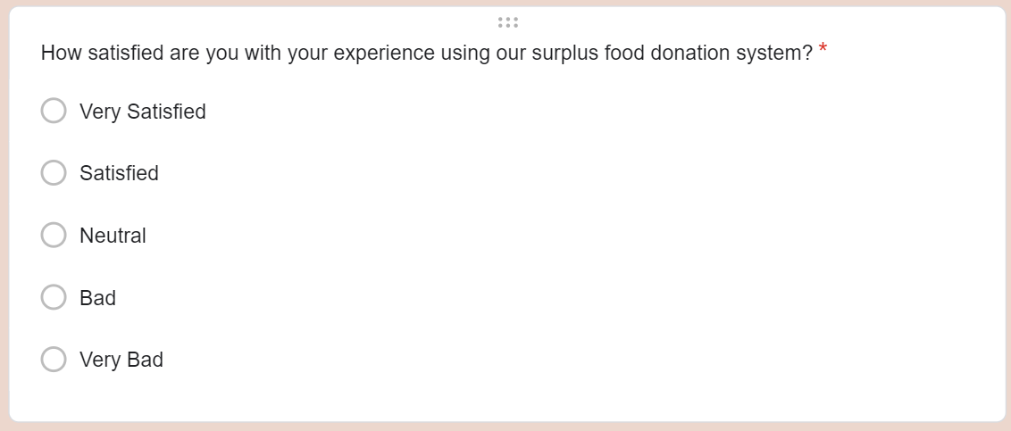

Figure 207: Post-survey questions of user experience

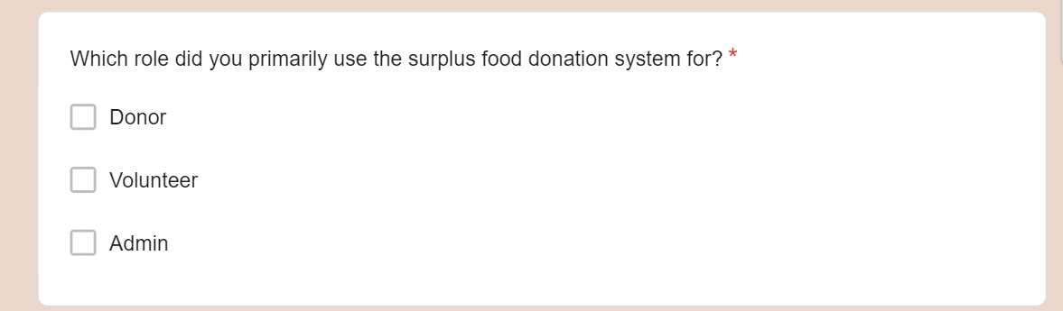

Figure 208: Post survey questions of user role

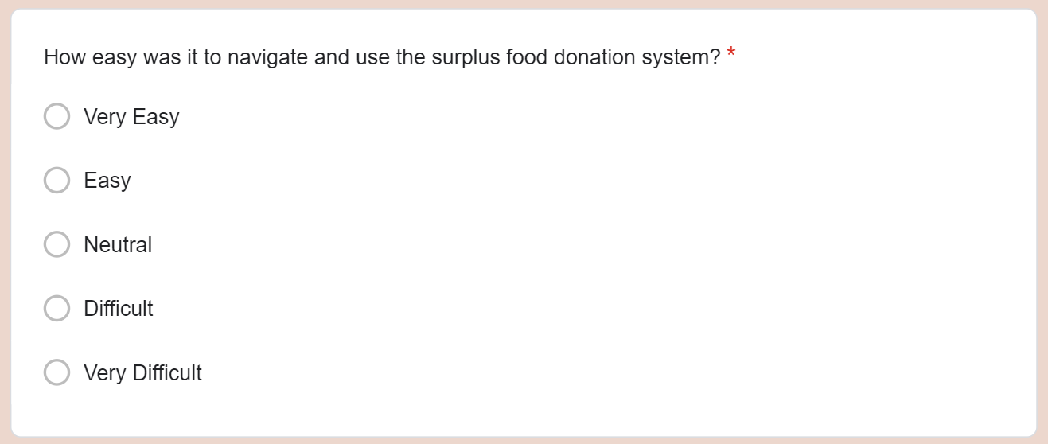

Figure 209: Post survey question of system navigation of surplus food donations system

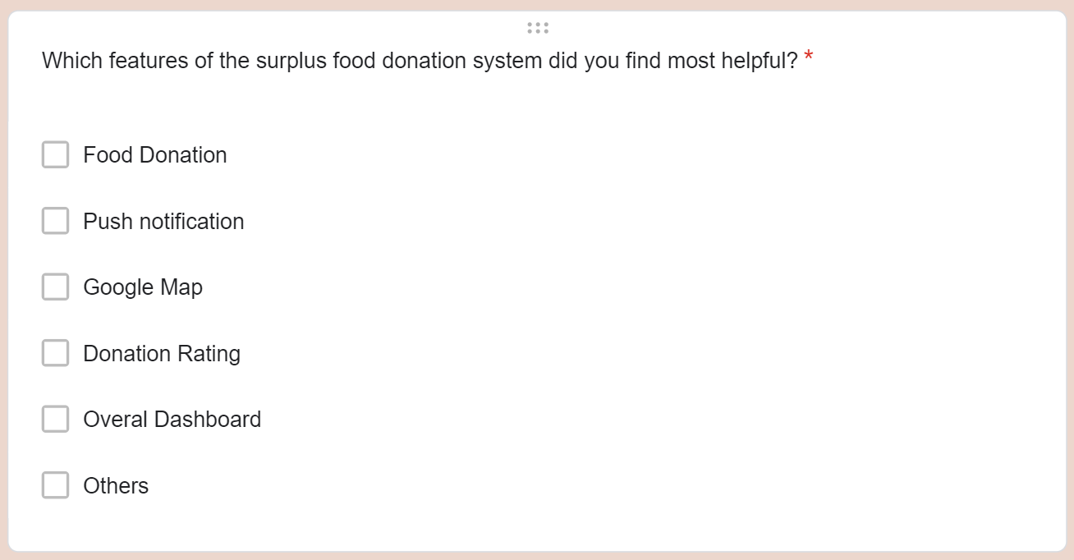

Figure 210: Post-survey question of donations system which features is helpful

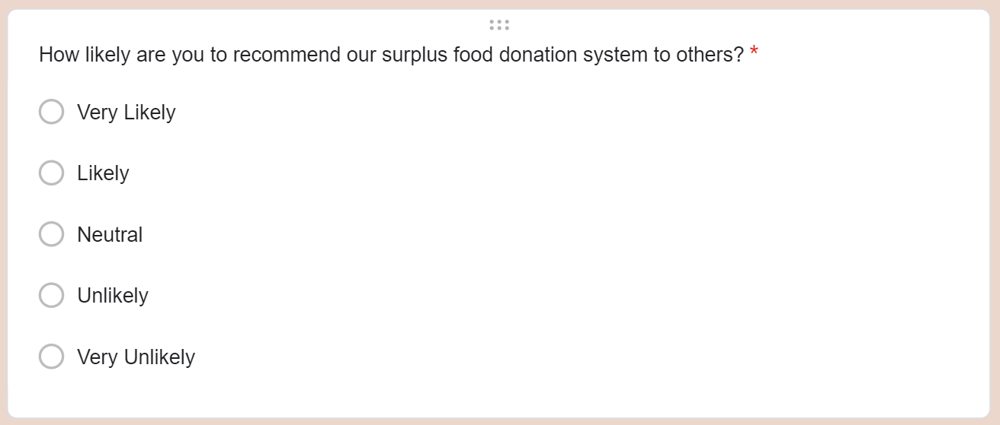

Figure 211: Post-survey of user recommend questions food donations system

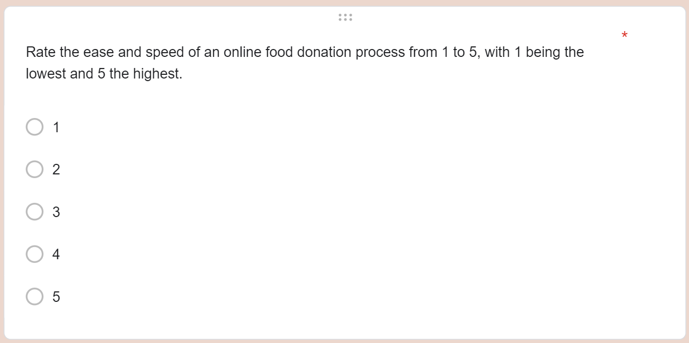

Figure 212: Post-survey questions of a rating point to the overall system

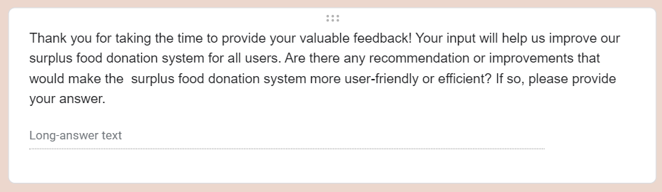

Figure 213: Post-survey of feedback optional questions

#### 7.2.1.4 Post-Servay Form Filled sample

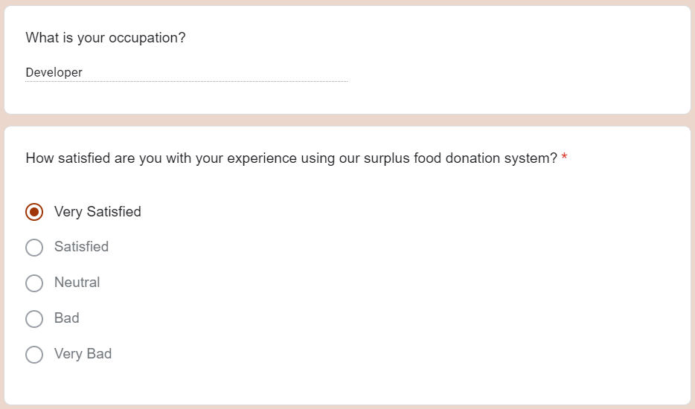

Figure 214: Post-survey questions filled sample of user experience

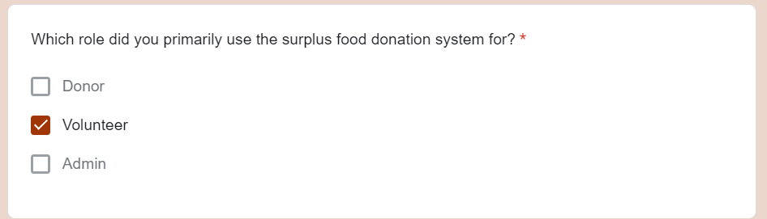

Figure 215: Post survey questions filled sample of user role

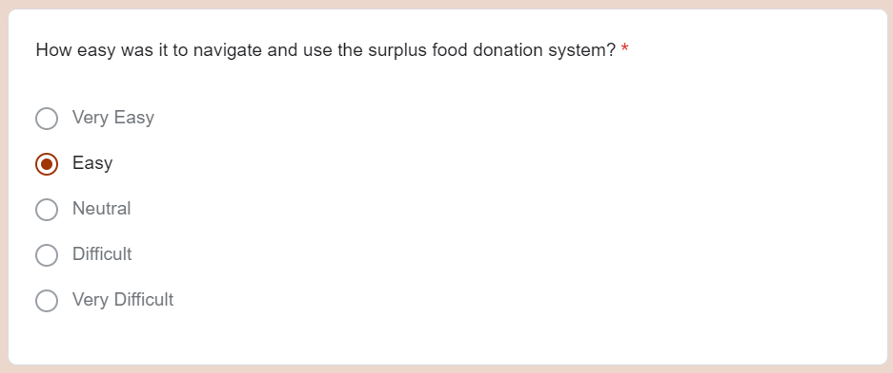

Figure 216: Post survey question filled sample of system navigation of surplus food donations system

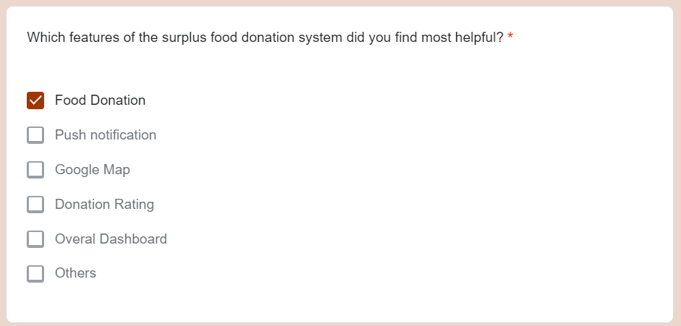

Figure 217: Post-survey question filled sample of donations system which features is helpful

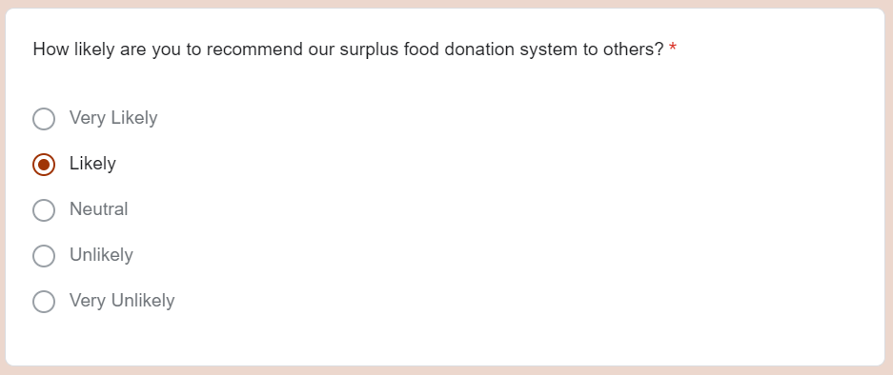

Figure 218: Post-survey filled sample of user recommend questions food donations system

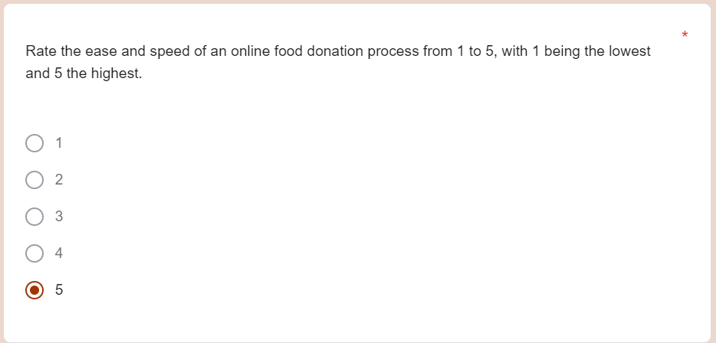

Figure 219: Post-survey questions filled sample of a rating point to the overall system

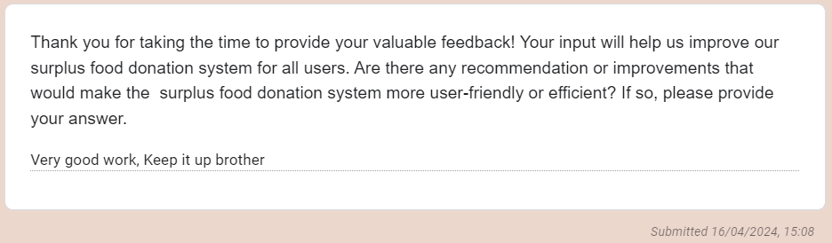

Figure 220: Post-survey of feedback optional filled sample

**Go back to the same page**

### 7.3.2 UML Diagram

#### 7.3.2.1 Use Case

* User Registration

Description: Users can register on the system. The admin verifies the registered details. If the registration details are valid, a success message is displayed; otherwise, an error message is shown.

* The user provides registration details.
* Admin verifies the registration details.
* If the details are valid, a success message is displayed.
* If the details are not valid, an error message is shown.
* User Login

Description: Registered users can provide their login details to access the system. The system authenticates the login details. If authentication is successful, the user can log in; otherwise, an error message is displayed.

* The user provides login details.
* The system authenticates the login details.
* If authentication is successful, the user is logged in.
* If authentication fails, an error message is displayed.
* View History

Description: Users can view their donation history. The system verifies the request and shows the donation history details.

* The user requests to view donation history.
* The system verifies the request.
* The system displays the donation history details.
* Donate Food

Description: Donors can post new food donations on the system. Users can view the details of food donations. Volunteers accept donated food for distribution. After distribution, users give feedback by giving a donation rating for the food received.

* Donor posts new food donations.
* Users view food donation details.
* Volunteers accept donated food for distribution.
* After distribution, users provide feedback by giving a donation rating.
* Complaints

Description: Users can file complaints to the admin when Donated food is not provided during the designated time and no one comes to receive the donated food.

* The user files a complaint to the admin.
* Admin addresses the complaint.
* These use cases outline the various functionalities of the system and the flow of actions within each scenario.

**Go back to the same page**

#### 7.3.2.2 Expanded Use Case

The expanded use case is given below:

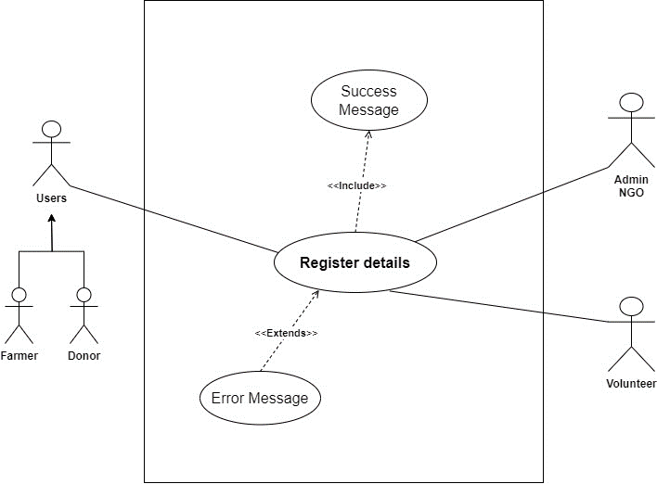

Figure 221: Register expanded use case

|  |  |  |
| --- | --- | --- |
| **Use Case:** | Register Details | |
| **Actors:** | Donor, Volunteer, NGO, Farmer | |
| **Descriptions:** | All users can input their respective details into the system. The system automatically registers the provided information upon submission, ensuring seamless integration and efficient data management. | |
| Typical Courses of Events: | | |
| **Donor, Volunteer, NGO, Farmer, Admin** | | **System Response** |
| 1. A user can provide the personal details for the register in the system. | |  |
|  | | 2. The system checks whether the provided details are valid or not. |
| 3. Request for register in the system. | |  |
|  | | 4. Conform register with a success message if no valid data, then show the error message. |

Table 52: Register user expanded use case table

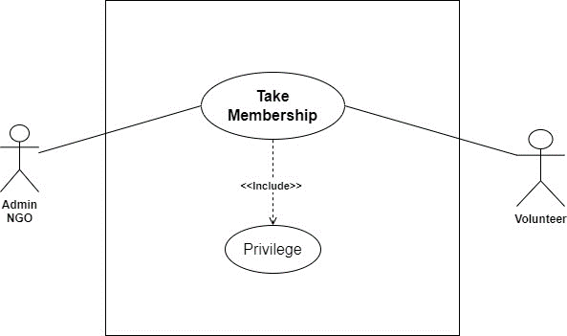

Table 53: Table membership Expanded use case

|  |  |  |
| --- | --- | --- |
| **Use Case:** | Take Membership | |
| **Actors:** | Volunteer, NGO | |
| **Descriptions:** | A new volunteer provides the personal details, and his/her details are registered with the system. The NGO provide the membership, and then volunteers take the new membership. | |
| Typical Courses of Events: | | |
| **Volunteer, NGO** | | **System Response** |
| 1. A new volunteer can provide the personal details for the registered membership in the NGO. | |  |
|  | | 2. Check the Volunteer details. |
| 3. Request to take membership in the NGO. | |  |
|  | | 4. Confirm the registered membership and give the privilege. |

Table 54: Take membership expanded use case table

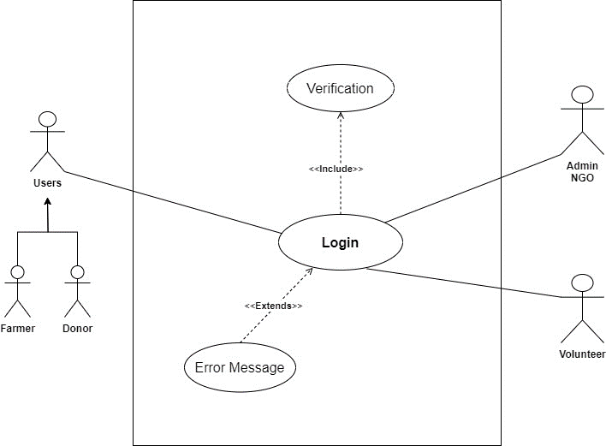

Table 55: Login expended use case diagram

|  |  |  |
| --- | --- | --- |
| **Use Case:** | Login | |
| **Actors:** | Donor, Volunteer, Farmer | |
| **Descriptions:** | After registering details in the system, all the users can provide valid details and log in to the system Then successfully log in to the system. | |
| Typical Courses of Events: | | |
| **Donor, Volunteer, Farmer** | | **System Response** |
| 1. A new user can provide the login details in the system. | |  |
|  | | 2. The system checks whether the provided details are valid or not. |
| 3. Request for login in the system. | |  |
|  | | 4. The system can navigate to the dashboard if valid data is provided to log otherwise shows the error message. |

Table 56: Login user expanded use case table

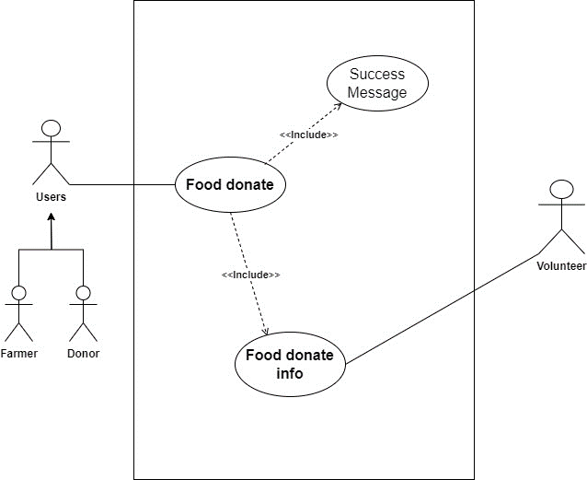

Table 57: Food donation expended use case diagram

|  |  |  |
| --- | --- | --- |
| **Use Case:** | Food Donation | |
| **Actors:** | Donor, Farmer, volunteers | |
| **Descriptions:** | The Donor or Farmer can donate the proper food information and details with location. The system can show the donation food details in the history after posting the donated food. | |
| Typical Courses of Events: | | |
| **Donor, Farmer** | | **Volunteers** |
| 1. A donor can post the food details for donation. | |  |
|  | | 2. After getting the donation information volunteers respond to the request to accept the food. |
| 3. Donors confirm to provide the food when contacted with the donor. | |  |
|  | | 4. Volunteers receive the food and go to distribute it. |

Table 58: Food donation user expanded use case table

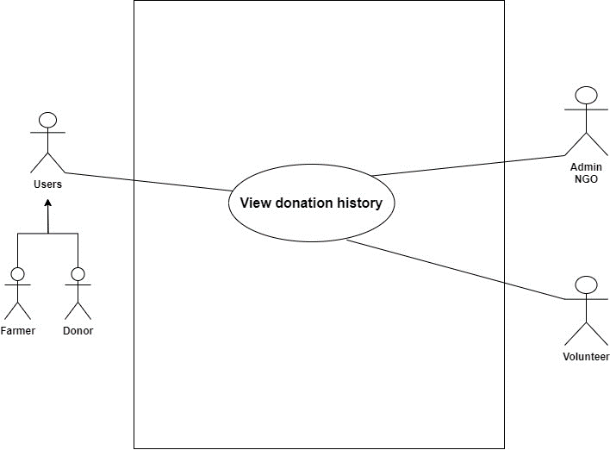

Table 59: View Donation history expended use case diagram

|  |  |  |
| --- | --- | --- |
| **Use Case:** | View Donation History | |
| **Actors:** | Volunteer, Farmer | |
| **Descriptions:** | All users can input their respective details into the system. The system automatically registers the provided information upon submission, ensuring seamless integration and efficient data management. | |
| Typical Courses of Events: | | |
| **Volunteer, Farmer** | | **System Response** |
| 1. A volunteer can view the donation post food details. | |  |
|  | | 2. show the donation food details with all information like food, donor, and location details. |
| 3. View the donated location. | |  |
|  | | 4. The system can show the food donated location with Google Maps. |

Table 60: View history user expanded use case table.

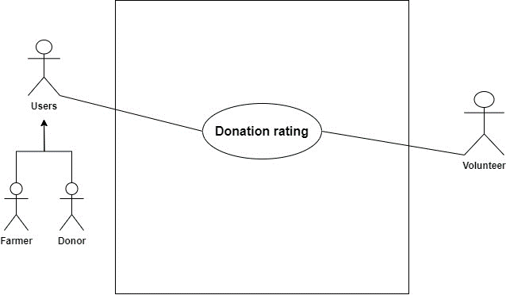

Table 61: Donation rating expanded use case diagram.

|  |  |  |
| --- | --- | --- |
| **Use Case:** | Donation Rating | |
| **Actors:** | Donor, Volunteer, Farmer | |
| **Descriptions:** | After the food is completely donated to some people the volunteer can give the donation rating to the donor with food distributed information. | |
| Typical Courses of Events: | | |
| **Volunteer** | | **Donor** |
| 1. After the food is received, give the donation rating with all the information. | |  |
|  | | 2. Get the donated rating info. |
| 3. Not possible to accept the donation of food if the volunteer cannot give a response. | |  |
|  | | 4. Volunteers do not respond to receive the food and when the expiration date is over the donor gets the expiration notification. |

Table 62: Donating rating expanded use case table

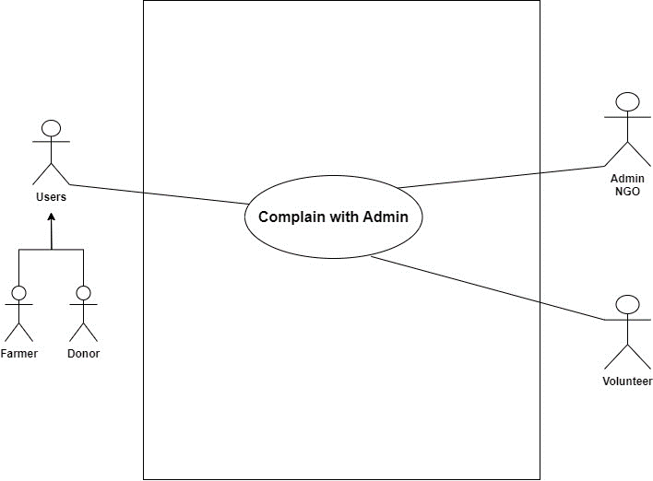

Table 63: Complaint with admin expanded use case diagram

|  |  |  |
| --- | --- | --- |
| **Use Case:** | Complain with Admin | |
| **Actors:** | Donor, Volunteer, Farmer | |
| **Descriptions:** | All users can input their respective details into the system. The system automatically registers the provided information upon submission, ensuring seamless integration and efficient data management. | |
| Typical Courses of Events: | | |
| **Donor, Volunteer, Farmer** | | **Admin Response** |
| 1. The food donation time donor volunteer and farmer can complain to the admin. | |  |
|  | | 2. Admin verifies the complaint and gives the warning. |
| 3. Received warning. | |  |

Table 64: Complaint with admin expanded use case table

**(Go back to the same page)**

#### 7.3.2 Sequence Diagram

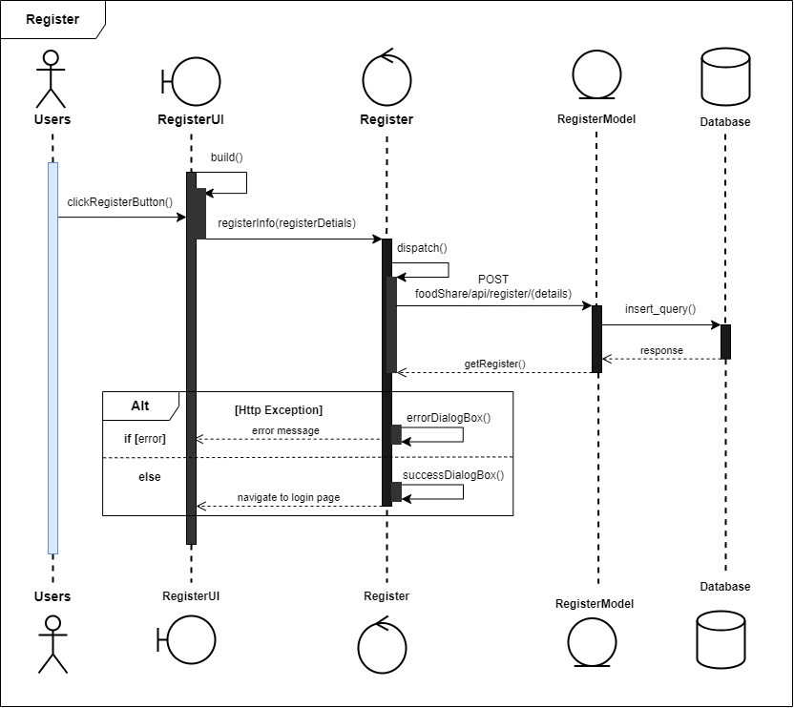

Figure 222: Sequence diagram of registered user

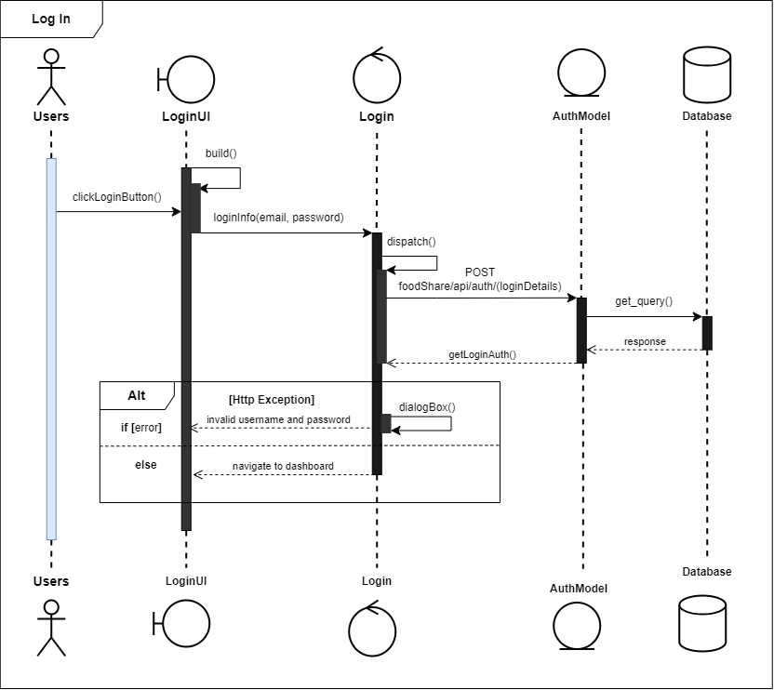

Table 65: Login sequence diagram

**(Go back to the same page)**

#### 7.3.2.3 Activity Diagram

Login Activity

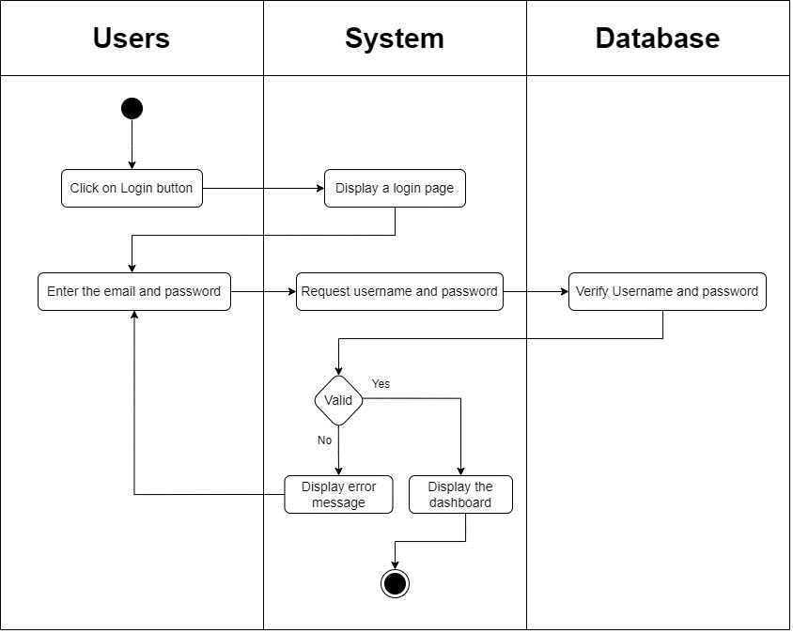

Figure 223: Login system activity diagram

Register Activity

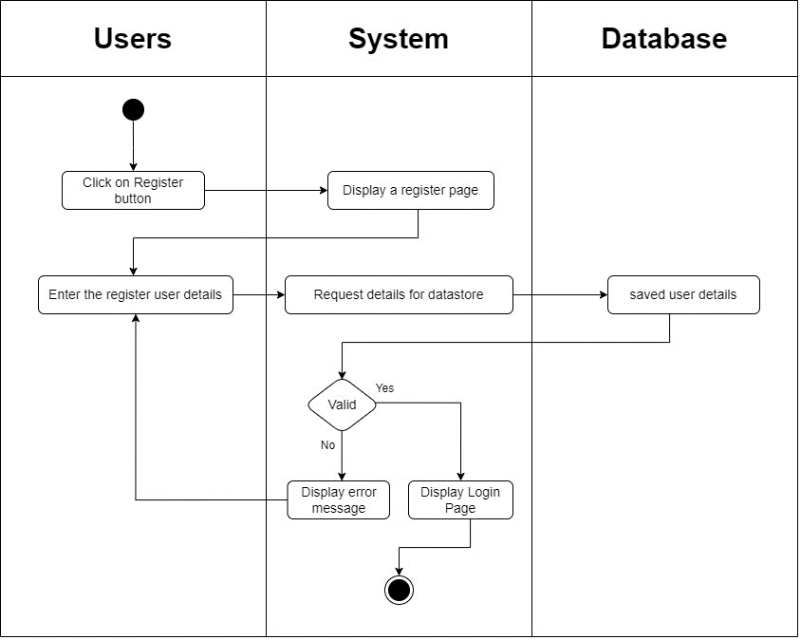

Figure 224: Register system activity diagram

Logout Activity

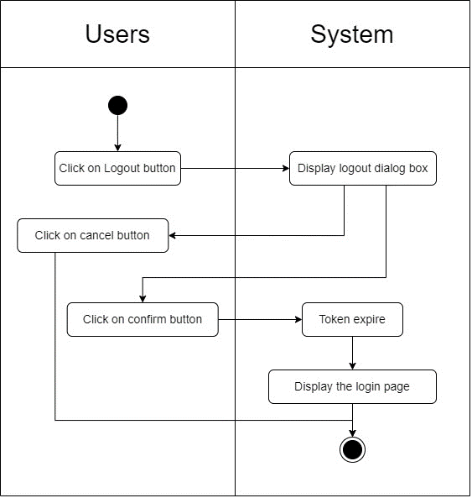

Figure 225: Logout system activity diagram

**(Go back to the same page)**

#### 7.3.2.4 Wireframe UI

Splash screen

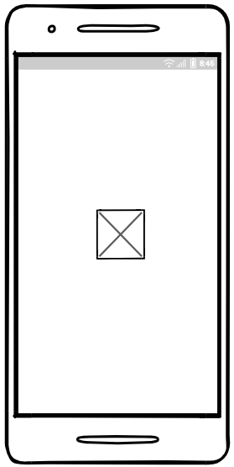

Figure 226: Splash screen mobile UI

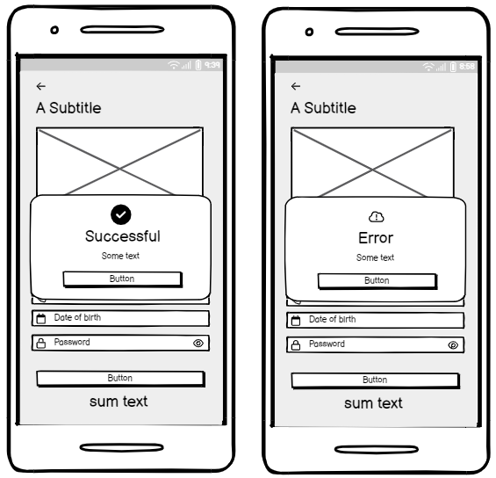

Figure 227: Register response message mobile UI

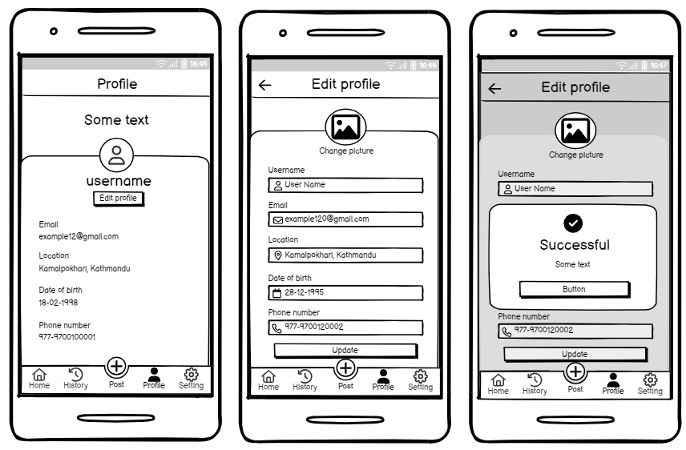

Figure 228: Donor Profile screen mobile UI

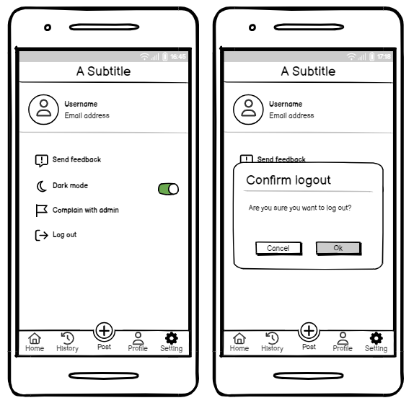

Figure 229: Donor Setting screen mobile UI

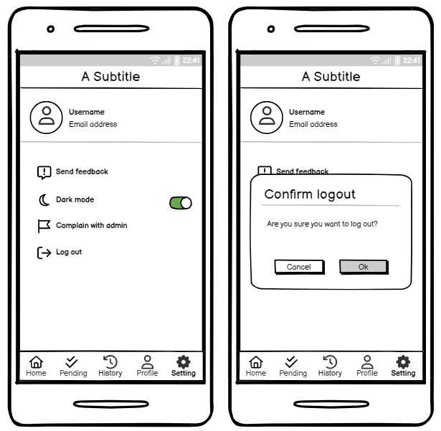

Figure 230: Volunteer Setting screen UI

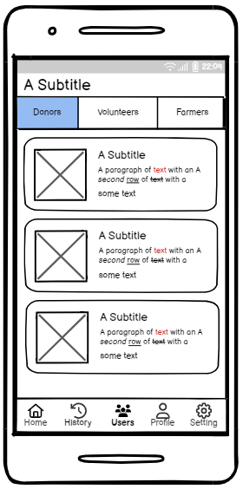

Figure 231: NGO Users screen UI

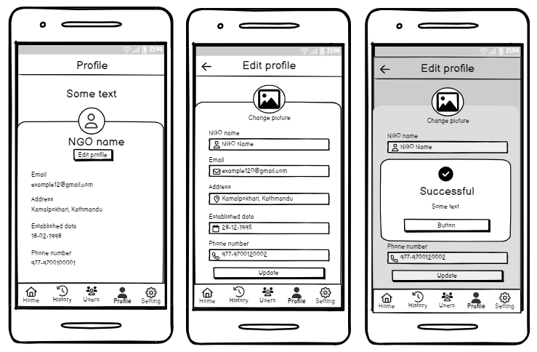

Figure 232: NGO Profile screen UI

**(Go back to the same page)**

#### 7.3.2.5 Entity Relation Diagram

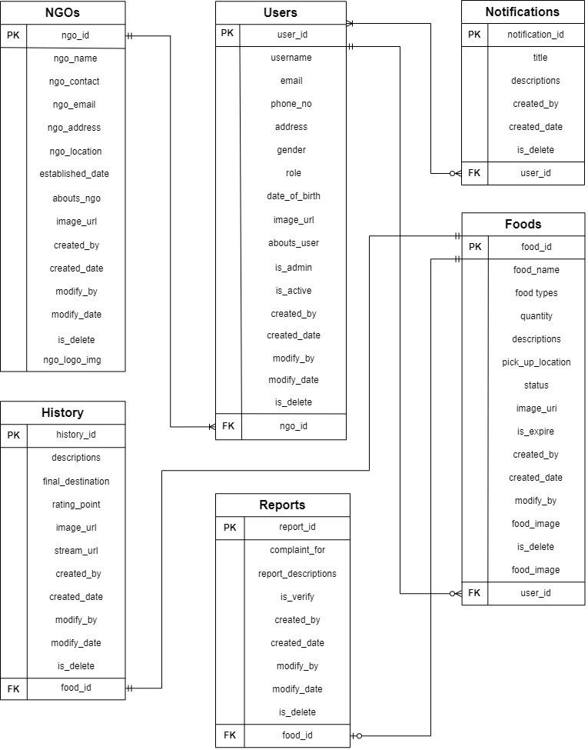

Figure 233: Initial or Actual ER-Diagram



Figure 234: Final ER-Diagram

**Go back to the same page**

#### 7.3.2.6 DFD Leve

Data flows are represented with arrows, indicating the direction of data movement between processes, data stores, and external entities. Each data flow is labelled to specify the type of data being transferred. Each process is represented by a rectangle with the process name written inside. Sub-processes are depicted by breaking down the main processes into smaller rectangles. By breaking down processes into sub-processes and illustrating data flows, Level 2 DFD enhances understanding of the system's functionality. It serves as a valuable communication tool between system designers, developers, and stakeholders, ensuring everyone has a clear understanding of the system's intricacies.

Register Details

The user can register details provided to the system by adding the registration details. The system receives the registration details and checks if they are valid. If the registration details are not valid, the system shows an error message indicating the invalid information. If the details are valid, the system records them in the database and provides a success message.

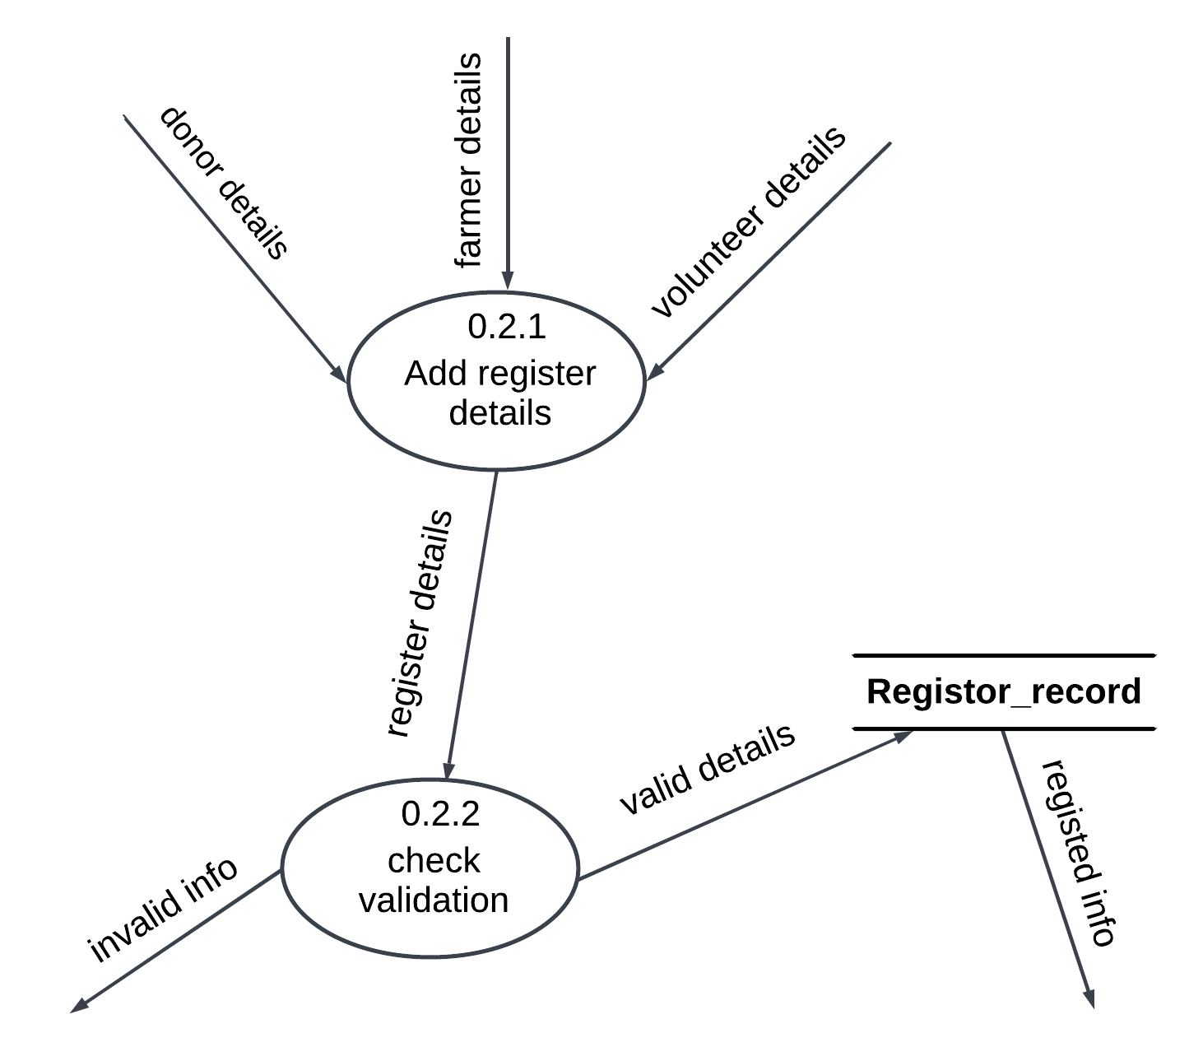

Figure 235: Register details DFD Level-2

Login System

The user can verify their registration account to log into the system using their email and password. The system checks the database to verify if the credentials are available. If the account has login authentication, the system displays a success message, and the user can navigate to the dashboard.

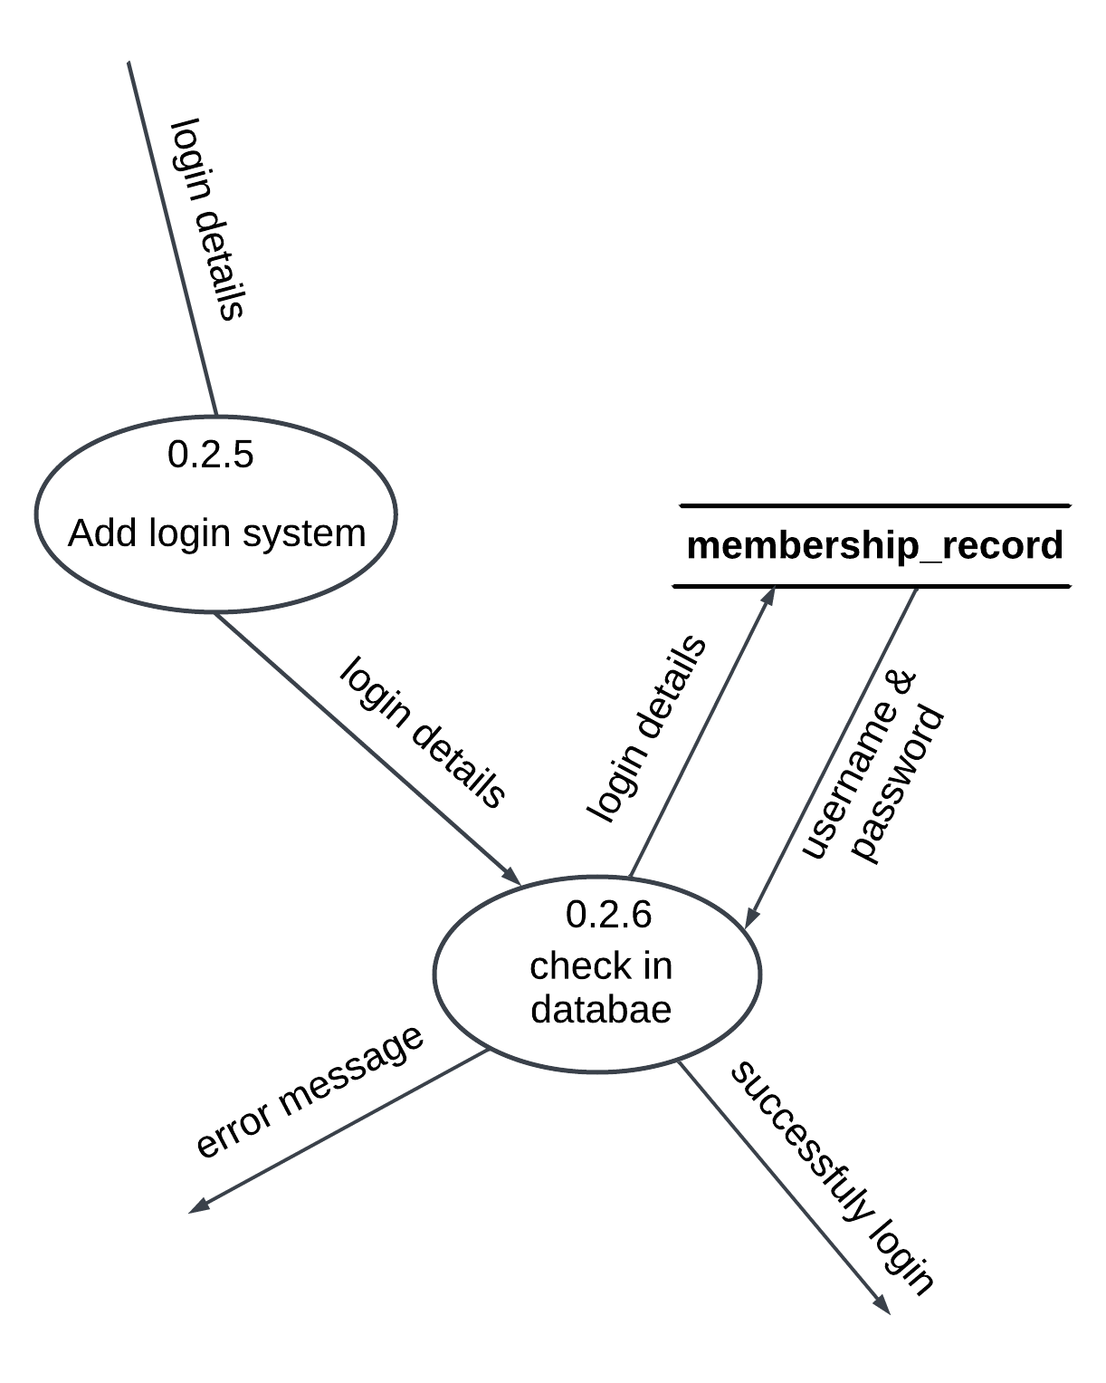

Figure 236: Login details DFD Level-2

**(Go Back to the same page)**

#### 7.3.2.7 More features implementations

* Implementations of Login Features

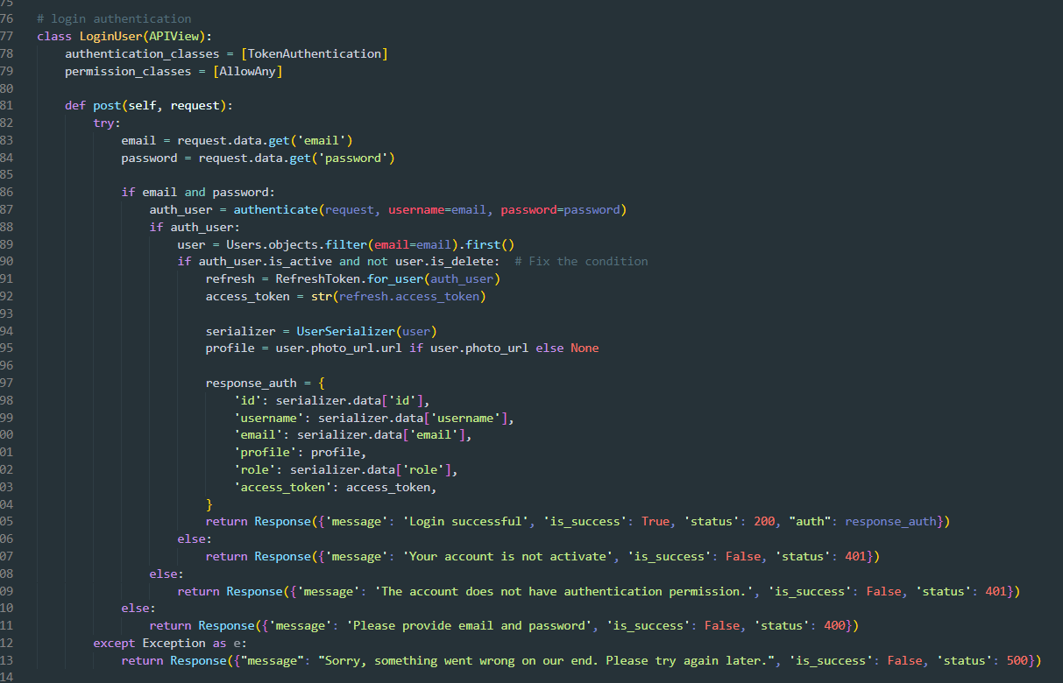

Figure 237: Login feature implementation in login API.



Figure 238: Login Api Call

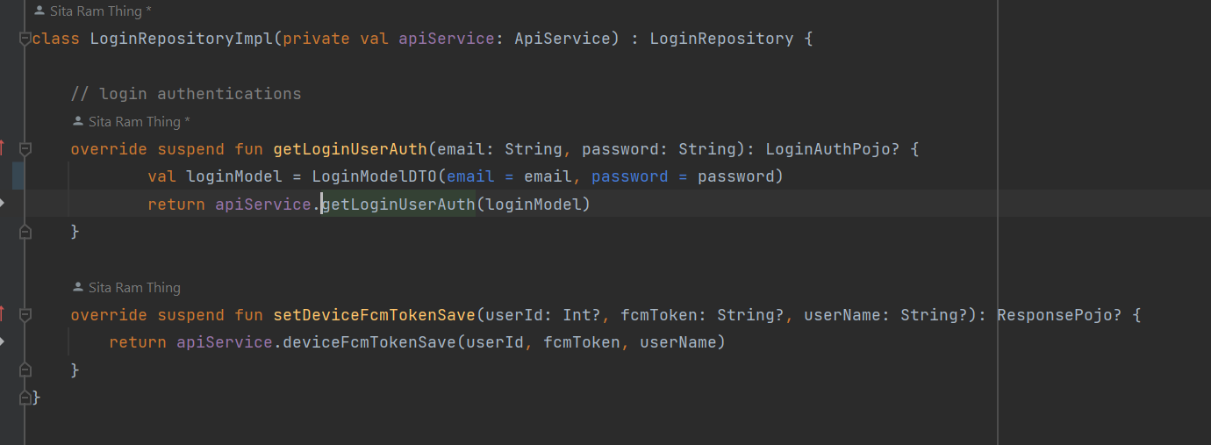

Figure 239: Login Repository Implementation

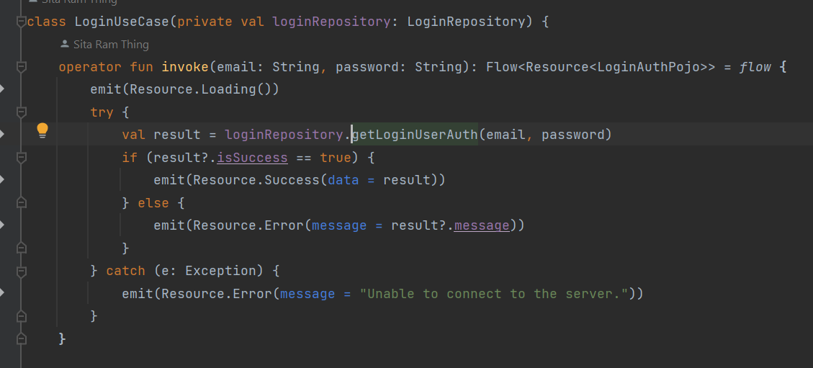

Figure 240: Login user use-case implementation.

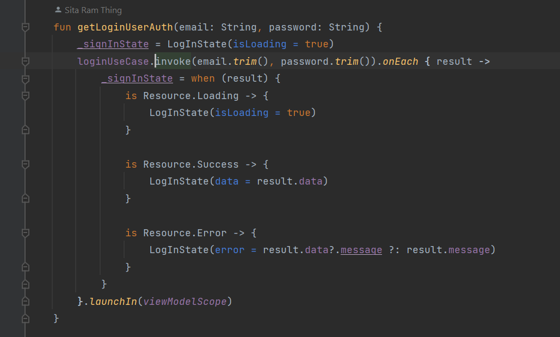

Figure 241: Login authentication view model implementation.

* Implementations of Register

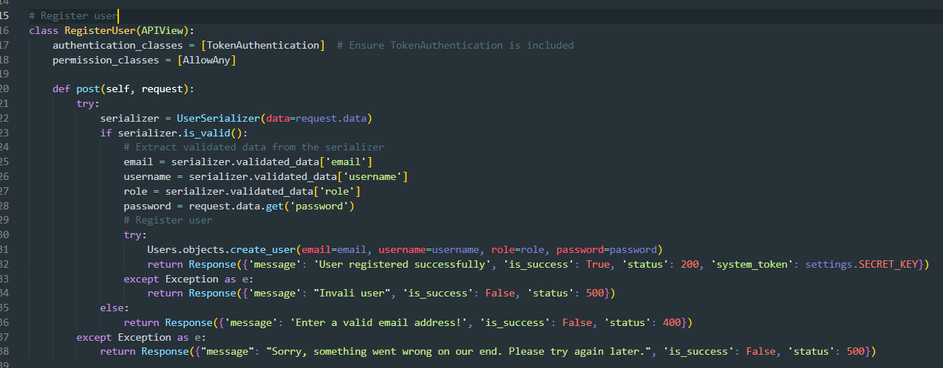

Figure 242: Register user Api view implementation.

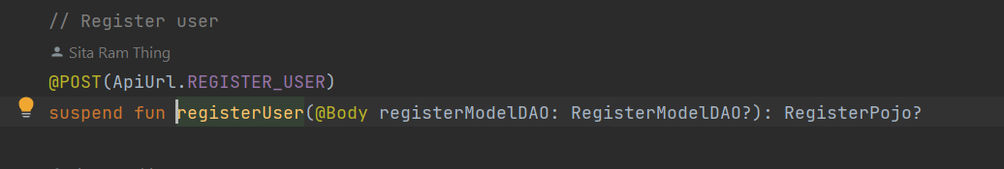

Figure 243: Register user repository implementation.

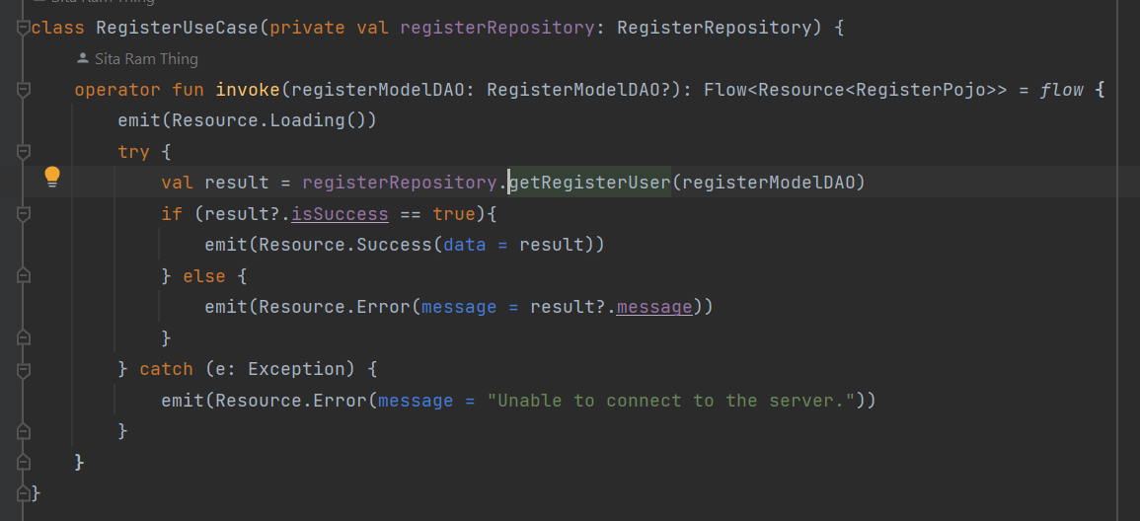

Figure 244: Register user use case implementation.

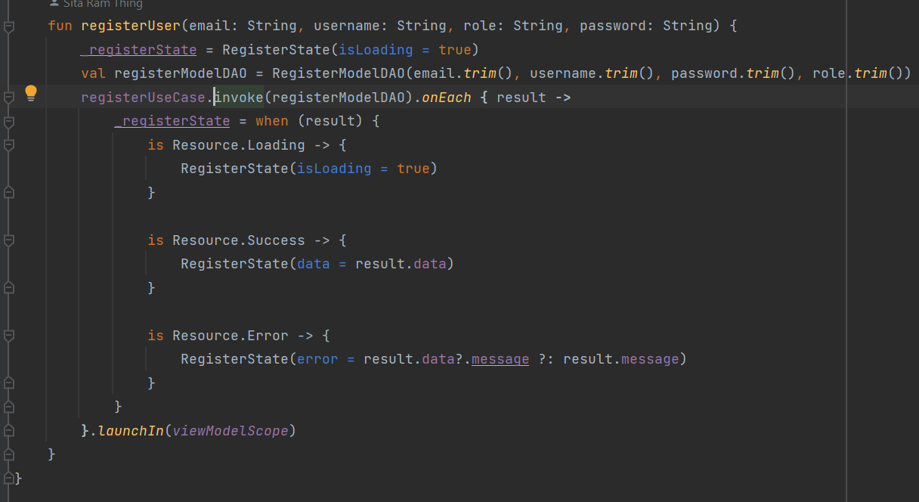

Figure 245: Register user view model implementations.

* Implementations of Forgot password.

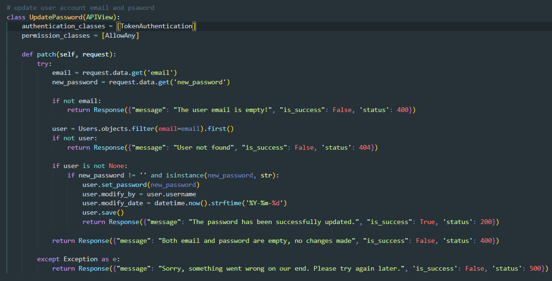

Figure 246: Update password Api view implementations.

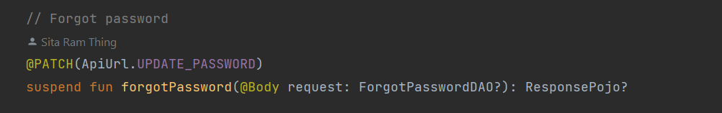

Figure 247: Forgot password API call implementation.

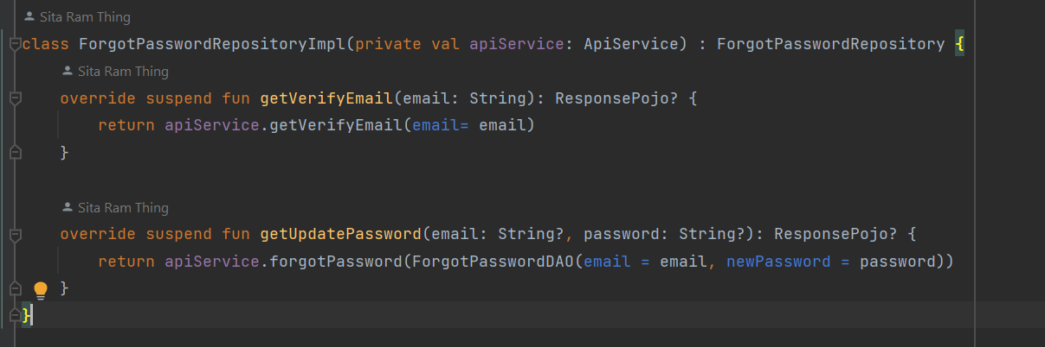

Figure 248: Forgot password repository implementation.

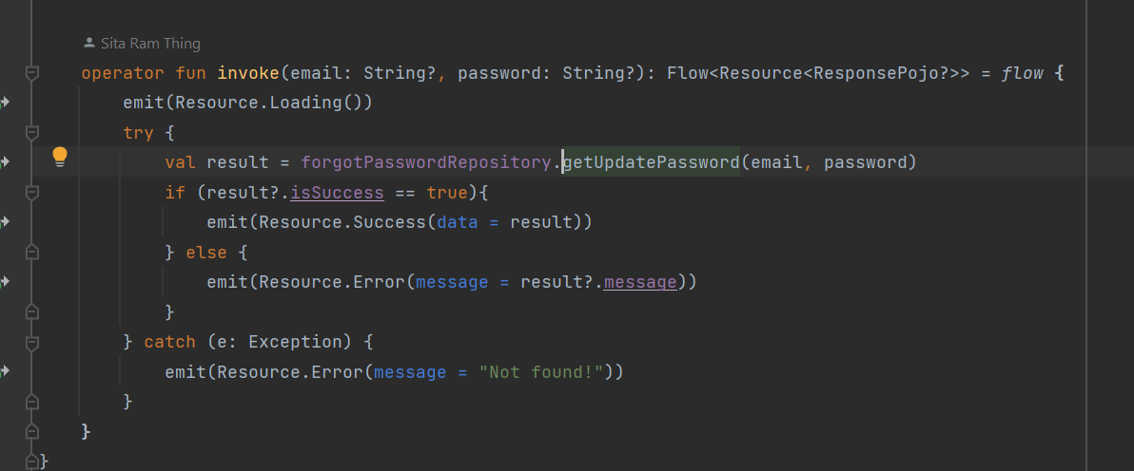

Figure 249: Forgot password use case implementation.

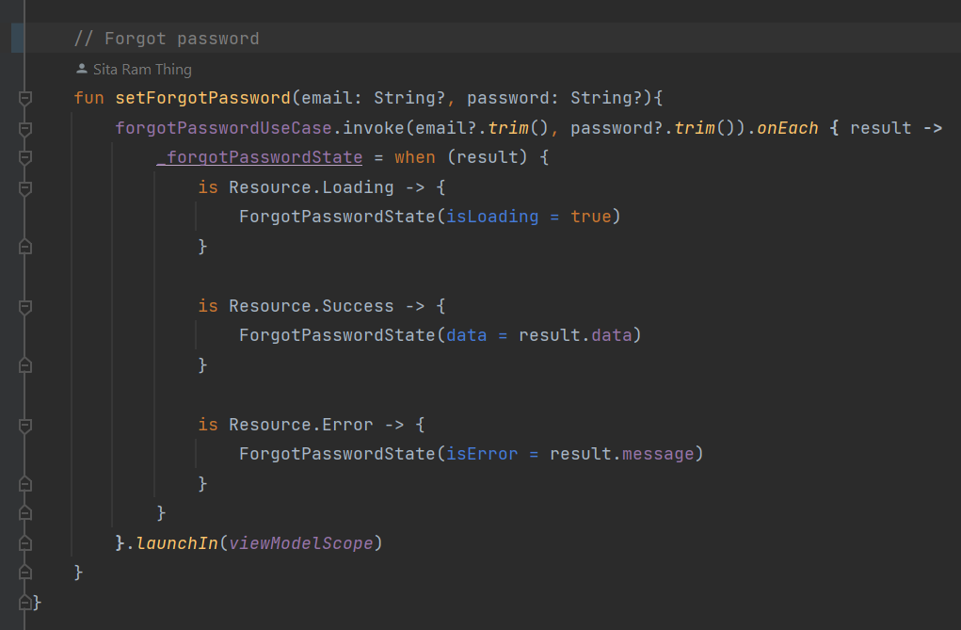

Figure 250: Forgot password view model implementation.

* Implementations of Updated profile

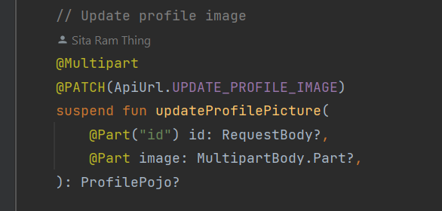

Figure 251: Update profile API call

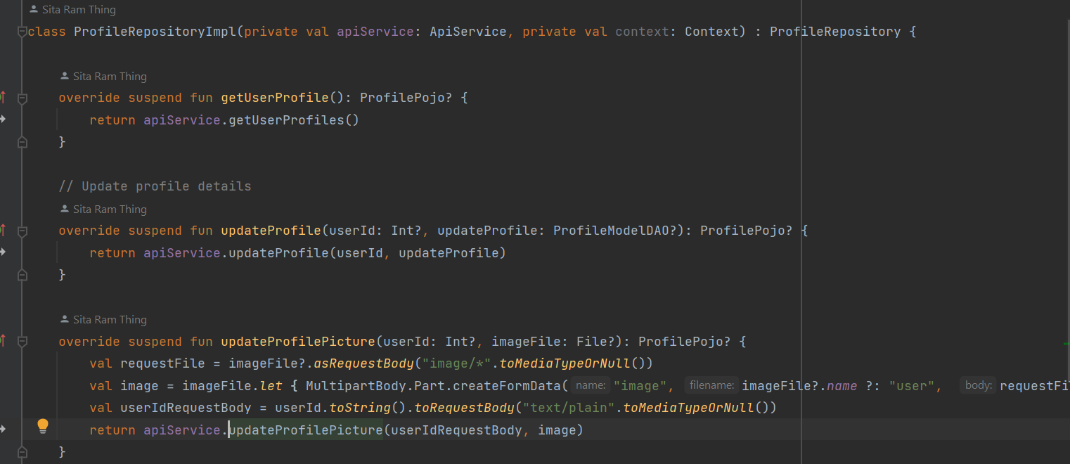

Figure 252: Update profile repository implementation.

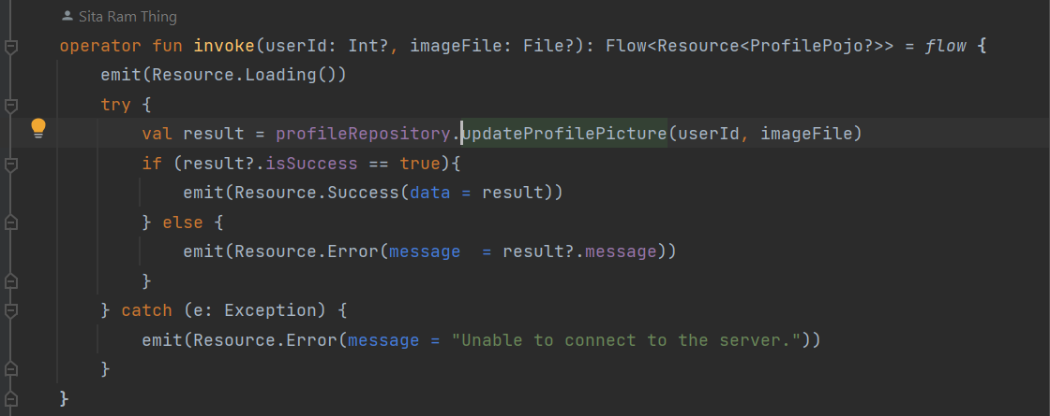

Figure 253: Update profile use case implementation.

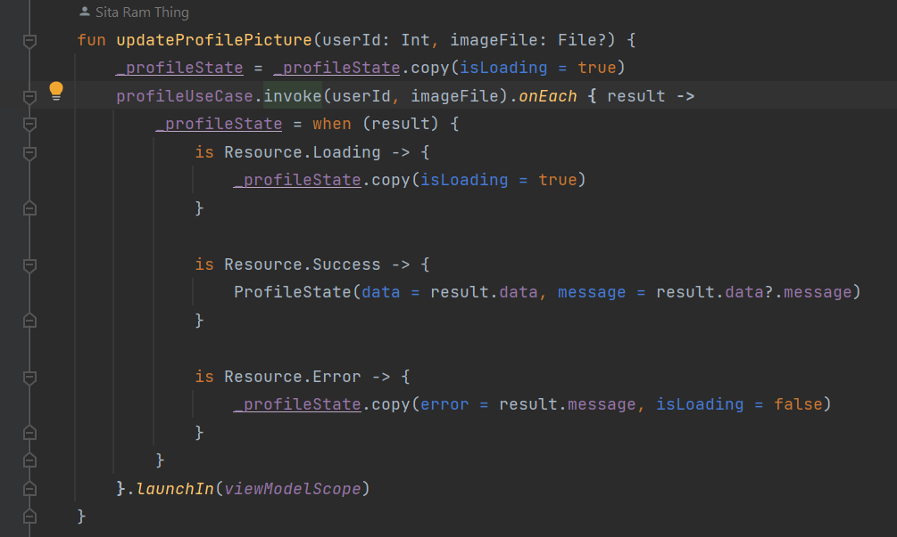

Figure 254: Update user profile view model implementation.

* Implementations of Updated food details

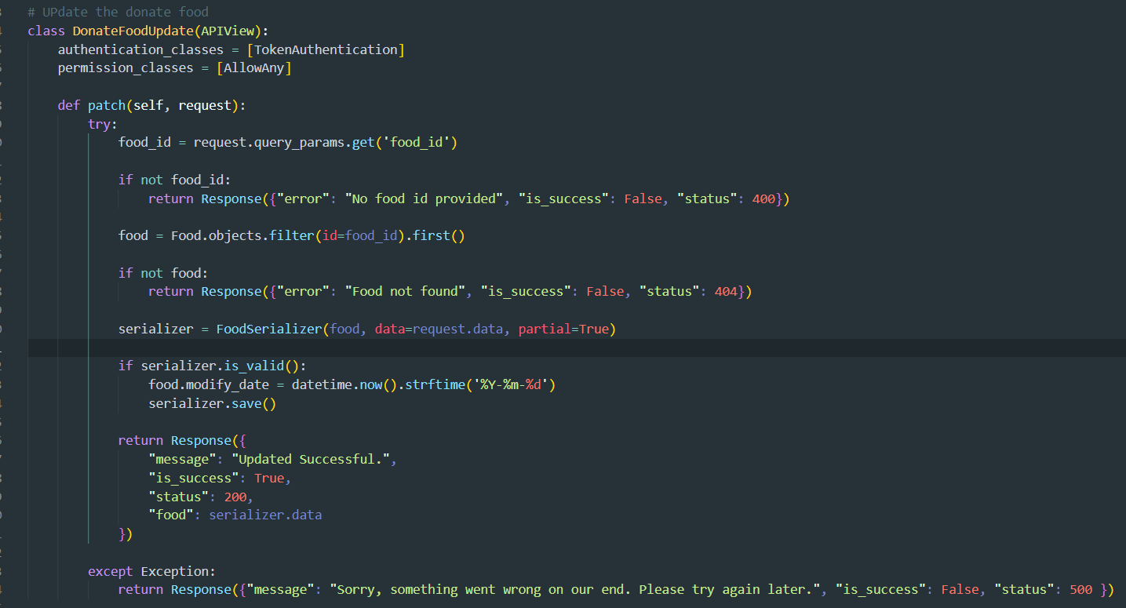

Figure 255: Food update Api function implementation.

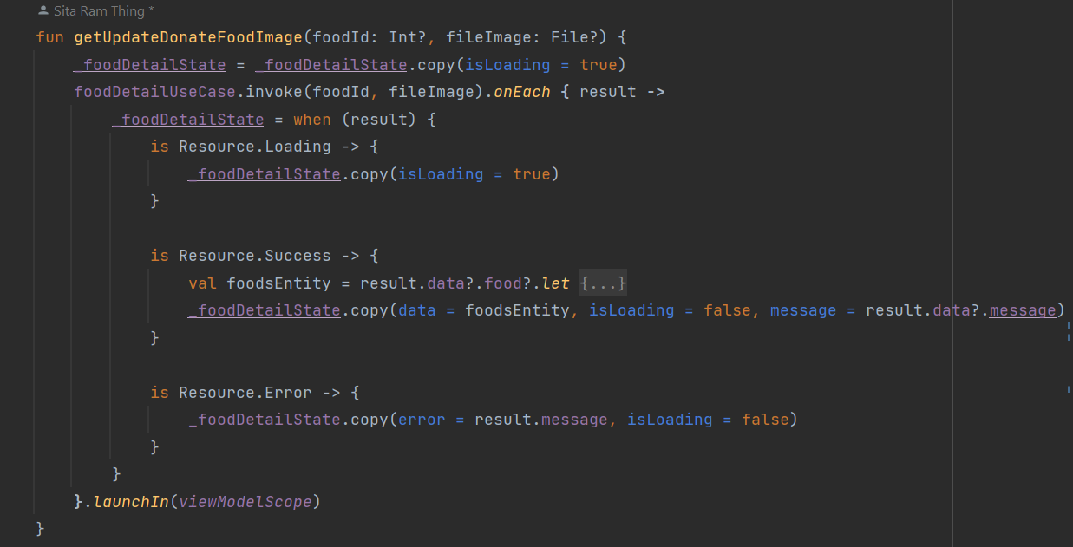

Figure 256: Update food details function and implementation in the view model

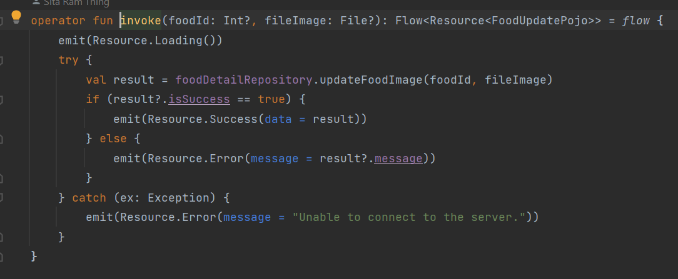

Figure 257: Update food details implementation in the use case

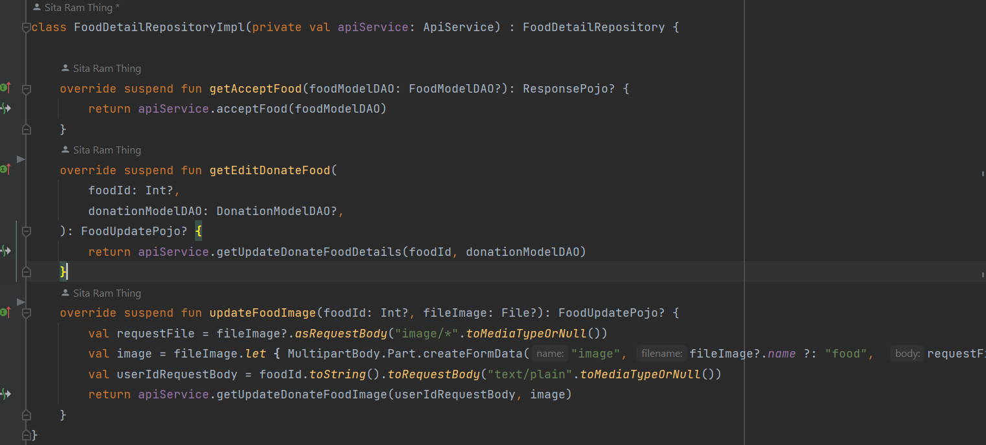

Figure 258: Implementation of the repositoryImpl in updated food details.

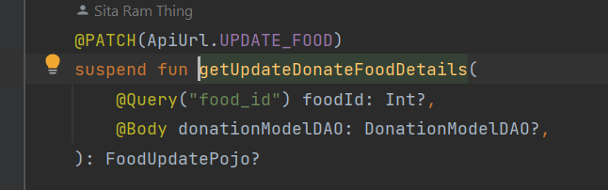

Figure 259: Update food details backend API call.

* Implementations of Delete food.

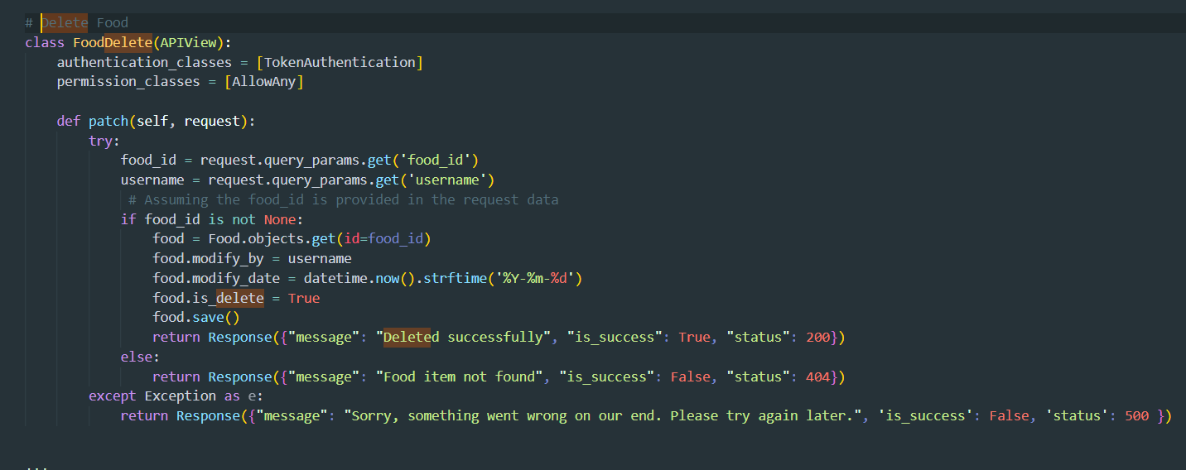

Figure 260: Delete Api function implement.

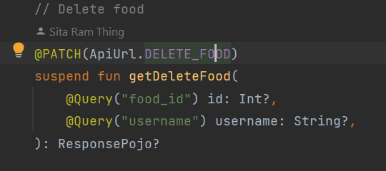

Figure 261: Delete Api call function Mobile.

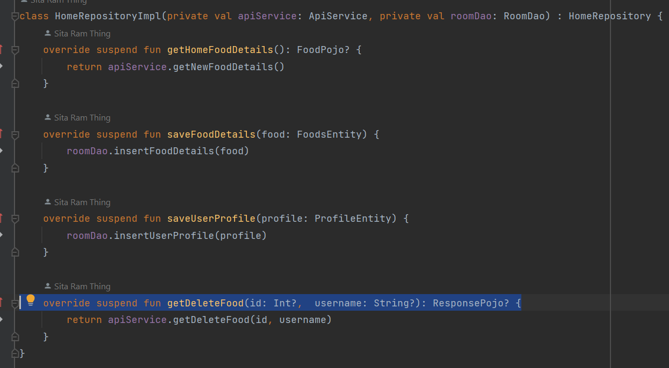

Figure 262: Repositorium for Delete function

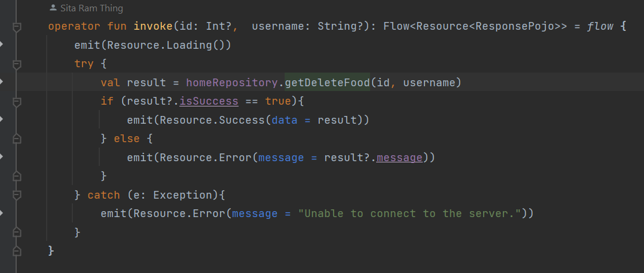

Figure 263: Food deletes use case implement.

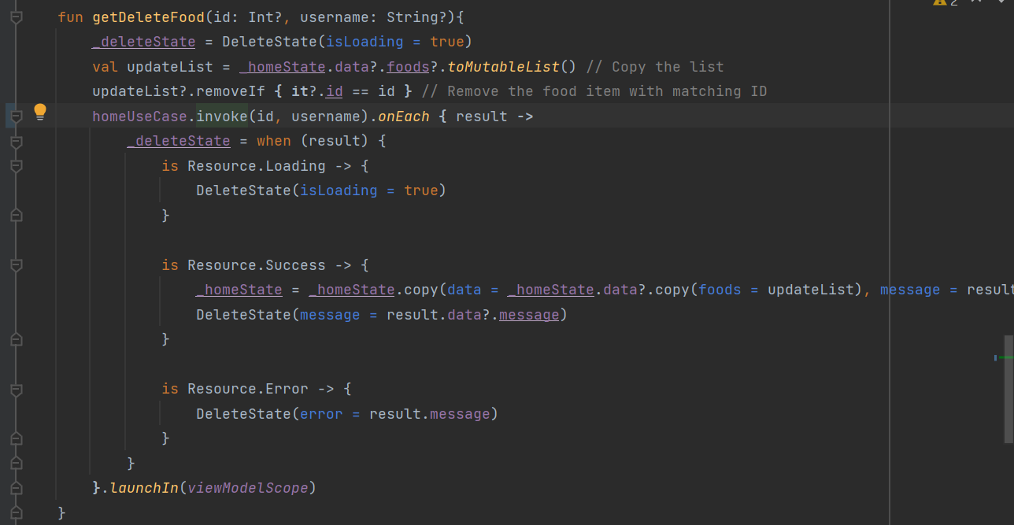

Figure 264: Food Delete View Model is implemented with state management.

* Implementations of Local notification

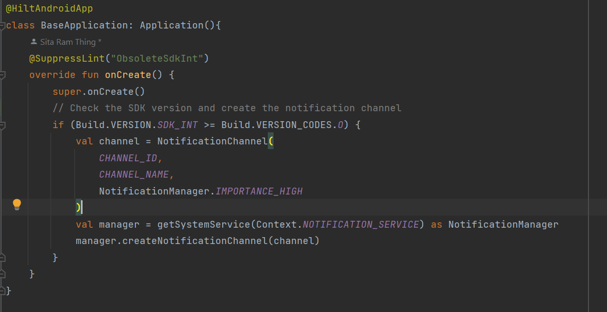

Figure 265: Create the notification channel

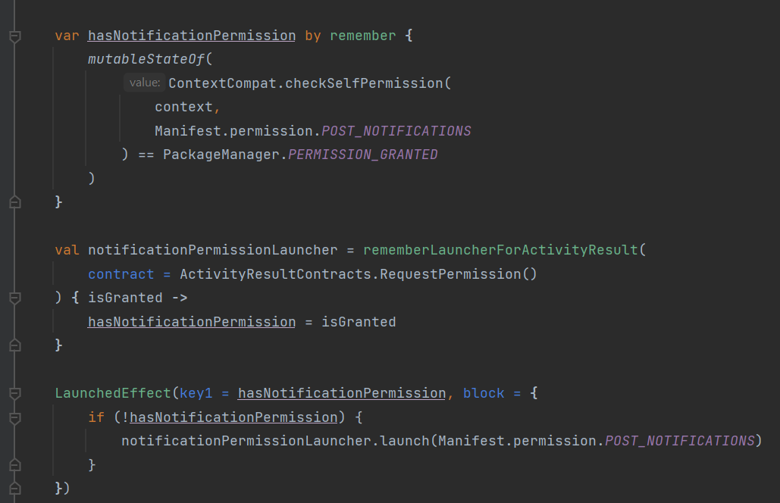

Figure 266: Generating the notification permission and asking for permission.

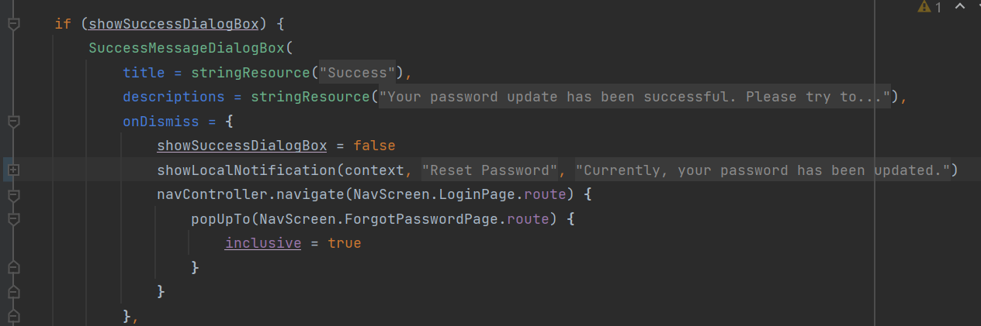

Figure 267: publish the local notification.

**Go back to the same page**

## 7.4 Appendix D: Implementation

### 7.4.1 Unit Test Plans

Unit test of waste food management system list of features:

|  |  |
| --- | --- |
| **Test plans** | **Descriptions** |
| **All User:** | |
| Login authentication | Enter the valid username and password to log in to the system and check whether the test is successful or not. |
| Register new user | Enrol the details of the newly registered user and register them in the system. Then, check the expected result. |
| Forgot password | After successfully verifying the user's email, they can enter a new password to update it. Then, check for a successful response. |
| Show local notification | After forgetting the password and the account was deactivated successfully the show the notification. |
| Auto redirect to the dashboard | After successful login without logging out, if the app is closed and reopened, it should reopen directly to the dashboard instead of the login screen. |
| The home screen only displays newly donated food | The home screen only displays newly donated food that is neither pending nor completed, along with the food donation history. |
| View donated food details | The user can click on "Donate Food" to view the donation details. |
| View self-profile | The user can view self-profile details on authenticating permission. |
| View other donor and volunteer profiles | The user can view any user profile details |
| View donation locations on the map | The user can view the food donation location with distance. |
| Update self-profile details | The user can update self-profile details |
| Receive push notifications | The user can receive push notifications after posting new food for donation. |
| View only self-history with ratings if the donation is completed | The user can view history only their history details. |
| Complain or report to the admin | If the donor fails to provide the food and the volunteer fails to pick up the food, they can be reported to the admin. |
| Logout system | The user can log out of the system without any exceptions, and the local storage will be cleared. |
| Update password | The user can update their account with a new password. |
| Account deactivation | The user can permanently deactivate their account if they no future need it. |
| **For Donors:** | |
| Post or donate food | The donor can post surplus food for donation by providing the food details. |
| Update post | The donor can update the donated food details in case of any mistakes in the post. |
| Delete posts | The donor can delete the post if there is any mistake or if it is no longer needed in the history. |
| **For Volunteers:** | |
| Accept food donations | The volunteer can accept the food and the food can show the pending status. |
| Donation rating | The volunteer can distribute the completed then give the rating. |
| Delete history | The volunteer can delete food history without any exceptions. |
| **For Admins:** | |
| View system status in Pai Chat to data | The admin can view the system's current status in the pian chart in the home. |
| Activate new accounts | The admin can verify and activate new user accounts. |
| Searching the data | The admin can research anywhere found data. |
| Sorting data in ascending and descending | The admin view the data is sorted by ascending and descending. |
| Remove the data | The admin can remove the unnecessary data |

Table 66: Unit tessting palnning tables

**Go back to the same page**

## 7.5 Appendix E: Testing and Analysis

### 7.5.1 System Testing

#### 7.5.1.1 Update profile image

|  |  |
| --- | --- |
| **Test Case** | **Descriptions** |
| **Objectives** | The user can update the user profile image if the user can needed. |
| **Actions** | The user can click the profile edit icon update the profile image and click the update confirm button. |
| **Expected Result** | The user profile details are successfully updated without any errors or exceptions. |
| **Actual Result** | The user profile image was successfully updated. |
| **Test** | The test was successful. |

Table 67: Update profile image test in the mobile app



Figure 268: Select the profile image

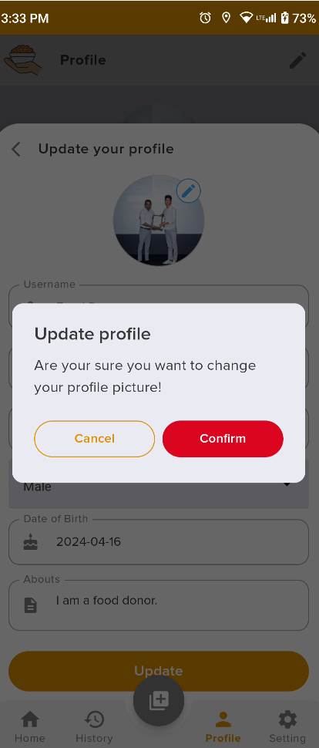

Figure 269: Display the confirmation message dialogue

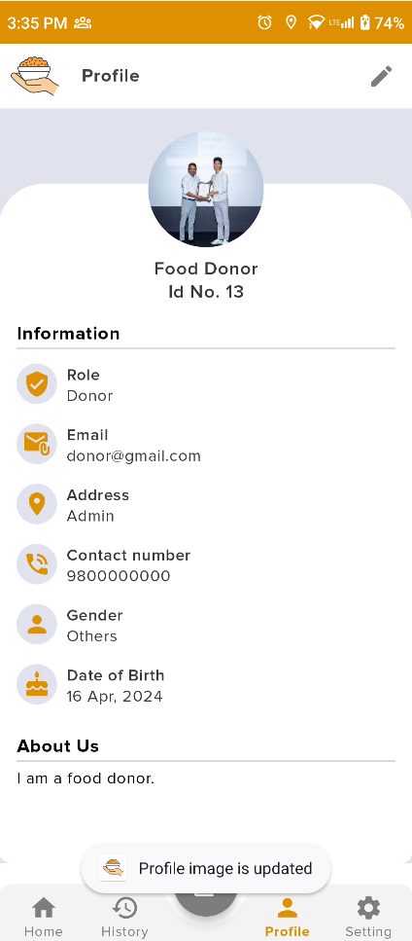

Figure 270: View the latest updated profile image

7.5.1.2 Deactivate user account (Delete account)

|  |  |
| --- | --- |
| **Test Case** | **Descriptions** |
| **Objectives** | The user can activate the account to deactivate it if the user does not need the user account. |
| **Actions** | Click the deactivate button and show to confirmation dialog box the click the deactivate. |
| **Expected Result** | The user account is successfully permanently deactivated without logout the application and showing the location notification. |
| **Actual Result** | The user account was successfully deactivated. |
| **Test** | The test was successful. |

Table 68: Deactivate user account test in mobile app

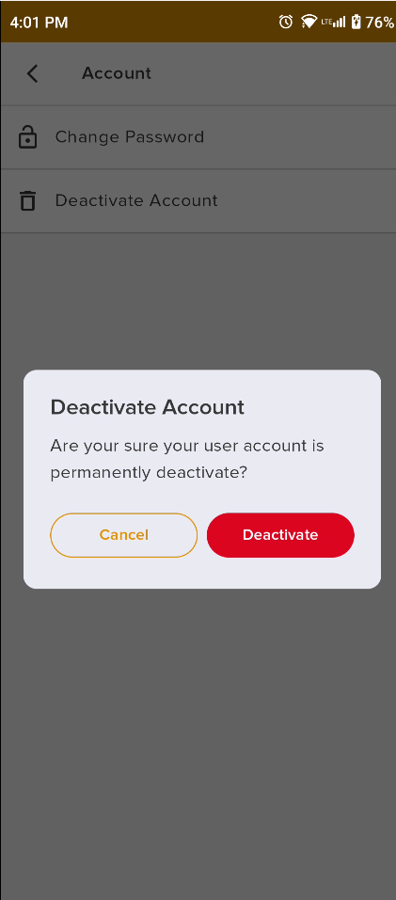

Figure 271: Display Account deactivate dialogue box

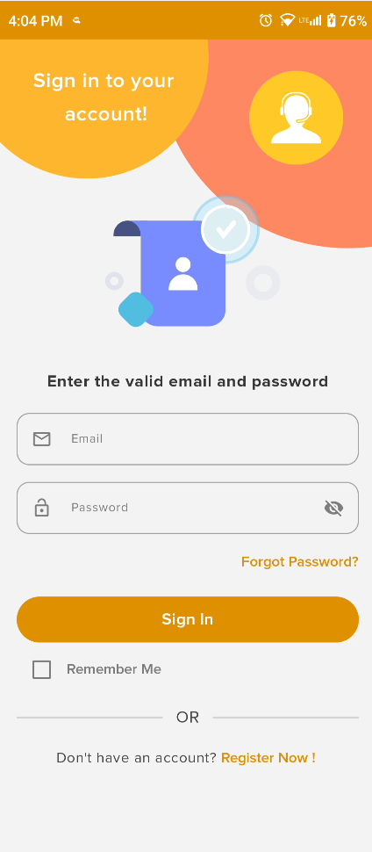

Figure 272: Navigate the login page

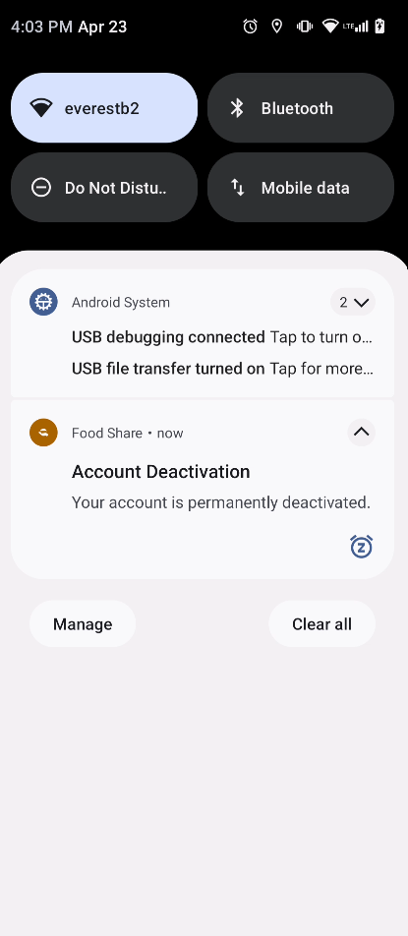

Figure 273: Account deactivate and out logout the system with get local notification

#### 7.5.1.3 Change password

|  |  |
| --- | --- |
| **Test Case** | **Descriptions** |
| **Objectives** | The user can change the new password for account security and remember the log in to the system. |
| **Actions** | Click the change password show the confirmation dialogue to fill in the password and click the update as |
| **Expected Result** | The user account should be successfully activated, allowing the user to log in to the system. |
| **Actual Result** | The user account was successfully activated. |
| **Test** | The test was successful. |

Table 69: Change password test mobile app

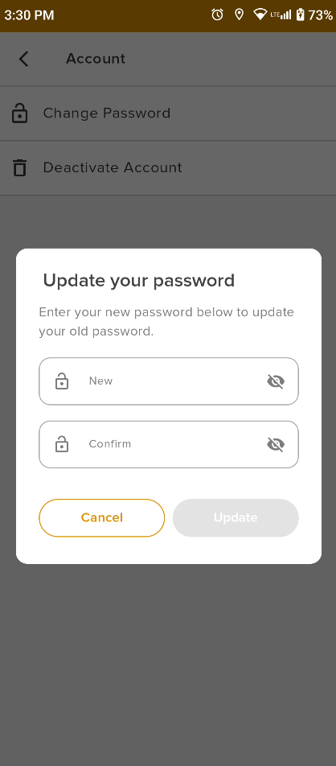

Figure 274: Change password input dialogue box

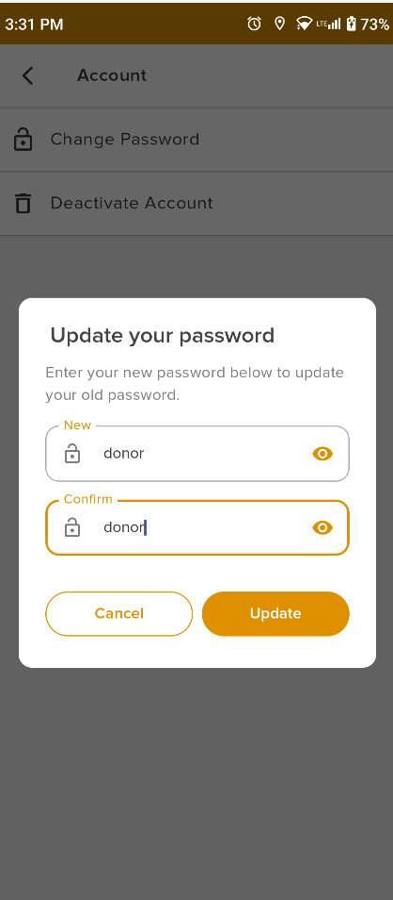

Figure 275: Enter the new and confirmation passwords in the dialogue box

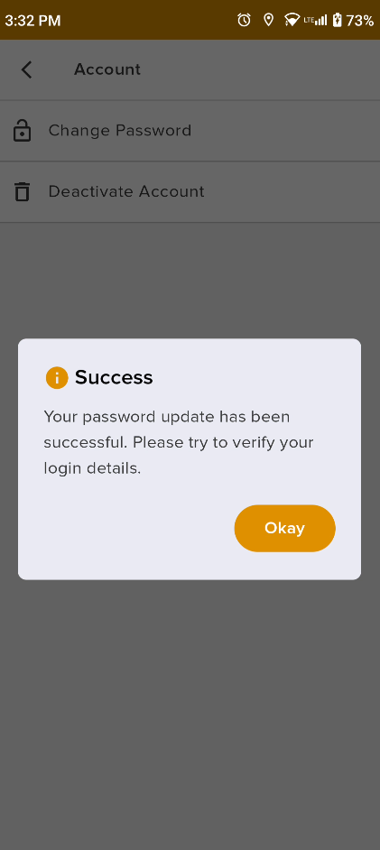

Figure 276: Display the success message7.5.1.4 Logout App

|  |  |
| --- | --- |
| **Test No** | **1** |
| **Objectives** | Go to the settings page and the user can log into the system in his account when showing the confirmation dialog box. |
| **Actions** | Click the logout button then display the confirmation button and click the logout button.  Button: Cancel, Log out |
| **Expected Result** | The user can successfully log out of the system and clear the preference with local storage. |
| **Actual Result** | The user was successfully logged out. |
| **Test** | The test was successful. |

Table 70: Logout test mobile app

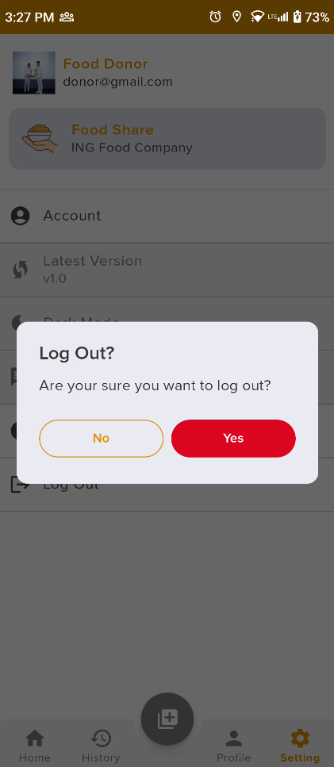

Figure 277: Logout confirmation dialogue box

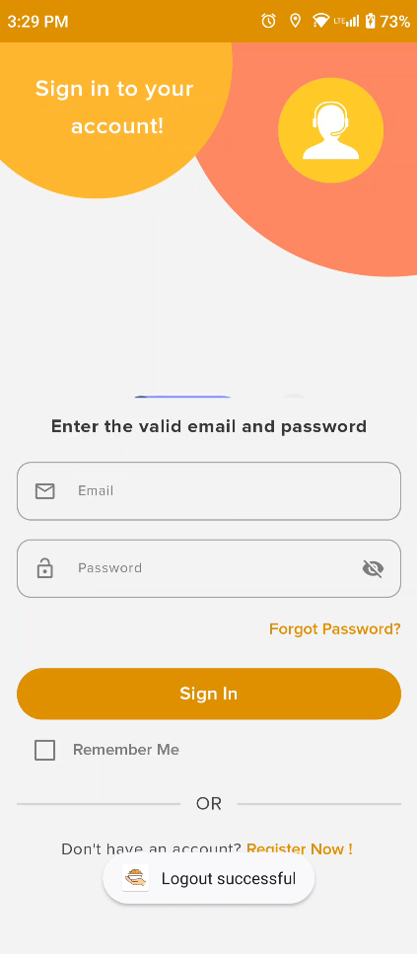

Figure 278: Logout success dialogue box

#### 7.5.1.5 Internet connection test

|  |  |
| --- | --- |
| **Test No** | **1** |
| **Objectives** | To check the internet connection where if the internet is not available then display the not internet screen. |
| **Actions** | Internet off to any activity in the application for API calls. |
| **Expected Result** | The user can off the internet and then show the not internet screen in the UI. |
| **Actual Result** | The UI is shown successfully. |
| **Test** | The test was successful. |

Table 71: Logout test mobile app



Figure 279: before the Internet disconnects the page

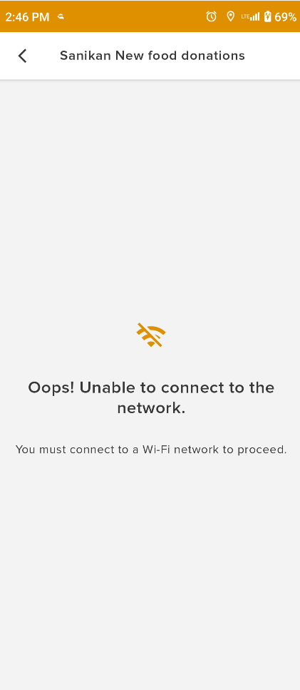

Figure 280: display the no internet connection fails the screen

#### 7.5.1.6 Show the local notification

|  |  |
| --- | --- |
| **Test Case** | **Descriptions** |
| **Objectives** | To forget the password and deactivate the user account. |
| **Actions** | Click the history button navigation bar and display the history list of history details. |
| **Expected Result** | To navigate the history page and show the history details without any error. |
| **Actual Result** | The histories are shown successfully. |
| **Test** | The test was successful. |

Table 72: View the History test in the mobile app

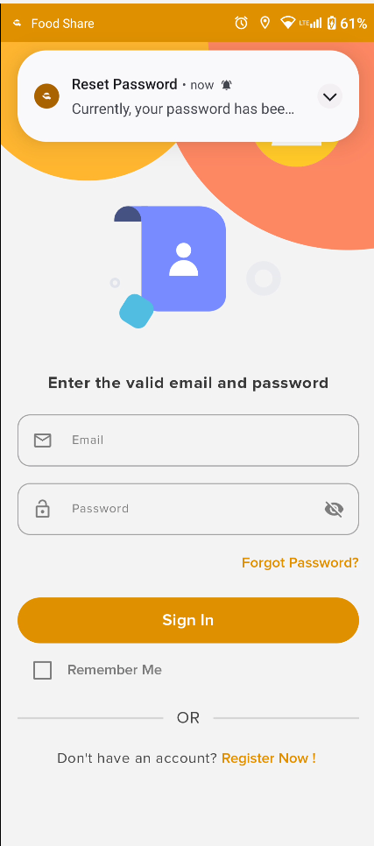

Figure 281: Display the local notification

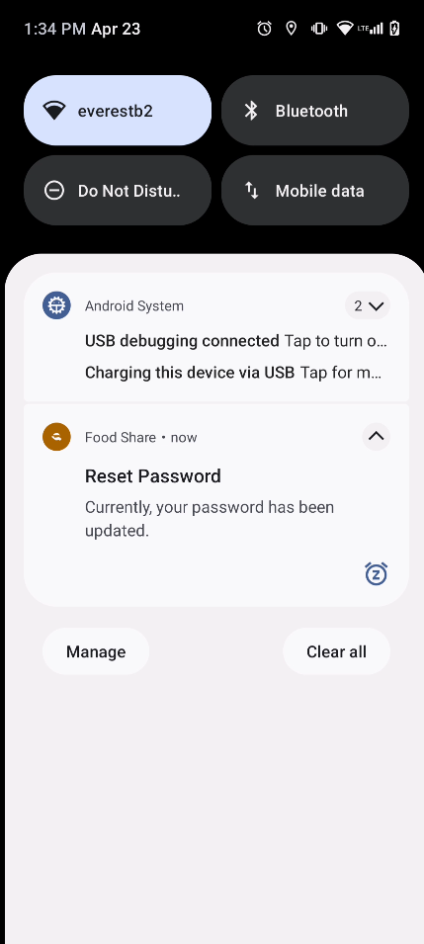

Figure 282: Show more details about the local notification

#### 7.5.1.7 Google map permission

|  |  |
| --- | --- |
| **Test Case** | **Descriptions** |
| **Objectives** | To display the welcome screen that asks for Google Maps permission after the user successfully installs the app and the intro slider screen is completed to open the welcome screen. |
| **Actions** | The user installs the application, completes the installation process, and navigates from the intro slider to the welcome screen. Then, the application displays the Google Maps permission request. where the user can click to allow the permission.   * Clicks the **WHILE USING THE APP** button for Map. * Clicks the **ALLOW** button for permission. |
| **Expected Result** | The application can be successfully accessed for Google Maps permission, and successfully displays the map and receives notifications. |
| **Actual Result** | The user grants permission to display the Google Map and receives notifications. |
| **Test** | The test was successful. |

Figure 283: System testing for Google Maps permission

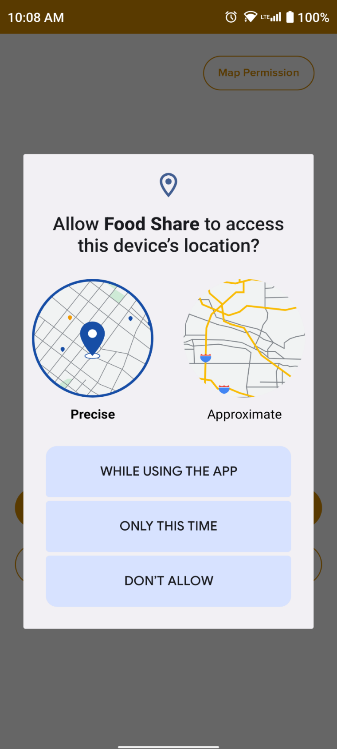

Figure 284: System test for Google Maps permission

**Go back to the same page**

## 7.5 Appendix F: Deployment (Not real deployment)

The system's fully developed planning phase to the development phase is completed. The first step was researching the food donation system and collecting information. Then, more details about the system were designed. After completing the system design and system architecture, they moved to the development phase. In the development phase, the backend was developed using Django Rest framework, the database was MySQL, the web development was done using HTML, CSS, and Javascript, and the mobile app was developed using Kotlin with Jetpack Compose, with local storage using Room database implemented. After development was completed, the system was released for end-user testing. The testing included functional, unit, and system testing to ensure the system was error-free. However, during the release of the mobile app, there was an error in uploading the APK file, which is available for free for 24 hours. Finally, the project was completed with documentation and submitted as the final year project.